Supplementary information

Association of sociodemographic factors and internet query data with pertussis infections in Shandong, China

Table S1. The search queries used in data analysis.
Pertussis | Pertussis infections
Pertussis vaccine | Pertussis prevention
Pertussis treatments | Pertussis infection period
Pertussis symptoms | Pertussis mortality
Pertussis medications | Pertussis in children

Figure S1. City-specific percentage of urban population, GPC, percentage of highly educated population and percentages of population (0-14 years old, 15-64 years old and over 65 years old) in Shandong.
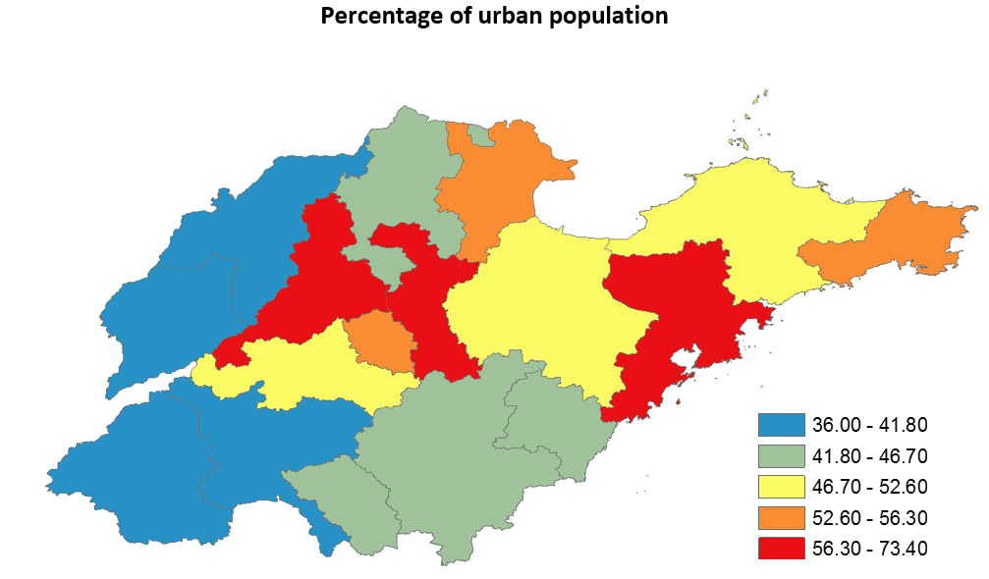
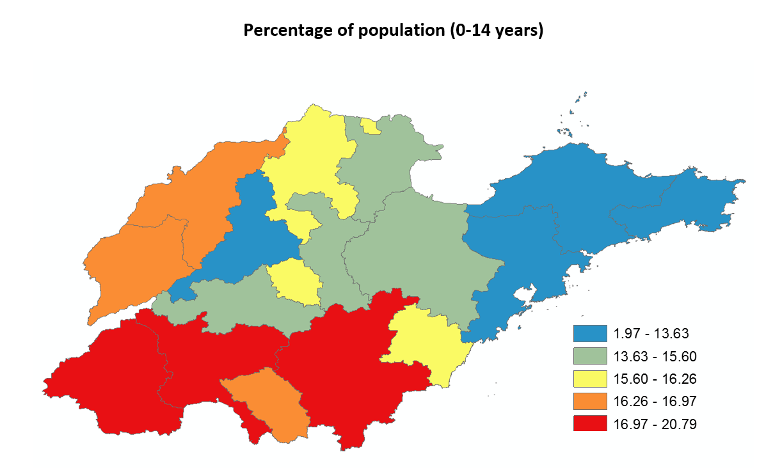
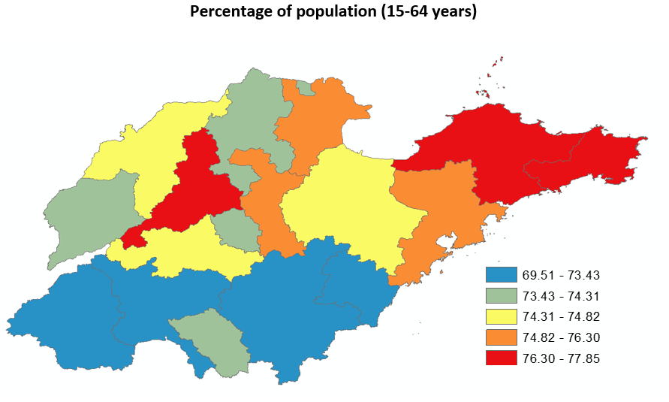
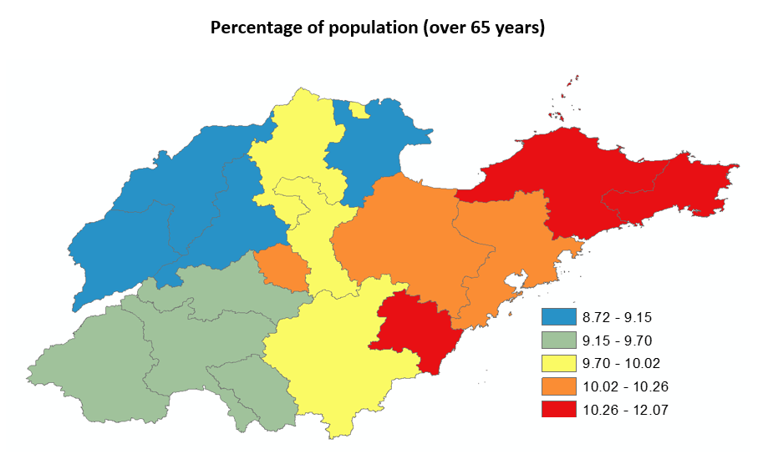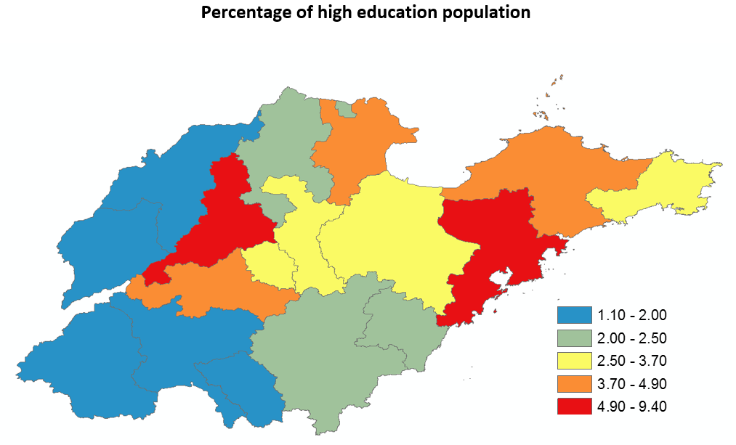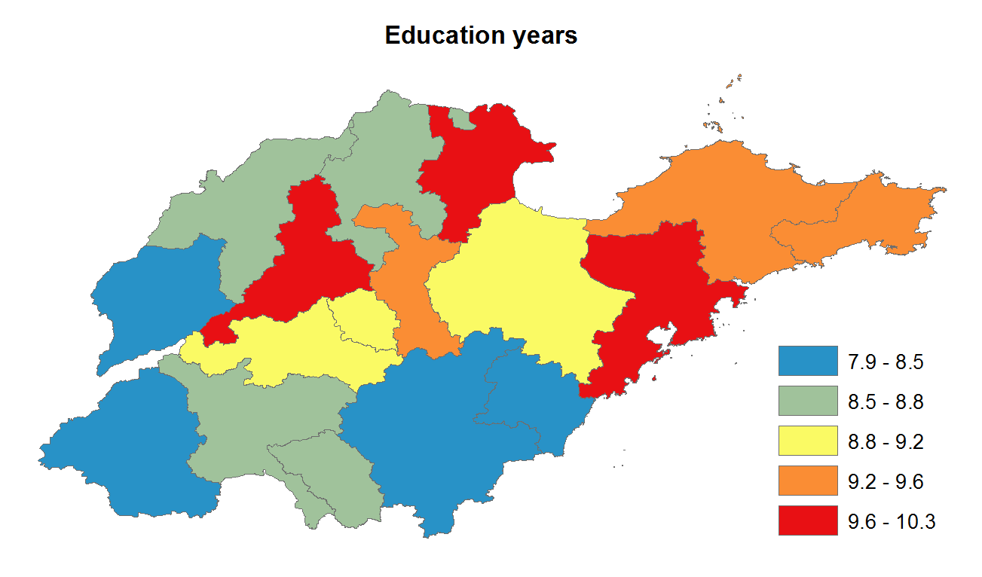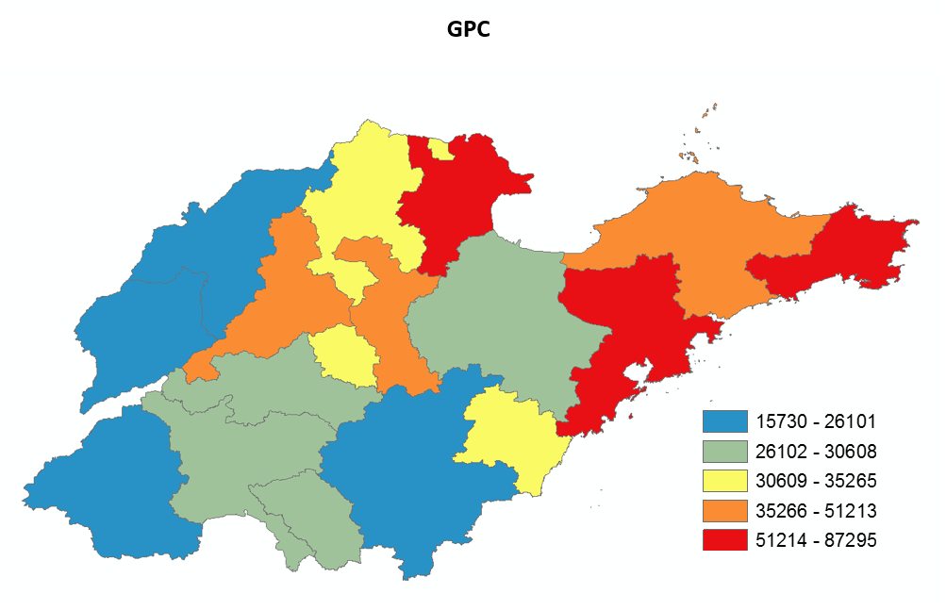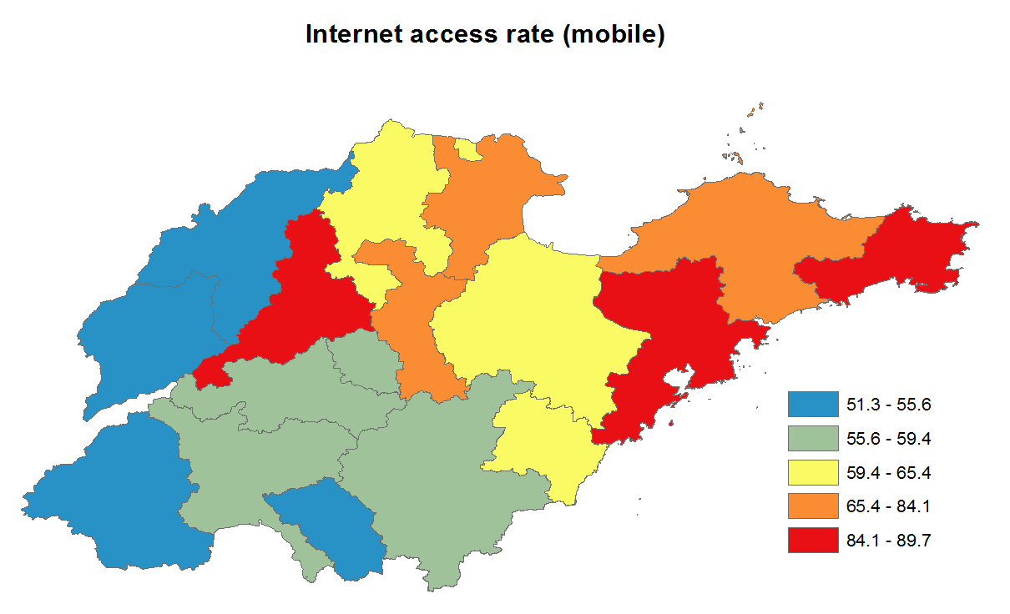
Percentage of highly educated population
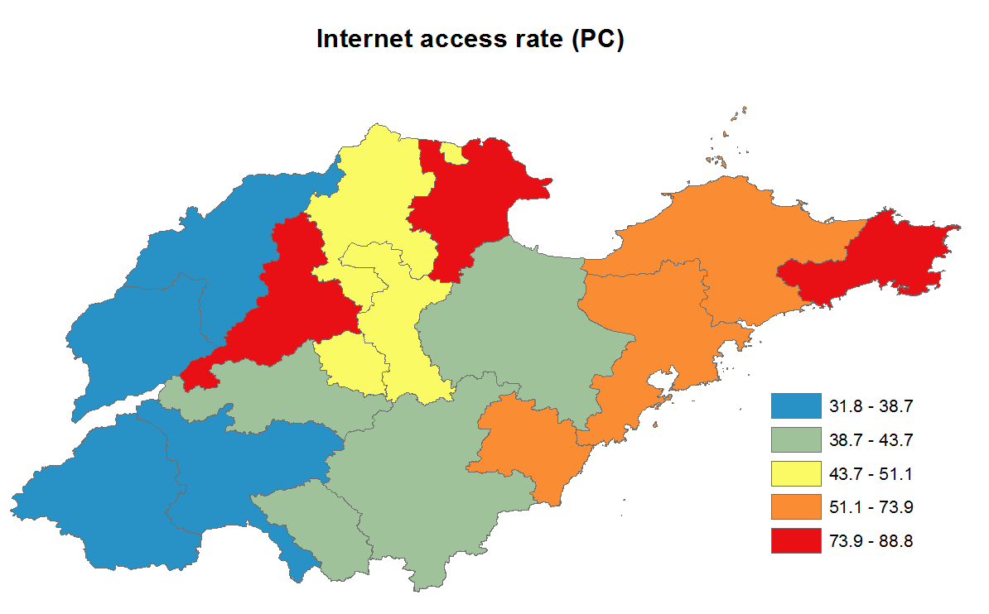

Figure S2. The regression tree modelling the hierarchical relationship between the temporal risks (time-series data, peaking number and increasing intensity) of pertussis infections and internet query with sociodemographic factors in Shandong province between 2009 and 2017 (The regression trees showed the threshold values, mean correlation coefficient; N is the percentage of entire data in the cell (the number of cities)).
A
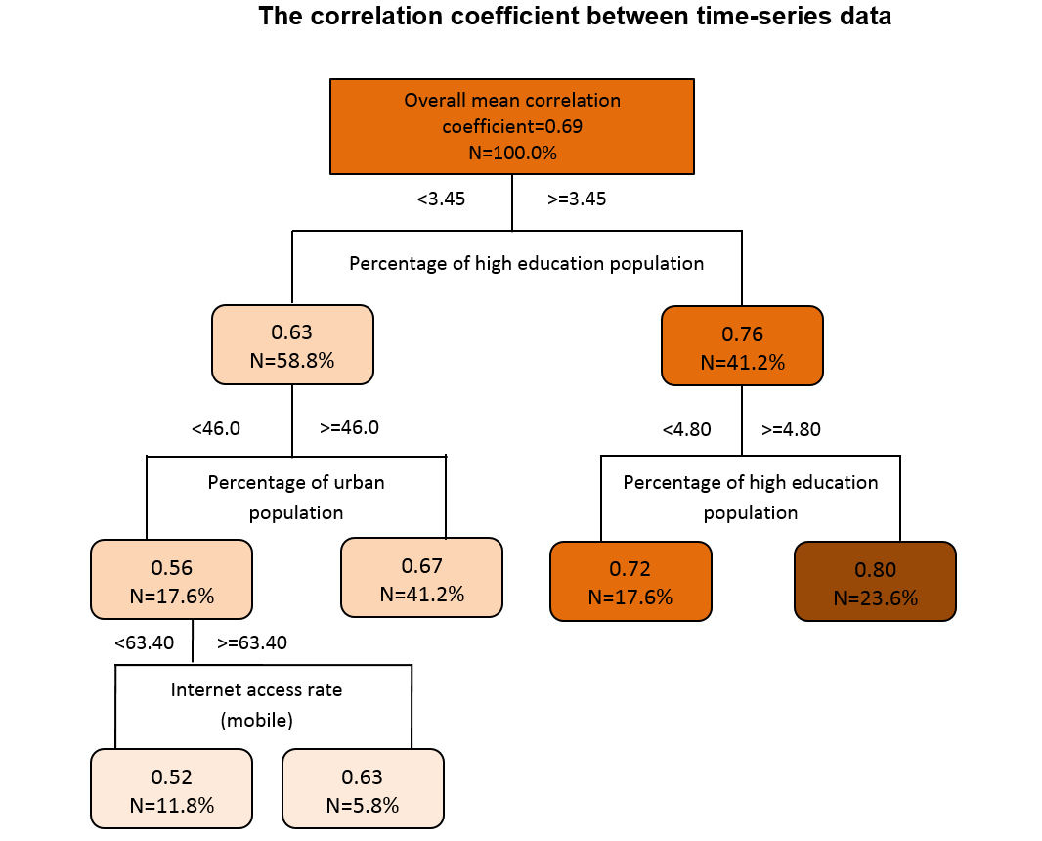
Percentage of highly educated population
Percentage of highly educated population

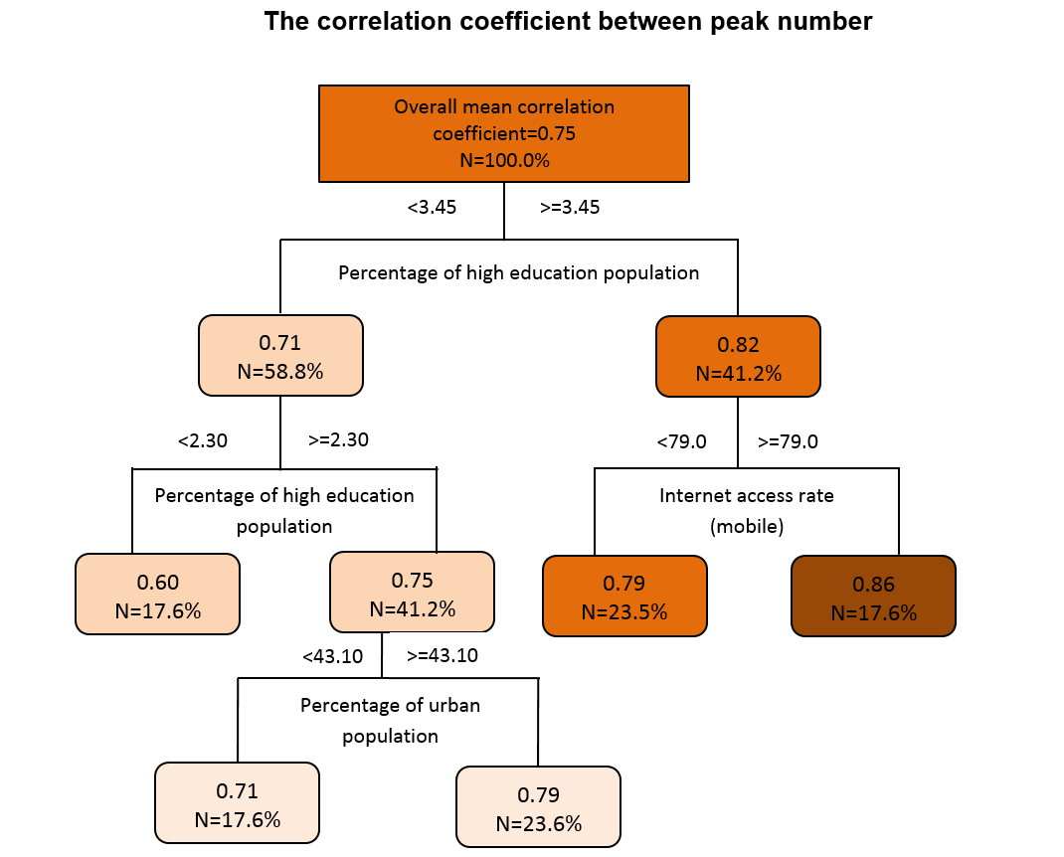
Percentage of highly educated population
Percentage of highly educated population
B
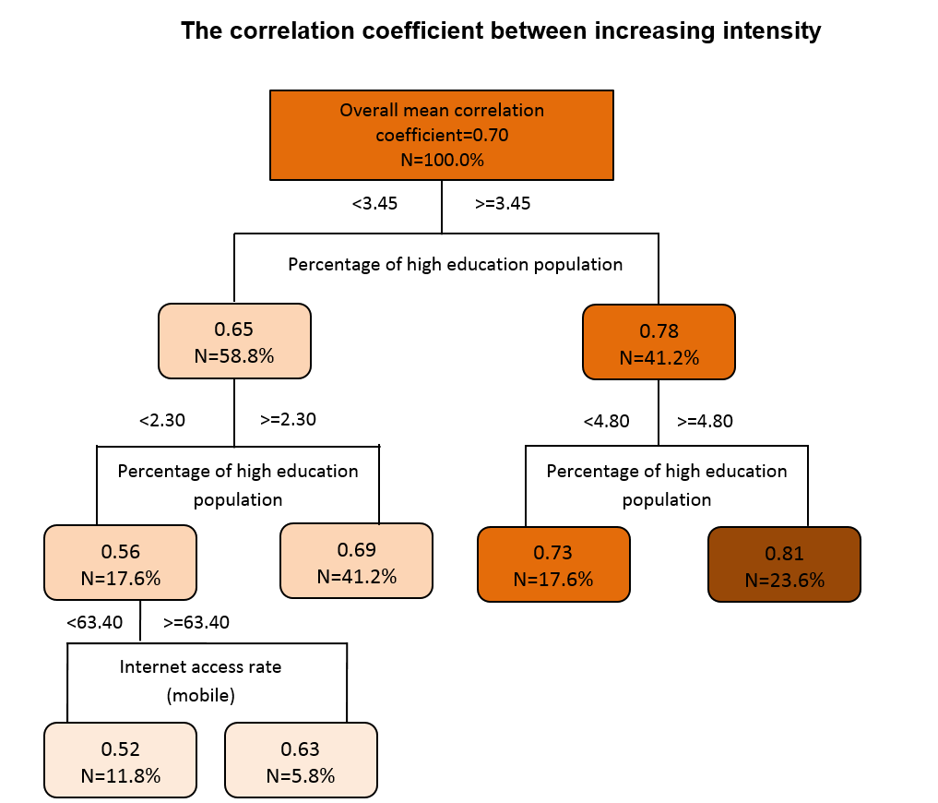
Percentage of highly educated population
Percentage of highly educated population
Percentage of highly educated population
C

