Clustering of hepatitis C virus antibody positivity within households and communities in Punjab, India

Supplementary materials
Supplementary figure 1: The prevalence of hepatitis C (anti-HCV) for each district that participated in the survey, re-printed with permission from Sood et al, 2018(1).
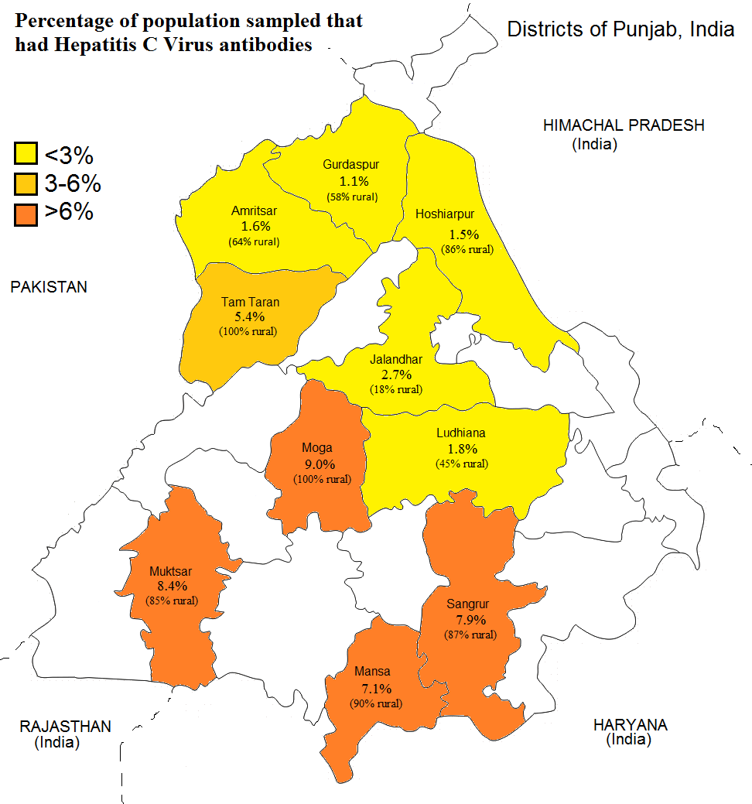

Supplementary table 1: Logistic regression odds ratios (95% confidence intervals) of hepatitis C virus RNA by individual characteristics (N=5543 individuals)
 | Odds Ratio (95% CI) for having HCV RNA
Variable | Unadjusted | Adjusted*
Another member of household HCV RNA+ | 6.11 (4.13, 9.04) | 3.88 (2.56, 5.89)
Living in rural dwelling | 3.57 (2.24, 5.69) | 1.54 (0.91, 2.60)
Living in the south | 3.30 (2.10, 5.20) | 2.64 (1.64, 4.26)
Age (years) | 1.02 (1.02, 1.03) | 1.01 (1.00, 1.02)
Male | 1.23 (0.86, 1.77)
Medical risks
Ever had surgery | 1.66 (1.16, 2.38)
Ever had a medical procedure | 2.33 (1.18, 4.57)
Ever had a dental procedure | 1.74 (1.22, 2.50)
Had a medical injection in the last 6 months | 1.42 (0.99, 2.05)
Ever had a streptomycin injection | 0.77 (0.23, 2.62)
Ever received blood | 2.22 (1.28, 3.83)
Ever been hospitalized | 1.47 (1.02, 2.13)
Medical risk score* | 1.33 (1.18, 1.51) | 1.18 (1.01, 1.38)*
Socio-Economic Indicators
Receiving water through a tube well | 2.76 (1.92, 3.98)
Certified healthcare | 0.46 (0.30, 0.70)
Kacha (less solid) vs pucca house (more solid) | 1.37 (0.79, 2.39)
Household income (rupees)
0-10,000 | 1
10,001-20,000 | 0.52 (0.33, 0.82)
>20,00 | 0.57 (0.33, 0.96)
Education level
None/primary | 1
Middle/secondary | 0.53 (0.37, 0.77)
Graduate | 0.15 (0.06, 0.40)
Socio-economic status score* | 0.61 (0.53, 0.70) | 0.67 (0.57, 0.78)*
Drugs (ever taken)
Ever drank alcohol | 0.59 (0.39, 0.89) | 0.58 (0.36, 0.95)
Ever used opium/bhuki | 4.72 (2.80, 7.94) | 3.02 (1.67, 5.48)
Ever smoked tobacco | 1.17 (0.55, 2.50)
Social risks
Have a tattoo | 1.51 (0.89, 2.58)
Use barbers | 1.45 (0.97, 2.18)
Have body piercings | 0.84 (0.58, 1.20)
Other variables
Ever been incarcerated | 2.54 (0.97, 6.63)
Ever had a motor vehicle accident | 1.85 (1.25, 2.75) | 1.61 (1.04, 2.50)
*For power only the combined socio-economic status score variable was included rather than the socio-economic variables, and similarly only the combined medical risk score from the individual medical risk variables. All other variables that were associated with anti-HCV in the single variable analysis were then included in the multivariable analysis.
Reference
1. Sood A, et al. The Burden of Hepatitis C Virus Infection in Punjab, India: A Population-based Serosurvey. PLoS One. 2018.

