Epidemiology and Infection
Factors associated with acquisition of glycopeptide-resistant enterococci during a single-strain outbreak
S. DEBOSCKER*^{1,2}, P. SCHNEIDER³, F. SEVERAC^{2,4}, C. MENARD⁵, J. GAUDART^{6,7}, T. LAVIGNE^{1,8}, N. MEYER^{2,4}

Supplementary Material
Informative priors and posterior Beta distribution
Parameters | Prior and posterior Beta distribution | Reference  (informative priors)
Gender (male) | 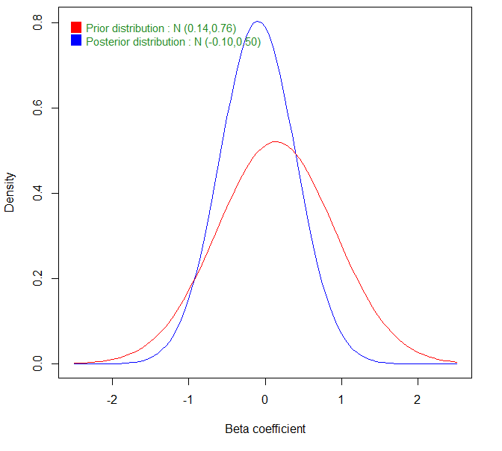 | Servais A, 2009 [13]  McEvoy SP, 2006 [10]  Karki S, 2012 [15]
Chemotherapy  (Ongoing cancer treatment) | 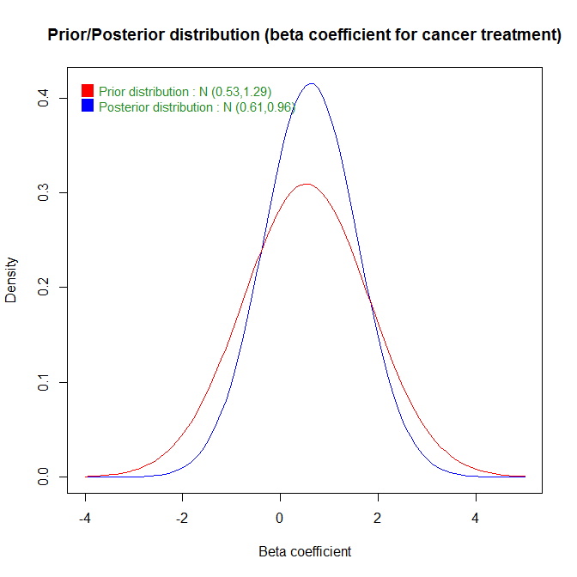 | Hoshuyama T, 2008 [7]
Diabetes | 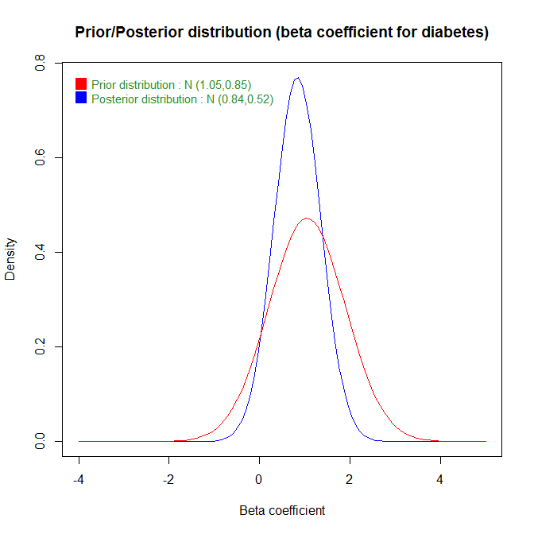 | Servais A, 2009 [13]  McEvoy SP, 2006 [10]
Chronic renal insufficiency | 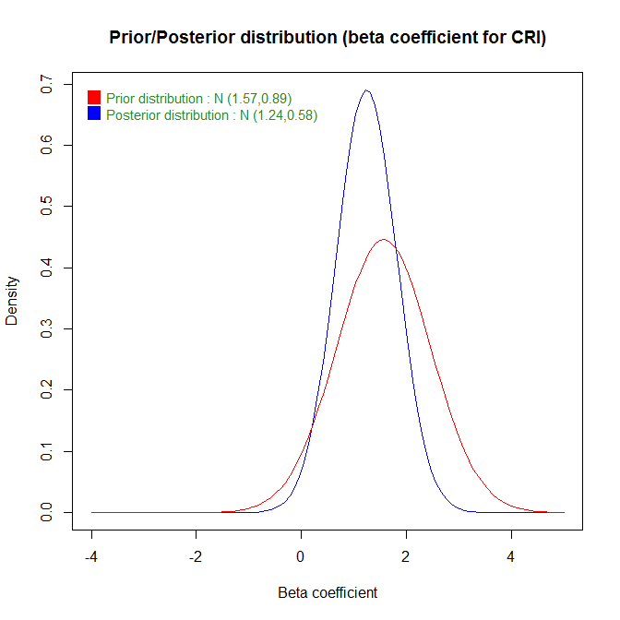 | McEvoy SP, 2006 [10]
Glycopeptides the previous month | 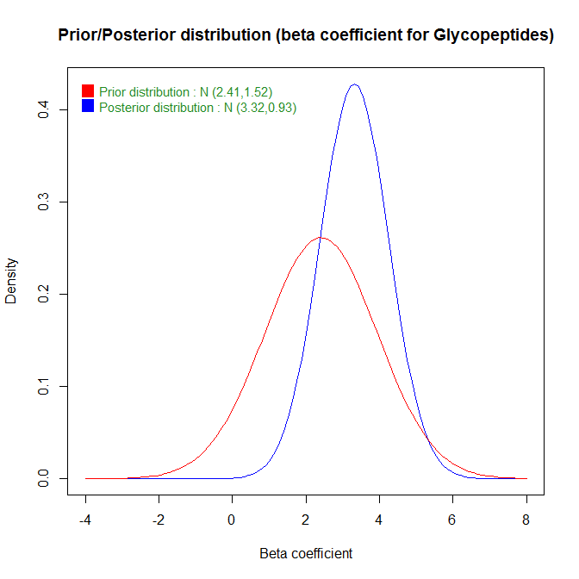 | Servais A, 2009 [13]
Fluoroquinolone the previous month | 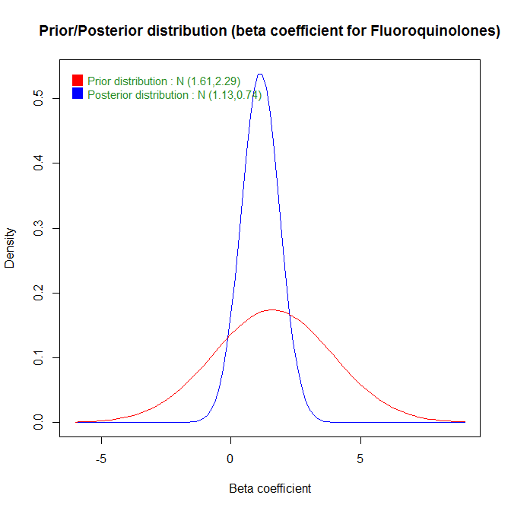 | Servais A, 2009 [13]
Antibiotics during hospitalization | 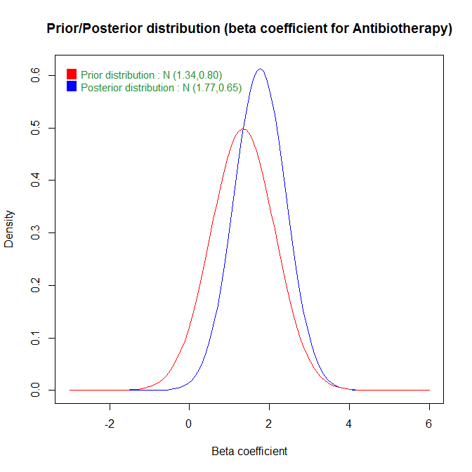 | Karki S, 2012 [15]
C3G during hospitalization | 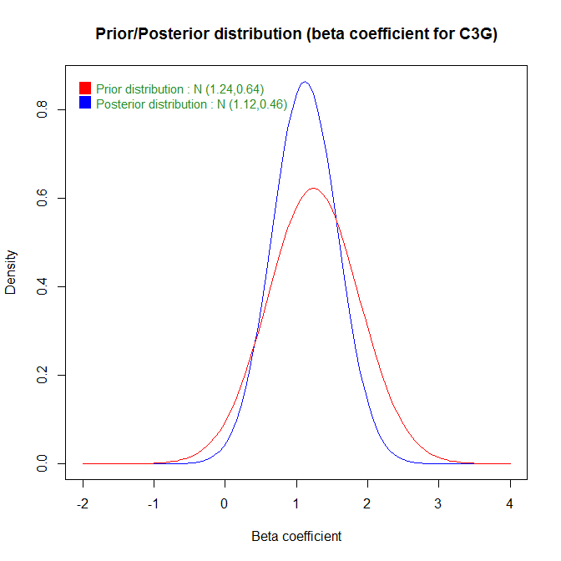 | McEvoy SP, 2006 [10]
Vancomycin during hospitalization | 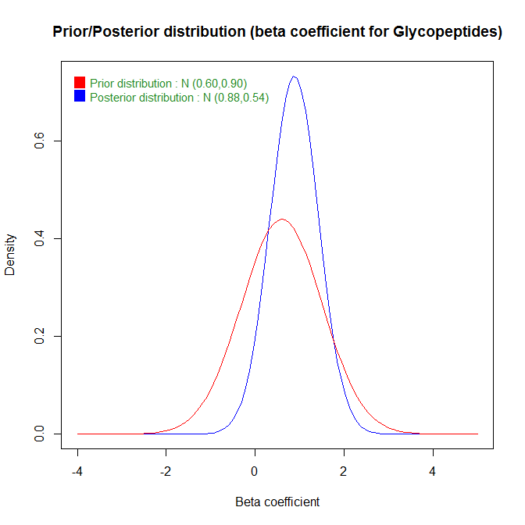 | MacIntyre CR, 2001 [11]  McEvoy SP, 2006 [10]
Fluoroquinolone during hospitalization | 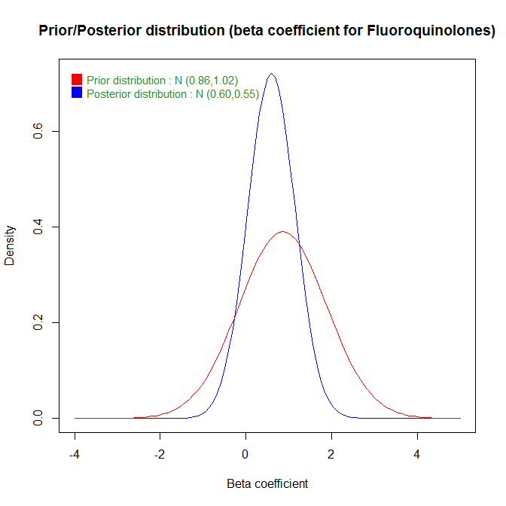 | McEvoy SP, 2006 [10]
Metronidazole during hospitalization | 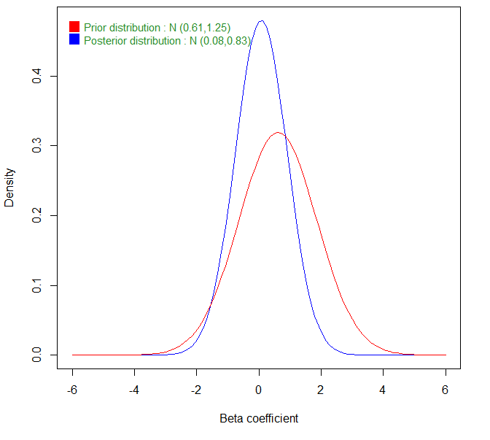 | MacIntyre CR, 2001 [11]  McEvoy SP, 2006 [10]  Karki S, 2012 [15]
Dialysis | 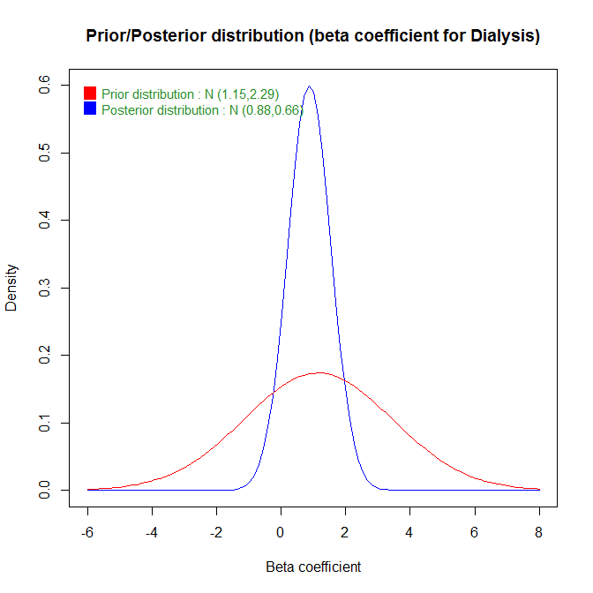 | Servais A, 2009 [13]  MacIntyre CR, 2001 [11]
Diarrhoea | 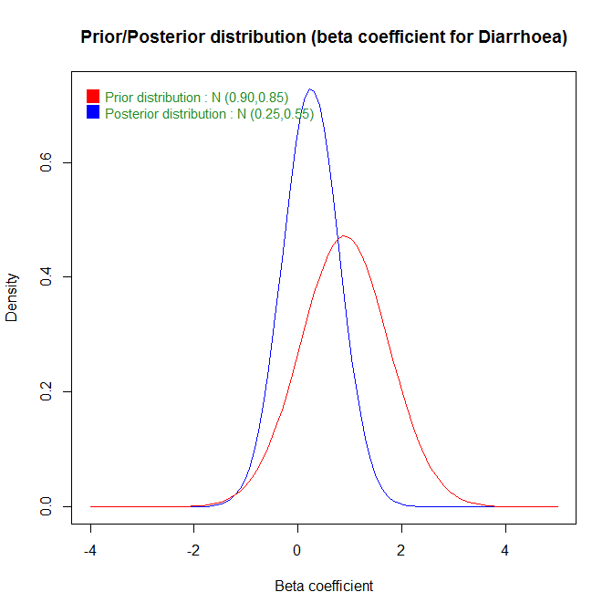 | Servais A, 2009 [13]  Karki S, 2012 [15]
Prolonged bed rest (dependence) | 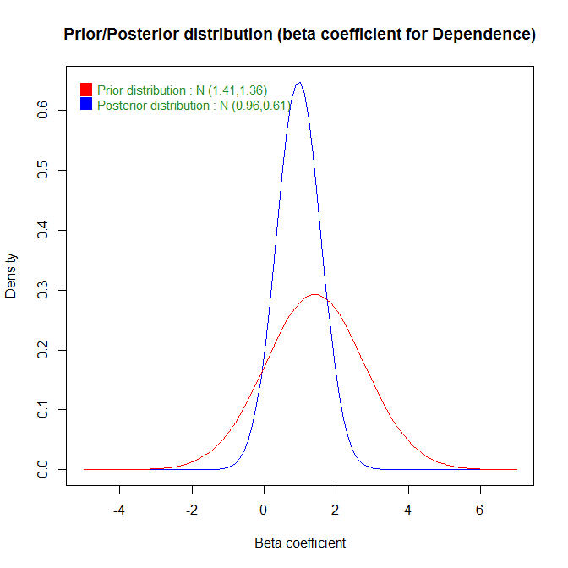 | Hoshuyama T, 2008 [7]
Age | 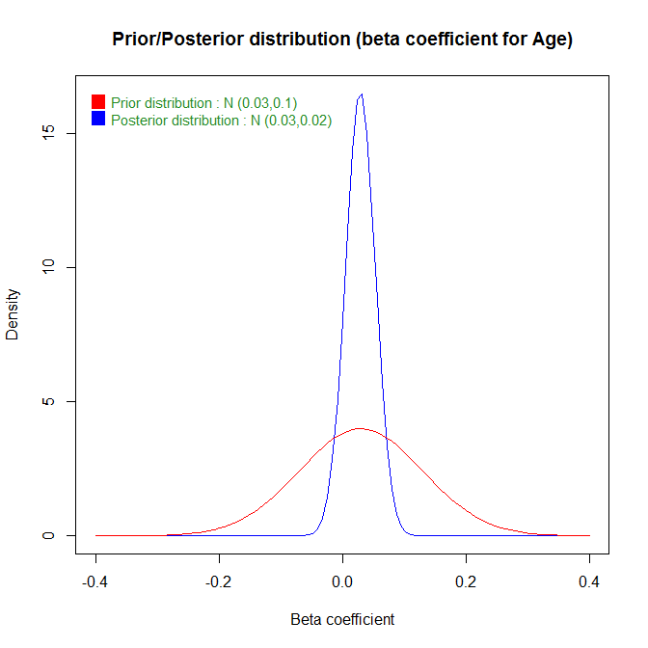 | McEvoy SP, 2006 [10]

