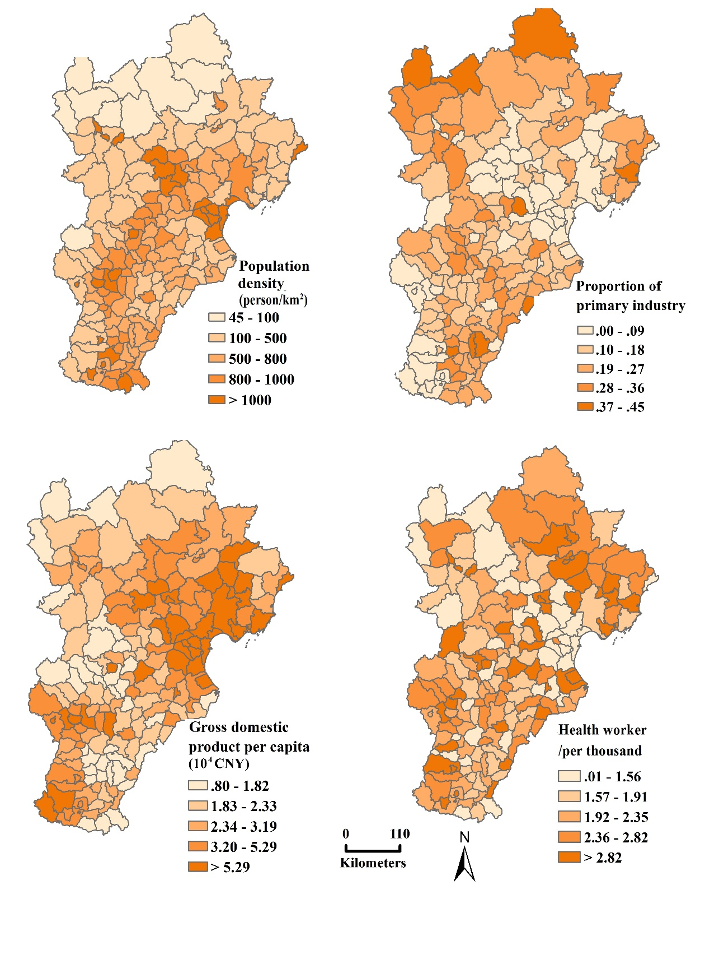
Figure S1. Spatial distribution of socio-economic factors in the counties of Beijing, Tianjin and Hebei

