Epidemiology and Infection

Childhood infections and common carotid intima media thickness in adolescence

A. C. Prins-van Ginkel, P. C. J. Bruijning-Verhagen, A. H. Wijga, M. L. Bots, U. Gehring, W. van der Hoek, G. H. Koppelman, L. van Rossem, C. S. P. M. Uiterwaal, H. A. Smit, M. A. B. van der Sande

Supplementary Material

Supplementary Table 1
ICPC code | Diagnosis
A03 | Fever
A71 | Measles
A72 | Chickenpox
A74 | Rubella
A76 | Viral exanthem other
A76/A77¹ | Viral disease other [with exanthem]
A77 | Viral disease other/NOS
A78 | Infectious disease other/NOS
B70 | Lymphadenitis acute
D70 | Gastrointestinal infection
D70/D73¹ | Gastrointestinal [presumed] infection
D71 | Mumps
D73 | Gastroenteritis presumed infection
H71 | Acute otitis media/myringitis
H71/H72¹ | Otitis media
H72 | Serous otitis media
H74 | Chronic otitis media/ear infection other
L70 | Infections musculoskeletal system
N07 | Convulsion/seizure (including fever-)
N71 | Meningitis/encephalitis
R71 | Whooping cough
R72 | Strep throat/scarlet fever
R72/R76¹ | Strep throat/scarlet fever/tonsillitis acute
R74 | Upper respiratory infection acute
R75 | Sinusitis acute/chronic
R76 | Tonsillitis acute/peritonsillar abscess
R77 | Laryngitis/tracheitis acute
R78 | Acute bronchitis/bronchiolitis
R78/R80/R81¹ | Acute bronchitis/bronchiolitis/influenza/pneumonia
R80 | Influenza [ex. R81]
R81 | Pneumonia
R82 | Pleurisy/pleural effusion
R83 | Respiratory infection other
S70 | Herpes zoster
S71 | Herpes simplex [ex. F85,X90,Y72]
S84 | Impetigo/impetiginization
U70 | Acute pyelonephritis/pyelitis
U71 | Cystitis/urinary infection
Y74 | Orchitis/epididymitis
 | Viral infection NOS²
ICPC: International Classification of Primary Care; NOS: Not otherwise specified. ¹ For the convenience of the participating GP some infectious disease diagnoses were combined on the questionnaires. ² The diagnosis viral infection not otherwise specified (NOS) was added to the questionnaire as a potential diagnosis.

Supplementary Table 2. Characteristics of participants invited for the common carotid intima media thickness (CIMT) measurement at age 16.
 | Eligible study population
 | % | N
Complete parent-reported data on the first 4 years of life | 93.6 | 1153
Complete GP data on the first 4 years of life | 25.2 | 310
Sex |  | 1232
Male | 53.7
Female | 46.3
Overweight mother before pregnancy |  | 1146
No | 83.2
Yes | 16.8
Parental education |  | 1219
Low | 41.9
High | 58.1
Allergic mother |  | 1232
No | 73.9
Yes | 26.1
Exposure to any smoking indoors first four years of life |  | 1190
No | 65.9
Yes | 34.1
Breastfeeding |  | 1213
No breastfeeding | 14.7
≤16 weeks of breastfeeding | 48.9
>16 weeks of breastfeeding | 36.4
 | Mean | SE (N)
Birth weight gram | 3533 | 15.2 (1228)
CIMT in μm age 16 years | 467 | 1.90 (420)
Total cholesterol mmol/L age 16 years | 3.85 | 0.03 (447)
HDL cholesterol mmol/L age 16 years | 1.35 | 0.02 (447)
GP: general practitioner; IMT: intima media thickness of common carotid artery; MI: multiple imputation; SE: standard error.

Supplementary Table 3. Difference in common carotid intima media thickness (CIMT) at age 16 years between exposed and reference group after multiple imputation and with total and HDL cholesterol in the model.
Determinant | ∆ CIMT μm (95% CI)
GP diagnosed infections
0-1 infection | Ref.
2-3 infections | 4.4 (-9.7-18.6)
4-6 infections | -1.9 (-16.7-12.9)
≥7 infections | 5.4 (-9.8-20.6)
Antibiotic prescriptions
0 prescriptions | Ref.
1 prescription | -7.8 (-21.1-5.4)
2 prescriptions | 7.4 (-9.3-24.1)
≥3 prescriptions | 8.6 (-5.0-22.2)
Parent-reported infections
0-2.5 infections | Ref.
3-5 infections | -9.7 (-22.8-3.3)
6-7 infections | 0.5 (-13.3-14.3)
≥8 infections | 10.9 (-2.1-23.8)
Models adjusted for gender, education of parents, birthweight, overweight of the mother before pregnancy, breastfeeding, allergy of the mother, indoor smoke exposure, high-density lipoprotein (HDL) and total cholesterol. GP: general practitioner; IMT: intima media thickness; MI: multiple imputation.

Supplementary table 4. Mean p-values of interaction terms of the 10 multiple imputation datasets
Exposure variable | Confounder | p-value
GP diagnosed infections | Gender | 0.60
 | Parental education | 0.08
 | Breastfeeding | 0.23
 | Maternal overweight | 0.67
 | Birth weight | 0.46
 | Allergic mother | 0.58
 | Smoke exposure | 0.54
Antibiotic prescriptions | Gender | 0.69
 | Parental education | 0.02
 | Breastfeeding | 0.62
 | Maternal overweight | 0.36
 | Birth weight | 0.04
 | Allergic mother | 0.001
 | Smoke exposure | 0.45
Parent reported infections | Gender | 0.52
 | Parental education | 0.53
 | Breastfeeding | 0.31
 | Maternal overweight | 0.23
 | Birth weight | 0.14
 | Allergic mother | 0.19
 | Smoke exposure | 0.62
GP: general practitioner; Bold indicates p-values below 0.10.

Supplementary Figure 1. Directed acyclic graph (DAG) of the confounders for the association between infections in early childhood and IMT in adolescence.
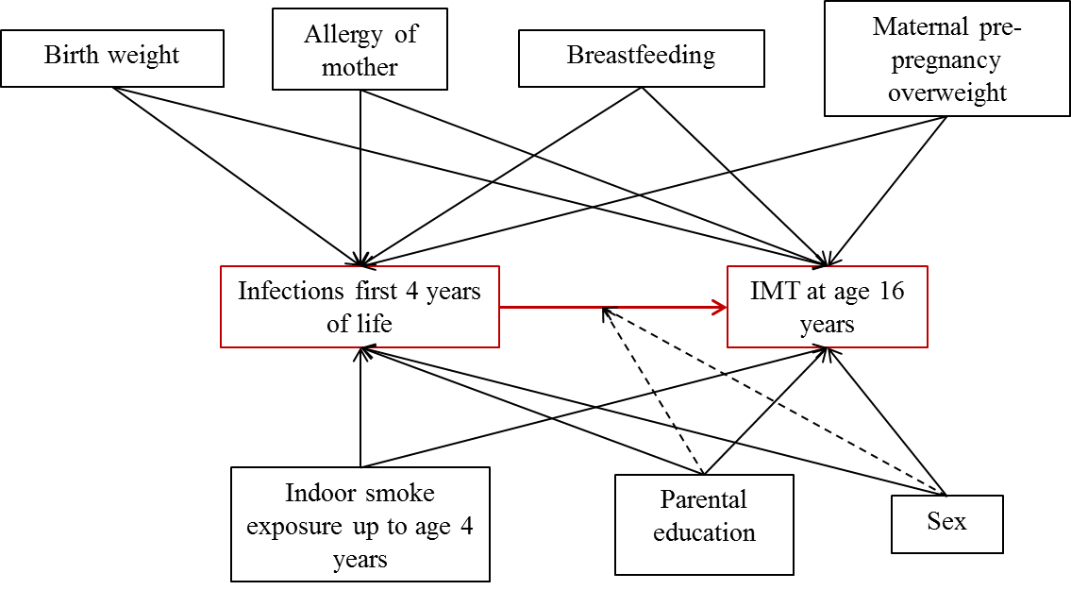
Confounders were selected based on previous studies investigating the association between infections and common intima media thickness (CIMT). The primary exposure and outcome are in red. The dashed line indicates (potential) effect modification.

