*\*Epidemiology and infection*

Enterococcal bacteraemia: Prognostic factors and risk factors for ampicillin resistance

T. Matsumura, M. Nagao*, S. Nakano, M. Yamamoto, Y. Matsumura, S. Ichiyama

Supplementary Material

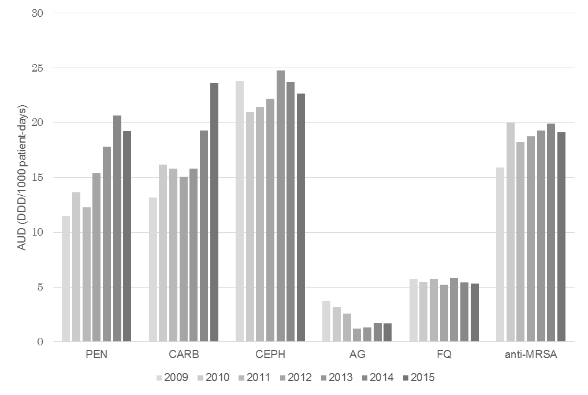

Supplemental Figure S1

Trajectory of antimicrobial use density (AUD) for each antibiotic from 2009 to 2015.

Abbreviations: PEN, penicillins; CARB, carbapenems; CEPH, cephalosporins; AG, aminoglycosides; FQ, fluoroquinolones; MRSA, methicillin-resistant *Staphylococcus aureus*

|  |  |  |  |  |  |  |  |  |  |  |  |  |  |  |  |
| --- | --- | --- | --- | --- | --- | --- | --- | --- | --- | --- | --- | --- | --- | --- | --- |
| Supplemental Table S1. Antibiotic susceptibility of isolated enterococci. | | | | | | | | | | | | | | | |
|  |  |  |  |  | All isolates  (n=235) | |  | *E. faecalis*  (n=98) | |  | *E. faecium*  (n=113) | |  | Other enterococci  (n=24) | |
| Ampicillin |  | R | : |  | 111 | (47) |  | 0 | (0) |  | 103 | (91) |  | 8 | (33) |
|  |  | I | : |  | 0 | (0) |  | 0 | (0) |  | 0 | (0) |  | 0 | (0) |
|  |  | S | : |  | 124 | (53) |  | 98 | (100) |  | 10 | (9) |  | 16 | (67) |
| Vancomycin |  | R | : |  | 0 | (0) |  | 0 | (0) |  | 0 | (0) |  | 0 | (0) |
|  |  | I | : |  | 1 | (0) |  | 0 | (0) |  | 0 | (0) |  | 1 | (4) |
|  |  | S | : |  | 234 | (100) |  | 98 | (100) |  | 113 | (100) |  | 23 | (96) |
| Teicoplanin |  | R | : |  | 0 | (0) |  | 0 | (0) |  | 0 | (0) |  | 0 | (0) |
|  |  | I | : |  | 0 | (0) |  | 0 | (0) |  | 0 | (0) |  | 0 | (0) |
|  |  | S | : |  | 235 | (100) |  | 98 | (100) |  | 113 | (100) |  | 24 | (100) |
| Levofloxacin |  | R | : |  | 125 | (53) |  | 16 | (16) |  | 105 | (93) |  | 4 | (17) |
|  |  | I | : |  | 3 | (1) |  | 0 | (0) |  | 1 | (1) |  | 2 | (8) |
|  |  | S | : |  | 107 | (46) |  | 82 | (84) |  | 7 | (6) |  | 18 | (75) |
| Erythromycin |  | R | : |  | 171 | (73) |  | 61 | (62) |  | 99 | (88) |  | 11 | (46) |
|  |  | I | : |  | 27 | (11) |  | 17 | (17) |  | 7 | (6) |  | 3 | (12) |
|  |  | S | : |  | 37 | (16) |  | 20 | (21) |  | 7 | (6) |  | 10 | (42) |
| Data represent the number (%) of isolated enterococci.  Abbreviations: R, resistant; I, intermediate; S, susceptible | | | | | | | | | | | | | | | |

|  |  |  |  |  |  |  |  |  |
| --- | --- | --- | --- | --- | --- | --- | --- | --- |
| Supplemental Table S2. Comparison of the baseline demographics and clinical characteristics of patients with *E. faecalis* and patients with *E. faecium* bacteraemia. | | | | | | | | |
| Variables |  | *E. faecalis* (n=98) | |  | *E. faecium* (n=113) | |  | *P*-value |
| Demographics | |  |  |  |  |  |  |  |
| Age, median (IQR) | | 71 | (60-78) |  | 62 | (52-73) |  | <0.001 |
| Sex (males) | | 62 | (63) |  | 63 | (56) |  | 0.326 |
| Ampicillin-resistant bacteraemia | | 0 | (0) |  | 103 | (91) |  | <0.001 |
| Polymicrobial bacteraemia | | 39 | (40) |  | 19 | (17) |  | <0.001 |
| Persistent bacteraemia | | 8 | (8.2) |  | 15 | (13) |  | 0.273 |
| Nosocomial infection | | 73 | (75) |  | 101 | (89) |  | 0.006 |
| ICU-acquired | | 5 | (5.1) |  | 31 | (27) |  | <0.001 |
| Underlying disease | |  |  |  |  |  |  |  |
| Heart disease | | 30 | (31) |  | 29 | (26) |  | 0.445 |
| Stroke/hemiplegia | | 20 | (20) |  | 9 | (8.0) |  | 0.015 |
| Chronic pulmonary disease | | 5 | (5.1) |  | 10 | (8.8) |  | 0.422 |
| Systemic autoimmune diseases | | 4 | (4.1) |  | 12 | (11) |  | 0.116 |
| Chronic kidney disease | | 8 | (8.2) |  | 15 | (13) |  | 0.273 |
| Diabetes mellitus | | 18 | (18) |  | 27 | (24) |  | 0.400 |
| Liver disease | | 21 | (21) |  | 51 | (45) |  | <0.001 |
| Hematological malignancy | | 7 | (7.1) |  | 26 | (23) |  | 0.002 |
| Solid tumor | | 46 | (47) |  | 46 | (41) |  | 0.405 |
| Prior operation (6 m) | | 47 | (48) |  | 52 | (46) |  | 0.784 |
| Indwelling devices | |  |  |  |  |  |  |  |
| Central venous catheter | | 37 | (38) |  | 54 | (48) |  | 0.164 |
| Arterial line | | 9 | (9.2) |  | 30 | (27) |  | 0.001 |
| Urinary devices | | 28 | (29) |  | 34 | (30) |  | 0.880 |
| Mechanical ventilation | | 11 | (11) |  | 23 | (20) |  | 0.091 |
| Bile duct devices | | 11 | (11) |  | 25 | (22) |  | 0.044 |
| Surgical drain | | 20 | (20) |  | 42 | (37) |  | 0.010 |
| Immunosuppression | |  |  |  |  |  |  |  |
| Solid organ transplantation | | 9 | (9.2) |  | 33 | (29) |  | <0.001 |
| BMT/HSCT | | 3 | (3.1) |  | 11 | (9.7) |  | 0.058 |
| Neutropenia | | 9 | (9.2) |  | 22 | (20) |  | 0.050 |
| Chemotherapy (30 d) | | 19 | (19) |  | 29 | (26) |  | 0.325 |
| Immunosuppressant | | 26 | (27) |  | 62 | (55) |  | <0.001 |
| Prior antibiotic exposure | | 79 | (81) |  | 109 | (97) |  | <0.001 |
| Penicillins | | 28 | (29) |  | 62 | (55) |  | <0.001 |
| Cephalosporins | | 70 | (71) |  | 100 | (89) |  | 0.003 |
| Carbapenems | | 19 | (19) |  | 55 | (49) |  | <0.001 |
| Quinolones | | 22 | (22) |  | 52 | (46) |  | <0.001 |
| Glycopeptides | | 22 | (22) |  | 44 | (39) |  | 0.011 |
| Sulfamethoxazole/Trimethoprim | | 16 | (16) |  | 53 | (47) |  | <0.001 |
| Days from admission to onset, median (IQR) | | 17 | (4-48) |  | 42 | (16-77) |  | <0.001 |
| Prior hospitalisation (1 y) | | 57 | (56) |  | 83 | (68) |  | 0.097 |
| Prior ICU admission (1 y) | | 25 | (26) |  | 49 | (43) |  | 0.009 |
| Prior enterococcal isolation (1 y) | | 32 | (32) |  | 50 | (44) |  | 0.091 |
| Source of bacteraemia | |  |  |  |  |  |  |  |
| Intra-abdominal | | 21 | (21) |  | 39 | (35) |  | 0.046 |
| Catheter-related bloodstream infection | | 11 | (11) |  | 12 | (11) |  | 1 |
| Febrile neutropenia | | 3 | (3.1) |  | 5 | (4.4) |  | 0.727 |
| Urinary tract | | 19 | (19) |  | 7 | (6.2) |  | 0.006 |
| Unknown | | 34 | (35) |  | 47 | (42) |  | 0.323 |
| Other | | 10 | (10) |  | 3 | (2.7) |  | 0.041 |
| Pitt bacteraemia score, median (IQR) | | 2 | (1-4) |  | 2 | (1-5) |  | 0.88 |
| Charlson comorbidity index, median (IQR) | | 3 | (2-6) |  | 3 | (3-5) |  | 0.181 |
| Data represent the number (%) of patients, unless otherwise indicated. Abbreviations: IQR, interquartile range; BMT, bone marrow transplantation; HSCT, hematopoietic stem cell transplantation; ICU, intensive care unit | | | | | | | | |

|  |  |  |  |  |  |
| --- | --- | --- | --- | --- | --- |
| Supplemental Table S3. Comparison of the baseline demographics and clinical characteristics of the 30-day survivors and non-survivors with *Enterococcus faecium* bacteraemia. | | | | | |
|  | 30-day mortality | | | |  |
| Variables | Survivors (n=82) | | Non-survivors (n=31) | | *P*-value |
| Demographics |  |  |  |  |  |
| Age, median (IQR) | 62 | (52-73) | 61 | (49-74) | 0.983 |
| Sex (males) | 44 | (54) | 19 | (61) | 0.517 |
| Ampicillin-resistant bacteraemia | 74 | (90) | 29 | (94) | 0.725 |
| Polymicrobial bacteraemia | 14 | (17) | 5 | (16) | 0.961 |
| Persistent bacteraemia | 8 | (9.8) | 7 | (23) | 0.094 |
| Nosocomial infection | 71 | (87) | 30 | (97) | 0.138 |
| ICU-acquired | 21 | (26) | 10 | (32) | 0.588 |
| Underlying disease |  |  |  |  |  |
| Heart disease | 18 | (22) | 11 | (36) | 0.104 |
| Stroke/hemiplegia | 6 | (7.3) | 3 | (9.7) | 0.645 |
| Chronic pulmonary disease | 9 | (11) | 1 | (3.2) | 0.234 |
| Systemic autoimmune diseases | 8 | (9.8) | 4 | (13) | 0.545 |
| Chronic kidney disease | 11 | (13) | 4 | (13) | 0.977 |
| Diabetes mellitus | 17 | (21) | 10 | (32) | 0.171 |
| Liver disease | 36 | (44) | 15 | (48) | 0.814 |
| Hematological malignancy | 15 | (18) | 11 | (36) | 0.059 |
| Solid tumor | 37 | (45) | 9 | (29) | 0.135 |
| Prior operation (6 m) | 42 | (51) | 10 | (32) | 0.057 |
| Indwelling devices |  |  |  |  |  |
| Central venous catheter | 32 | (39) | 22 | (71) | 0.003 |
| Arterial line | 16 | (20) | 14 | (45) | 0.008 |
| Urinary devices | 23 | (28) | 11 | (36) | 0.441 |
| Mechanical ventilation | 11 | (13) | 12 | (39) | 0.002 |
| Bile duct devices | 20 | (24) | 5 | (16) | 0.280 |
| Surgical drain | 29 | (35) | 13 | (42) | 0.578 |
| Immunosuppression |  |  |  |  |  |
| Solid organ transplantation | 24 | (29) | 9 | (29) | 0.859 |
| BMT/HSCT | 5 | (6.1) | 6 | (19) | 0.035 |
| Neutropenia | 10 | (12) | 12 | (39) | <0.001 |
| Chemotherapy (30 d) | 18 | (22) | 11 | (36) | 0.175 |
| Immunosuppressant | 43 | (52) | 19 | (61) | 0.461 |
| Prior antibiotic exposure | 79 | (96) | 30 | (97) | 0.981 |
| Penicillins | 42 | (51) | 20 | (65) | 0.270 |
| Cephalosporins | 74 | (90) | 26 | (84) | 0.341 |
| Carbapenems | 37 | (45) | 18 | (58) | 0.278 |
| Quinolones | 38 | (46) | 14 | (45) | 0.797 |
| Glycopeptides | 29 | (35) | 15 | (48) | 0.292 |
| Sulfamethoxazole/Trimethoprim | 33 | (40) | 20 | (65) | 0.029 |
| Days from admission to onset, median (IQR) | 40 | (14-75) | 42 | (18-105) | 0.605 |
| Prior hospitalisation (1 y) | 61 | (74) | 18 | (58) | 0.118 |
| Prior ICU admission (1 y) | 35 | (43) | 14 | (45) | 0.901 |
| Prior enterococcal isolation (1 y) | 39 | (48) | 11 | (36) | 0.215 |
| Source of bacteraemia |  |  |  |  |  |
| Intra-abdominal | 35 | (43) | 4 | (13) | 0.003 |
| Catheter-related bloodstream infection | 6 | (7.3) | 6 | (19) | 0.087 |
| Febrile neutropenia | 4 | (4.9) | 1 | (3.2) | 0.683 |
| Urinary tract | 7 | (8.5) | 0 | (0) | 0.120 |
| Unknown | 27 | (33) | 20 | (65) | <0.001 |
| Other | 3 | (3.73) | 0 | (0) | 0.319 |
| Pitt bacteraemia score, median (IQR) | 1 | (0-3) | 6 | (2-8) | <0.001 |
| Charlson comorbidity index, median (IQR) | 3 | (3-6) | 4 | (3-5) | 0.432 |
| Data represent the number (%) of patients unless otherwise indicated. Abbreviations: IQR, interquartile range; ICU, intensive care unit; BMT, bone marrow transplantation; HSCT, hematopoietic stem cell transplantation | | | | | |