Epidemiology and Infection
Prediction of Shigellosis outcomes in Israel using machine learning classifiers
G. Adamker, T. Holzer, I. Karakis, M. Amitay, E. Anis, S. R. Singer and Z. Barnett-Itzhaki
Supplementary Material
Supp. Figure 1 – Shigellosis morbidity rate (per 100,000) in Israel by sex – 2002-2015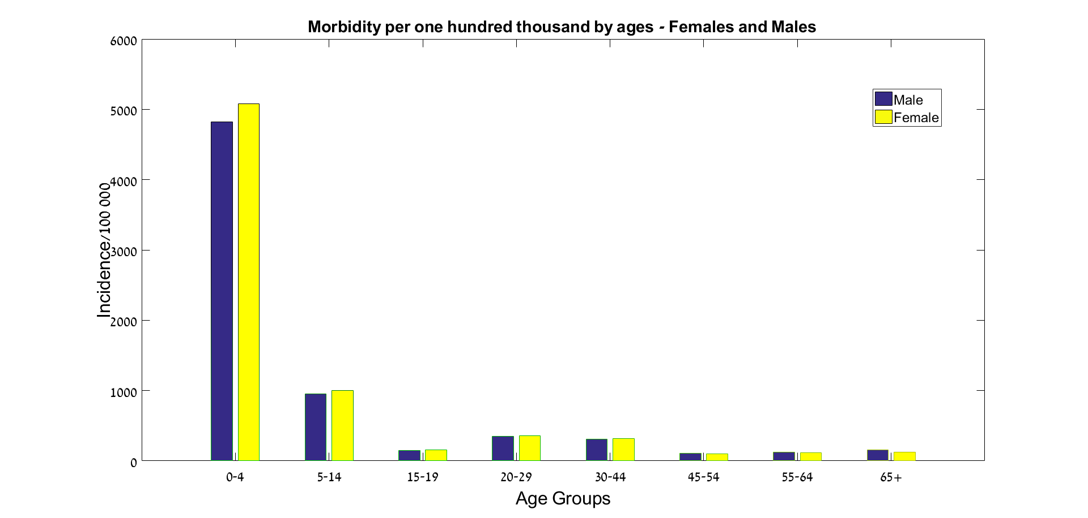
Supp. Figure 2 – Hospitalization incidence by month (2002-2015)
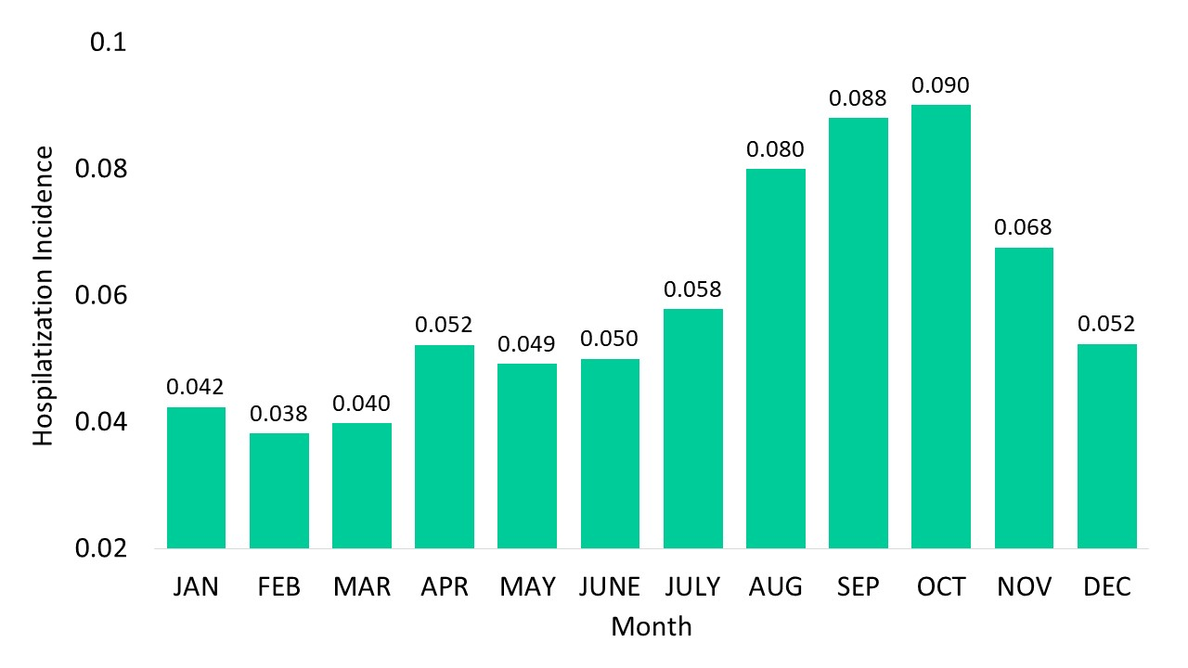
Supplementary text 1
Neural networks parameters
Shigellosis type
The neural network’s type is "Pattern Recognition Neural Network". There are two layers. The hidden layer consists of 16 neurons.
The training function we used (trainscg) is Scaled conjugate gradient backpropagation and the loss function (performance function) is cross-entropy. The adaptation function we used (adaptwb) adapts the network with weight and bias learning rules.

Hospitalization
The neural network’s type is "Pattern Recognition Neural Network". There are two layers. The hidden layer consists of 19 neurons.
The training function we used (trainscg) is Scaled conjugate gradient backpropagation and the loss function (performance function) is cross-entropy. The adaptation function we used (adaptwb) adapts the network with weight and bias learning rules.

Supplementary text 2 – Classification model for Shigella species – confusion matrices
Confusion matrix for the LR model

Predicted  species  Actual  species | S. sonnei | S. flexneri
S. sonnei | 11,358 | 252
S. flexneri | 684 | 391

Average confusion matrix for the NN model
Due to the stochastic nature of the model, we ran the algorithm 100 times and calculated the average performances. The average results (number of predictions/100 iterations) are as following:

Predicted  species  Actual  species | S. sonnei | S. flexneri
S. sonnei | 5,655 | 326
S. flexneri | 133 | 228

Confusion matrix for the SVM Gaussian model
Predicted  species  Actual  species | S. sonnei | S. flexneri
S. sonnei | 11,458 | 152
S. flexneri | 784 | 291

