Supplementary section: Patterns and predictors of respiratory infection hospitalisations across the first year of life

Supplementary text 1: Major and minor congenital malformations.

The majority of congenital malformations (section Q of the ICD-10) were considered major and thus any participant with one or more were excluded from our analyses. The following table shows the congenital malformations identified as minor and thus if a participant had one or more of the following only, they were not excluded from our analysis. In total, 3.79% (n=16,538) were excluded for having a major congenital malformation identified prior to neonatal discharge.

Supplementary table 1: Complete list of minor congenital malformations
ICD-10 | Description | ICD-10 | Description
Q10.0 | Congenital ptosis | Q66.5 | Congenital pes planus
Q10.1 | Congenital ectropion | Q66.6 | Oth congenital valgus deformities feet
Q10.2 | Congenital entropion | Q66.7 | Pes cavus
Q10.3 | Other congenital malformations of eyelid | Q66.8 | Other congenital deformities of feet
Q10.5 | Cong stenosis stricture lacrimal duct | Q67.0 | Facial asymmetry
Q13.0 | Coloboma of iris | Q67.1 | Compression facies
Q13.2 | Other congenital malformations of iris | Q67.2 | Dolichocephaly
Q13.5 | Blue sclera | Q67.3 | Plagiocephaly
Q15.8 | Oth spec congenital malformations of eye | Q67.4 | Oth cong deformities skull face & jaw
Q17.0 | Accessory auricle and ear tag | Q67.41 | Depressions in skull
Q17.1 | Macrotia | Q67.6 | Pectus excavatum
Q17.3 | Other misshapen ear | Q67.7 | Pectus carinatum
Q17.4 | Misplaced ear | Q67.8 | Other congenital deformities of chest
Q18.0 | Sinus fistula & cyst of branchial cleft | Q68.0 | Cong defrm sternocleidomastoid musc
Q18.1 | Preauricular sinus and cyst | Q68.1 | Congenital deformities of hand
Q18.3 | Webbing of neck | Q68.10 | Congenital deformity of hand unspecified
Q18.4 | Macrostomia | Q68.8 | Oth spec cong musculoskeletal defrm
Q18.6 | Macrocheilia | Q69.0 | Accessory finger(s)
Q18.8 | Oth spec cong malform face & neck | Q69.1 | Accessory thumb(s)
Q27 | Oth cong malform peripheral vasc sys | Q69.2 | Accessory toe(s)
Q30.2 | Fissured notched and cleft nose | Q69.21 | Accessory hallux [halluces]
Q30.8 | Other congenital malformations of nose | Q69.29 | Other accessory toe(s)
Q35.7 | Cleft uvula | Q69.9 | Polydactyly unspecified
Q35.7 | Cleft uvula | Q70.3 | Webbed toes
Q38.1 | Ankyloglossia | Q74.1 | Congenital malformations of knee
Q38.2 | Macroglossia | Q70.3 | Webbed toes
Q38.3 | Oth & ? congenital malformations tongue | Q74.1 | Congenital malformations of knee
Q38.4 | Cong malform salivary glands & ducts | Q75.0 | Craniosynostosis
Q38.5 | Congenital malformations of palate NEC | Q75.2 | Hypertelorism
Q38.50 | Congenital malformation of palate ? | Q75.3 | Macrocephaly
Q38.6 | Oth & ? cong malformations of mouth | Q75.8 | Oth spec cong malform skull fce bone
Q43.5 | Ectopic anus | Q76.0 | Spina bifida occulta
Q43.5 | Ectopic anus | Q76.43 | Oth congenital anomalies vertebra(e)
Q52.3 | Imperforate hymen | Q79.5 | Oth cong malformations abdominal wall
Q52.4 | Other & ? cong malformations of vagina | Q79.8 | Oth cong malform musculoskeletal sys
Q52.5 | Fusion of labia | Q82.4 | Ectodermal dysplasia (anhidrotic)
Q52.6 | Other & ? cong malformations of clitoris | Q82.5 | Congenital non-neoplastic naevus
Q52.8 | Oth spec cong malform femle genitalia | Q82.8 | Oth spec congenital malformations skin
Q53.1 | Undescended testicle unilateral | Q82.81 | Hidrotic ectodermal dysplasia
Q53.2 | Undescended testicle bilateral | Q83.2 | Absent nipple
Q53.9 | Undscnd testicle unspecified laterality | Q83.3 | Accessory nipple
Q54.4 | Congenital chordee | Q83.8 | Other congenital malformations of breast
Q55.1 | Hypoplasia of testis and scrotum | Q84.1 | Cong morph disturbances hair NEC
Q55.2 | Other & ? cong malform testis & scrotum | Q84.2 | Other congenital malformations of hair
Q55.20 | Cong malform of testis and scrotum ? | Q84.3 | Anonychia
Q55.21 | Retractile testis | Q84.4 | Congenital leukonychia
Q55.6 | Other & ? cong malform of penis | Q84.5 | Enlarged and hypertrophic nails
Q55.8 | Oth spec cong malform male gen org | Q84.6 | Other congenital malformations of nails
Q55.9 | Cong malformation male gen org unsp | Q84.8 | Oth spec cong malformations integument
Q66.2 | Metatarsus varus
Q66.3 | Oth congenital varus deformities of feet

Supplementary text 2: Congenital infections and any infection prior to discharge.

Neonates diagnosed with chronic respiratory disease originating in the perinatal period, intrauterine/neonatal asphyxia or an immunological disorder (at any time in the first 12 months of life) were excluded because these are or may result in severe or chronic conditions which may be related to the more common and less severe conditions of interest and to respiratory infection. The full list of conditions which led to exclusions are shown in the table below. In total 0.94% (n=4,101) of the sample were excluded for being diagnoses with one or more of these conditions.

Supplementary table 2: Complete list of immunological, chronic respiratory and hypoxia/asphyxia
ICD-10 | Description | ICD-10 | Description
 | Immunological disorders
D80 | Immunodef w predom antibody defects | D86 | Sarcoidosis
D80.0 | Hereditary hypogammaglobulinaemia | D86.0 | Sarcoidosis of lung
D80.1 | Nonfamilial hypogammaglobulinaemia | D86.1 | Sarcoidosis of lymph nodes
D80.2 | Selective deficiency of immunoglobulin A | D86.2 | Sarcoidosis lung w lymph nodes
D80.3 | Selective deficiency of IgG subclasses | D86.3 | Sarcoidosis of skin
D80.4 | Selective deficiency of immunoglobulin M | D86.8 | Sarcoidosis of other and combined sites
D80.5 | Immunodeficiency with increased IgM | D86.9 | Sarcoidosis unspecified
D80.6 | Ab def nr norm Ig or hyperimmunoglobem | D89 | Other disorders inv immune mechanism NEC
D80.7 | Transient hypogammaglobulinaemia infancy | D89.0 | Polyclonal hypergammaglobulinaemia
D80.8 | Oth immunodef w predom antibody defects | D89.1 | Cryoglobulinaemia
D80.9 | Immunodef w predom antibody defects unsp | D89.2 | Hypergammaglobulinaemia unspecified
D81 | Combined immunodeficiencies | D89.3 | Immune reconstitution syndrome
D81.0 | Sev cmb immunodef w reticlr dysgenesis | D89.8 | Other spec disrd inv immune mechn NEC
D81.1 | Sev cmb immunodef w low T & B cell no | D89.9 | Disorder involving immune mechanism unsp
D81.2 | Sev cmb immunodef w norm-low B cell no |  | Hypoxia/asphyxia
D81.3 | Adenosine deaminase [ADA] deficiency | P20 | Intrauterine hypoxia
D81.4 | Nezelof's syndrome | P20.0 | Intrauterine hypoxia before onset labour
D81.5 | Purine nucleoside phosphorylase def | P20.1 | Intrauterine hypoxia during labour
D81.6 | Major histocompat complex class I def | P20.9 | Intrauterine hypoxia unspecified
D81.7 | Major histocompat complex class II def | P21 | Birth asphyxia
D81.8 | Other combined immunodeficiencies | P21.0 | Severe birth asphyxia
D81.9 | Combined immunodeficiency unspecified | P21.1 | Mild and moderate birth asphyxia
D82 | Immunodef ass w other major defects | P21.9 | Birth asphyxia unspecified
D82.0 | Wiskott-Aldrich syndrome |  | Chronic neonatal respiratory disorders
D82.1 | Di George's syndrome | P27 | Perinatal chronic respiratory disease
D82.2 | Immunodeficiency w short limbed stature | P27.0 | Wilson-Mikity syndrome
D82.3 | Immunodef fol hered dfct respn to EBV | P27.1 | Chronic neonatal lung disease
D82.4 | Hyperimmunoglobulin E [IgE] syndrome | P27.8 | Oth chr respiratory dis perinatal period
D82.8 | Immunodef ass w oth spec major defects | P27.9 | Unsp chr resp dis perinatal period
D82.9 | Immunodef ass w major defect unsp
D83 | Common variable immunodeficiency
D83.0 | Com var immunodef predom abn Bcell no fn
D83.1 | Com var immunodef predom I/r Tcell disrd
D83.2 | Com var immunodef w auto- Ab B or T cell
D83.8 | Other common variable immunodeficiencies
D83.9 | Common variable immunodeficiency unsp
D84 | Other immunodeficiencies
D84.0 | Lymphocyte function antigen-1 defect
D84.1 | Defects in the complement system
D84.8 | Other specified immunodeficiencies
D84.9 | Immunodeficiency unspecified

Supplementary text 3: Congenital infections and any infection prior to discharge.

In addition to all of sections A and B (Certain infectious and parasitic diseases) participants were excluded if they had any other infectious disease prior to neonatal discharge or any congenital disease at any time in the study period. In total, 3.7% (n=16,285) of the sample were excluded for this reason. Most of the infections included would be highly unlikely to occur in a newborn prior to discharge but we decided an exhaustive list was the best approach.

Supplementary table 3 (a): Complete list of any infection prior to neonatal discharge (in addition to all of sections A and B)
ICD-10 | Description | ICD-10 | Description
G00 | Bacterial meningitis NEC | J17.1 | Pneumonia in viral dis class elsewhere
G00.0 | Haemophilus meningitis | J17.2 | Pneumonia in mycoses
G00.1 | Pneumococcal meningitis | J17.3 | Pneumonia in parasitic diseases
G00.2 | Streptococcal meningitis | J17.8 | Pneumonia in other dis class elsewhere
G00.3 | Staphylococcal meningitis | J18 | Pneumonia organism unspecified
G00.8 | Other bacterial meningitis | J18.0 | Bronchopneumonia unspecified
G00.9 | Bacterial meningitis unspecified | J18.1 | Lobar pneumonia unspecified
G01 | Meningitis in bact dis class elsewhere | J18.2 | Hypostatic pneumonia unspecified
G02 | Mengits in oth infect & parasit dis cl/e | J18.8 | Other pneumonia organism unspecified
G02.0 | Meningitis in viral dis class elsewhere | J18.9 | Pneumonia unspecified
G02.1 | Meningitis in mycoses | J20 | Acute bronchitis
G02.8 | Mengits oth spec infect parasit dis cl/e | J20.0 | Ac bronchitis dt Mycoplasma pneumoniae
G03 | Meningitis dt other & unspecified causes | J20.1 | Ac bronchitis dt Haemophilus influenzae
G03.0 | Nonpyogenic meningitis | J20.2 | Acute bronchitis due to streptococcus
G03.1 | Chronic meningitis | J20.3 | Acute bronchitis due to coxsackievirus
G03.2 | Benign recurrent meningitis [Mollaret] | J20.4 | Acute bronchitis dt parainfluenza virus
G03.8 | Meningitis due to other specified causes | J20.5 | Ac bronchitis dt resp syncytial virus
G03.9 | Meningitis unspecified | J20.6 | Acute bronchitis due to rhinovirus
G04 | Encephalitis, myelitis encephalomyelitis | J20.7 | Acute bronchitis due to echovirus
G04.0 | Acute disseminated encephalitis | J20.8 | Acute bronchitis dt other spec organisms
G04.1 | Tropical spastic paraplegia | J20.9 | Acute bronchitis unspecified
G04.2 | Bact meningoencephalit meningomyelit NEC | J21 | Acute bronchiolitis
G04.8 | Oth encephalit myelitis encephalomyelit | J21.0 | Ac bronchiolitis dt resp syncytial virus
G04.9 | Encephalit myelitis encephalomyelit unsp | J21.1 | Ac brchlts dt human metapneumovirus
G05 | Encephalit myelitis encephalomyelit cl/e | J21.8 | Ac bronchiolitis dt other spec organisms
G05.0 | Encephalit &/or myelitis bact dis cl/e | J21.9 | Acute bronchiolitis unspecified
G05.1 | Encephalit &/or myelitis viral dis cl/e | J22 | Unsp acute lower respiratory infection
G05.2 | Encephalit &or myelit infect parasit dis | J31.1 | Chronic nasopharyngitis
G05.8 | Encephalit &/or myelitis oth dis cl/e | J31.2 | Chronic pharyngitis
G06 | Intracranial intraspinal abs & granuloma | J32 | Chronic sinusitis
G06.0 | Intracranial abscess and granuloma | J32.0 | Chronic maxillary sinusitis
G06.1 | Intraspinal abscess and granuloma | J32.1 | Chronic frontal sinusitis
G06.2 | Extradural & subdural abscess unsp | J32.2 | Chronic ethmoidal sinusitis
G07 | Intrcran intraspinal abs granuloma cl/e | J32.3 | Chronic sphenoidal sinusitis
G08 | Intrcran intraspin phleb & thrombophleb | J32.4 | Chronic pansinusitis
G09 | Sequelae of inflammatory diseases of CNS | J32.8 | Other chronic sinusitis
H00 | Hordeolum and chalazion | J32.9 | Chronic sinusitis unspecified
H00.0 | Hordeolum & other deep inflam of eyelid | J34.0 | Abscess furuncle and carbuncle of nose
H00.1 | Chalazion | J34.1 | Cyst and mucocele of nose & nasal sinus
H01 | Other inflammation of eyelid | J35 | Chronic diseases of tonsils and adenoids
H01.0 | Blepharitis | J35.0 | Chronic tonsillitis
H01.1 | Noninfectious dermatoses of eyelid | J35.1 | Hypertrophy of tonsils
H01.8 | Other specified inflammation of eyelid | J35.2 | Hypertrophy of adenoids
H01.9 | Inflammation of eyelid unspecified | J35.3 | Hypertrophy tonsils with adenoids
H10 | Conjunctivitis | J35.8 | Oth chronic diseases tonsils & adenoids
H10.0 | Mucopurulent conjunctivitis | J35.9 | Chronic disease tonsils & adenoids unsp
H10.1 | Acute atopic conjunctivitis | J36 | Peritonsillar abscess
H10.2 | Other acute conjunctivitis | J37 | Chronic laryngitis and laryngotracheitis
H10.3 | Acute conjunctivitis unspecified | J37.0 | Chronic laryngitis
H10.4 | Chronic conjunctivitis | J37.1 | Chronic laryngotracheitis
H10.5 | Blepharoconjunctivitis | J40 | Bronchitis not spec as acute or chronic
H10.8 | Other conjunctivitis | J41 | Simple & mucopurulent chronic bronchitis
H10.9 | Conjunctivitis unspecified | J41.0 | Simple chronic bronchitis
H30 | Chorioretinal inflammation | J41.1 | Mucopurulent chronic bronchitis
H30.0 | Focal chorioretinal inflammation | J41.8 | Mx simple & mucopurulent chr bronchitis
H30.1 | Disseminated chorioretinal inflammation | J42 | Unspecified chronic bronchitis
H30.2 | Posterior cyclitis | J43 | Emphysema
H30.8 | Other chorioretinal inflammations | J43.0 | MacLeod's syndrome
H30.9 | Chorioretinal inflammation unspecified | J43.1 | Panlobular emphysema
H32.0 | Chorioret inflam infect parasit dis cl/e | J43.2 | Centrilobular emphysema
H44.0 | Purulent endophthalmitis | J43.8 | Other emphysema
H44.1 | Other endophthalmitis | J43.9 | Emphysema unspecified
H45.1 | Endophthalmitis in diseases cl/e | J44 | Other COPD
H62 | Disorders external ear in diseases cl/e | J44.0 | COPD with acute lower resp infection
H62.0 | Otitis externa in bacterial disease cl/e | J44.1 | COPD with acute exacerbation unspecified
H62.1 | Otitis externa in viral disease cl/e | J44.8 | Other specified COPD
H62.2 | Otitis externa in mycoses | J44.9 | COPD unspecified
H62.3 | Otitis ext oth infect parasit dis cl/e | J47 | Bronchiectasis
H62.4 | Otitis externa in other diseases cl/e | J85.0 | Gangrene and necrosis of lung
H62.8 | Oth disrd external ear in diseases cl/e | J85.1 | Abscess of lung with pneumonia
H65 | Nonsuppurative otitis media | J85.2 | Abscess of lung without pneumonia
H65.0 | Acute serous otitis media | J85.3 | Abscess of mediastinum
H65.1 | Other acute nonsuppurative otitis media | J86 | Pyothorax
H65.2 | Chronic serous otitis media | J86.0 | Pyothorax with fistula
H65.3 | Chronic mucoid otitis media | J86.9 | Pyothorax without fistula
H65.4 | Oth chronic nonsuppurative otitis media | J90 | Pleural effusion NEC
H65.9 | Nonsuppurative otitis media unspecified | J91 | Pleural effusion in conditions cl/e
H66 | Suppurative and unspecified otitis media | J92 | Pleural plaque
H66.0 | Acute suppurative otitis media | J92.0 | Pleural plaque with presence of asbestos
H66.1 | Chr tubotympanic suppuratve otitis media | J92.9 | Pleural plaque without asbestos
H66.2 | Chr atticoantral suppuratve otitis media | J93 | Pneumothorax
H66.3 | Other chronic suppurative otitis media | J93.0 | Spontaneous tension pneumothorax
H66.4 | Suppurative otitis media unspecified | J93.1 | Other spontaneous pneumothorax
H66.9 | Otitis media unspecified | J93.2 | Iatrogenic pneumothorax
H67 | Otitis media in diseases class elsewhere | J93.8 | Other pneumothorax
H67.0 | Otitis media in bacterial diseases cl/e | J93.9 | Pneumothorax unspecified
H67.1 | Otitis media in viral diseases cl/e | J94 | Other pleural conditions
H67.8 | Otitis media in other diseases cl/e | J94.0 | Chylous effusion
H70 | Mastoiditis and related conditions | J94.1 | Fibrothorax
H70.0 | Acute mastoiditis | J94.2 | Haemothorax
H70.1 | Chronic mastoiditis | J94.8 | Other specified pleural conditions
H70.2 | Petrositis | J94.9 | Pleural condition unspecified
H70.8 | Other mastoiditis and related conditions | L00 | Staphylococcal scalded skin syndrome
H70.9 | Mastoiditis unspecified | L01 | Impetigo
I00 | Rheumatic fever wo mention heart inv | L01.0 | Impetigo [any organism] [any site]
I01 | Rheumatic fever with heart involvement | L01.1 | Impetiginisation of other dermatoses
I01.0 | Acute rheumatic pericarditis | L02 | Cutaneous abscess furuncle & carbuncle
I01.1 | Acute rheumatic endocarditis | L02.0 | Cutan abscess furuncle & carbuncle face
I01.2 | Acute rheumatic myocarditis | L02.1 | Cutan abscess furuncle & carbuncle neck
I01.8 | Other acute rheumatic heart disease | L02.2 | Cutan abscess furuncle & carbuncle trunk
I01.9 | Acute rheumatic heart disease unsp | L02.3 | Cutan abscess furuncle carbuncle buttock
I02 | Rheumatic chorea | L02.4 | Cutan abscess furuncle & carbuncle limb
I02.0 | Rheumatic chorea with heart involvement | L02.40 | Cutan abs furuncle & carbuncle limb ?
I02.9 | Rheumatic chorea wo heart involvement | L02.41 | Cutan abs furuncle & carbuncle upp limb
I05 | Rheumatic mitral valve diseases | L02.42 | Cutan abs furuncle & carbuncle low limb
I05.0 | Mitral stenosis | L02.43 | Cutan abs furuncle & carbuncle foot
I05.1 | Rheumatic mitral insufficiency | L02.8 | Cutan abs furuncle carbuncle other sites
I05.2 | Mitral stenosis with insufficiency | L02.9 | Cutan abscess furuncle & carbuncle unsp
I05.8 | Other mitral valve diseases | L03 | Cellulitis
I05.9 | Mitral valve disease unspecified | L03.0 | Cellulitis of finger and toe
I06 | Rheumatic aortic valve diseases | L03.01 | Cellulitis of finger
I06.0 | Rheumatic aortic stenosis | L03.02 | Cellulitis of toe
I06.1 | Rheumatic aortic insufficiency | L03.1 | Cellulitis of other parts of limb
I06.2 | Rheumatic aortic stenosis w insuff | L03.10 | Cellulitis of upper limb
I06.8 | Other rheumatic aortic valve diseases | L03.11 | Cellulitis of lower limb
I06.9 | Rheumatic aortic valve disease unsp | L03.12 | Cellulitis of upper limb
I07 | Rheumatic tricuspid valve diseases | L03.13 | Cellulitis of lower limb
I07.0 | Tricuspid stenosis | L03.14 | Cellulitis of foot
I07.1 | Tricuspid insufficiency | L03.19 | Cellulitis of limb NEC
I07.2 | Tricuspid stenosis with insufficiency | L03.2 | Cellulitis of face
I07.8 | Other tricuspid valve diseases | L03.3 | Cellulitis of trunk
I07.9 | Tricuspid valve disease unspecified | L03.8 | Cellulitis of other sites
I08 | Multiple valve diseases | L03.9 | Cellulitis unspecified
I08.0 | Disorders both mitral & aortic valves | L04 | Acute lymphadenitis
I08.1 | Disorders both mitral & tricuspid valves | L04.0 | Acute lymphadenitis face head & neck
I08.2 | Disorders both aortic & tricuspid valves | L04.1 | Acute lymphadenitis of trunk
I08.3 | Cmb disrd mitral, aortic tricuspid valve | L04.2 | Acute lymphadenitis of upper limb
I08.8 | Other multiple valve diseases | L04.3 | Acute lymphadenitis of lower limb
I08.9 | Multiple valve disease unspecified | L04.8 | Acute lymphadenitis of other sites
I09 | Other rheumatic heart diseases | L04.9 | Acute lymphadenitis unspecified
I09.0 | Rheumatic myocarditis | L05 | Pilonidal cyst
I09.1 | Rheumatic dis endocardium unsp valve | L05.0 | Pilonidal cyst with abscess
I09.2 | Chronic rheumatic pericarditis | L05.9 | Pilonidal cyst without abscess
I09.8 | Other specified rheumatic heart diseases | L08 | Oth local infection skin & sbc tissue
I09.9 | Rheumatic heart disease unspecified | L08.0 | Pyoderma
J00 | Acute nasopharyngitis [common cold] | L08.1 | Erythrasma
J01 | Acute sinusitis | L08.8 | Oth spec local infectn skin sbc tissue
J01.0 | Acute maxillary sinusitis | L08.9 | Local infection skin & sbc tissue unsp
J01.1 | Acute frontal sinusitis | N30 | Cystitis
J01.2 | Acute ethmoidal sinusitis | N30.0 | Acute cystitis
J01.3 | Acute sphenoidal sinusitis | N30.1 | Interstitial cystitis (chronic)
J01.4 | Acute pansinusitis | N30.2 | Other chronic cystitis
J01.8 | Other acute sinusitis | N30.3 | Trigonitis
J01.9 | Acute sinusitis unspecified | N30.4 | Irradiation cystitis
J02 | Acute pharyngitis | N30.8 | Other cystitis
J02.0 | Streptococcal pharyngitis | N30.9 | Cystitis unspecified
J02.8 | Acute pharyngitis dt oth spec organisms | N39.0 | Urinary tract infection site not spec
J02.9 | Acute pharyngitis unspecified | N41 | Inflammatory diseases of prostate
J03 | Acute tonsillitis | N41.0 | Acute prostatitis
J03.0 | Streptococcal tonsillitis | N41.1 | Chronic prostatitis
J03.8 | Acute tonsillitis dt oth spec organisms | N41.2 | Abscess of prostate
J03.9 | Acute tonsillitis unspecified | N41.3 | Prostatocystitis
J04 | Acute laryngitis and tracheitis | N41.8 | Other inflammatory diseases of prostate
J04.0 | Acute laryngitis | N41.9 | Inflammatory disease of prostate unsp
J04.1 | Acute tracheitis | N45 | Orchitis and epididymitis
J04.2 | Acute laryngotracheitis | N45.0 | Orchitis epididymitis w abscess
J05 | Ac obstructive laryngitis & epiglottitis | N45.9 | Orchitis epididymitis wo abscess
J05.0 | Acute obstructive laryngitis [croup] | N49 | Inf disrd of male genital organs NEC
J05.1 | Acute epiglottitis | N49.0 | Inflammatory disorders seminal vesicle
J06 | Acute URTI multiple & unspecified sites | N49.1 | Inf disrd sperm cd tunica vaginalis vas
J06.0 | Acute laryngopharyngitis | N49.2 | Inflammatory disorders of scrotum
J06.8 | Other acute URTI of multiple sites | N49.8 | Inf disrd of oth spec male genital org
J06.9 | Acute URTI unspecified | N49.9 | Inf disrd of unsp male genital organ
J09 | Influenza dt id zoo pand influenza virus | N70 | Salpingitis and oophoritis
J10 | Influenza dt other id influenza virus | N70.0 | Acute salpingitis and oophoritis
J10.0 | Influenza w pneumonia other virus id | N70.1 | Chronic salpingitis and oophoritis
J10.1 | Influenza w oth resp manif oth virus id | N70.9 | Salpingitis and oophoritis unspecified
J10.8 | Influenza w oth manif other virus id | N71 | Inf dis of uterus except cervix
J11 | Influenza virus not identified | N71.0 | Acute inflammatory disease of uterus
J11.0 | Influenza w pneum virus not identified | N71.1 | Chronic inflammatory disease of uterus
J11.1 | Influenza w oth resp manif virus not id | N71.9 | Inflammatory disease of uterus unsp
J11.8 | Influenza w oth manif virus not id | N72 | Inflammatory disease of cervix uteri
J12 | Viral pneumonia not elsewhere classified | N73 | Oth female pelvic inflammatory diseases
J12.0 | Adenoviral pneumonia | N73.0 | Acute parametritis and pelvic cellulitis
J12.1 | Respiratory syncytial virus pneumonia | N73.1 | Chronic parametritis & pelvic cellulitis
J12.2 | Parainfluenza virus pneumonia | N73.2 | Unsp parametritis and pelvic cellulitis
J12.3 | Human metapneumovirus pneumonia | N73.3 | Female acute pelvic peritonitis
J12.8 | Other viral pneumonia | N73.4 | Female chronic pelvic peritonitis
J12.9 | Viral pneumonia unspecified | N73.5 | Female pelvic peritonitis unspecified
J13 | Pneumonia dt Streptococcus pneumoniae | N73.6 | Female pelvic peritoneal adhesions
J14 | Pneumonia due to Haemophilus influenzae | N73.8 | Oth spec female pelvic inflammatory dis
J15 | Bacterial pneumonia NEC | N73.9 | Female pelvic inflammatory disease unsp
J15.0 | Pneumonia due to Klebsiella pneumoniae | N74 | Female pelvic inf disrd in dis cl/e
J15.1 | Pneumonia due to Pseudomonas | N74.0 | Tuberculous infection cervix uteri
J15.2 | Pneumonia due to staphylococcus | N74.1 | Female tuberculous pelvic inf dis
J15.3 | Pneumonia due to streptococcus group B | N74.2 | Female syphilitic pelvic inf dis
J15.4 | Pneumonia due to other streptococci | N74.3 | Female gonococcal pelvic inf dis
J15.5 | Pneumonia due to Escherichia coli | N74.4 | Female chlamydial pelvic inf dis
J15.6 | Pneumonia dt oth gram neg bact | N74.8 | Female pelvic inf disrd in oth dis cl/e
J15.7 | Pneumonia dt Mycoplasma pneumoniae | N75 | Diseases of Bartholin's gland
J15.8 | Other bacterial pneumonia | N75.0 | Cyst of Bartholin's gland
J15.9 | Bacterial pneumonia unspecified | N75.1 | Abscess of Bartholin's gland
J16 | Pneumonia dt other infect organisms NEC | N75.8 | Other diseases of Bartholin's gland
J16.0 | Chlamydial pneumonia | N75.9 | Disease of Bartholin's gland unsp
J16.8 | Pneumonia dt oth spec infect organisms | N76 | Other inflammation of vagina and vulva
J17 | Pneumonia in diseases class elsewhere | N76.0 | Acute vaginitis
J17.0 | Pneumonia in bact dis class elsewhere | N76.1 | Subacute and chronic vaginitis
 |  | N76.2 | Acute vulvitis
 |  | N76.3 | Subacute and chronic vulvitis
 |  | N76.4 | Abscess of vulva
 |  | N76.5 | Ulceration of vagina
 |  | N76.6 | Ulceration of vulva
 |  | N76.8 | Oth spec inflammation of vagina & vulva
 |  | N77 | Vulvovaginal ulceration inflam dis cl/e
 |  | N77.0 | Ulceration vulva infect parasit dis cl/e
 |  | N77.1 | Vaginits vulvits infect parasit dis cl/e
 |  | N77.8 | Vulvovaginal ulceratn inflam in dis cl/e

Supplementary table 3 (b): Complete list of congenital infection
ICD-10 | Description | ICD-10 | Description
P23 | Congenital pneumonia | P36.5 | Sepsis of newborn due to anaerobes
P23.0 | Congenital pneumonia due to viral agent | P36.8 | Other bacterial sepsis of newborn
P23.1 | Congenital pneumonia due to Chlamydia | P36.9 | Bacterial sepsis of newborn unspecified
P23.2 | Congenital pneumonia dt staphylococcus | P37 | Oth congenital infect & parasit diseases
P23.3 | Cong pneumonia dt Strep B | P37.0 | Congenital tuberculosis
P23.4 | Congenital pneumonia dt Escherichia coli | P37.1 | Congenital toxoplasmosis
P23.5 | Congenital pneumonia due to Pseudomonas | P37.2 | Neonatal (disseminated) listeriosis
P23.6 | Cong pneumonia dt oth bacterial agents | P37.3 | Congenital falciparum malaria
P23.8 | Congenital pneumonia dt oth organisms | P37.4 | Other congenital malaria
P23.9 | Congenital pneumonia unspecified | P37.5 | Neonatal candidiasis
P35 | Congenital viral diseases | P37.50 | Neonatal candidiasis, unspecified
P35.0 | Congenital rubella syndrome | P37.51 | Top or GI neonatal candidiasis
P35.1 | Congenital cytomegalovirus infection | P37.52 | Invasive neonatal candidiasis
P35.2 | Congenital herpesviral infectn | P37.59 | Other neonatal candidiasis
P35.3 | Congenital viral hepatitis | P37.8 | Oth spec congenital infect & parasit dis
P35.8 | Other congenital viral diseases | P37.9 | Congenital infect & parasit disease unsp
P35.9 | Congenital viral disease unspecified | P38 | Omphalitis newborn w or wo mild haem
P36 | Bacterial sepsis of newborn | P39 | Oth infectn specific to perinatal period
P36.0 | Newborn sepsis dt streptococcus group B | P39.0 | Neonatal infective mastitis
P36.1 | Newborn sepsis oth / unsp streptococci | P39.1 | Neonatal conjunctivitis & dacryocystitis
P36.2 | Newborn sepsis dt Staphylococcus aureus | P39.2 | Intra-amniotic infection of fetus NEC
P36.3 | Newborn sepsis dt oth / unsp staph | P39.3 | Neonatal urinary tract infection
P36.4 | Sepsis of newborn dt Escherichia coli | P39.4 | Neonatal skin infection
 |  | P39.8 | Oth spec infectn spec to perintl period
 |  | P39.9 | Infectn spec to perinatal peri unsp

Supplementary table 4: The ICD-10-AM codes which defined the Respiratory Infections Hospitalisation (RIH)
ICD-10 | Description | ICD-10 | Description
A15.0 | TB lung conf sputm mico w or wo cult | J15.5 | Pneumonia due to Escherichia coli
A15.1 | TB lung confirmed by culture only | J15.6 | Pneumonia dt oth gram neg bact
A15.2 | TB lung confirmed histologically | J15.7 | Pneumonia dt Mycoplasma pneumoniae
A15.3 | TB lung confirmed by unspecified means | J15.8 | Other bacterial pneumonia
A15.4 | TB intrathoracic nodes conf bact & histo | J15.9 | Bacterial pneumonia unspecified
A15.5 | TB larynx trach bronc conf bact & histo | J16 | Pneumonia dt other infect organisms NEC
A15.6 | Tuberculous pleurisy conf bact & histo | J16.0 | Chlamydial pneumonia
A15.7 | Primary respiratory TB conf bact & histo | J16.8 | Pneumonia dt oth spec infect organisms
A15.8 | Other respiratory TB conf bact & histo | J17 | Pneumonia in diseases class elsewhere
A15.9 | Respiratory TB unsp conf bact & histo | J17.0 | Pneumonia in bact dis class elsewhere
A16 | Respiratory TB not conf bact & histo | J17.1 | Pneumonia in viral dis class elsewhere
A16.0 | TB lung negative bact & histo | J17.2 | Pneumonia in mycoses
A16.1 | TB lung no bact & histo exam done | J17.3 | Pneumonia in parasitic diseases
A16.2 | TB lung wo bact & histo confirmation | J17.8 | Pneumonia in other dis class elsewhere
A16.3 | TB intrathor nodes wo bact & histo conf | J18 | Pneumonia organism unspecified
A16.4 | TB lrnx trach bronc wo bact & histo conf | J18.0 | Bronchopneumonia unspecified
A16.5 | Tubrcul pleurisy wo bact & histo conf | J18.1 | Lobar pneumonia unspecified
A16.7 | Primary resp TB wo bact & histo conf | J18.2 | Hypostatic pneumonia unspecified
A16.8 | Oth respiratory TB wo bact & histo conf | J18.8 | Other pneumonia organism unspecified
A16.9 | Respiratory TB unsp wo bact & histo conf | J18.9 | Pneumonia unspecified
A31.0 | Pulmonary mycobacterial infection | J20 | Acute bronchitis
A36.0 | Pharyngeal diphtheria | J20.0 | Ac bronchitis dt Mycoplasma pneumoniae
A36.1 | Nasopharyngeal diphtheria | J20.1 | Ac bronchitis dt Haemophilus influenzae
A36.2 | Laryngeal diphtheria | J20.2 | Acute bronchitis due to streptococcus
A37 | Whooping cough | J20.3 | Acute bronchitis due to coxsackievirus
A37.0 | Whooping cough dt Bordetella pertussis | J20.4 | Acute bronchitis dt parainfluenza virus
A37.1 | Whooping cough dt Bordetella parapertuss | J20.5 | Ac bronchitis dt resp syncytial virus
A37.8 | Whooping cough dt oth Bordetella species | J20.6 | Acute bronchitis due to rhinovirus
A37.9 | Whooping cough unspecified | J20.7 | Acute bronchitis due to echovirus
A38 | Scarlet fever | J20.8 | Acute bronchitis dt other spec organisms
A42.0 | Pulmonary actinomycosis | J20.9 | Acute bronchitis unspecified
A43.0 | Pulmonary nocardiosis | J21 | Acute bronchiolitis
B25.0 | Cytomegaloviral pneumonitis | J21.0 | Ac bronchiolitis dt resp syncytial virus
B37.1 | Pulmonary candidiasis | J21.1 | Ac brchlts dt human metapneumovirus
B38.0 | Acute pulmonary coccidioidomycosis | J21.8 | Ac bronchiolitis dt other spec organisms
B38.1 | Chronic pulmonary coccidioidomycosis | J21.9 | Acute bronchiolitis unspecified
B38.2 | Pulmonary coccidioidomycosis unsp | J22 | Unsp acute lower respiratory infection
B39.0 | Acute pulmonary histoplasmosis capsulati | J31.1 | Chronic nasopharyngitis
B39.1 | Chr pulmonary histoplasmosis capsulati | J31.2 | Chronic pharyngitis
B39.2 | Pulmonary histoplasmosis capsulati unsp | J32 | Chronic sinusitis
B40.0 | Acute pulmonary blastomycosis | J32.0 | Chronic maxillary sinusitis
B40.1 | Chronic pulmonary blastomycosis | J32.1 | Chronic frontal sinusitis
B40.2 | Pulmonary blastomycosis unspecified | J32.2 | Chronic ethmoidal sinusitis
B41.0 | Pulmonary paracoccidioidomycosis | J32.3 | Chronic sphenoidal sinusitis
B42.0 | Pulmonary sporotrichosis | J32.4 | Chronic pansinusitis
B44.0 | Invasive pulmonary aspergillosis | J32.8 | Other chronic sinusitis
B44.1 | Other pulmonary aspergillosis | J32.9 | Chronic sinusitis unspecified
B44.2 | Tonsillar aspergillosis | J34.0 | Abscess furuncle and carbuncle of nose
B45.0 | Pulmonary cryptococcosis | J34.1 | Cyst and mucocele of nose & nasal sinus
B46.0 | Pulmonary mucormycosis | J35 | Chronic diseases of tonsils and adenoids
J00 | Acute nasopharyngitis [common cold] | J35.0 | Chronic tonsillitis
J01 | Acute sinusitis | J35.1 | Hypertrophy of tonsils
J01.0 | Acute maxillary sinusitis | J35.2 | Hypertrophy of adenoids
J01.1 | Acute frontal sinusitis | J35.3 | Hypertrophy tonsils with adenoids
J01.2 | Acute ethmoidal sinusitis | J35.8 | Oth chronic diseases tonsils & adenoids
J01.3 | Acute sphenoidal sinusitis | J35.9 | Chronic disease tonsils & adenoids unsp
J01.4 | Acute pansinusitis | J36 | Peritonsillar abscess
J01.8 | Other acute sinusitis | J37 | Chronic laryngitis and laryngotracheitis
J01.9 | Acute sinusitis unspecified | J37.0 | Chronic laryngitis
J02 | Acute pharyngitis | J37.1 | Chronic laryngotracheitis
J02.0 | Streptococcal pharyngitis | J40 | Bronchitis not spec as acute or chronic
J02.8 | Acute pharyngitis dt oth spec organisms | J41 | Simple & mucopurulent chronic bronchitis
J02.9 | Acute pharyngitis unspecified | J41.0 | Simple chronic bronchitis
J03 | Acute tonsillitis | J41.1 | Mucopurulent chronic bronchitis
J03.0 | Streptococcal tonsillitis | J41.8 | Mx simple & mucopurulent chr bronchitis
J03.8 | Acute tonsillitis dt oth spec organisms | J42 | Unspecified chronic bronchitis
J03.9 | Acute tonsillitis unspecified | J43 | Emphysema
J04 | Acute laryngitis and tracheitis | J43.0 | MacLeod's syndrome
J04.0 | Acute laryngitis | J43.1 | Panlobular emphysema
J04.1 | Acute tracheitis | J43.2 | Centrilobular emphysema
J04.2 | Acute laryngotracheitis | J43.8 | Other emphysema
J05 | Ac obstructive laryngitis & epiglottitis | J43.9 | Emphysema unspecified
J05.0 | Acute obstructive laryngitis [croup] | J44 | Other COPD
J05.1 | Acute epiglottitis | J44.0 | COPD with acute lower resp infection
J06 | Acute URTI multiple & unspecified sites | J44.1 | COPD with acute exacerbation unspecified
J06.0 | Acute laryngopharyngitis | J44.8 | Other specified COPD
J06.8 | Other acute URTI of multiple sites | J44.9 | COPD unspecified
J06.9 | Acute URTI unspecified | J47 | Bronchiectasis
J09 | Influenza dt id zoo pand influenza virus | J85.0 | Gangrene and necrosis of lung
J10 | Influenza dt other id influenza virus | J85.1 | Abscess of lung with pneumonia
J10.0 | Influenza w pneumonia other virus id | J85.2 | Abscess of lung without pneumonia
J10.1 | Influenza w oth resp manif oth virus id | J85.3 | Abscess of mediastinum
J10.8 | Influenza w oth manif other virus id | J86 | Pyothorax
J11 | Influenza virus not identified | J86.0 | Pyothorax with fistula
J11.0 | Influenza w pneum virus not identified | J86.9 | Pyothorax without fistula
J11.1 | Influenza w oth resp manif virus not id | J90 | Pleural effusion NEC
J11.8 | Influenza w oth manif virus not id | J91 | Pleural effusion in conditions cl/e
J12 | Viral pneumonia not elsewhere classified | J92 | Pleural plaque
J12.0 | Adenoviral pneumonia | J92.0 | Pleural plaque with presence of asbestos
J12.1 | Respiratory syncytial virus pneumonia | J92.9 | Pleural plaque without asbestos
J12.2 | Parainfluenza virus pneumonia | J93 | Pneumothorax
J12.3 | Human metapneumovirus pneumonia | J93.0 | Spontaneous tension pneumothorax
J12.8 | Other viral pneumonia | J93.1 | Other spontaneous pneumothorax
J12.9 | Viral pneumonia unspecified | J93.2 | Iatrogenic pneumothorax
J13 | Pneumonia dt Streptococcus pneumoniae | J93.8 | Other pneumothorax
J14 | Pneumonia due to Haemophilus influenzae | J93.9 | Pneumothorax unspecified
J15 | Bacterial pneumonia NEC | J94 | Other pleural conditions
J15.0 | Pneumonia due to Klebsiella pneumoniae | J94.0 | Chylous effusion
J15.1 | Pneumonia due to Pseudomonas | J94.1 | Fibrothorax
J15.2 | Pneumonia due to staphylococcus | J94.2 | Haemothorax
J15.3 | Pneumonia due to streptococcus group B | J94.8 | Other specified pleural conditions
J15.4 | Pneumonia due to other streptococci | J94.9 | Pleural condition unspecified

Supplementary text 5: Conditions which defined the RIH exclusive variable.

The following conditions were used to exclude RIH as having arisen from perinatal factors (i.e., acted as proximal risk factors). As an example of the way this alternative outcome variable worked in practice, consider three study participants each with two inpatient episodes within a given calendar month, the first with two episodes with respiratory infections and no exclusionary conditions, the second with one episode with a respiratory infection and no exclusionary condition and another episode with a respiratory infection and an exclusionary condition, and the third with two episodes with both respiratory infections and exclusionary conditions. The entries in the vector in the order of patients for the first RIH variable (RIH inclusive) is (1,1,1) while for the second RIH variable (RIH exclusive) is (1,1,0).
Importantly, we note that the relationship between these factors and respiratory infection is complicated and debateable (i.e., what came first). We also understand that this list is not exhaustive, as almost every reader will be able to suggest another disorder which should have been placed on the list or one which should not have been placed on the list. However, our purpose was not to create a ‘perfect’ respiratory infections variable, free from proximal causes, but rather to see if our main result could be replicated with these restrictive exclusions in place. If the results were not replicated then it suggests predicting patterns of respiratory infection from perinatal/neonatal factors is complicated by the more proximal diseases which accompany them and our findings would be questionable. However, if our main analysis was replicated with these exclusions, it would suggest we can reasonably infer the impact of perinatal/neonatal risk factors on RIH pattern independent of the diseases which accompany them.
Supplementary table 5: The conditions used to define the second RIH variable used in the sensitivity analyses
ICD code | Section and disorders
 | Section C
C0-C99 | All malignant neoplasms
 | Section D
D55-77 | Haemolytic/aplastic anaemias and other blood disorders
 | Section E
E10-E15 | All diabetic disorders
E40-E90 | Malnutrition, deficiencies, weight disorders and metabolic disorders
 | Section G
G10-99 | All non-inflammatory disorders
 | Section J
J45-46 | All asthma disorders
 | Section L
L20-31 | All eczema and dermatitis
 | Section N
N10-20 | All renal disorders

Supplementary text 6: Geographic divisions of QLD.

Due to confidentiality concerns common in Australia we were not given participant postcode (zip code) information. Instead, we were provided with 20 regional codes which mapped individuals to their local Hospital and Health Services zone. These 20 regions were then divided up into four broad geographic regions of QLD as described below (the map can be found at https://www.health.qld.gov.au/maps):

1. South East Queensland (SEQ):
- Gold Coast
- Metro North (north Brisbane)
- Metro South (south Brisbane)
- Sunshine coast
- West Moreton
- Metro North/West Moreton

2. Northern QLD:
- Cairns and Hinterland
- Townsville
- Torres and Cape
- North West
- Cairns and Hinterland/Townsville
- Townsville/North West

3. Central QLD:
- Central West
- Darling Downs
- South West
- Central West/North West
- Central QLD/Darling Downs

4. South QLD:
- Mackay
- Central QLD
- Wide Bay

Supplementary text 7: The 4-class solution in spatial-temporal subsamples.
Note: for all graphs numbers in the box legend indicate class prevalence; y-axis represents probability of RIH; the x-axis shows month since birth beginning with month 0 being the first month; and Mplus does not order or colour code the classes in the same order for each model.
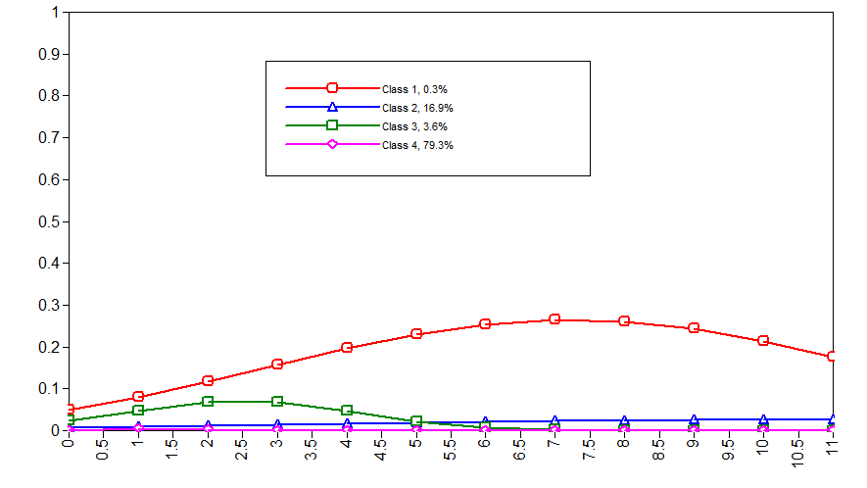Figure 1 (a): The 4-class solution in the full sample.

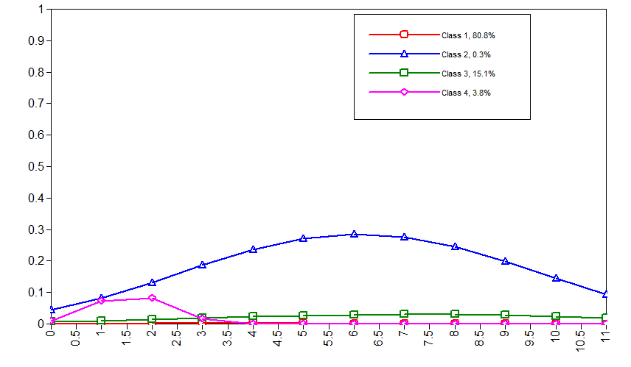
Figure 1 (b): The 4-class solution among babies born in summer.
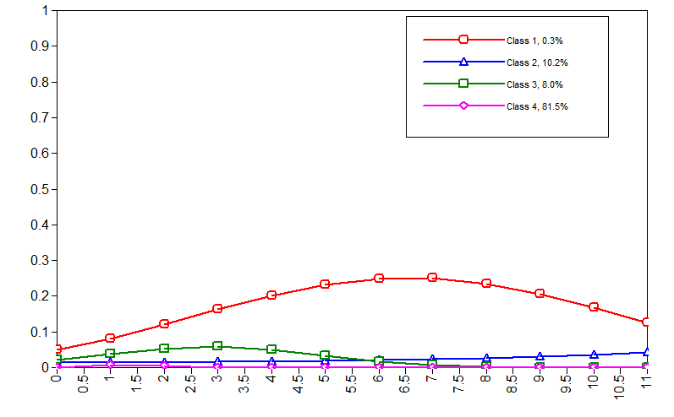
Figure 1 (c): The 4-class solution among babies born in autumn.
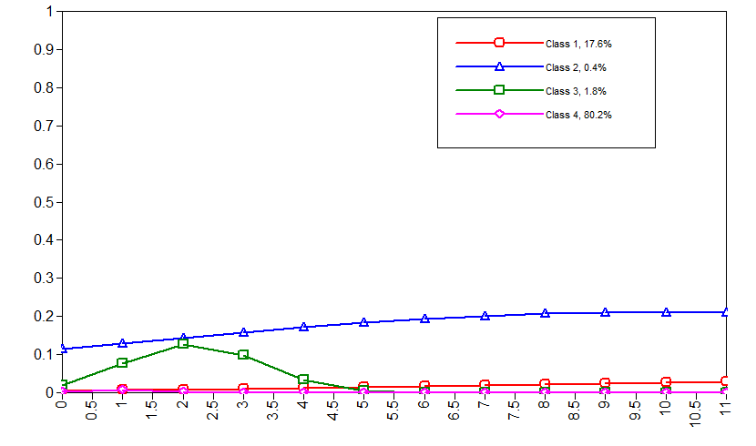
Figure 1 (d): The 4-class solution among babies born in winter.

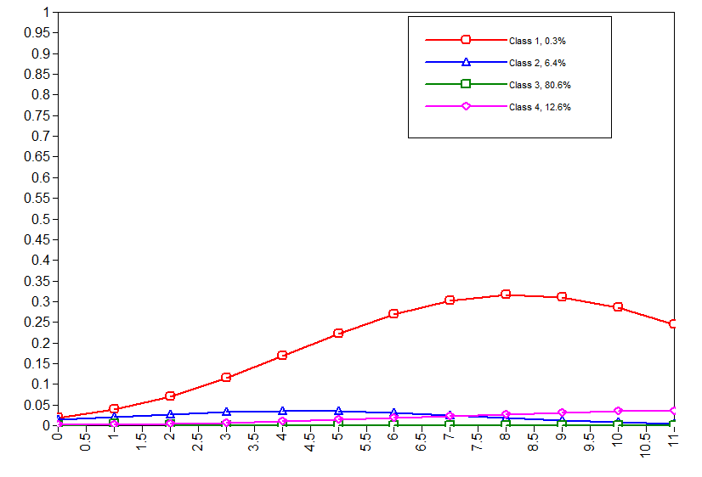
Figure 1 (e): The 4-class solution among babies born in spring.

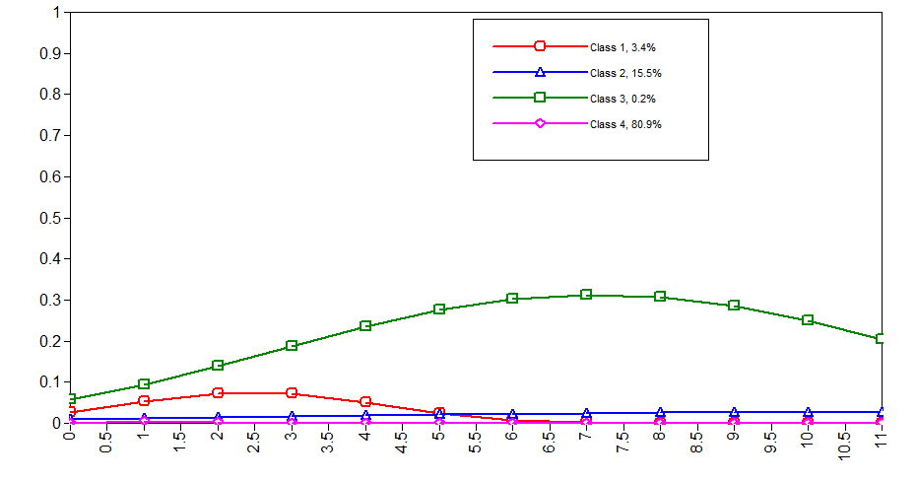
Figure 1 (f): The 4-class solution among babies born in 2009-2010.

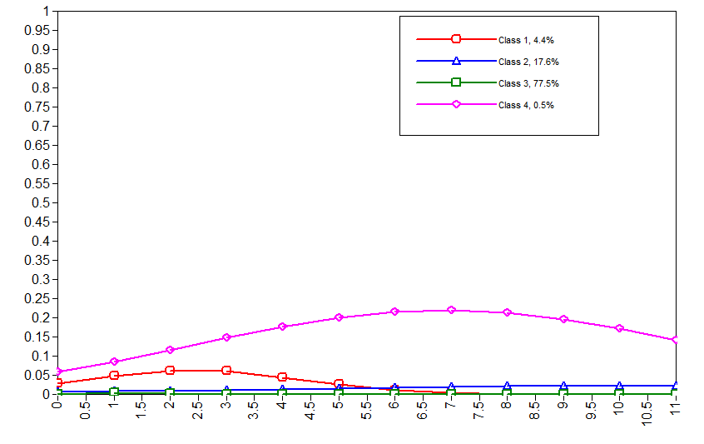 Figure 1 (g): The 4-class solution among babies born in 2011-2012.

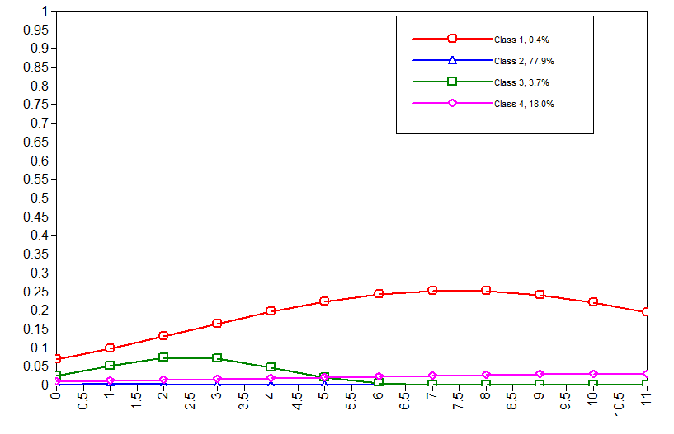
Figure 1 (h): The 4-class solution among babies born in 2013-2014.

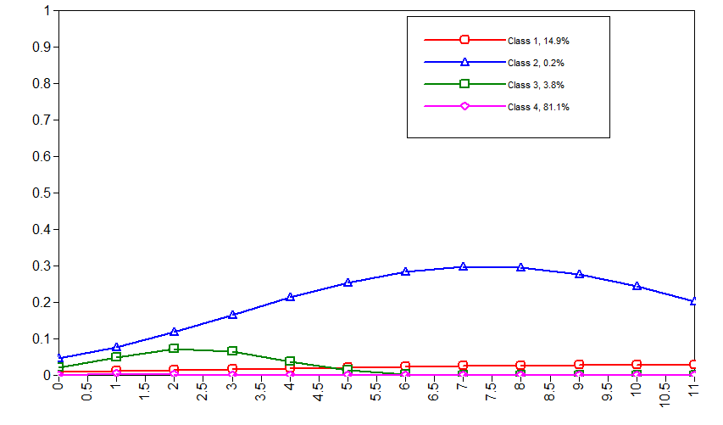
Figure 1 (h): The 4-class solution among babies born in South East Queensland (SEQ).

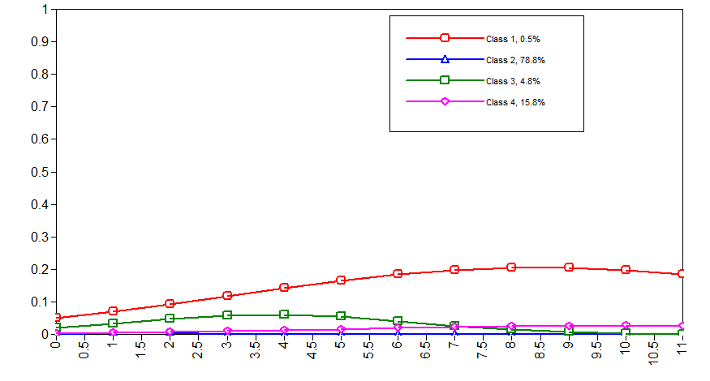
Figure 1 (i): The 4-class solution among babies born in North Queensland.

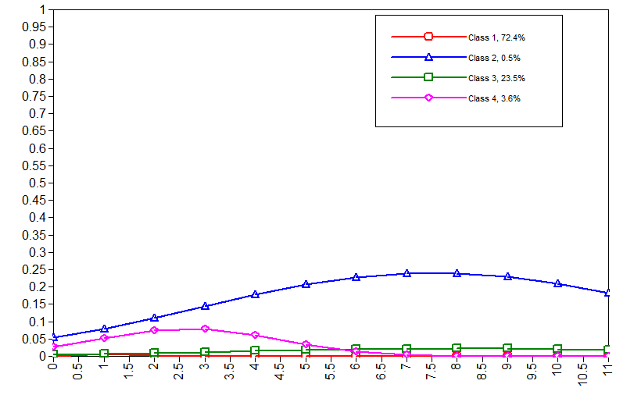
Figure 1 (j): The 4-class solution among babies born in West Queensland.
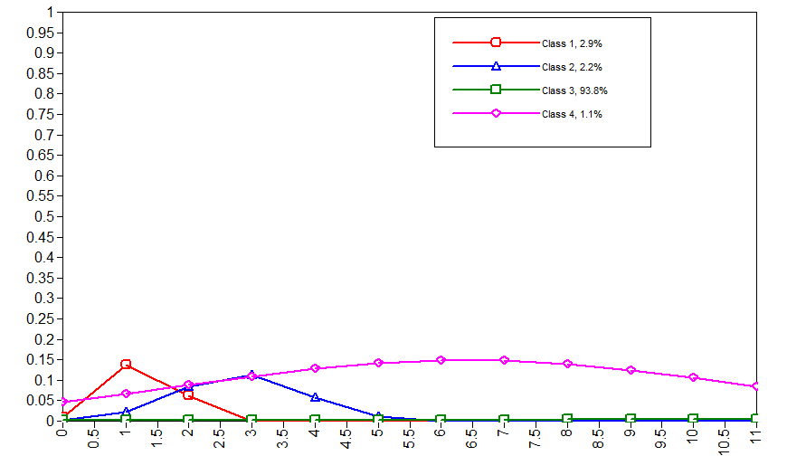
Figure 1 (k): The 4-class solution among babies born in South Queensland.

Supplementary text 8: Results using the restricted RIH variable as defined in supplementary section 5.

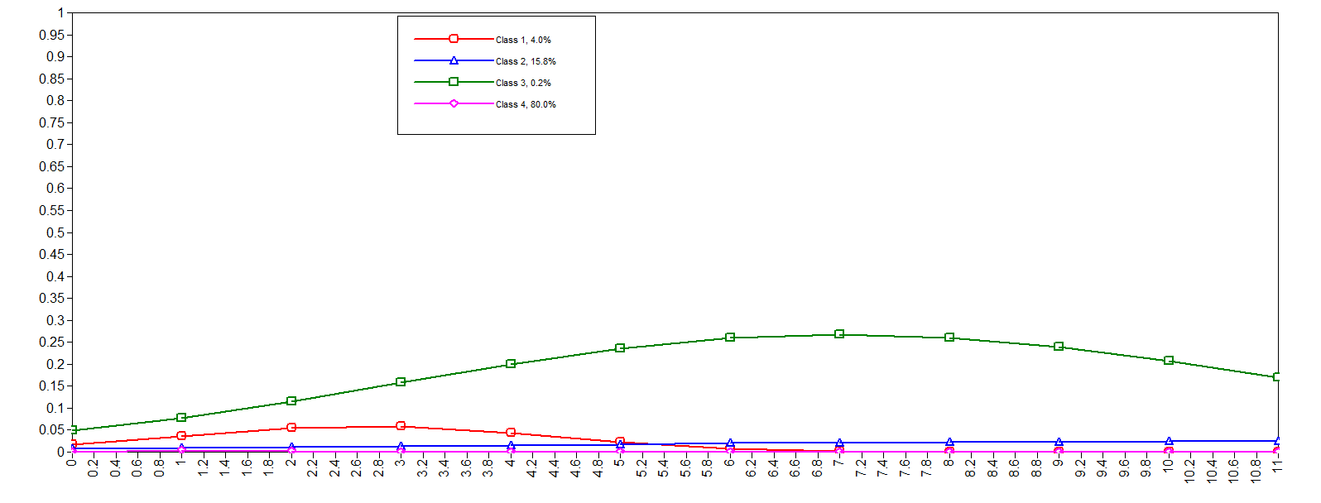
Supplementary figure 2: Trajectories from the 4 class solution using the restricted RIH variable [fit indices: BIC=209659; BIC-SSA=209401; Entropy=0.63).

Supplementary table 6: Multinomial logistic regression showing the associations among neonatal pulmonary morbidities and RIH trajectories [expressed as odds ratios (OR) with 95% confidence intervals (95% CI) and p-value (p)] (n=314,481) using the restricted RIH variable

 | Chronic/None |  |  |  | Early/None |  |  |  | Low/None |  |  |  | Chronic/Low |  |  |  | Early/Low |  |  |  | Chronic/Early
 | OR | 95% CI |  | p | OR | 95% CI |  | p | OR | 95% CI |  | p | OR | 95% CI |  | p | OR | 95% CI |  | p | OR | 95% CI |  | p
Predictors
TTN | 0.85 | 0.31 | 2.33 | 0.745 | 2.16 | 1.51 | 3.10 | 0.000 | 1.49 | 1.21 | 1.85 | 0.000 | 0.57 | 0.19 | 1.64 | 0.295 | 1.45 | 0.95 | 2.20 | 0.083 | 0.39 | 0.13 | 1.13 | 0.084
RDS | 2.79 | 1.58 | 4.94 | 0.000 | 2.10 | 1.37 | 3.22 | 0.001 | 1.54 | 1.18 | 2.01 | 0.001 | 1.81 | 0.93 | 3.51 | 0.080 | 1.36 | 0.83 | 2.22 | 0.217 | 1.33 | 0.66 | 2.66 | 0.422
ORS | 1.40 | 0.63 | 3.14 | 0.412 | 1.60 | 0.96 | 2.67 | 0.072 | 1.27 | 0.96 | 1.68 | 0.088 | 1.10 | 0.46 | 2.66 | 0.831 | 1.26 | 0.69 | 2.30 | 0.458 | 0.88 | 0.34 | 2.24 | 0.782
MAS | 1.67 | 0.27 | 10.37 | 0.585 | 1.37 | 0.34 | 5.54 | 0.658 | 1.41 | 0.75 | 2.65 | 0.283 | 1.18 | 0.16 | 8.57 | 0.871 | 0.97 | 0.20 | 4.76 | 0.971 | 1.22 | 0.14 | 10.72 | 0.861
PAPN | 5.50 | 1.73 | 17.49 | 0.004 | 1.31 | 0.12 | 14.57 | 0.828 | 3.15 | 1.07 | 9.21 | 0.037 | 1.75 | 0.46 | 6.64 | 0.412 | 0.42 | 0.03 | 5.55 | 0.506 | 4.21 | 0.31 | 56.82 | 0.279
SAPN | 8.22 | 3.40 | 19.90 | 0.000 | 2.44 | 0.91 | 6.59 | 0.077 | 0.81 | 0.30 | 2.20 | 0.676 | 10.19 | 2.16 | 48.01 | 0.003 | 3.03 | 0.68 | 13.51 | 0.146 | 3.36 | 0.93 | 12.18 | 0.065
female | 0.34 | 0.25 | 0.46 | 0.000 | 0.61 | 0.53 | 0.71 | 0.000 | 0.59 | 0.55 | 0.62 | 0.000 | 0.58 | 0.42 | 0.79 | 0.001 | 1.04 | 0.88 | 1.23 | 0.642 | 0.55 | 0.40 | 0.77 | 0.000
smoke | 2.20 | 1.64 | 2.96 | 0.000 | 1.53 | 1.28 | 1.82 | 0.000 | 1.57 | 1.45 | 1.70 | 0.000 | 1.40 | 1.02 | 1.93 | 0.040 | 0.97 | 0.80 | 1.19 | 0.783 | 1.44 | 1.02 | 2.03 | 0.036
low SES | 1.82 | 1.05 | 3.15 | 0.032 | 0.89 | 0.72 | 1.11 | 0.298 | 1.38 | 1.24 | 1.53 | 0.000 | 1.33 | 0.74 | 2.36 | 0.339 | 0.65 | 0.50 | 0.84 | 0.001 | 2.04 | 1.14 | 3.67 | 0.017
Middle SES | 1.09 | 0.62 | 1.90 | 0.765 | 0.73 | 0.59 | 0.89 | 0.002 | 1.14 | 1.03 | 1.26 | 0.012 | 0.96 | 0.53 | 1.72 | 0.879 | 0.64 | 0.50 | 0.82 | 0.000 | 1.50 | 0.83 | 2.71 | 0.182
no partner | 1.99 | 1.48 | 2.68 | 0.000 | 1.60 | 1.33 | 1.93 | 0.000 | 1.38 | 1.27 | 1.51 | 0.000 | 1.44 | 1.04 | 1.99 | 0.029 | 1.16 | 0.94 | 1.43 | 0.174 | 1.24 | 0.88 | 1.75 | 0.223
public | 0.91 | 0.62 | 1.33 | 0.626 | 1.03 | 0.87 | 1.22 | 0.715 | 0.99 | 0.92 | 1.06 | 0.733 | 0.92 | 0.62 | 1.37 | 0.688 | 1.04 | 0.86 | 1.26 | 0.656 | 0.88 | 0.59 | 1.33 | 0.552
prev preg | 1.19 | 1.13 | 1.26 | 0.000 | 1.26 | 1.22 | 1.29 | 0.000 | 1.16 | 1.14 | 1.18 | 0.000 | 1.03 | 0.97 | 1.09 | 0.336 | 1.08 | 1.05 | 1.12 | 0.000 | 0.95 | 0.89 | 1.01 | 0.102
preterm | 3.00 | 1.95 | 4.63 | 0.000 | 2.29 | 1.74 | 3.01 | 0.000 | 1.84 | 1.59 | 2.13 | 0.000 | 1.64 | 1.01 | 2.64 | 0.044 | 1.25 | 0.91 | 1.71 | 0.169 | 1.31 | 0.79 | 2.17 | 0.290
low bwt | 2.29 | 1.44 | 3.63 | 0.000 | 1.02 | 0.70 | 1.49 | 0.913 | 1.41 | 1.19 | 1.68 | 0.000 | 1.62 | 0.97 | 2.70 | 0.067 | 0.72 | 0.47 | 1.10 | 0.133 | 2.24 | 1.25 | 4.01 | 0.007
overweight | 1.54 | 1.09 | 2.16 | 0.014 | 1.21 | 1.01 | 1.45 | 0.038 | 1.24 | 1.15 | 1.33 | 0.000 | 1.24 | 0.86 | 1.78 | 0.244 | 0.98 | 0.79 | 1.20 | 0.828 | 1.27 | 0.86 | 1.86 | 0.223
obese | 2.30 | 1.69 | 3.14 | 0.000 | 1.69 | 1.43 | 2.00 | 0.000 | 1.54 | 1.43 | 1.66 | 0.000 | 1.49 | 1.08 | 2.08 | 0.017 | 1.10 | 0.91 | 1.34 | 0.340 | 1.36 | 0.96 | 1.93 | 0.084
age <18 | 0.84 | 0.19 | 3.78 | 0.819 | 0.74 | 0.19 | 2.90 | 0.662 | 2.69 | 2.09 | 3.46 | 0.000 | 0.31 | 0.07 | 1.47 | 0.142 | 0.27 | 0.07 | 1.14 | 0.075 | 1.14 | 0.15 | 8.52 | 0.899
age>35 | 0.62 | 0.43 | 0.90 | 0.011 | 0.75 | 0.62 | 0.90 | 0.002 | 0.69 | 0.64 | 0.75 | 0.000 | 0.90 | 0.61 | 1.33 | 0.589 | 1.08 | 0.87 | 1.34 | 0.498 | 0.83 | 0.55 | 1.25 | 0.378

