a)
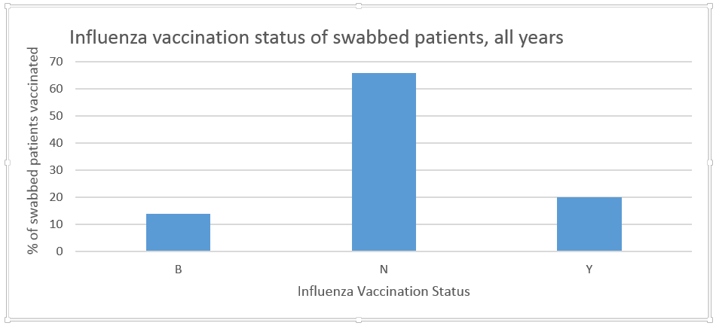

b)
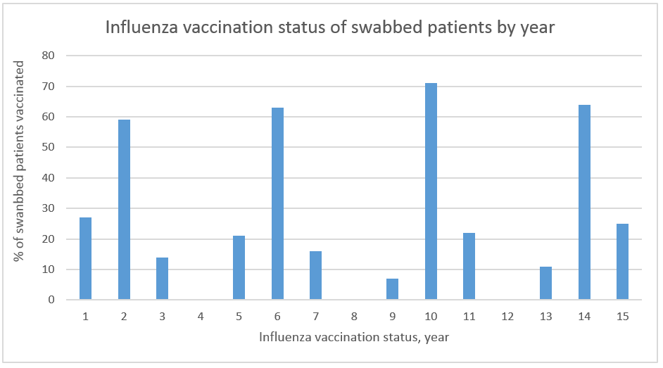

Figure S1. Influenza vaccination status for swabbed working-age ILI patients, 2010-2013: a) all years and b) by year.

