Epidemiology & Infection

The impact of implementing an Xpert MTB/RIF algorithm on drug-sensitive pulmonary tuberculosis: a retrospective analysis

K. Rees, N. Muditambi, M. Maswanganyi, J. Railton, J. A. McIntyre, H.E. Struthers, P.B. Fourie, R.P.H. Peters

Supplementary material
Supplementary figure S1. Flow chart of Xpert MTB/RIF algorithm as implemented in South Africa for diagnosis of pulmonary tuberculosis.
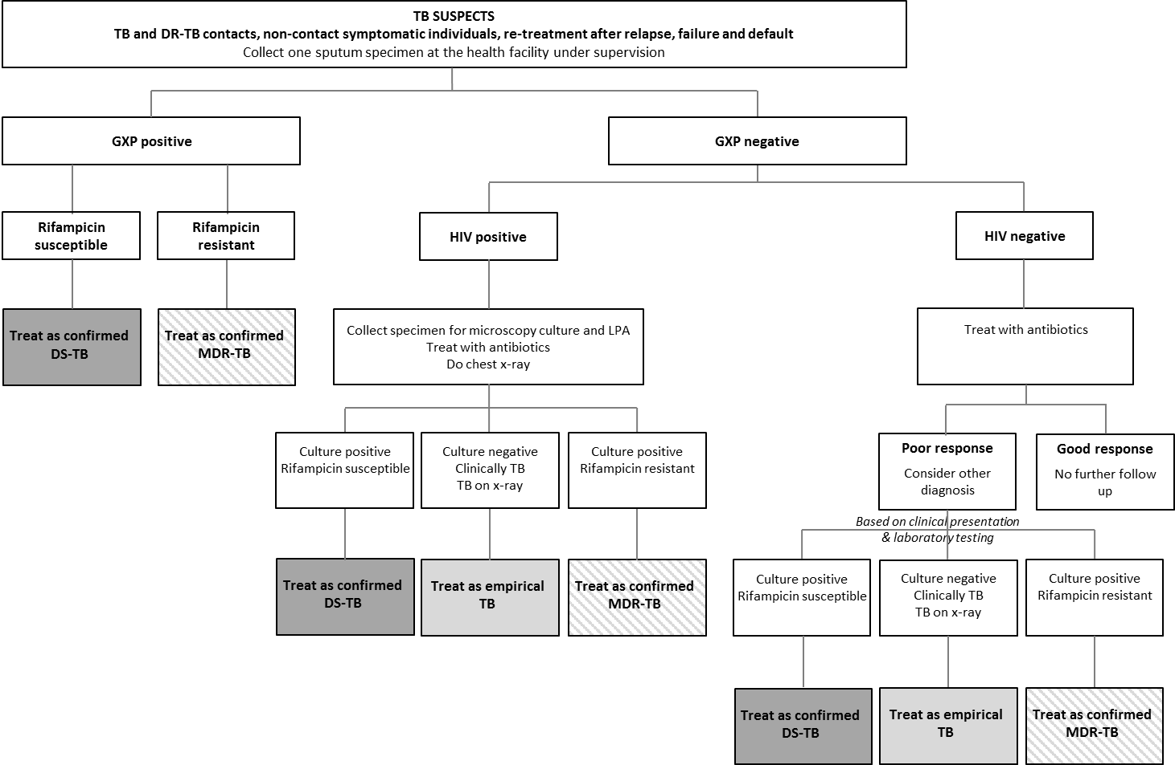
Note. Figure adapted from the National Tuberculosis Management Guidelines of the Department of Health of South Africa [8].
TB, tuberculosis; GXP, GeneXpert; HIV, human immunodeficiency virus; DS, drug-sensitive; MDR, multidrug resistant.

