Epidemiology and Infection

Environmental effects on the survival and potential transmission of Neisseria meningitidis outside of the host

C. L. SWAIN, D. R. MARTIN, D. SIM, T. W. JORDAN and J. K. MACKICHAN

Supplementary Material

Supplementary Figure S1. Survival of isolate NZ98/254 at ambient temperature and humidity, averaged by season. Later time points are in the inset box.
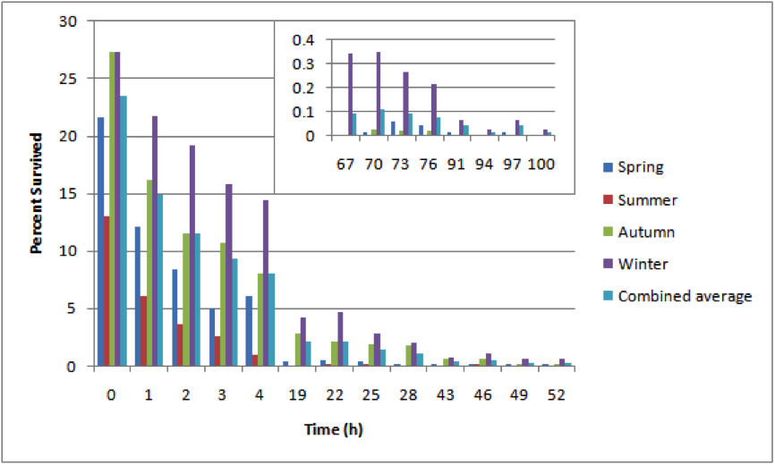

Supplementary Figure S2. Comparison of survival of C:2a:P1.7-2,4 with W:2a:P1.7-2,4 strain types at 30ºC, 30% relative humidity. Error bars are standard deviations, three replicates for each of three strains per strain type. Results shown are for the first two days, results for later days are summarized in Supplementary Table S6.

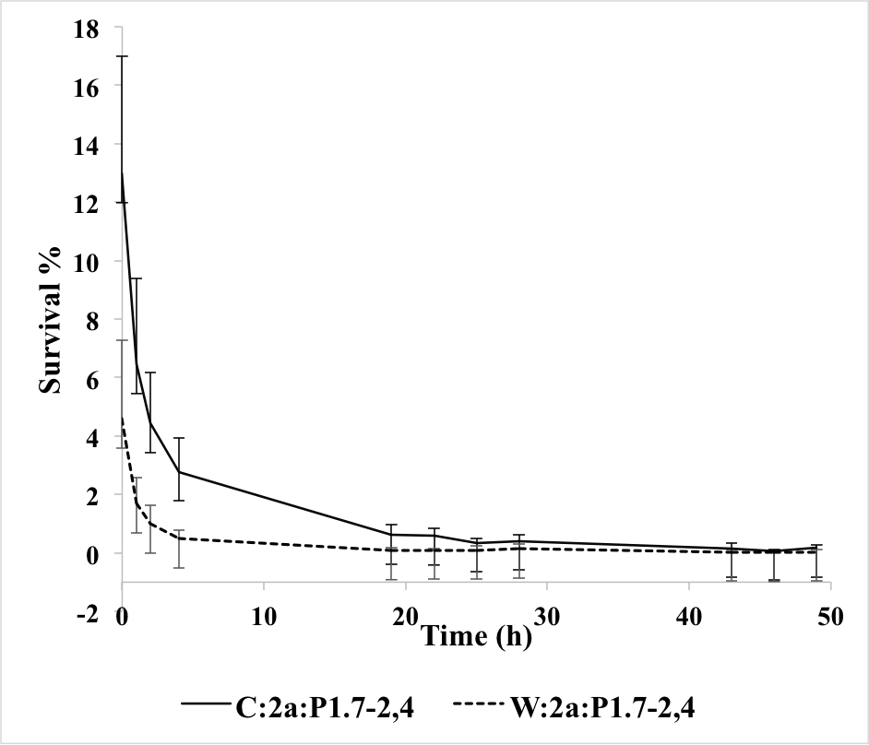

Supplementary Table S1. Mean percent survival over time of four isolates dried onto glass and maintained under ambient conditions of temperature and humidity in the laboratory. Values in brackets are numbers of independent experiments.

Percentage of meningococci surviving at each time
Time (h) | NZ98/254 (n=22) | NZ03/280  (n=7) | NZ07/024  (n=2) | Cu00162  (n=2)
0 | 23.45 | 16.97 | 6.49 | 19.44
1 | 14.95 | 11.29 | 3.48 | 13.43
2 | 11.48 | 9.37 | 1.77 | 12.83
3 | 9.32 | 6.78 | 0.55 | 9.47
4 | 8.06 | 6.75 | 0.39 | 7.09
19 | 2.15 | 0.60 | 0.03 | 3.02
22 | 2.10 | 0.80 | 0.11 | 1.39
25 | 1.43 | 0.81 | 0.03 | 2.76
28 | 1.15 | 0.60 | 0.03 | 1.74
43 | 0.42 | 0.17 | 0.06 | 0.57
46 | 0.51 | 0.22 | 0.03 | 1.03
49 | 0.25 | 0.26 | 0.03 | 1.05
52 | 0.25 | 0.14 | 0.03 | 0.81
67 | 0.09 | 0.03 |  | 0.03
70 | 0.11 | 0.06 |  | 0.07
73 | 0.09 | 0.02 |  | 0
76 | 0.07 | 0.01 |  | 0
91 | 0.04 | 0.01 |  | 0
94 | 0.01 |  |  | 0.04
97 | 0.04
100 | 0.01

Surviving meningococci were measured at zero time immediately after drying, then at intervals until viable meningococci were not detected (0 values).

Supplementary Table S2
Analysis of survival of four strains under ambient conditions of temperature and humidity in the laboratory.
Strain | Median  $$\hat{β}$$ | n | Mean $$\hat{β}$$ | SD | SEM | Minimum  $$\hat{β}$$ | Lower Quartile  (25%) | Upper Quartile  (75%) | Maximum$$\hat{β}$$
NZ98/254 | -0.171 | 22 | -0.293 | 0.221 | 0.047 | -0.685 | -0.486 | -0.106 | -0.056
NZ03/280 | -0.119 | 7 | -0.252 | 0.238 | 0.09 | -0.727 | -0.315 | -0.102 | -0.083
NZ07/024 | -0.618 | 2 | -0.618 | 0.642 | 0.454 | -1.072 | -1.072 | -0.164 | -0.164
Cu00162 | -0.113 | 2 | -0.113 | 0.079 | 0.056 | -0.168 | -0.168 | -0.057 | -0.057

Values shown include median, mean, and minimum and maximum values of $\hat{β}$ for the independent biological replicates for each strain; n number of experiments, SD standard deviation, SEM standard error of the mean.

Supplementary Table S3
Mean percent survival at intervals for three strains in a warm room at 36ºC and 20% relative humidity.
Time (h) | NZ98/254  n=8 | NZ03/280  n=5 | Cu00162  n=2
0 | 26.03 | 15.77 | 19.44
1 | 15.27 | 9.46 | 13.18
2 | 11.52 | 8.71 | 8.78
3 | 8.26 | 6.4 | 8.12
4 | 8.84 | 3.92 | 6.63
19 | 2.50 | 1.48 | 4.14
22 | 2.03 | 1.3 | 3.72
25 | 1.22 | 1.26 | 3.31
28 | 1.45 | 2.23 | 2.99
43 | 0.49 | 0.64 | 2.35
46 | 0.65 | 0.54 | 2.83
49 | 0.64 | 0.78 | 2.17
52 | 0.46 | 0.52 | 2.57
67 | 0.38 | 0.35 | 1.34
70 | 0.38 | 0.32 | 0.94
73 | 0.30 | 0.20 | 0.72
76 | 0.46 | 0.45 | 0.53
91 | 0.2 | 0.09 | 0.27
94 | 0.35 | 0.17 | 0.37
97 | 0.16 | 0.09 | 0.08
100 | 0.1 | 0.05 | 0.12
115 | 0.06 | 0.03 | 0.21
118 | 0.07 | 0.02 | 0.11
121 | 0.11 | 0.04 | 0.12
124 | 0.06 | 0.04 | 0.11
139 | 0.04 | 0.01 | 0.06
142 | 0.08 | 0.01 | 0.16
145 | 0.04 | 0.06 | 0.22
163 | 0.01 | 0.01 | 0.04
172 | 0.01 | 0 | 0
187 | 0.02 | 0.02 | 0.04
196 | 0.01 | 0.01 | 0
211 | 0 | 0 | 0.04
220 | 0.02 | 0 | 0
235 | 0 | 0 | 0
244 | 0.01
259 | 0
268 | 0.02

Surviving meningococci were measured at zero time immediately after drying, then at intervals until viable meningococci were not detected (0 values).
Supplementary Table S4
Survival of three strains in an incubator at 36ºC and 95% relative humidity.

Isolate | Inoculation  (CFU) | Survival, 0 min  % | Survival, 30 min  % | Survival, 60 min  %
NZ98/254
Trial 1 | 934 | 26.8 | 0 | 0
Trial 2 | 647 | 25.5 | 0 | 0
NZ03/280
Trial 1 | 804 | 18.7 | nd | 0
Trial 2 | 885 | 13.2 | 0 | 0
Trial 3 | 777 | 17.8 | nd | 0
Cu00162
Trial 1 | 135 | 42.9 | 1.9 | 0
Trial 2 | 610 | 20.6 | 1.0 | 0
Trial 3 | 610 | 24.6 | nd | 0

nd = not done; measurements were not made at these time points

Supplementary Table S5
Analysis of survival at 30ºC, 30% relative humidity.
Strain type and isolate | Median  $$\hat{β}$$ | Mean $$\hat{β}$$ | SD | SEM | Minimum  $$\hat{β}$$ | Lower Quartile  (25%) | Upper Quartile  (75%) | Maximum$$\hat{β}$$
B:4:P1.7-2,4
NZ94/167 | -0.153 | -0.145 | 0.035 | 0.020 | -0.175 | -0.164 | -0.130 | -0.107
NZ98/254 | -0.118 | -0.132 | 0.080 | 0.027 | -0.335 | -0.133 | -0.089 | -0.067
NZ03/280 | -0.191 | -0.233 | 0.106 | 0.061 | -0.354 | -0.273 | -0.173 | -0.154
NZ06/007 | -0.126 | -0.128 | 0.013 | 0.007 | -0.141 | -0.134 | -0.121 | -0.116
NZA2-085-1* | -0.075 | -0.074 | 0.004 | 0.002 | -0.078 | -0.077 | -0.073 | -0.070
NZA2-362-1* | -0.090 | -0.086 | 0.021 | 0.012 | -0.105 | -0.098 | -0.077 | -0.064
NZA2-367-1* | -0.094 | -0.102 | 0.013 | 0.008 | -0.117 | -0.106 | -0.094 | -0.094
C:2a:P1.7-2,4
NZ96/059 | -0.131 | -0.126 | 0.021 | 0.012 | -0.144 | -0.138 | -0.117 | -0.103
NZ03/236 | -0.113 | -0.110 | 0.015 | 0.009 | -0.124 | -0.119 | -0.104 | -0.094
NZ04/154 | -0.098 | -0.098 | 0.013 | 0.007 | -0.110 | -0.104 | -0.092 | -0.085
W:2a:P1.7-2,4
NZ04/102 | -0.129 | -0.236 | 0.199 | 0.115 | -0.465 | -0.297 | -0.122 | -0.114
NZ04/117 | -0.180 | -0.177 | 0.043 | 0.025 | -0.218 | -0.199 | -0.157 | -0.133
NZ05/050 | -0.101 | -0.136 | 0.074 | 0.043 | -0.221 | -0.161 | -0.094 | -0.087
W:nt:P1.18-1,3
NZ04/140 | -0.518 | -0.757 | 0.628 | 0.363 | -1.47 | -0.994 | -0.401 | -0.824
NZ06/105 | -0.243 | -0.235 | 0.124 | 0.071 | -0.355 | -0.299 | -0.176 | -0.108
NZ06/113 | -0.267 | -0.266 | 0.069 | 0.04 | -0.334 | -0.301 | -0.232 | -0.196
NZ07/024 | -0.228 | -0.286 | 0.188 | 0.109 | -0.497 | -0.363 | -0.181 | -0.134
NZA1-153-1* | -0.304 | -0.315 | 0.061 | 0.035 | -0.381 | -0.343 | -0.282 | -0.26
NZA1-478-1* | -0.169 | -0.45 | 0.518 | 0.30 | -1.048 | -0.609 | -0.151 | -0.330
B:4:P1.19,15
Cu00612 | -0.113 | -0.125 | 0.036 | 0.018 | -0.176 | -0.149 | -0.1 | -0.097
B:4:P1.7,16
H44/76-SL | -0.1 | -0.114 | 0.032 | 0.015 | -0.163 | -0.129 | -0.09 | -0.086

Values shown include median, mean, and minimum and maximum values of $\hat{β}$ for the independent biological replicates for each strain; n number of experiments, SD standard deviation, SEM standard error of the mean.
n=3 for all strains except NZ98/254 (n=9), Cu00162 (n=4), H44/76-SL (n=5).
* Carriage strains. All other strains are invasive isolates.

Supplementary Table S6
Comparison of survival data at 30°C, 30% relative humidity for C:2a:P1.7-2,4 and its W:2a:P1.7-2,4 capsule switch variant. Three isolates from each strain type were analysed in triplicate.
 | C:2a:P1.7-2,4 | W:2a:P1.7-2,4
Initial survival % (range) | 12.98 (7.7-19.6) | 4.6 (1.57-9.32)
Decrease in survival first 4 h (mean %) | 4.7 | 9.6
Survival range Day 2 (%) | 0.35-0.61 | 0.09-0.14
Survival range Day 3 (%) | 0.06-0.18 | 0.02-0.05
Survival range Day 4 (%) | 0.01-0.06 | 0-0.01
Survival range Day 5 (%) | 0.007-0.01
Survival range Day 6 (%) | 0-0.06

Supplementary Table S7
Analysis of survival at 30°C, 22% relative humidity. All strains were examined in triplicate.
Strain type and isolate | Median  $$\hat{β}$$ | Mean $$\hat{β}$$ | SD | SEM | Minimum  $$\hat{β}$$ | Lower Quartile  (25%) | Upper Quartile  (75%) | Maximum$$\hat{β}$$
B:4:P1.7-2,4
NZ94/167 | -0.086 | -0.086 | 0.018 | 0.01 | -0.103 | -0.095 | -0.077 | -0.67
NZ98/254 | -0.04 | -0.052 | 0.025 | 0.014 | -0.080 | -0.060 | -0.038 | -0.038
NZA2-367-1 | -0.066 | -0.08 | 0.037 | 0.021 | -0.122 | -0.094 | -0.059 | -0.052
W:nt:P1.18-1,3
NZ04/140 | -0.128 | -0.113 | 0.039 | 0.023 | -0.142 | -0.135 | -0.098 | -0.068
NZ07/024 | -0.212 | -0.241 | 0.076 | 0.044 | -0.327 | -0.270 | -0.198 | -0.183
NZA1-478-1 | -0.891 | -1.037 | 0.643 | 0.371 | -1.74 | -1.316 | -0.685 | -0.479
B:4:P1.19,15
Cu00612 | -0.05 | -0.05 | 0.009 | 0.005 | -0.059 | -0.055 | -0.046 | -0.041
B:4:P1.7,16
H44/76-SL | -0.05 | -0.049 | 0.005 | 0.003 | -0.053 | -0.052 | -0.047 | -0.044

Values shown include median, mean, and minimum and maximum values of $\hat{β}$ for the independent biological replicates for each strain; n number of experiments, SD standard deviation, SEM standard error of the mean.

Supplementary Table S8
Mann-Whitney U statistical comparison of survival at 30°C, 30% relative humidity with 30°C, 22% relative humidity.

Strain type | Number of experiments |  | Test statistic (U) | Probability (P)
 | 30% RH | 22% RH
B:4:P1.7-2,4¹ | 27 | 9 | 41.0 | 0.002
W:nt:P1.18-1,3² | 18 | 9 | 72.0 | 0.668
Cuban and Norwegian strains³ | 9 | 6 | 0.00 | <0.001

1,2. Results for New Zealand carriage and invasive isolates have been combined for this analysis.
3. Results are combined for the Cuban and Norwegian epidemic isolates.

