Novel hemotropic mycoplasmas are widespread and genetically diverse in vampire bats: Supplemental Material

D. V. VOLOKHOV, D. J. BECKER, L. M. BERGNER, M. S. CAMUS, R. J. ORTON, V. E. CHIZHIKOV, S. M. ALTIZER, D. G. STREICKER

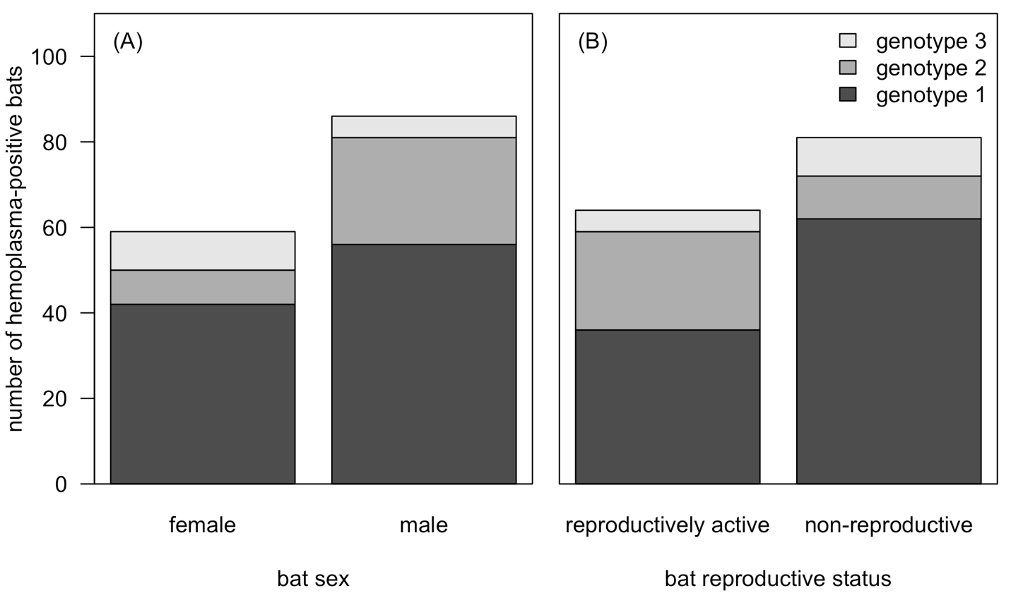
Figure S1. Associations between vampire bat demographic covariates and infection with one of the three novel hemoplasma genotypes.

Table S1. Sample size, sampling dates, and prevalence across field sites in Peru and Belize.
Site | Dates | Sample size | Hemoplasma-positive | Infection prevalence
AM1 | 4/23/15 | 1 | 1 | 1.00
AM1 | 4/28/15 | 1 | 1 | 1.00
AM1 | 10/12/15 | 10 | 7 | 0.70
AM1 | 10/13/15 | 11 | 7 | 0.64
AM1 | 6/20/16 | 1 | 1 | 1.00
AM1 | 8/9/16 | 3 | 2 | 0.67
AM1 | 8/10/16 | 2 | 2 | 1.00
API1 | 8/21/15 | 12 | 7 | 0.58
API141 | 8/15/15 | 6 | 4 | 0.67
AYA11 | 7/25/15 | 5 | 4 | 0.80
AYA11 | 7/26/15 | 1 | 1 | 1.00
AYA13 | 7/21/15 | 5 | 4 | 0.80
AYA14 | 7/22/15 | 1 | 0 | 0.00
CA1 | 10/9/15 | 8 | 4 | 0.50
CA1 | 10/10/15 | 8 | 7 | 0.88
CA1 | 6/16/16 | 7 | 1 | 0.14
CA1 | 6/17/16 | 3 | 2 | 0.67
CA1 | 8/4/16 | 2 | 1 | 0.50
CA1 | 8/5/16 | 6 | 4 | 0.67
LR1 | 9/23/15 | 2 | 1 | 0.50
LR1 | 9/7/16 | 5 | 5 | 1.00
LR2 | 9/19/15 | 7 | 6 | 0.86
LR2 | 5/13/16 | 1 | 0 | 0.00
LR2 | 9/11/16 | 5 | 4 | 0.80
LR2 | 9/12/16 | 2 | 2 | 1.00
LR3 | 9/16/15 | 5 | 5 | 1.00
LR3 | 9/17/15 | 2 | 1 | 0.50
LR3 | 5/8/16 | 2 | 2 | 1.00
LR3 | 9/2/16 | 6 | 4 | 0.67
LR3 | 9/3/16 | 3 | 3 | 1.00
LR4 | 8/30/16 | 4 | 2 | 0.50
LR4 | 8/31/16 | 2 | 2 | 1.00
LR4 | 9/14/16 | 2 | 1 | 0.50
LR6 | 9/11/15 | 1 | 1 | 1.00
OW1 | 4/22/15 | 14 | 8 | 0.57
OW1 | 4/23/15 | 3 | 1 | 0.33
OW1 | 4/27/16 | 10 | 4 | 0.4
OW2 | 4/21/15 | 1 | 1 | 1.00
OW2 | 4/23/15 | 3 | 2 | 0.67
OW2 | 4/24/15 | 8 | 6 | 0.75
OW2 | 4/25/16 | 17 | 11 | 0.65
OW2 | 4/26/16 | 4 | 2 | 0.50
OW2 | 4/27/16 | 13 | 9 | 0.69
OW2 | 4/29/16 | 9 | 7 | 0.78
Table S3. 95% confidence set of GLMMs predicting hemoplasma infection status. Models are ranked by ΔAICc with the number of estimated coefficients (k), the Akaike weights (wi), and the marginal (R²_{m}) and conditional R² (R²_{c}). A random effect of bat ID is included in all GLMMs.

Hemoplasma infection status ~ fixed effects | k | ΔAICc | R²_{m} | R²_{c} | w_{i}
~ age + rep + season + rep:season | 7 | 0 | 0.16 | 0.205 | 0.16
~ age + rep + season + sex + rep:season | 8 | 1.19 | 0.165 | 0.206 | 0.09
~ age + country + rep + season + rep:season | 8 | 1.45 | 0.163 | 0.203 | 0.08
~ age + rep | 3 | 2.15 | 0.087 | 0.136 | 0.05
~ age + rep + season + year + rep:season | 8 | 2.17 | 0.16 | 0.205 | 0.05
~ age + rep + sex | 4 | 2.69 | 0.1 | 0.136 | 0.04
~ age + country + rep | 4 | 3.26 | 0.094 | 0.149 | 0.03
~ rep + season + sex + rep:season | 7 | 3.55 | 0.128 | 0.163 | 0.03
~ rep + season + rep:season | 6 | 3.64 | 0.112 | 0.15 | 0.03
~ age + country + rep + sex | 5 | 3.66 | 0.108 | 0.149 | 0.02
~ age + rep + season + sex + season:sex | 8 | 3.78 | 0.144 | 0.182 | 0.02
~ age + rep + year | 4 | 4.04 | 0.089 | 0.138 | 0.02
~ rep + season + sex + season:sex | 7 | 4.1 | 0.117 | 0.155 | 0.02
~ rep + sex | 3 | 4.31 | 0.065 | 0.101 | 0.02
~ age + rep + sex + rep:sex | 5 | 4.49 | 0.099 | 0.136 | 0.02
~ age + rep + season + sex | 6 | 4.54 | 0.115 | 0.16 | 0.02
~ age + rep + season | 5 | 4.56 | 0.099 | 0.156 | 0.02
~ age + rep + sex + year | 5 | 4.62 | 0.101 | 0.138 | 0.02
~ rep | 2 | 4.68 | 0.047 | 0.093 | 0.01
~ age + country + rep + sex + rep:sex | 6 | 5.13 | 0.107 | 0.152 | 0.01
~ country + rep + season + sex + rep:season | 8 | 5.2 | 0.13 | 0.162 | 0.01
~ age + country + rep + season | 6 | 5.2 | 0.107 | 0.158 | 0.01
~ country + rep + season + rep:season | 7 | 5.25 | 0.115 | 0.148 | 0.01
~ age + country + rep + year | 5 | 5.33 | 0.094 | 0.15 | 0.01
~ age + country + rep + season + sex | 7 | 5.35 | 0.122 | 0.162 | 0.01
~ age + country | 3 | 5.57 | 0.067 | 0.119 | 0.01
~ age | 2 | 5.67 | 0.053 | 0.1 | 0.01
~ country + rep + season + sex + season:sex | 8 | 5.69 | 0.12 | 0.152 | 0.01
~ rep + season + sex + rep:season + rep:sex | 8 | 5.69 | 0.129 | 0.165 | 0.01
~ rep + season + sex + year + rep:season | 8 | 5.72 | 0.128 | 0.163 | 0.01
~ country + rep + sex | 4 | 5.74 | 0.07 | 0.111 | 0.01
~ rep + season + year + rep:season | 7 | 5.75 | 0.112 | 0.15 | 0.01
~ age + country + rep + sex + year | 6 | 5.76 | 0.108 | 0.15 | 0.01
~ rep + season + sex | 5 | 5.88 | 0.083 | 0.128 | 0.01
~ age + season | 4 | 5.94 | 0.079 | 0.133 | 0.01
~ rep + season + sex + rep:sex + season:sex | 8 | 6.1 | 0.117 | 0.154 | 0.01
~ rep + sex + year | 4 | 6.19 | 0.066 | 0.103 | 0.01
~ rep + season + sex + year + season:sex | 8 | 6.27 | 0.117 | 0.155 | 0.01
~ rep + sex + rep:sex | 4 | 6.32 | 0.063 | 0.1 | 0.01
~ age + rep + season + sex + rep:sex | 7 | 6.33 | 0.114 | 0.16 | 0.01
~ country + rep | 3 | 6.36 | 0.049 | 0.101 | 0.01
~ age + rep + sex + year + rep:sex | 6 | 6.43 | 0.1 | 0.138 | 0.01
~ rep + year | 3 | 6.51 | 0.048 | 0.096 | 0.01
~ rep + season + sex + rep:season + season:sex | 9 | 6.66 | 0.135 | 0.179 | 0.01
~ age + rep + season + year | 6 | 6.68 | 0.099 | 0.156 | 0.01
~ age + rep + season + sex + year | 7 | 6.69 | 0.115 | 0.16 | 0.01
~ country + rep + season + sex | 6 | 6.95 | 0.088 | 0.128 | 0
~ age + country + season | 5 | 6.98 | 0.085 | 0.135 | 0
~ rep + season | 4 | 7.01 | 0.059 | 0.11 | 0
~ age + country + rep + season + year | 7 | 7.35 | 0.107 | 0.158 | 0
~ country + rep + season + year + rep:season | 8 | 7.38 | 0.115 | 0.148 | 0
~ age + sex | 3 | 7.41 | 0.056 | 0.106 | 0
~ age + country + rep + year + country:year | 6 | 7.42 | 0.095 | 0.148 | 0
~ age + year | 3 | 7.53 | 0.055 | 0.102 | 0
~ age + country + sex | 4 | 7.55 | 0.068 | 0.123 | 0
~ age + country + year | 4 | 7.65 | 0.067 | 0.12 | 0
~ country + rep + sex + rep:sex | 5 | 7.67 | 0.068 | 0.111 | 0
~ country + rep + sex + year | 5 | 7.78 | 0.07 | 0.112 | 0

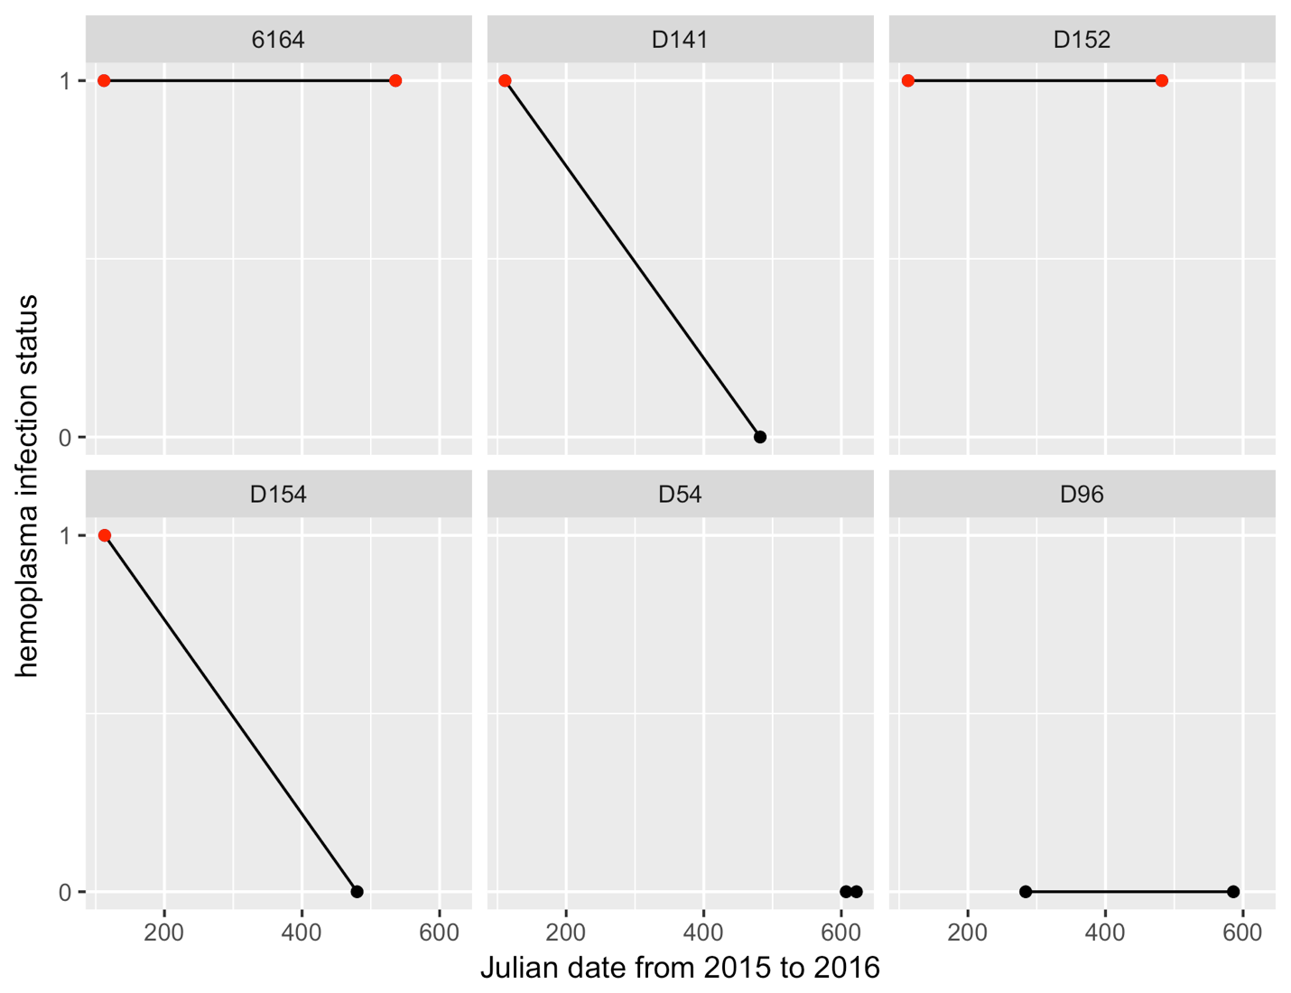
Figure S2. Dynamics of hemoplasma infection (pooled genotypes) for recaptured bats (n=6) between 2015 and 2016. Infected bats are shown in red, uninfected bats are shown in black.

