Epidemiology and Infection

Practical applications of using quantitative interferon-gamma responses to predict future disease progression in badgers naturally infected with Mycobacterium bovis

S.N. BUZDUGAN¹, M.A. CHAMBERS², R.J. DELAHAY³, J.A. DREWE¹

- Veterinary Epidemiology, Economics and Public Health Group, Royal Veterinary College, London, UK
- Animal and Plant Health Agency, Weybridge, UK
- National Wildlife Management Centre, Animal and Plant Health Agency, Woodchester Park, Gloucestershire, UK

*Corresponding author: J A Drewe, Veterinary Epidemiology, Economics and Public Health Group, Royal Veterinary College, Hawkshead Lane, North Mymms, Hertfordshire AL9 7TA, UK.
Email: jdrewe@rvc.ac.uk

Supplementary material

This supplementary material includes three tables (Tables S1 to S3) and six figures (Figures S1 to S6).

Supplementary Tables

Table S1. The distribution of Stat-Pak and culture test results across the time periods used in the analysis. Data are derived from 2,342 Stat-Pak tests and 2,388 culture tests performed on 550 badgers at Woodchester Park from July 2006 to October 2013 (the maximum observation period per badger was 86 months).

Time period |  | Number of Stat-Pak test results obtained per time period | Number (%) of positive Stat-Pak test results obtained per time period | Number of culture test results obtained per time period | Number (%) of positive culture test results obtained per time period
Short term | 0 to 3 months | 744 | 111 (15) | 739 | 8 (1)
 | 0 to 6 months | 1,013 | 144 (14) | 1005 | 9 (1)
 | 0 to 9 months | 1,134 | 166 (14) | 1132 | 11 (1)
 | 0 to 12 months | 1,370 | 215 (16) | 1371 | 19 (1)
Medium term | 12 to 24 months | 433 | 101 (23) | 454 | 19 (4)
Long term | 24 to 86 months | 539 | 167 (30) | 563 | 31 (6)
Total | 0 to 86 months | 2,342 | 483 (21) | 2,388 | 69 (3)

Table S2. Frequency distribution of the results of the Stat-Pak serological test and mycobacterial culture of clinical samples in relation to different categories of IFNγ OD result. Data from tests performed on 550 badgers at Woodchester Park from July 2006 to October 2013.

IFNγ category | IFNγ OD value  (PPD-B minus PPD-A) | Number (%*) of Stat-Pak test results |  |  | Number (%*) of culture test results
 |  | Negative | Positive | Total | Negative | Positive | Total
0 | <0 | 764 (84) | 143 (16) | 907 | 898 (97) | 24 (3) | 922
1 | 0.000 - 0.043 | 913 (81) | 208 (19) | 1121 | 1,117 (97) | 30 (3) | 1,147
2 | 0.044 - 0.366 | 134 (60) | 91 (40) | 225 | 219 (96) | 10 (4) | 229
3 | 0.367 - 0.696 | 24 (56) | 19 (44) | 43 | 40 (95) | 2 (5) | 42
4 | 0.697 - 1.920 | 24 (52) | 22 (48) | 46 | 45 (94) | 3 (6) | 48
Total | 0.000 - 1.920 | 1,859 (79) | 483 (21) | 2,342 | 2,319 (97) | 69 (3) | 2,388
*Percentages of positive and negative Stat-Pak or culture test results within each IFNγ category.

Table S3. Breakdown of the number, type, and mycobacterial culture test result, of samples collected for from 550 different badgers at Woodchester Park from July 2006 to October 2013. The 70 culture-positive samples came from 56 individual badgers, indicating some badgers had a positive result on more than one sample type: 10 badgers were culture-positive on 2 sample types and 2 badgers were culture-positive on 3 sample types.

Sample type | Number of samples collected | Culture positive |  | Culture negative
 |  | Number | % | Number | %
Bite wound | 105 | 16 | 15 | 89 | 85
Faeces | 1413 | 11 | 1 | 1402 | 99
Lymph node | 15 | 7 | 47 | 8 | 53
Oesophageal aspirate | 1974 | 6 | 0.3 | 1968 | 99.7
Tracheal aspirate | 2188 | 3 | 0.1 | 2185 | 99.9
Urine | 1826 | 17 | 1 | 1809 | 99
Other lesions | 42 | 10 | 24 | 32 | 76

Supplementary Figures

Figures S1 to S6 show the regression lines for IFNγ OD values, fitted to data for each type of clinical sample that was cultured for M. bovis. On the x-axis, data points clustering at zero represent negative culture results and data points clustering at 1 represent positive culture results. Note that y-axes are plotted on a logarithmic scale. Sample sizes are given in Table S3.

Figure S1. Culture sample: Bite wound swabs
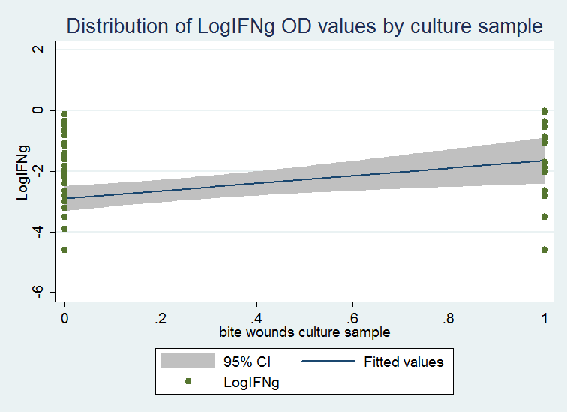
Figure S2. Culture sample: Faeces
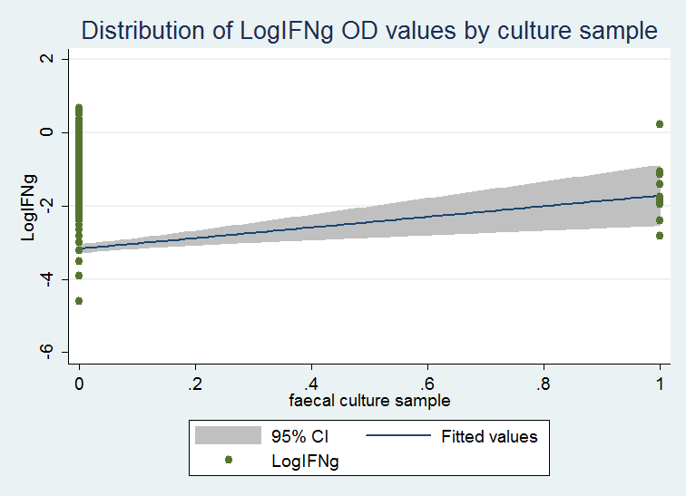
Figure S3. Culture sample: Diseased lymph node swabs
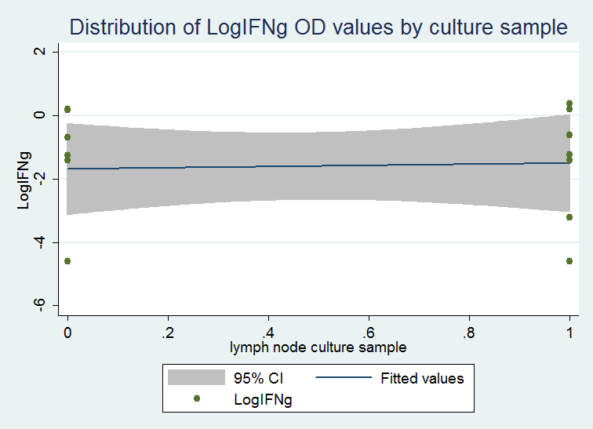

Figure S4. Culture sample: Oesophageal aspirates
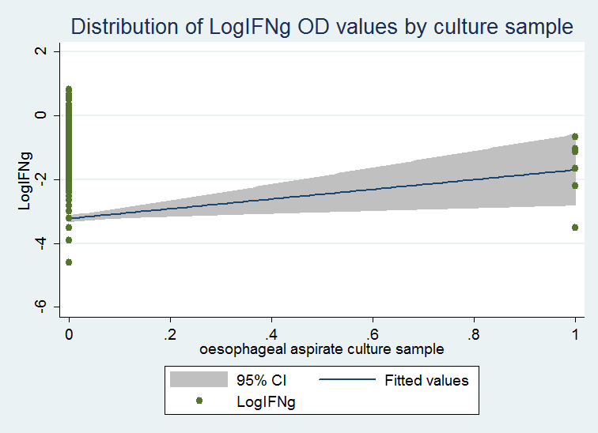

Figure S5. Culture sample: Tracheal aspirates
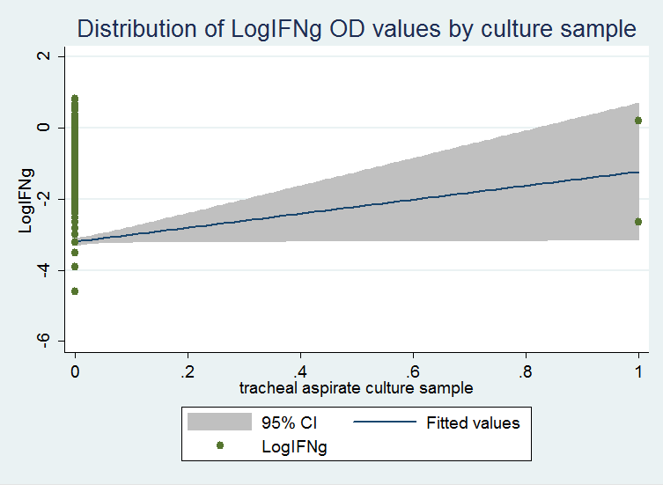

Figure S6. Culture sample: Urine