Epidemiology and Infection

Measles Elimination and Immunization: National Surveillance Trends in Japan, 2008–2015

S. INAIDA, S. MATSUNO, F. KOBUNE

Supplementary Material

Figure S1. Yearly measles case in Japan (2008–2015)
The number of case
Year

Figure S2. Measles cases by age cohorts in Japan. The number of case for each age cohort was compared before and after the catch-up vaccination programme was implemented. (A) 2008, (B) 2009–2014. (2015 was not included as only 36 cases were detected)
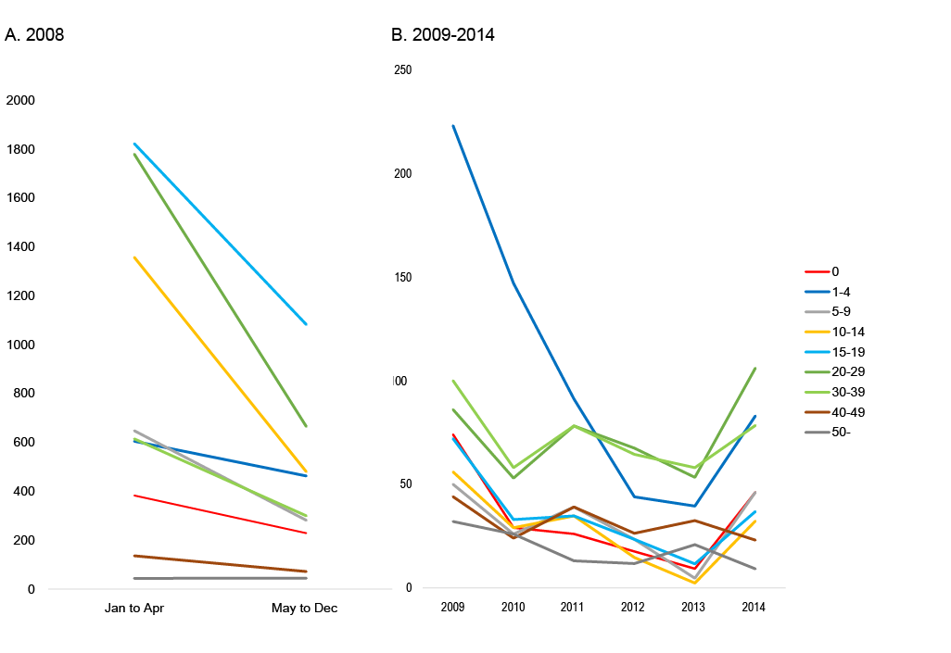
The number of case
- 2008 B. 2009–20014

0
1–4
5–9
10–14
15–19
20–29
30–39
40–49
50–

