The raw data we use to build Figure 1 (yearly mortality rates for the period 1784-1853, First and Second Divisions) are disclosed in Semmelweis’s book, Tabelle XVII, p 62 [note: there is another Tabelle XVII in Braun's book, which is also used, read below], Tabelle XXII, p 139, Tablelle I, p 3 and Tablelle XXIII, p 140. They are also disclosed, as supplementary materials, in Noakes et al. paper. We do not include the images of the pages where these yearly values can be found because we do not analyze the yearly data.

There are some inconsistencies in the data if we compare Semmelweis's yearly data and Braun's yearly data (yearly mortality rates for the period 1784-1853 are also disclosed on pages 441-444 of Braun’s book, pages 441-444.) For example, with respect to the year 1848, Braun discloses, on page 444, as the number of admissions in the First Division, 3780 and, in the Second, 2219, totaling 5999 admissions in both divisions if we add the values or, if we look at page 443, 6999; Semmelweis discloses the values 3556 for the number of admissions in 1848 in the First Division and 3219 in the Second Division- the data we use to build Figure 1.) There are no inconsistencies in the number of deaths: 45 in the First Division and 43 in the Second. In any case, the figures build with the different sources are almost undistinguishable.

______________________________________________________________________

Figure 2 and our calculations are based on the monthly data drawn from Braun’s and Semmelweis’s books. Semmelweis cited and copied Braun’s monthly data (page 445, see below, which is cited by Semmelweis as ‘Tabelle XVII’) and thus assumed that Braun’s figures were correct. The original pages are shown below and available in: (note: Noakes et al. do not provide monthly values in the supplementary materials and we have some concerns with the data we think they used, read note 2 in main text.)

- Monthly mortality rates for the period January, 1846- December, 1848, in the First and the Second Divisions are found in Semmelweis’s book, Tabelle VI, p.15 (Feb, 1847), Tabelle XXXVII, pp 215-216, Tabelle XXXIX; pp 217-219, Tabelle XL, p. 219 (Oct and Nov, 1848) and Tabelle XLIV, pp 229-232
- Monthly mortality rates for the period January, 1849- December, 1852, , in the First and the Second Divisions are found in Tabelle XVII in Braun’s book, p. 445

There are no inconsistencies between Semmelweis values and Braun's values; in fact, Semmleiweis cited and used 'Tabelle XVII' of Braun's book on page 445 and thus assumed that Braun’s figures were correct.

Sum of Semmelweis's disclosed monthly data for the number of admissions in 1846 and 1848 in the First Division are different to the yearly values provided by himself. For example, the sum of the monthly numbers of admissions, in 1848, is 3456, while Semmelweis discloses the value 3556 for the yearly number of admissions in 1848. In the main text we use monthly data; if we use yearly data, the results are quite similar (for example, CMR-Ref is 2.19 instead of 2.15, the number of preventable deaths under Braun's leadership is 73 instead of 66 and this value is 25 times smaller, instead of 33 times smaller, than the number of preventable deaths that one would expect had Braun allowed puerperal mortality to have returned to the high levels of 1846, with a yearly mortality ratio of 11.45% instead of 13.69%) and do not modify our statements in the discussion section.

References

- Chiari JB, Braun C, Spaeth J. Klinik der Geburtshilfe und Gynaekologie [Internet]. Ferdinand Enke; 1855 [cited 2016 Aug 23]. 738 p. Available from: https://books.google.com/books?id=F8REAAAAcAAJ&pgis=1
- Semmelweis IF. Die Aetiologie, der Begriff und die Prophylaxis des Kindbettfiebers [Internet]. 1861 [cited 2016 Aug 23]. Available from: https://books.google.com/books?id=O2haAAAAcAAJ&pgis=1
- Noakes TD, Borresen J, Hew-Butler T, Lambert MI, Jordaan E. Semmelweis and the aetiology of puerperal sepsis 160 years on: an historical review. Epidemiol Infect [Internet]. 2008 Jan [cited 2016 Aug 23];136(1):1–9. Available from: https://www.ncbi.nlm.nih.gov/pmc/articles/PMC2870773/pdf/S0950268807008746a.pdf

Monthly mortality rates January, 1846- December, 1848, Both divisions- Semmelweis’s book, Tabelle VI, p.15 (Feb, 1847), Tabelle XXXVII, pp215-216, Tabelle XXXIX; p. 217-219, Tabelle XL, p. 219 (oct and Nov, 1848) and Tabelle XLIV, pp. 229-232

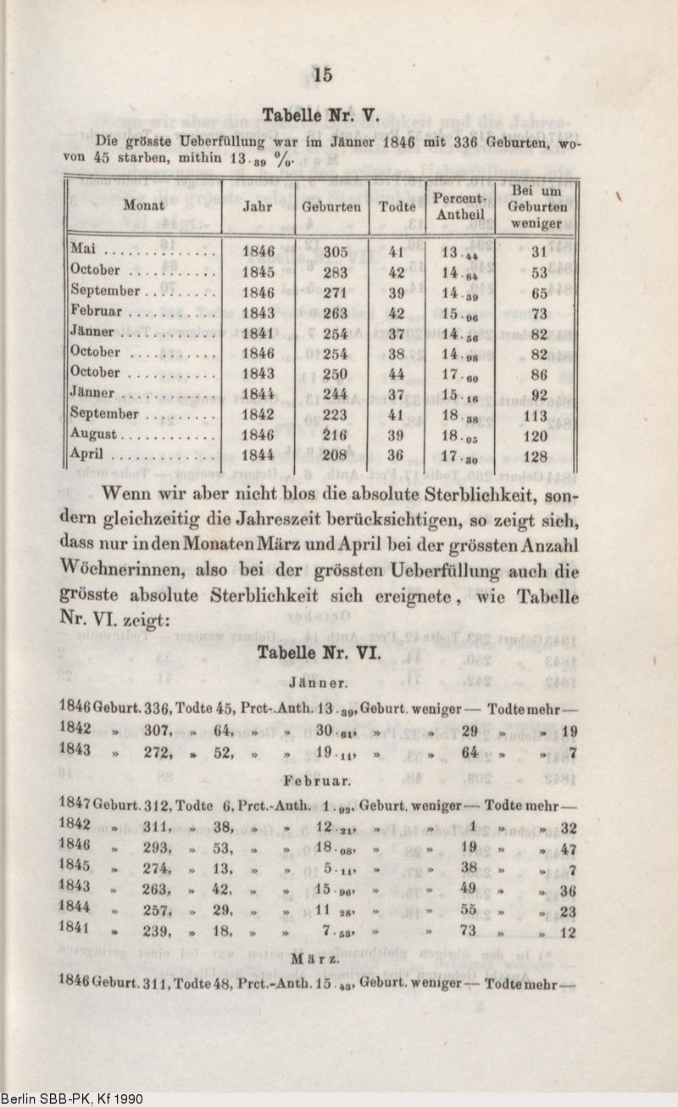

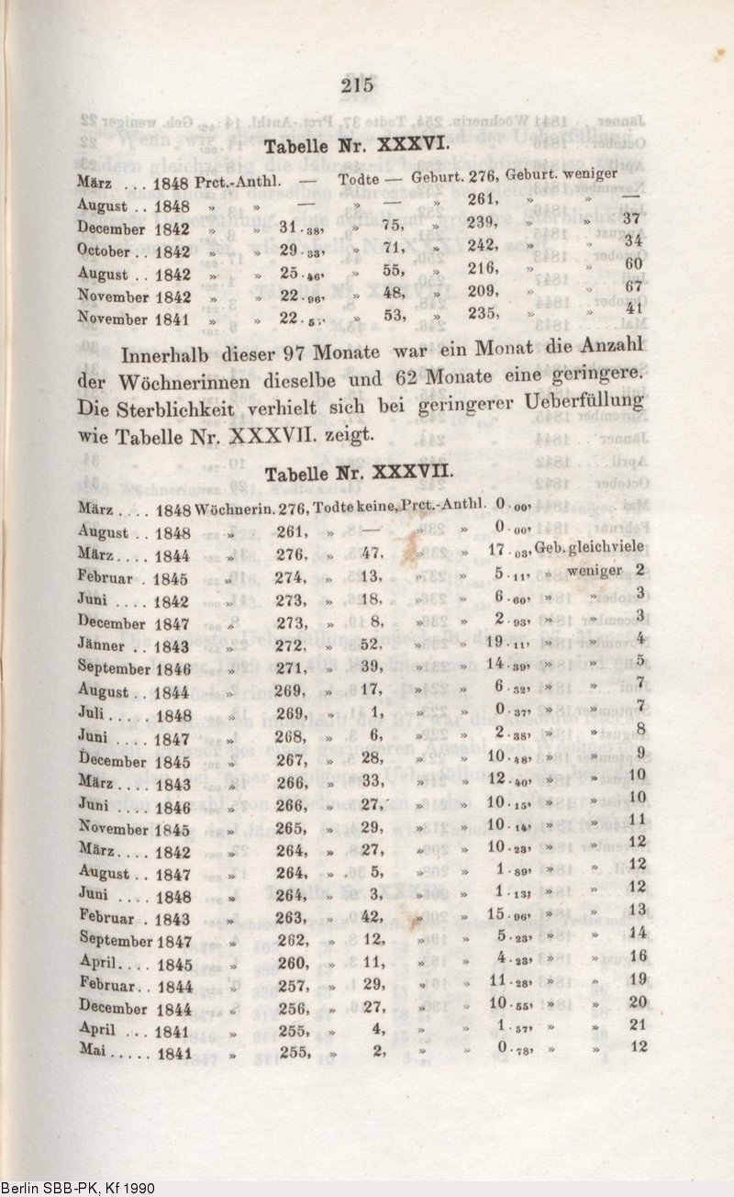

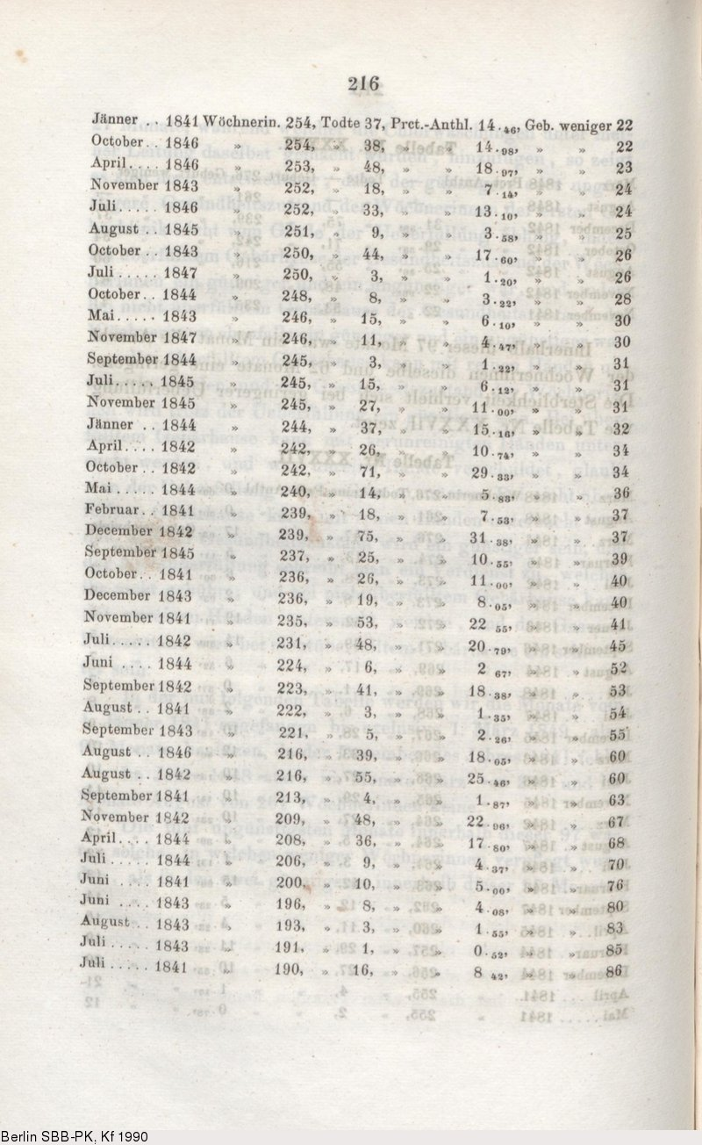

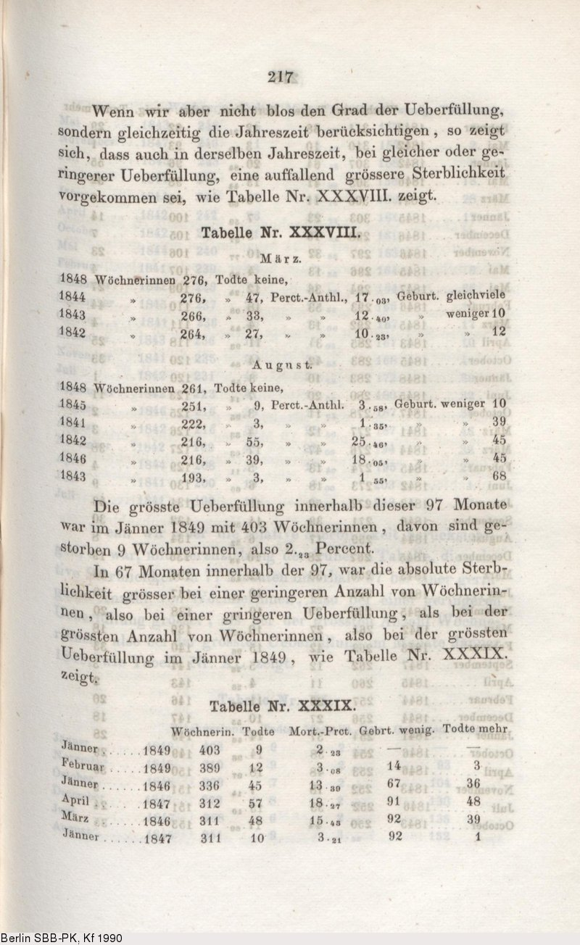
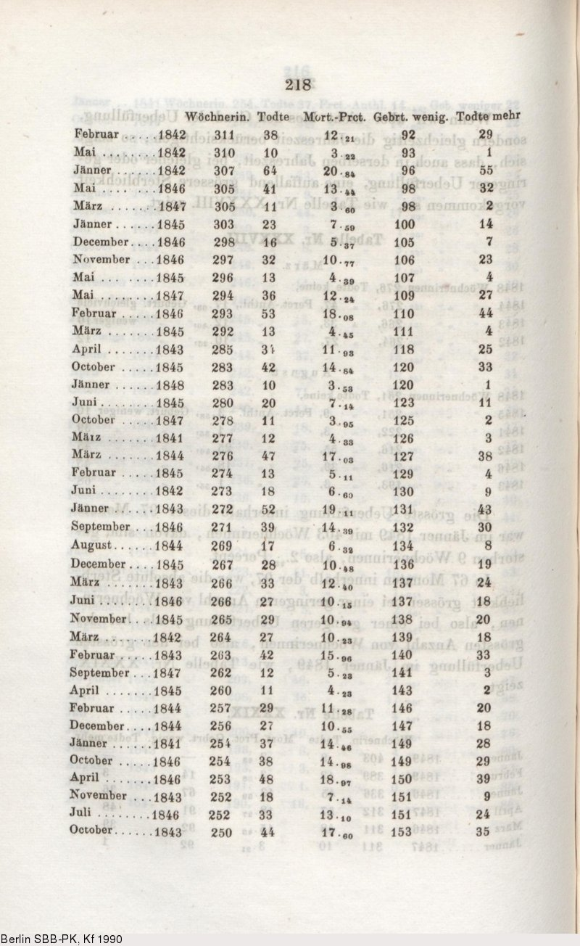
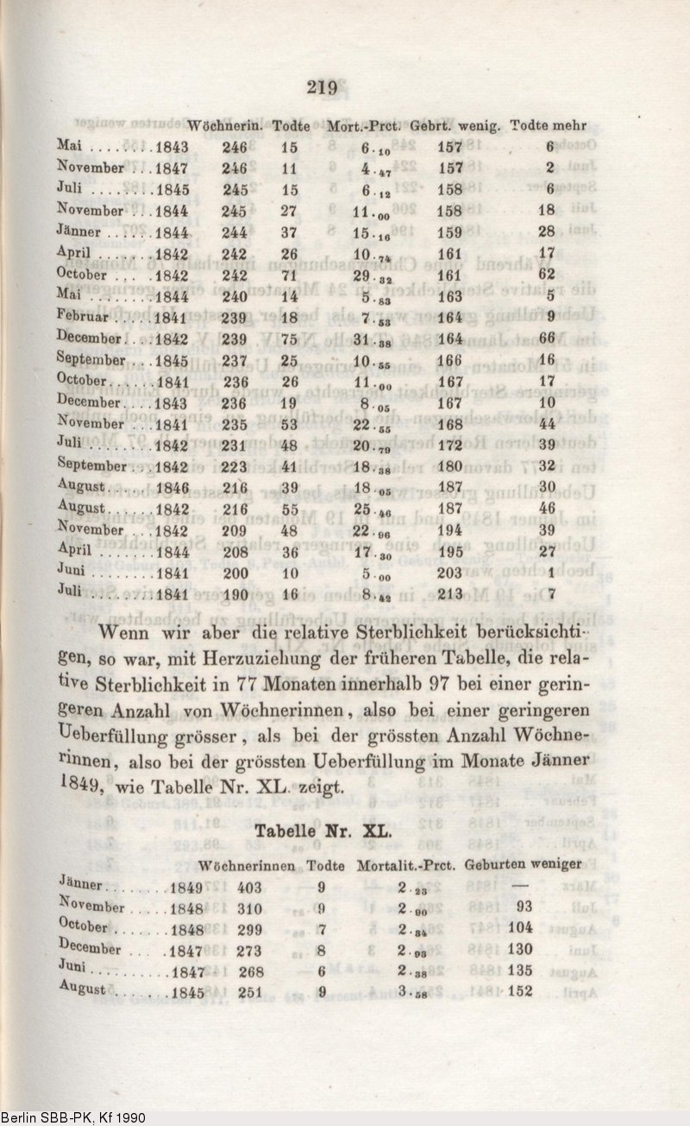

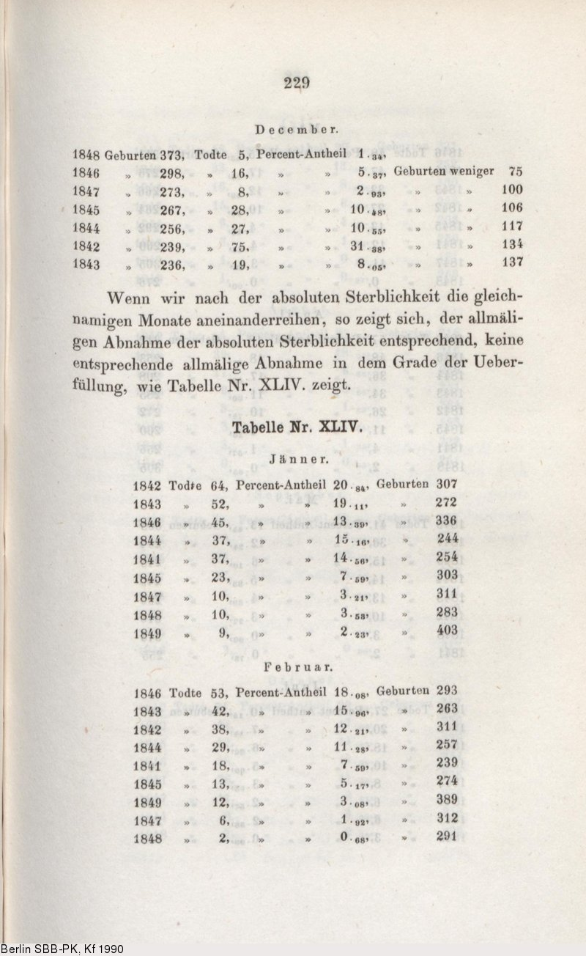
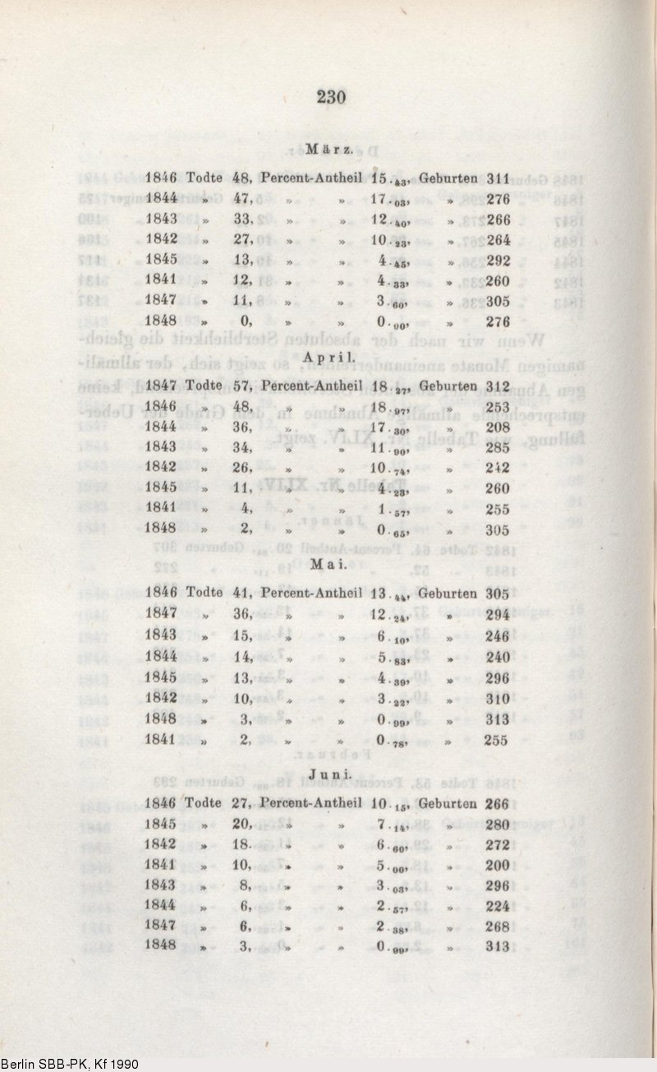
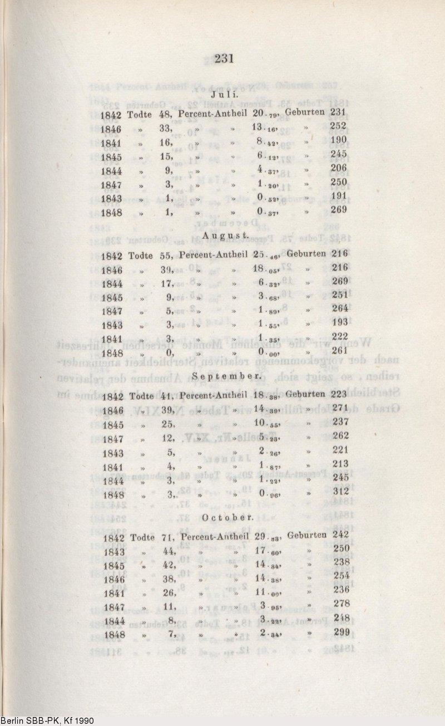
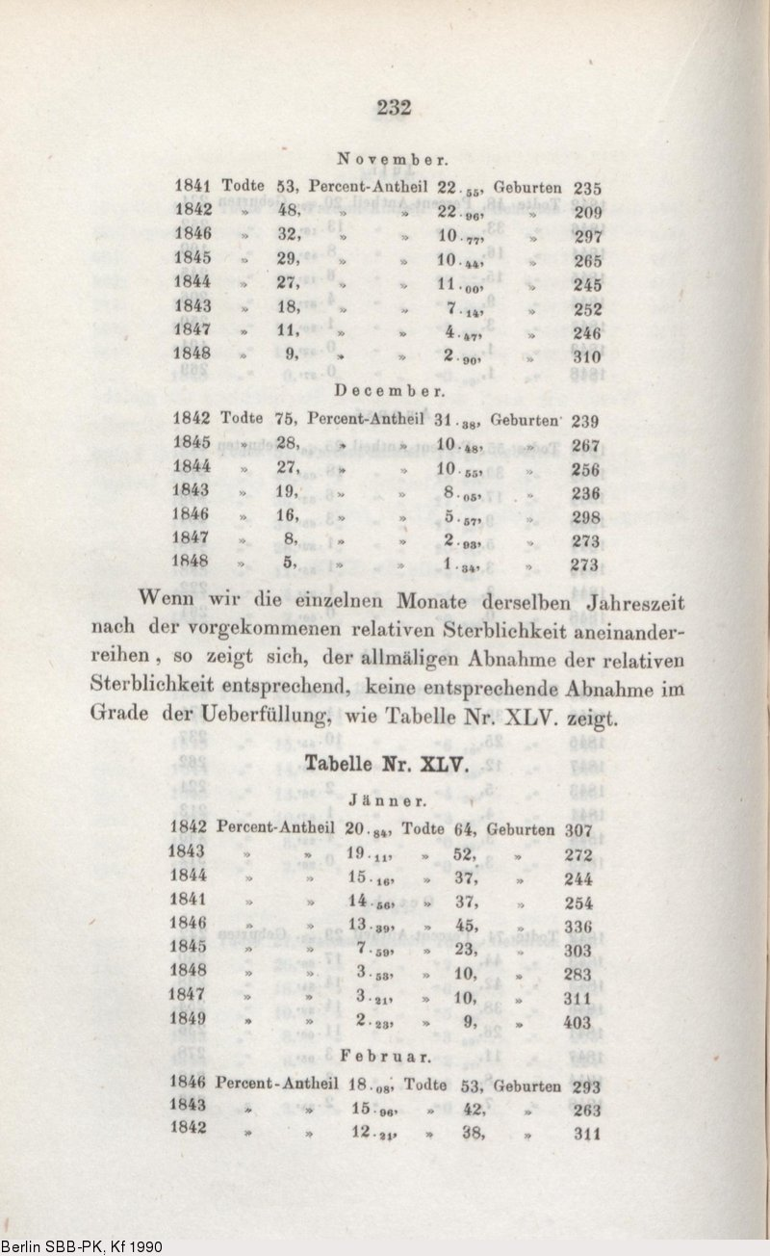
Monthly mortality rates January, 1849- December, 1852, Both divisions- Braun’s book, p.445
