Supplementary information
Figure S1. The frequency distribution and map of the proportion of MMR1 vaccinated population across 2020 area unit levels in New Zealand (top inset and map), with a close up of the Auckland region also shown (bottom), for the year 2006.
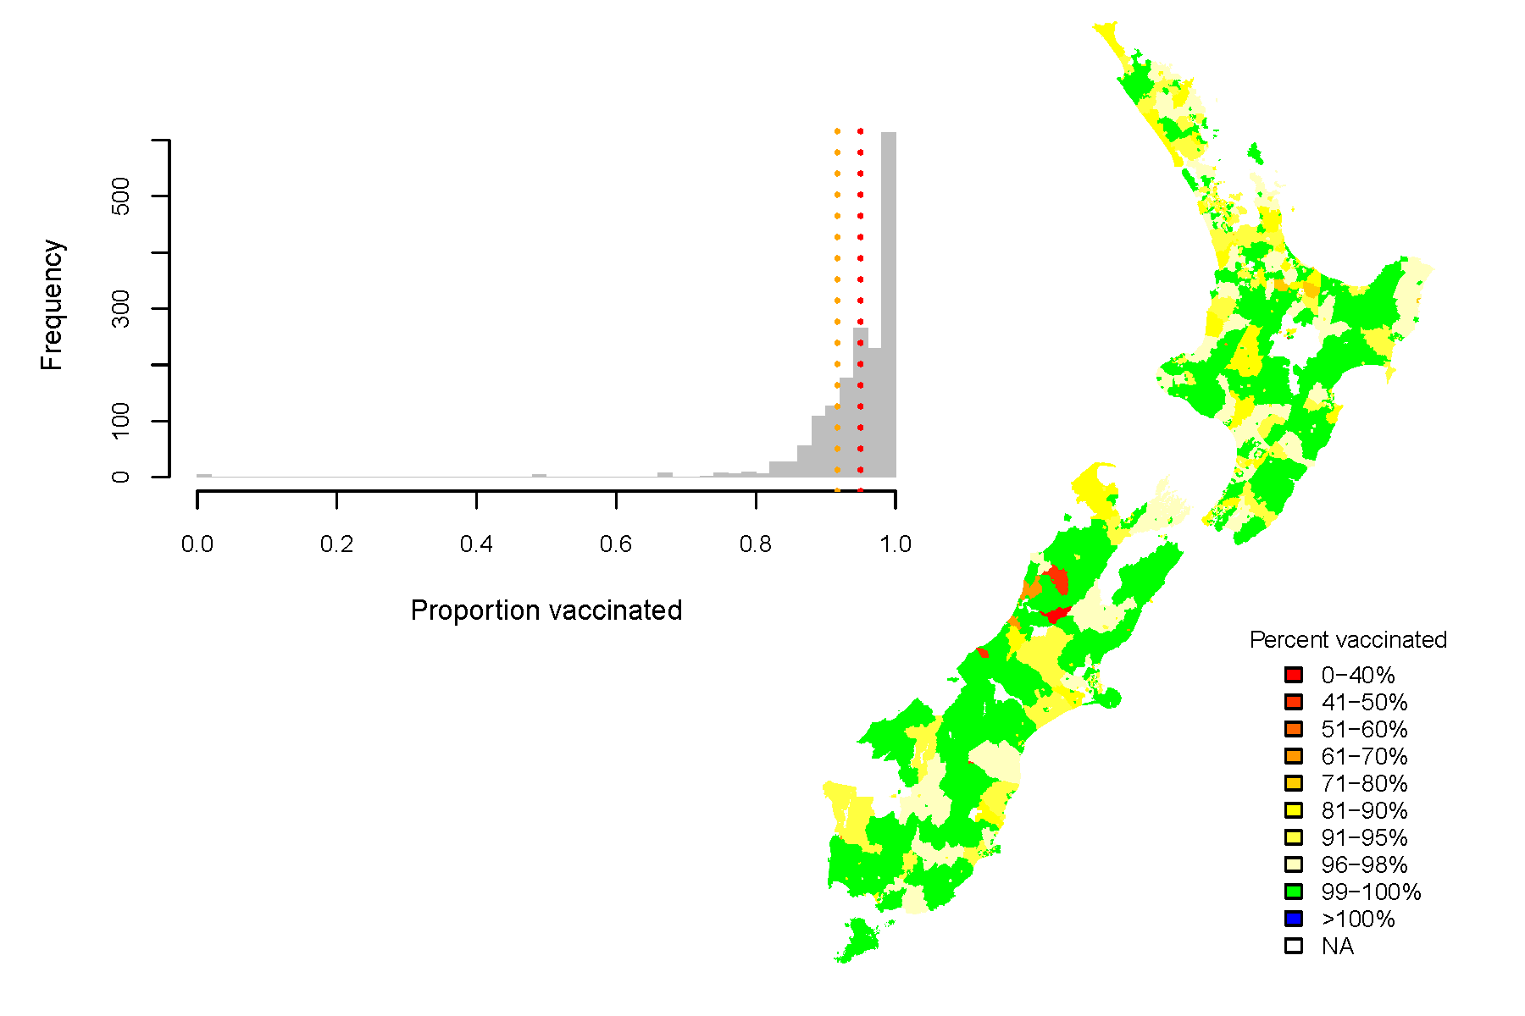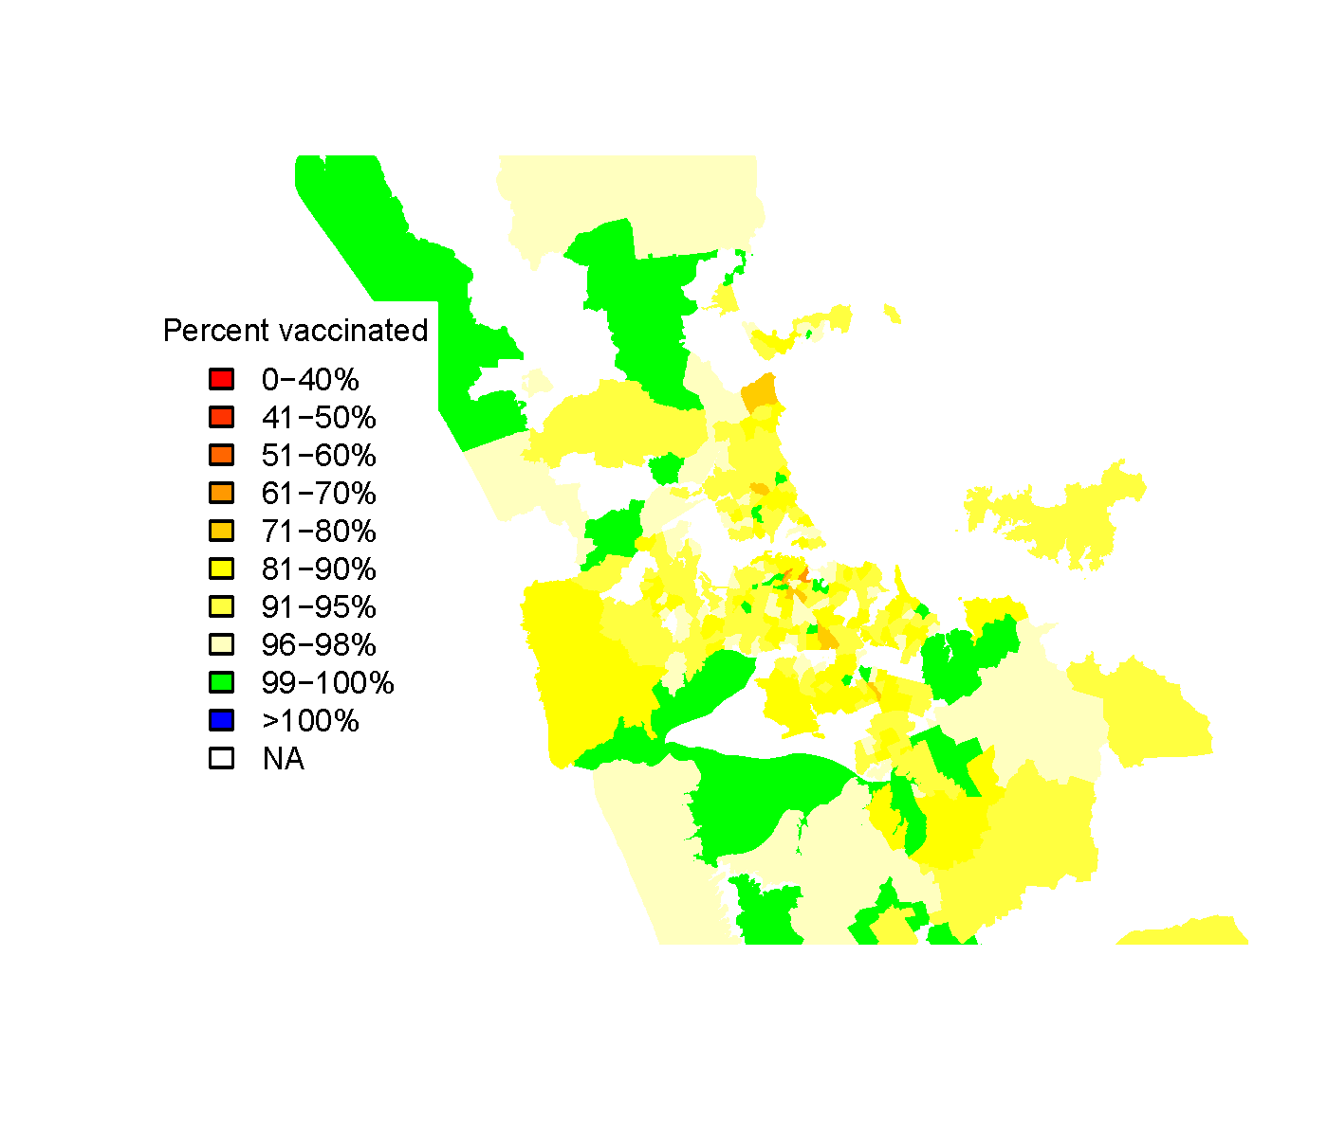
Figure S2 Global trend in measles incidence. The main figure shows the recent trends and the incidence the global trend since 1990.

Figure S3 Trends in international travel, determined by immigration and non-New Zealander arrival data and New Zealander travel departure destinations. Note this is for all age categories.

Table S1 Measles cases (Cases), population sizes (Population) and per 10,000 of measles in specific age (Age), ethnicity (Ethnicity) and socio-economic deprivation (NZDep) categories from 2007-2014. MELAA is Middle Eastern/Latin American/African.
NZDep | Age | Ethnicity | Population | Cases | Per 10,000
1-3 | 0-1 | Asian | 2269 | 6 | 26.44
4-7 | 0-1 | Asian | 3748 | 10 | 26.68
8-10 | 0-1 | Asian | 2583 | 3 | 11.61
1-3 | 2-4 | Asian | 3403 | 1 | 2.94
4-7 | 2-4 | Asian | 5623 | 0 | 0.00
8-10 | 2-4 | Asian | 3874 | 0 | 0.00
1-3 | 5-17 | Asian | 20625 | 6 | 2.91
4-7 | 5-17 | Asian | 29721 | 8 | 2.69
8-10 | 5-17 | Asian | 16777 | 2 | 1.19
1-3 | 18-24 | Asian | 12057 | 2 | 1.66
4-7 | 18-24 | Asian | 23904 | 3 | 1.25
8-10 | 18-24 | Asian | 21063 | 3 | 1.42
1-3 | 25+ | Asian | 54258 | 4 | 0.74
4-7 | 25+ | Asian | 86055 | 11 | 1.28
8-10 | 25+ | Asian | 54759 | 8 | 1.46
1-3 | 0-1 | European | 23961 | 40 | 16.69
4-7 | 0-1 | European | 28051 | 58 | 20.68
8-10 | 0-1 | European | 16866 | 24 | 14.23
1-3 | 2-4 | European | 35942 | 37 | 10.29
4-7 | 2-4 | European | 42076 | 22 | 5.23
8-10 | 2-4 | European | 25299 | 6 | 2.37
1-3 | 5-17 | European | 180875 | 160 | 8.85
4-7 | 5-17 | European | 194100 | 118 | 6.08
8-10 | 5-17 | European | 106731 | 40 | 3.75
1-3 | 18-24 | European | 63051 | 24 | 3.81
4-7 | 18-24 | European | 94422 | 26 | 2.75
8-10 | 18-24 | European | 68016 | 20 | 2.94
1-3 | 25+ | European | 619698 | 54 | 0.87
4-7 | 25+ | European | 734550 | 46 | 0.63
8-10 | 25+ | European | 371985 | 29 | 0.78
1-3 | 0-1 | Māori | 3265 | 9 | 27.57
4-7 | 0-1 | Māori | 8378 | 13 | 15.52
8-10 | 0-1 | Māori | 15094 | 32 | 21.20
1-3 | 2-4 | Māori | 4897 | 4 | 8.17
4-7 | 2-4 | Māori | 12568 | 12 | 9.55
8-10 | 2-4 | Māori | 22642 | 10 | 4.42
1-3 | 5-17 | Māori | 21750 | 8 | 3.68
4-7 | 5-17 | Māori | 53963 | 33 | 6.12
8-10 | 5-17 | Māori | 94758 | 74 | 7.81
1-3 | 18-24 | Māori | 7329 | 3 | 4.09
4-7 | 18-24 | Māori | 20862 | 2 | 0.96
8-10 | 18-24 | Māori | 35664 | 8 | 2.24
1-3 | 25+ | Māori | 35934 | 1 | 0.28
4-7 | 25+ | Māori | 87192 | 3 | 0.34
8-10 | 25+ | Māori | 140820 | 4 | 0.28
1-3 | 0-1 | MELAA | 273 | 0 | 0.00
4-7 | 0-1 | MELAA | 519 | 2 | 38.54
8-10 | 0-1 | MELAA | 553 | 1 | 18.08
1-3 | 2-4 | MELAA | 410 | 0 | 0.00
4-7 | 2-4 | MELAA | 778 | 0 | 0.00
8-10 | 2-4 | MELAA | 830 | 1 | 12.05
1-3 | 5-17 | MELAA | 1832 | 0 | 0.00
4-7 | 5-17 | MELAA | 3121 | 0 | 0.00
8-10 | 5-17 | MELAA | 3250 | 1 | 3.08
1-3 | 18-24 | MELAA | 906 | 0 | 0.00
4-7 | 18-24 | MELAA | 1806 | 0 | 0.00
8-10 | 18-24 | MELAA | 2076 | 2 | 9.63
1-3 | 25+ | MELAA | 4569 | 0 | 0.00
4-7 | 25+ | MELAA | 7452 | 5 | 6.71
8-10 | 25+ | MELAA | 6342 | 1 | 1.58
1-3 | 0-1 | Pacific | 643 | 1 | 15.55
4-7 | 0-1 | Pacific | 2113 | 6 | 28.40
8-10 | 0-1 | Pacific | 7389 | 48 | 64.96
1-3 | 2-4 | Pacific | 964 | 0 | 0.00
4-7 | 2-4 | Pacific | 3169 | 1 | 3.16
8-10 | 2-4 | Pacific | 11084 | 10 | 9.02
1-3 | 5-17 | Pacific | 4212 | 2 | 4.75
4-7 | 5-17 | Pacific | 13419 | 4 | 2.98
8-10 | 5-17 | Pacific | 47165 | 21 | 4.45
1-3 | 18-24 | Pacific | 1707 | 0 | 0.00
4-7 | 18-24 | Pacific | 6174 | 4 | 6.48
8-10 | 18-24 | Pacific | 18189 | 5 | 2.75
1-3 | 25+ | Pacific | 8580 | 1 | 1.17
4-7 | 25+ | Pacific | 26688 | 3 | 1.12
8-10 | 25+ | Pacific | 74757 | 9 | 1.20

Table S2 Summary of the proportion of 2006-2014 birth cohorts vaccinated against measles-mumps-rubella (MMR) dose 1 and MMR2 across 2020 area units in New Zealand, as on 10 July 2014.
Year | Vaccine | 1st Q | Mean | 3rd Q
2006 | MMR1 | 92.31 | 94.57 | 100.00
 | MMR2 | 86.11 | 90.29 | 97.14
2007 | MMR1 | 92.86 | 94.99 | 100.00
 | MMR2 | 85.92 | 89.90 | 96.43
2008 | MMR1 | 93.65 | 95.69 | 100.00
 | MMR2 | 84.51 | 89.08 | 95.83
2009 | MMR1 | 93.90 | 95.75 | 100.00
 | MMR2 | 83.02 | 87.73 | 94.44
2010 | MMR1 | 93.26 | 95.57 | 100.00
 | MMR2 | 62.50 | 69.74 | 77.91
2011 | MMR1 | 92.86 | 94.92 | 100.00
 | MMR2 | 0.00 | 6.06 | 8.93
2012 | MMR1 | 93.33 | 95.27 | 100.00
 | MMR2 | 0.00 | 4.03 | 4.76
2013 | MMR1 | 55.56 | 62.76 | 70.00
 | MMR2 | 0.00 | 2.17 | 2.63
2014 | MMR1 | 0.00 | 0.88 | 0.00
 | MMR2 | 0.00 | 0.67 | 0.00

Table S3 Highest measles incidence per million in 2013 according to WHO published data (12).
Country | Incidence
Georgia | 1806
Namibia | 455
Equatorial Guinea | 436
Angola | 409
Lebanon | 379
Nigeria | 313
Somalia | 311
Sudan | 260
Lesotho | 251
Uganda | 217
Netherlands | 159
Central African Republic | 132
Turkey | 100
Sri Lanka | 100
Togo | 85
Sudan | 76
Gabon | 75
Niger | 71
Nepal | 68
Benin | 63
Ethiopia | 57
Romania | 51
Pakistan | 49
Thailand | 40
Indonesia | 39
Qatar | 36
Cameroon | 35
Syrian Arab Republic | 34
Djibouti | 33
United Kingdom | 31

Table S4 Foreign national arrival numbers by nationality for 0-19-year-olds (Foreign nationals), New Zealander departure numbers by country of destination (New Zealanders), and the sum of traveler numbers by country (Total), in 2013.
Country | Foreign nationals | New Zealanders | Total
Australia | 130703 | 1017540 | 1148243
United States | 20247 | 142200 | 162447
United Kingdom | 25155 | 96680 | 121835
Fiji | 6040 | 112260 | 118300
China | 26380 | 73340 | 99720
Samoa | 4047 | 44060 | 48107
India | 7013 | 40760 | 47773
Thailand | 5233 | 42060 | 47293
Japan | 20534 | 21840 | 42374
France | 12173 | 15980 | 28153
Indonesia | 2580 | 25100 | 27680
Germany | 14793 | 12800 | 27593
Canada | 5013 | 21720 | 26733
Korea, Republic of | 10398 | 13980 | 24378
Tonga | 3477 | 20120 | 23597
Malaysia | 5981 | 17480 | 23461
Singapore | 4887 | 18300 | 23187
Hong Kong | 3281 | 18000 | 21281
Philippines | 3147 | 17260 | 20407
South Africa | 3763 | 14000 | 17763
Vanuatu | 168 | 15580 | 15748
Italy | 997 | 13620 | 14617
Viet Nam | 1040 | 12640 | 13680

