Epidemiology and Infection, Epidemics and aetiology of hand, foot, and mouth disease in Xiamen, China from 2008–2015, S. Z. HE, M. Y. CHEN, X. R. XU, Q. YAN, J. J. NIU, W. H. WU, X. S. SU, S. X. GE, S. Y. ZHANG, N. S. XIA
Supplementary Material
Supplementary Table S1: Primers used for amplifying partial 5′ UTR sequences of all HEVs and partial VP1 sequences of EV71 and CA16
Primer |  |  | Region | Sequence (5’→3’) | Location | Length (bp)
EV | Outer-primer
 | Sense | 59F | 5’UTR | CYTTGTGCGCCTGTTTT | 59-75 | 530
 | Antisense | 588R | 5’UTR | ATTGTCACCATAAGCAGCC | 588-570
 | Inner-primer
 | Sense | 153Fa  153Fb | 5’UTR  5’UTR | CAAGCACTTCTGTTTCCC  CAAGYACTTCTGTMWCCCC | 153-170  153-172 | 389
 | Anti-sense | 588R | 5’UTR | CCCAAAGTAGTCGGTTCC | 541-524
EV71 | Outer-primer
 | Sense | C45F2a | VP1 | CRGGATTAGTTGGAGAGATAG | 2686-2706 | 398
 |  | C45F2b | VP1 | CRGGGTTAGTTGGAGAGATAG | 2686-2706
 | Antisense | C45R1a | VP1 | ATCTTTCTCCTGTTTGTGTTC | 3083-3063
 |  | C45R1b | VP1 | GTCTTTCTCTTGCTTGTGTTC | 3083-3063
 | Inner-primer
 | Sense | C45F3 | VP1 | ACRGGTTACGCGCAAATG | 2766-2783 | 255
 | Anti-sense | C45R2 | VP1 | CGCAGGTGACATGAATGG | 3020-3003
CA16 | Outer-primer
 | Sense | CAF2 | VP1 | TGCAGACATGATTGACCAG | 2457-2475 | 507
 | Antisense | CAR2a | VP1 | TGCCTACAGTTCTGATGCTA | 3163-3144
 |  | CAR2b | VP1 | TCCCTACTGTCCTAATGCTA | 3163-3144
 | Inner-primer
 | Sense | CAF3 | VP1 | TGTGTTGAACCAYCACTCC | 2649-2667 | 176
 | Anti-sense | CAR3a | VP1 | TGAATAGCTCACACTTACGC | 2824-2805
 |  | CAR3b | VP1 | TAGGTAAACAACTCGCATTT | 2824-2805

Supplementary Table S2: Primers used for amplifying VP1 sequences of non-EV71 and non-CA16 HEVs
Primer |  |  | Region | Sequence (5’→3’) | Location | Length (bp)
CA6 | Outer-primer
 | Sense | CV-A6-VP1-F1 | VP3 | GARGCTAACATYATAGCTCTTGGAGC | 2343-2371 | 984
 | Antisense | CV-A6-VP1-R1 | VP3 | CCYTCATARTCHGTGGTGG TTATGCT | 3301-3326
 | Inner-primer
 | Sense | CV-A6-VP1-F2 | VP1 | GACACYGAYGARATY CAACAAACAGC | 2406-2431 | 890
 | Anti-sense | CV-A6-VP1-R2 | VP1 | CGRTCRGTTGCAGTGTTWGTTATTGT | 3271-3296
CA5 | Sense | CA5-VP1F | VP1 | CAGAGCACTAAGTGGACCAAT | 2484-2504 | 833
 | Antisense | CA5-VP1R | VP1 | TGGTTATATTGGTCCTGTTCG | 3296-3316
CA10 | Sense | CA10-VP1F | VP1 | TGACCCTGTGGAGGATAT | 2438-2457 | 894
 | Anti-sense | CA10-VP1R | VP1 | CATATTAGCTTGCTTGATGC | 3309-3328
CB3 | Sense | CB3-VP1F | VP1 | AGCGTGCAATGATTTCTC | 2379-2396 | 927
 | Anti-sense | CB3-VP1R | VP1 | CACTGCTCCAGATTGTTG | 3288-3305

Supplementary Table S3: Overview of HFMD cases detected in the State Key Laboratory of Molecular Vaccinology and Molecular Diagnostics from January 2009 to September 2015
Year | No. Case | Age | Male | Female | M:F
2009 | 2307 | 2.65±2.33 | 1466 | 841 | 1.74
2010 | 1318 | 2.99±1.7 | 784 | 534 | 1.47
2011 | 425 | 2.50±1.43 | 280 | 145 | 1.93
2012 | 358 | 2.57±1.61 | 239 | 119 | 2.01
2013 | 499 | 2.23±2.30 | 302 | 197 | 1.53
2014 | 605 | 2.62±2.94 | 373 | 232 | 1.60
2015(1-9) | 354 | 2.47±2.67 | 225 | 129 | 1.74
Total | 5866 | 2.67±2.25 | 3669 | 2197 | 1.67

Supplementary Table S4: HFMD cases caused by minor HEV genotypes
Year  Genotype |  | 2009 | 2010 | 2011 | 2012 | 2013 | 2014 | 2015 | Total
Species A | CA2 | 4 | 2 | 0 | 1 | 0 | 0 | 8 | 15
 | CA4 | 0 | 0 | 0 | 13 | 1 | 54 | 0 | 68
 | CA5 | 11 | 1 | 1 | 0 | 1 | 2 | 1 | 17
 | CA12 | 4 | 1 | 5 | 0 | 0 | 0 | 0 | 10
Species B | CA9 | 3 | 1 | 1 | 1 | 0 | 0 | 0 | 6
 | CB2 | 1 | 0 | 0 | 0 | 0 | 0 | 0 | 1
 | CB3 | 8 | 1 | 1 | 0 | 0 | 0 | 0 | 10
 | CB5 | 1 | 0 | 0 | 0 | 0 | 0 | 0 | 1
 | E3 | 0 | 0 | 0 | 1 | 0 | 0 | 0 | 1
 | E9 | 0 | 0 | 0 | 0 | 0 | 0 | 1 | 1
 | E19 | 0 | 0 | 0 | 0 | 1 | 0 | 0 | 1
 | E24 | 0 | 0 | 1 | 0 | 0 | 0 | 0 | 1
 | E26 | 0 | 0 | 0 | 0 | 0 | 1 | 0 | 1
 | E27 | 0 | 0 | 0 | 0 | 0 | 1 | 2 | 3
 | EV68 | 0 | 0 | 0 | 0 | 0 | 0 | 1 | 1
 | EV74 | 1 | 0 | 0 | 0 | 1 | 1 | 0 | 3
 | EV75 | 0 | 0 | 0 | 0 | 0 | 1 | 0 | 1
 | EV77 | 0 | 0 | 0 | 0 | 1 | 0 | 0 | 1
Species C |  | 0 | 0 | 0 | 0 | 0 | 0 | 0 | 0
Species D |  | 0 | 0 | 0 | 0 | 0 | 0 | 0 | 0
Not determined |  | 33 | 57 | 28 | 13 | 22 | 11 | 12 | 176
Total |  | 66 | 63 | 37 | 29 | 28 | 70 | 25 | 318

Supplementary Figure S1: Age distribution of overall cases, male cases and female cases from 2009–2015

Supplementary Figure S2: Age distribution of the genotype-specific cases from 2009–2015
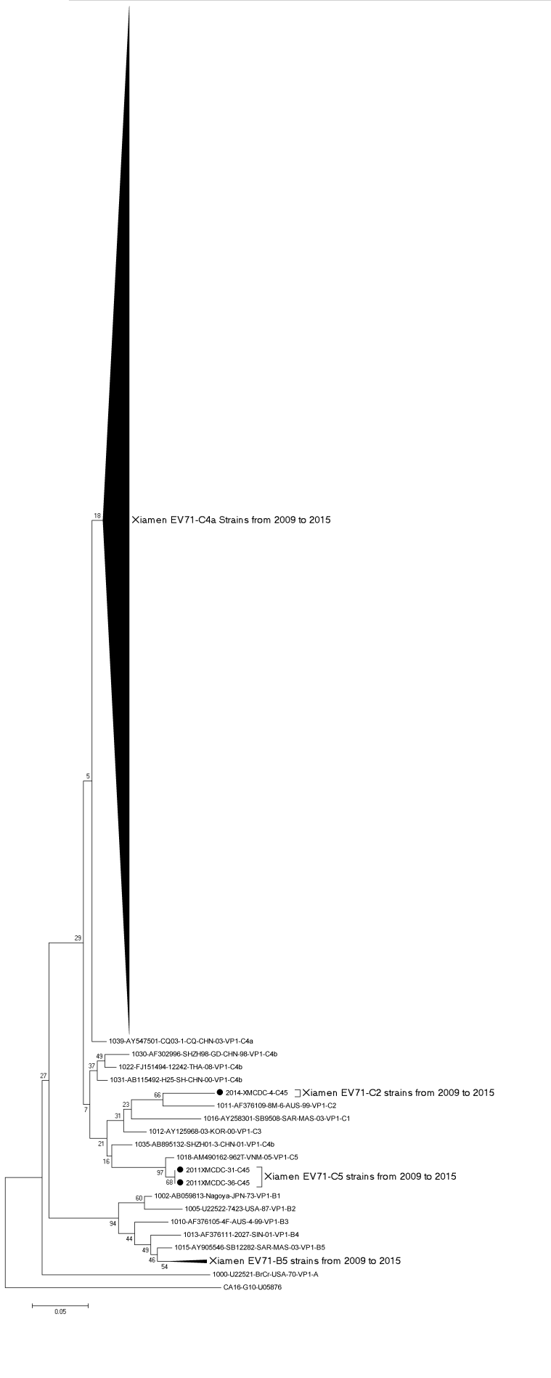
Supplementary Figure S3: Phylogenetic tree based on partial EV71 VP1 sequences (255-bp) (constructed using a neighbour-joining method with a Kimura two-parameter model of nucleotide substitution in MEGA version 5.0, with a bootstrap value of 1000).

Supplementary Figure S4: Temporal distribution of CA16 subgenotype branches in Xiamen from 2009-2012
Supplementary Figure S5: Phylogenetic tree based on partial CA16 VP1 sequences (176-bp) (constructed using a neighbour-joining method with a Kimura two-parameter model of nucleotide substitution in MEGA version 5.0, with a bootstrap value of 1000).
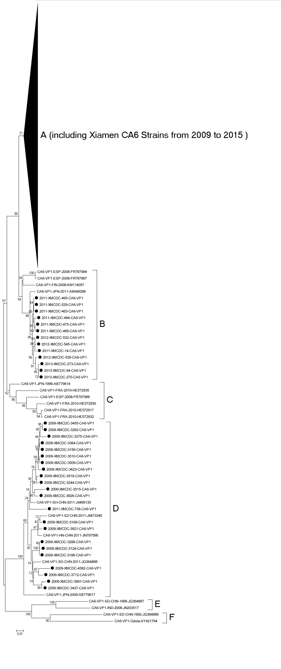
Supplementary Figure S6: Phylogenetic tree based on complete CA6 VP1 sequences (constructed using a neighbour-joining method with Kimura two-parameter model of nucleotide substitution in MEGA version 5.0, with a bootstrap value of 1000).
Supplementary Figure S7: Phylogenetic tree based on complete CA10 VP1 sequences (constructed using a neighbour-joining method with Kimura two-parameter model of nucleotide substitution in MEGA version 5.0, with a bootstrap value of 1000).

