**Appendix 1: Time series of Malaria across the 20 provinces**

**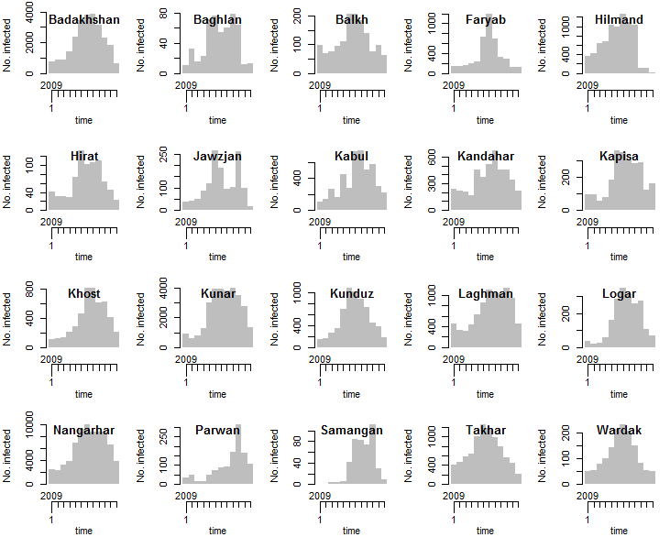**

**Appendix 2: Time series of leishmaniasis across the 20 provinces**

**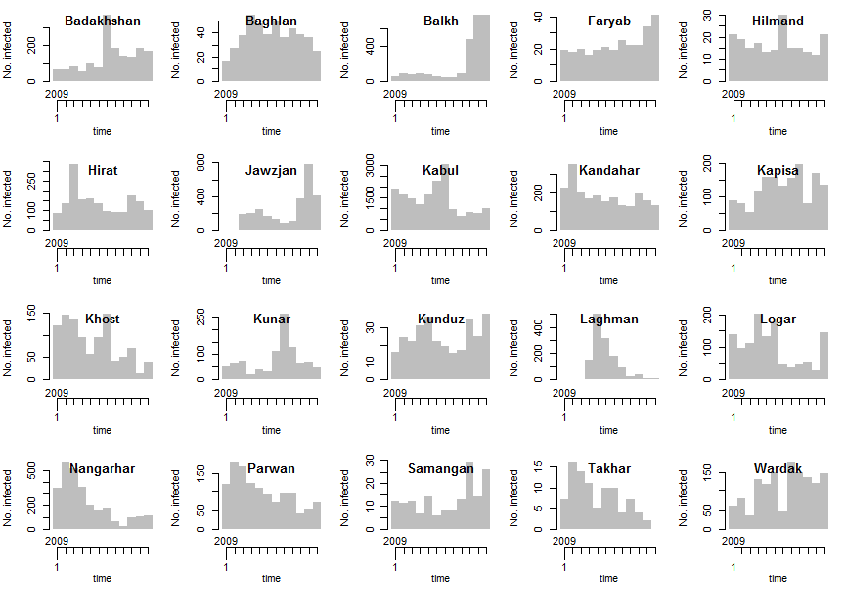**

**Appendix 3: Maps of Malaria cases in the 20 provinces from January 2009 to December 2009**

|  |  |
| --- | --- |
| **D:\Users\oa14418\Documents\research\mal-leish\report\map_jan.pngJanuary 2009** | **D:\Users\oa14418\Documents\research\mal-leish\report\map_feb.pngFebruary 2009** |
| **D:\Users\oa14418\Documents\research\mal-leish\report\map_mar.pngMarch 2009** | **D:\Users\oa14418\Documents\research\mal-leish\report\map_apr.pngApril 2009** |

|  |  |
| --- | --- |
| **D:\Users\oa14418\Documents\research\mal-leish\report\map_may.pngMay 2009** | **D:\Users\oa14418\Documents\research\mal-leish\report\map_jun.pngJune 2009** |
| **D:\Users\oa14418\Documents\research\mal-leish\report\map_jul.pngJuly 2009** | **D:\Users\oa14418\Documents\research\mal-leish\report\map_aug.pngAugust 2009** |

|  |  |
| --- | --- |
| **D:\Users\oa14418\Documents\research\mal-leish\report\map_sep.pngSeptember 2009** | **D:\Users\oa14418\Documents\research\mal-leish\report\map_oct.pngOctober 2009** |
| **D:\Users\oa14418\Documents\research\mal-leish\report\map_nov.pngNovember 2009** | **D:\Users\oa14418\Documents\research\mal-leish\report\map_dec.pngDecember 2009** |

**Appendix 4: Maps of leishmaniasis cases in the 20 provinces from January 2009 to December 2009**

|  |  |
| --- | --- |
| **D:\Users\oa14418\Documents\research\mal-leish\report\les-map-jan.png**  **January** | **D:\Users\oa14418\Documents\research\mal-leish\report\les-map-feb.png**  **February** |
| **D:\Users\oa14418\Documents\research\mal-leish\report\les-map-mar.png**  **March** | **D:\Users\oa14418\Documents\research\mal-leish\report\les-map-apr.png**  **March** |

|  |  |
| --- | --- |
| **D:\Users\oa14418\Documents\research\mal-leish\report\les-map-may.png**  **May** | **D:\Users\oa14418\Documents\research\mal-leish\report\les-map-jun.png**  **June** |
| **D:\Users\oa14418\Documents\research\mal-leish\report\les-map-jul.png**  **July** | **D:\Users\oa14418\Documents\research\mal-leish\report\les-map-aug.png**  **August** |

|  |  |
| --- | --- |
| **D:\Users\oa14418\Documents\research\mal-leish\report\les-map-sep.png**  **September** | **D:\Users\oa14418\Documents\research\mal-leish\report\les-map-oct.png**  **October** |
| **D:\Users\oa14418\Documents\research\mal-leish\report\les-map-nov.png**  **November** | **D:\Users\oa14418\Documents\research\mal-leish\report\les-map-dec.png**  **December** |

**Appendix 5: Time series plots of average monthly environmental data for the 20 provinces used in this study. (a)Temperature. (b) Precipitation.**

|  |  |
| --- | --- |
| **D:\Users\oa14418\Documents\research\mal-leish\report\profile_temp.png**  (a) | **D:\Users\oa14418\Documents\research\mal-leish\report\profile_precip.png** (b) |