SUPPLEMENTARY MATERIAL

The dataset used in the models has 462 influenza A cases (331 index cases and 131 secondary cases). The supplementary figure is reproduced below.
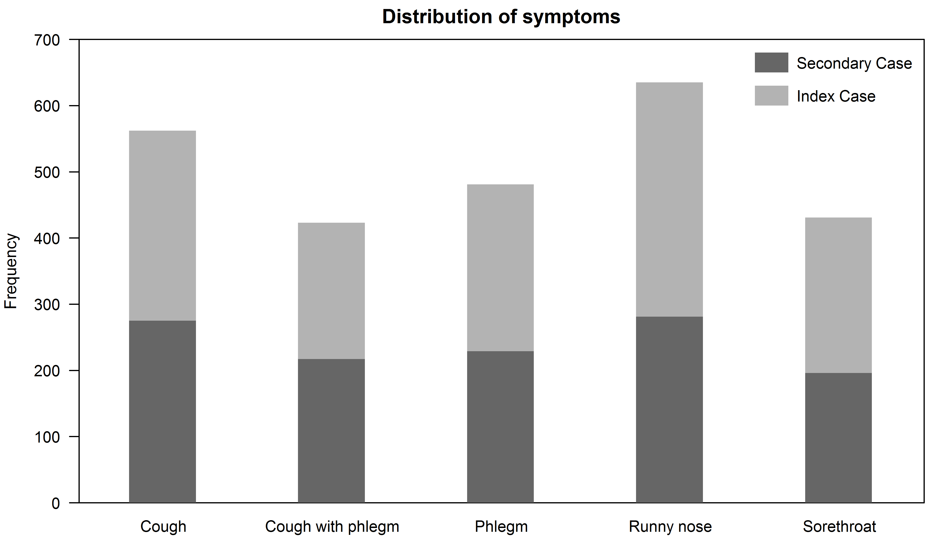

Discrete-generation transmission model

For simplicity in this explanation we will ignore symptoms and assume the household is of size 4. The black and grey arrows represent successful and unsuccessful infections, respectively.

Individual A is the index case in the household (HH). With transmission probabilities according to the age structured chain binomial model A is then able to infect other members. This represents transmission as occurring in discrete infection generations, with those infected on generation $g$ able to infect those as yet uninfected on generation $g+1$ but not on subsequent generations. For example, A, who is infected in G1, can infect one member (individual B), two members (individual B and C) or three members (individual B, C and D) in G2. In the scenario when one individual in the household is infected, only A is infected in the household.

The table below shows all the possible combinations. Because the number of combinations is large for larger households, for computational efficiency, rather than summing the probability of all combinations, we use data augmentation to treat the unknown infection tree for each household as an additional parameter to estimate. The MCMC routine is used to explore the combined space of parameters and infection trees to integrate out the nuisance infection trees.

Furthermore, depending on the type of model fitted (no symptoms, half infectious, free parameter or multiple symptoms), it considers the presence of symptoms, age-structure (adult or child) and other household sizes (one–seven) which is not represented in the table below.

No. of infected individuals | Possible generation tree
1 HH member infected  A is infected. | 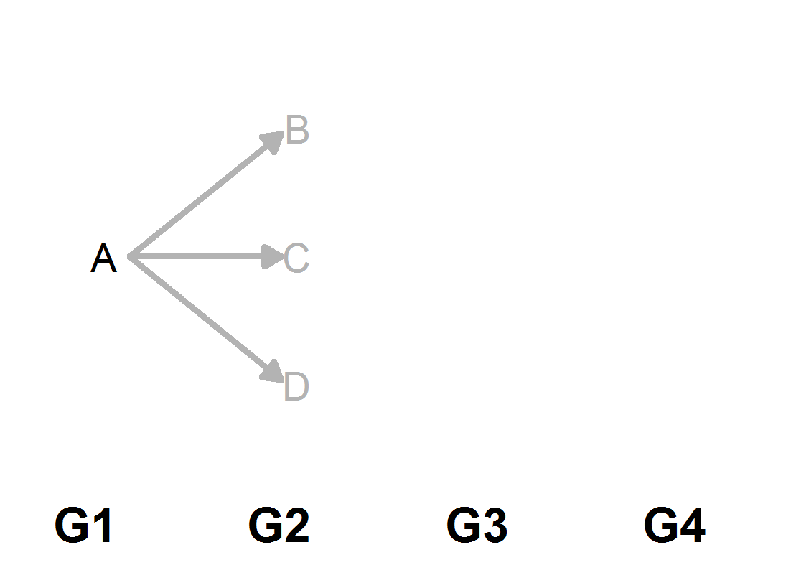
2 HH members infected  A and B are infected. | 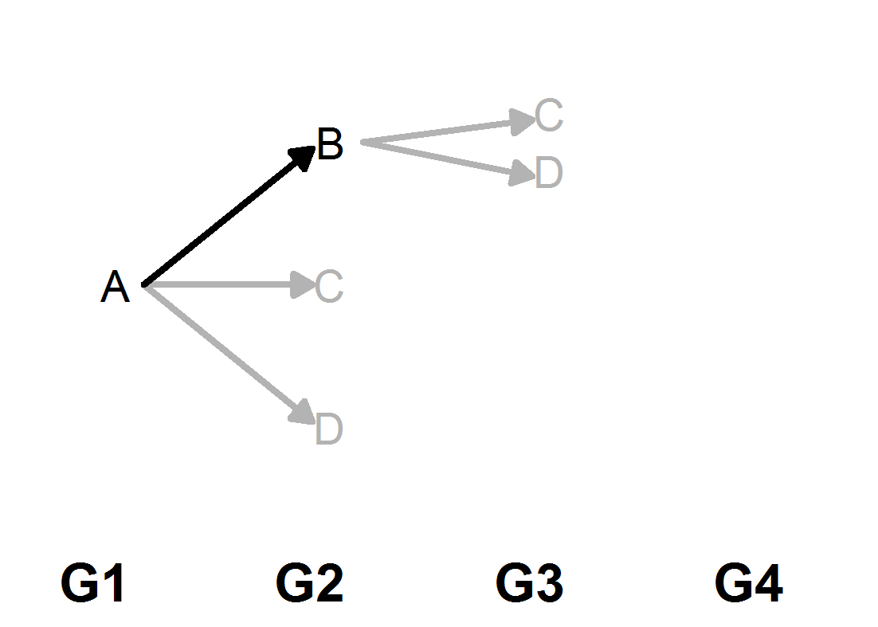
3 HH members infected  A, B and C are infected. | 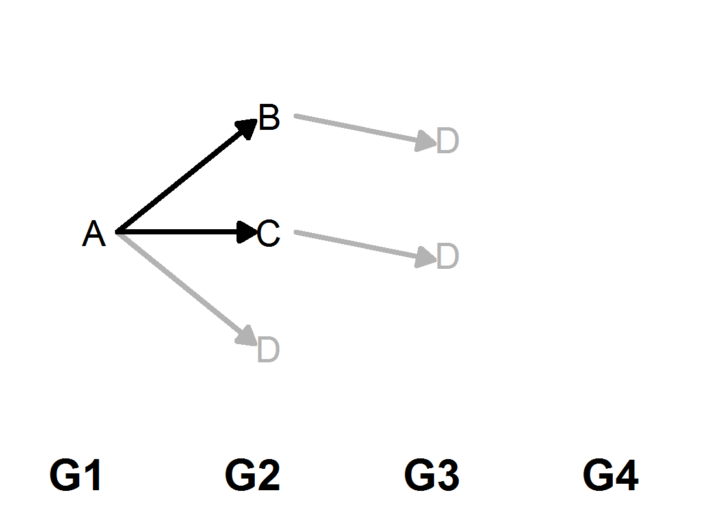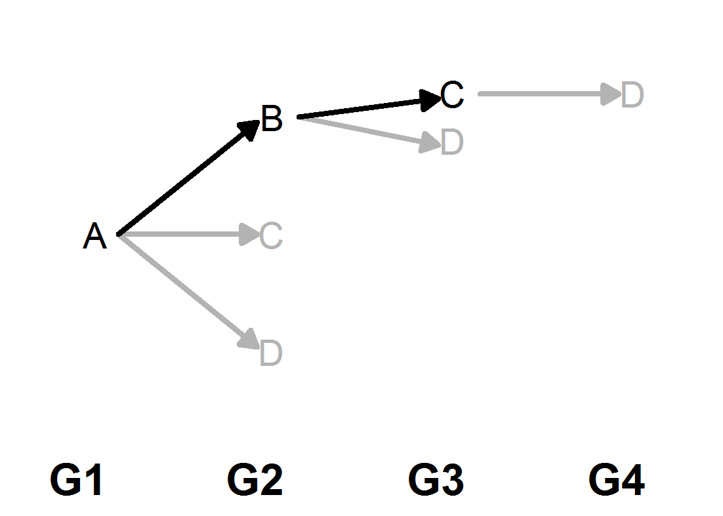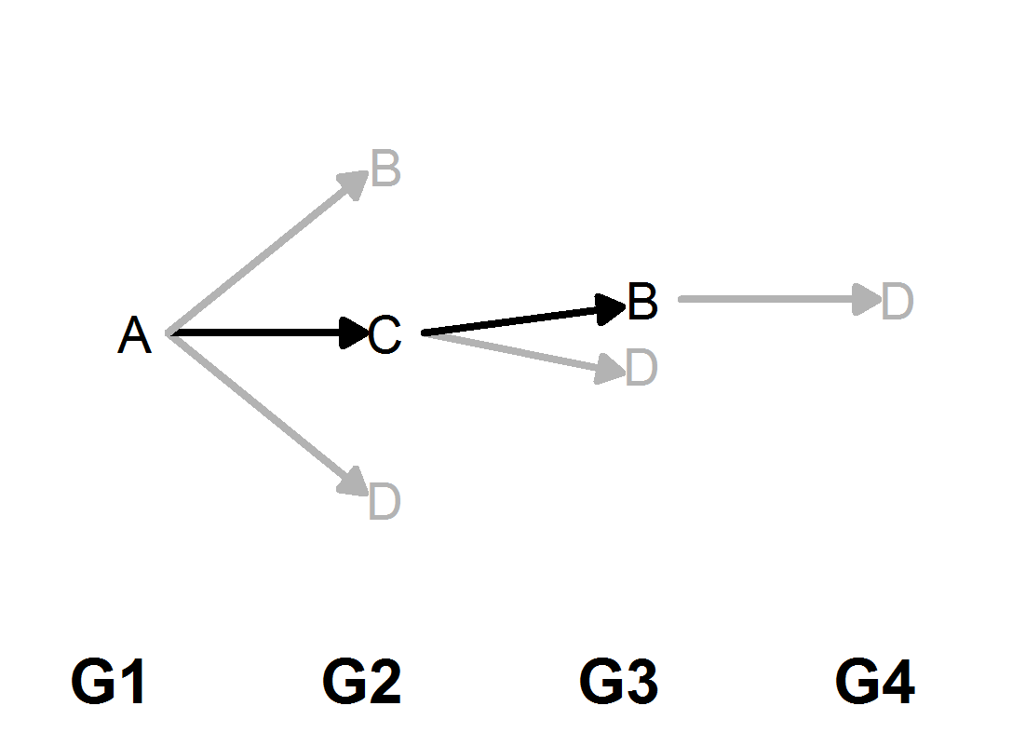
4 HH members infected.  A, B, C and D are all infected. | 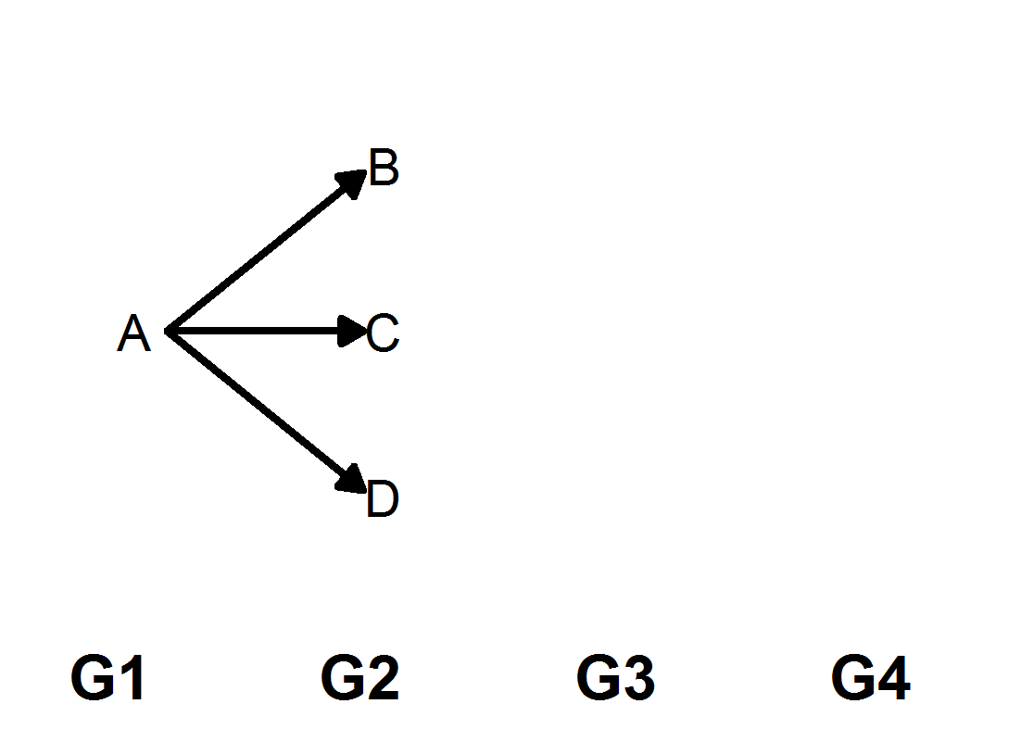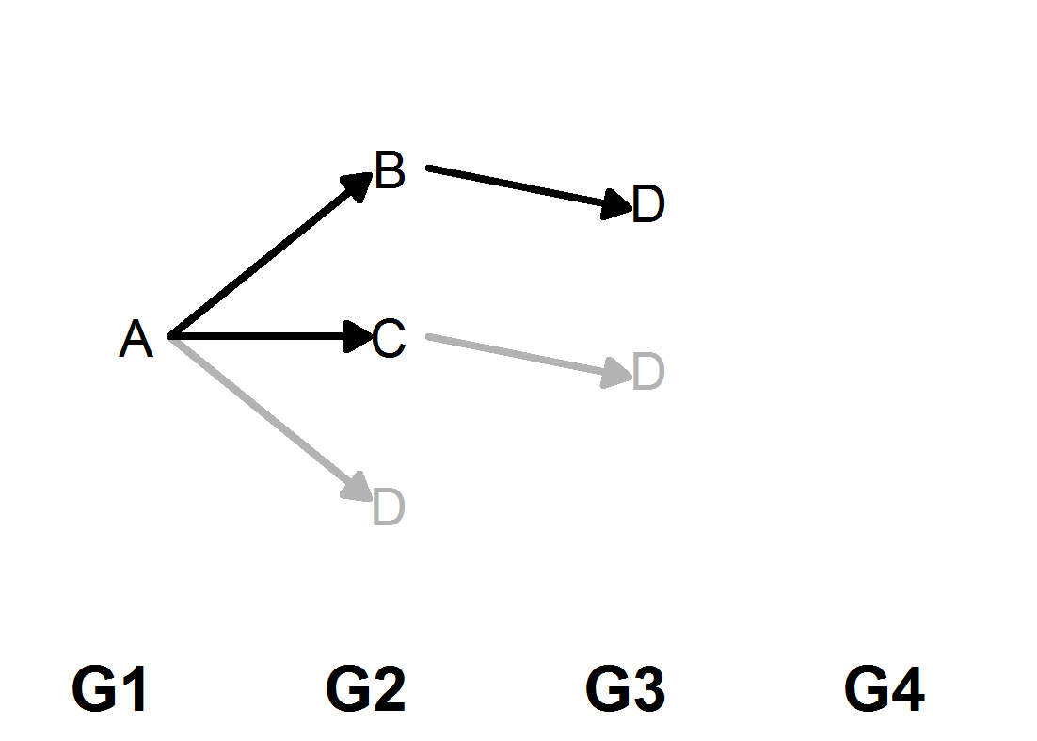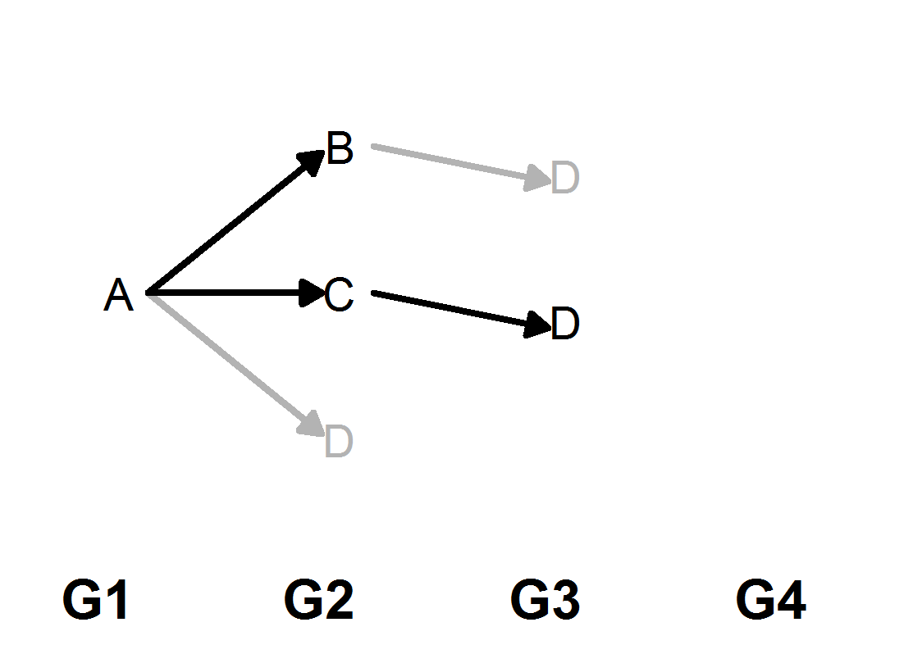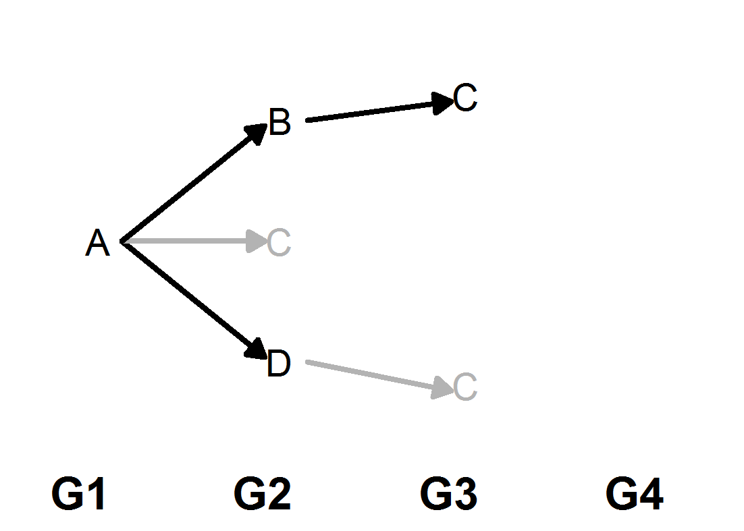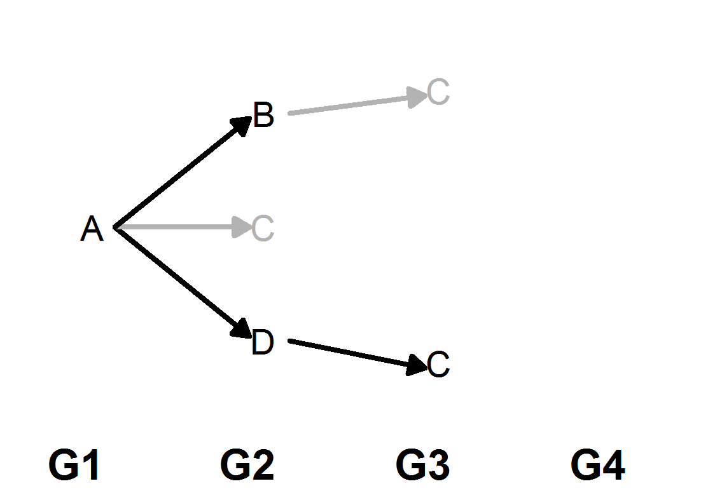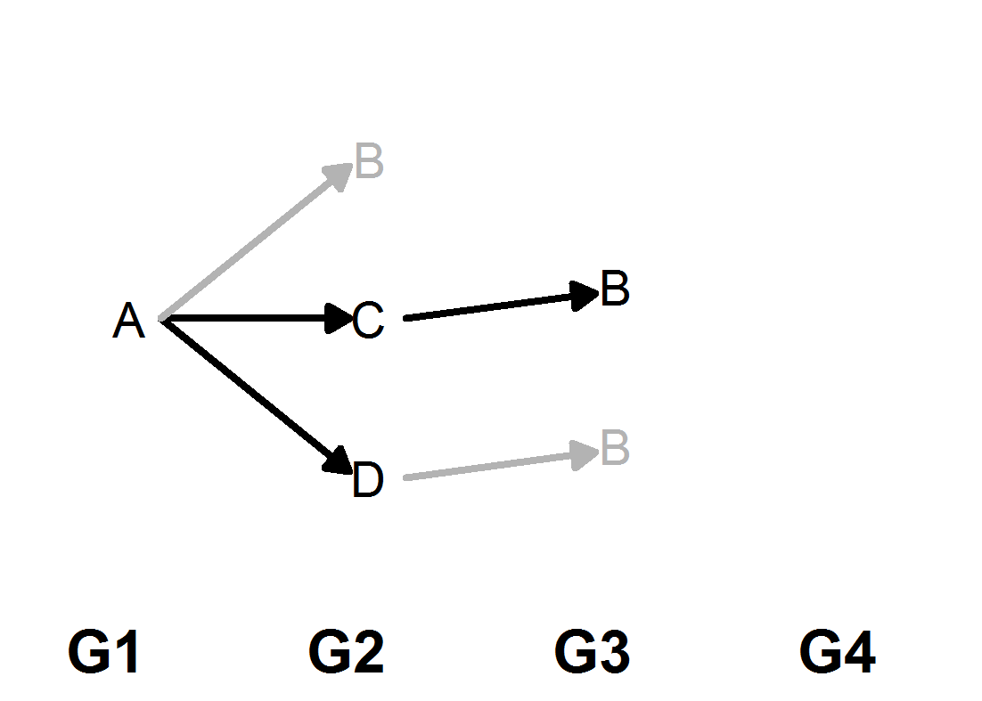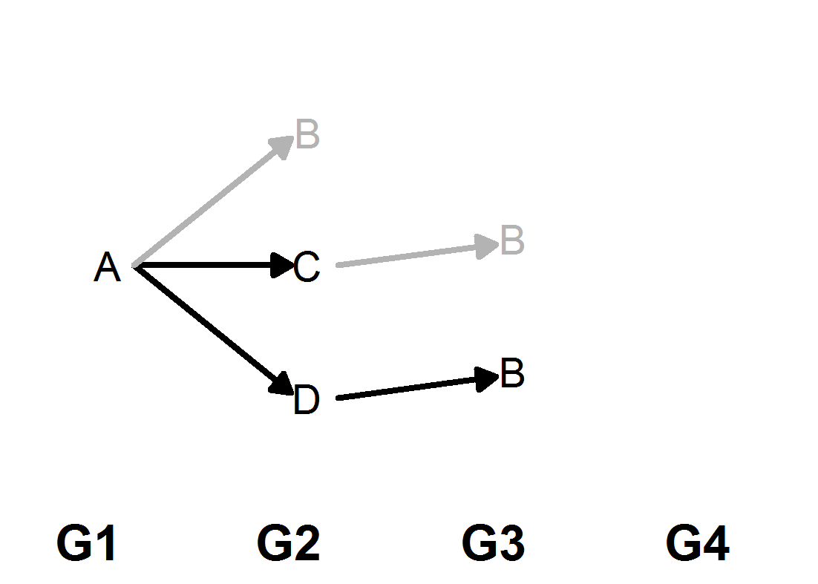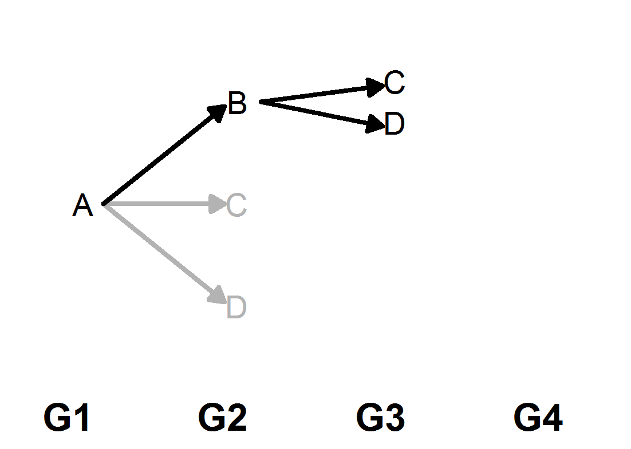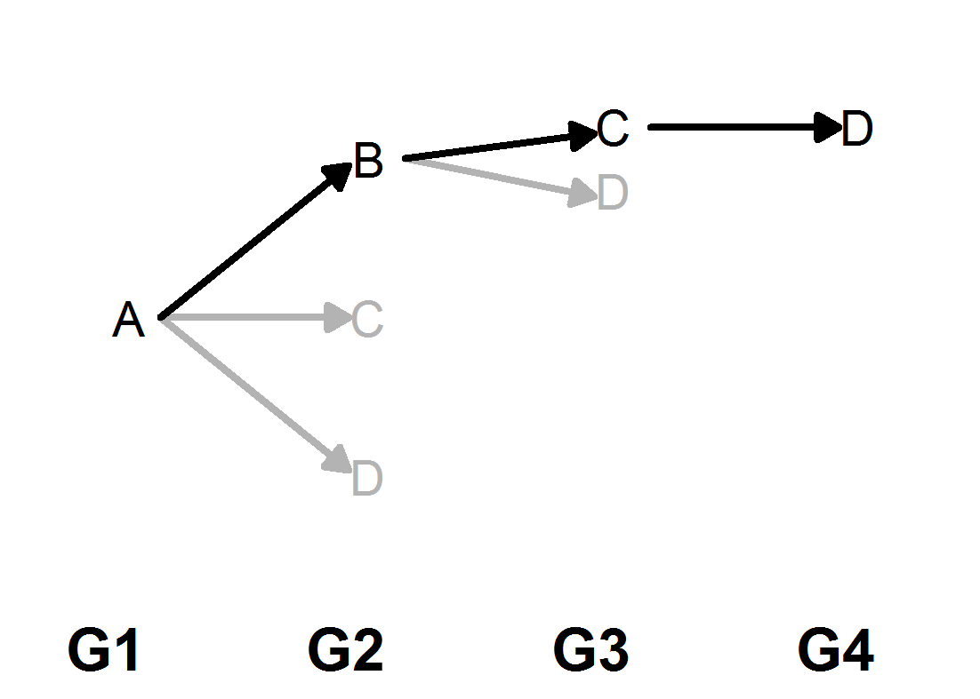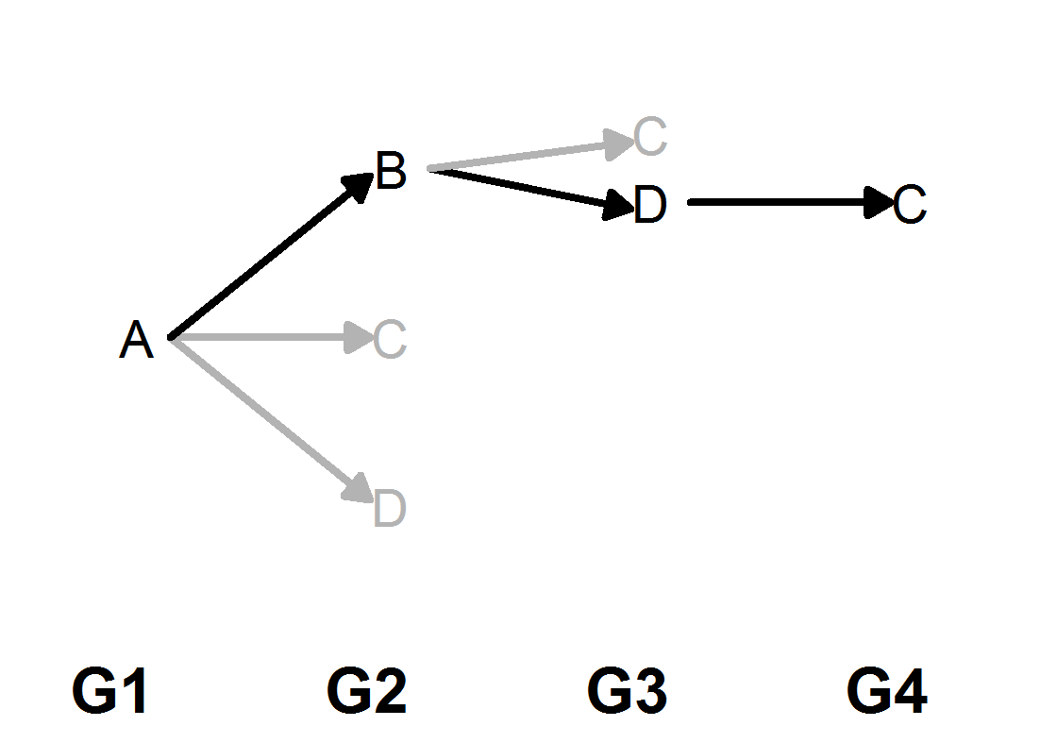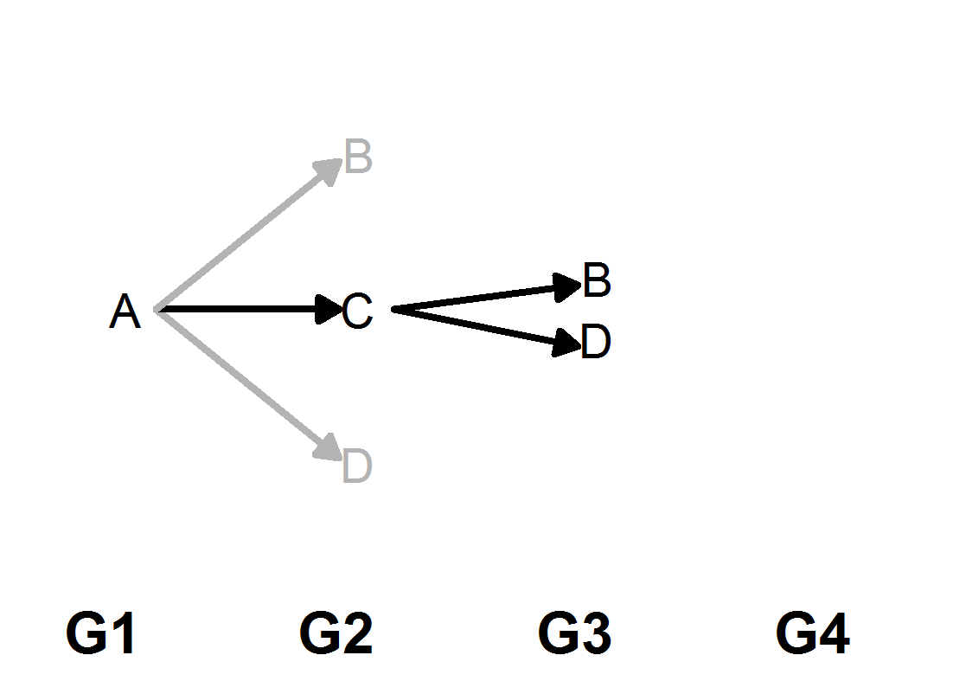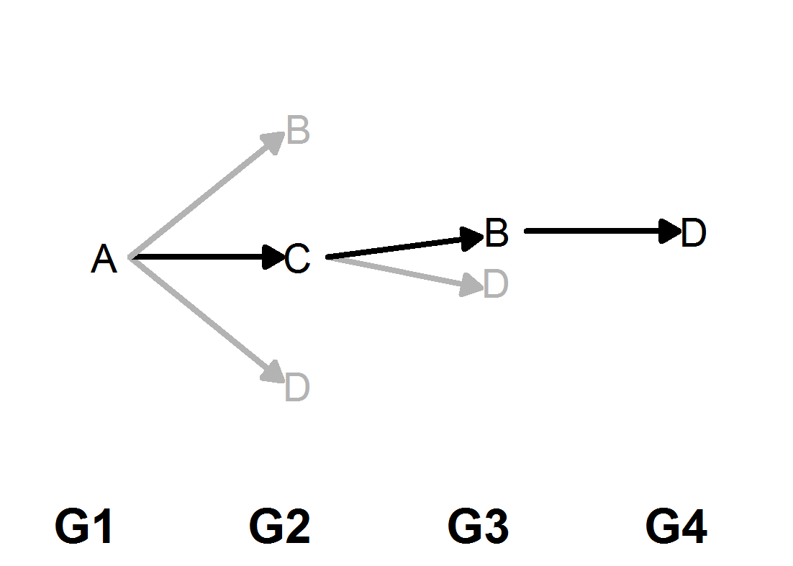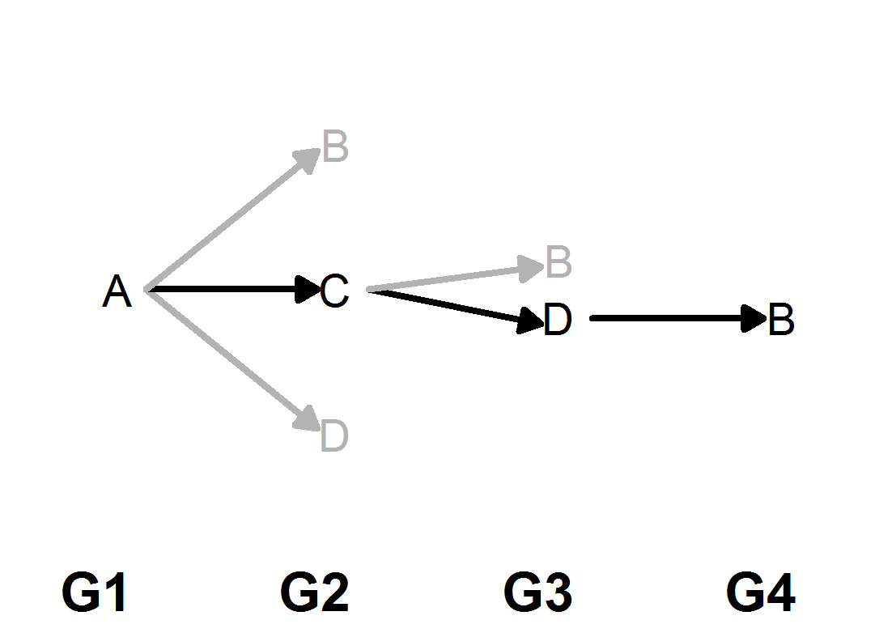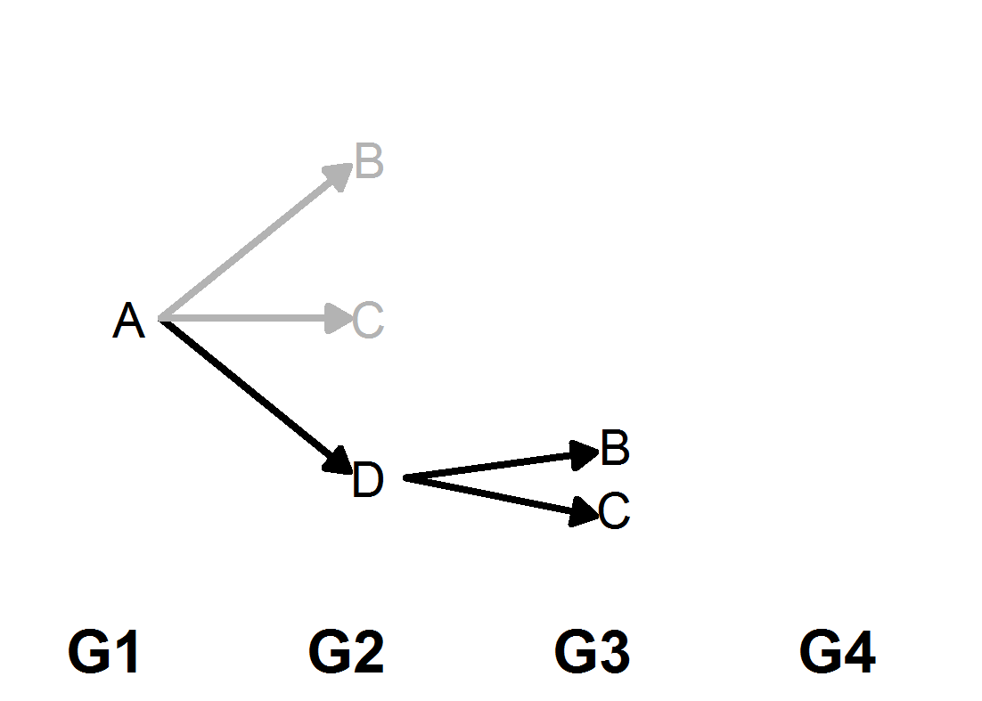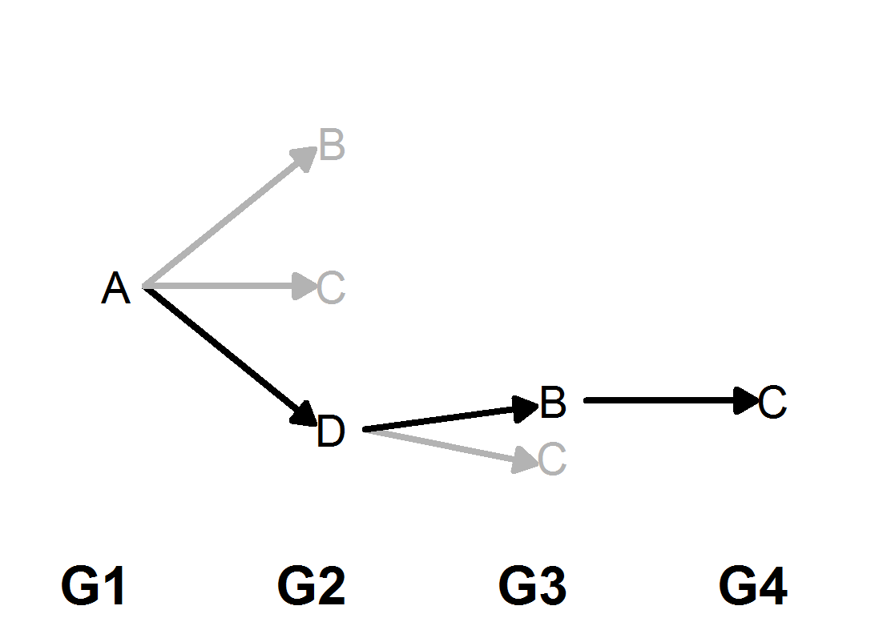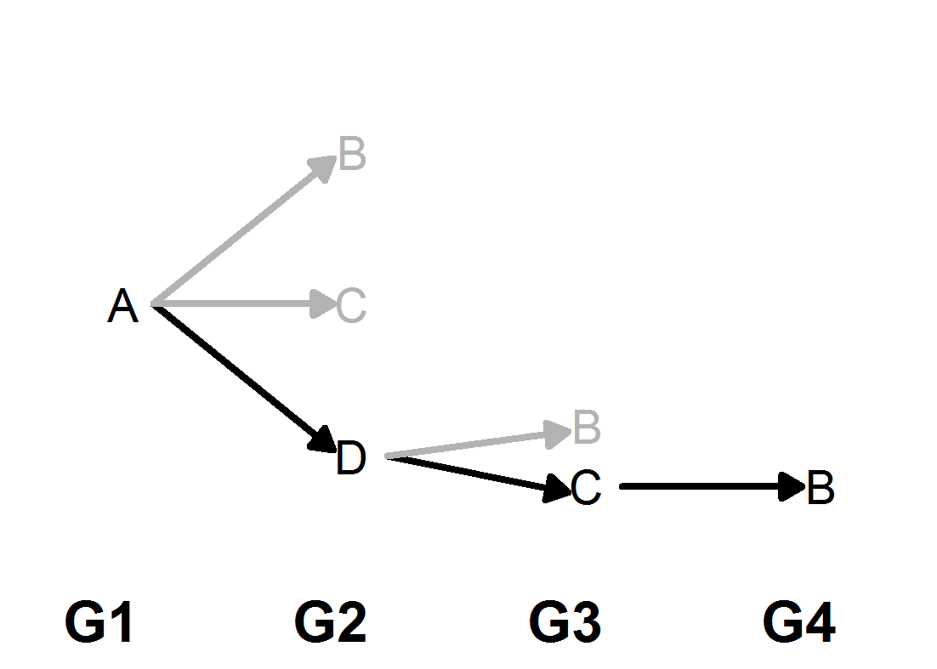
The black and grey arrows represent successful and unsuccessful infections, respectively.

