Epidemiology and Infection

Meteorological factors affecting Scrub typhus occurrence: a retrospective study of Yamagata Prefecture, Japan, 1984–2014

J. Seto, Y. Suzuki, R. Nakao, K. Otani, K. Yahagi, and K. Mizuta

Supplementary Material

Supplementary Figure S1. Location of Yamagata Prefecture and geographical features of scrub typhus in Japan.

Supplementary Table S1. Results of negative binomial regression between each meteorological factor and the number of scrub typhus cases in Yamagata, Japan, 1984–2014.

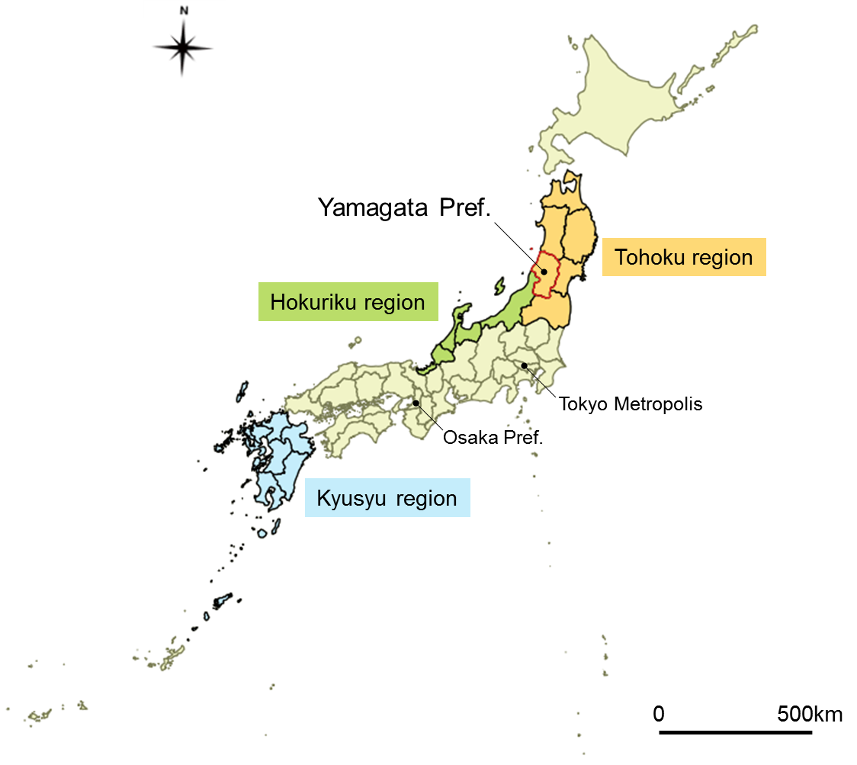

Supplementary Figure S1. Yamagata Prefecture is located in the Tohoku region, which is in the northern part of Honshu Island, Japan. In the Tohoku and Hokuriku regions, scrub typhus occurs mainly in spring – early summer because Leptotrombidium pallidum, a major vector of Karp and Gilliam type scrub typhus, is widely distributed. By contrast, in the southern part of Japan such as in the Kyushu region, scrub typhus occurs mainly in autumn – early winter because L. scutellare, a major vector of Kawasaki and Kuroki type scrub typhus, is widely distributed.

Supplementary Table S1. Results of negative binomial regression between each meteorological factor and the number of scrub typhus cases in Yamagata, Japan, 1984–2014.
Category | Month | Coefficient | S. E. | P value | AIC
Average temperature (°C) | Intercept | -4.662 | 3.469 | 0.179
 | Population | 1.442 | 2.219 | 0.516
 | July (prior year) | 0.225 | 0.071 | 0.002 | 182.4
 | Intercept | -7.337 | 2.705 | 0.007
 | Population | 1.225 | 1.685 | 0.467
 | August (prior year) | 0.331 | 0.059 | 0.000 | 168.8
 | Intercept | -4.231 | 4.182 | 0.312
 | Population | 2.109 | 2.552 | 0.408
 | September (prior year) | 0.195 | 0.087 | 0.026 | 186.6
 | Intercept | -1.129 | 3.994 | 0.777
 | Population | 1.113 | 2.634 | 0.673
 | October (prior year) | 0.150 | 0.101 | 0.138 | 189.0
 | Intercept | 1.952 | 3.093 | 0.528
 | Population | -0.279 | 2.429 | 0.908
 | November (prior year) | 0.087 | 0.078 | 0.265 | 189.9
 | Intercept | 2.856 | 2.971 | 0.336
 | Population | -0.437 | 2.419 | 0.857
 | December (prior year) | -0.061 | 0.091 | 0.499 | 190.5
 | Intercept | 1.849 | 2.819 | 0.512
 | Population | 0.148 | 2.293 | 0.949
 | January | -0.170 | 0.081 | 0.037 | 187.1
 | Intercept | 2.386 | 2.958 | 0.420
 | Population | -0.190 | 2.406 | 0.937
 | February | -0.086 | 0.081 | 0.288 | 189.9
 | Intercept | 2.612 | 2.973 | 0.380
 | Population | -0.197 | 2.427 | 0.935
 | March | -0.070 | 0.087 | 0.421 | 190.4
Aggregate rainfall (mm) | Intercept | 4.775 | 2.598 | 0.066
 | Population | -1.487 | 2.092 | 0.477
 | July of prior year | -0.004 | 0.001 | 0.000 | 178.4
 | Intercept | 3.417 | 2.955 | 0.248
 | Population | -0.838 | 2.394 | 0.726
 | August (prior year) | -0.001 | 0.001 | 0.260 | 189.7
 | Intercept | 1.544 | 2.532 | 0.542
 | Population | 0.013 | 2.054 | 0.995
 | September (prior year) | 0.004 | 0.001 | 0.001 | 181.1
 | Intercept | 3.586 | 2.943 | 0.223
 | Population | -0.693 | 2.355 | 0.768
 | October (prior year) | -0.004 | 0.002 | 0.080 | 188.2
 | Intercept | 3.583 | 3.155 | 0.256
 | Population | -0.897 | 2.491 | 0.719
 | November (prior year) | -0.001 | 0.002 | 0.427 | 190.4
Aggregate snowfall (cm) | Intercept | 1.226 | 2.918 | 0.674
 | Population | 0.496 | 2.339 | 0.832
 | December (prior year) | 0.003 | 0.001 | 0.049 | 187.2
 | Intercept | 2.152 | 2.705 | 0.426
 | Population | -0.794 | 2.223 | 0.721
 | January | 0.004 | 0.002 | 0.015 | 185.1
 | Intercept | 3.085 | 2.944 | 0.295
 | Population | -0.961 | 2.426 | 0.692
 | February | 0.002 | 0.002 | 0.364 | 190.1
 | Intercept | 0.679 | 3.069 | 0.825
 | Population | 0.978 | 2.449 | 0.690
 | March | 0.003 | 0.002 | 0.103 | 188.3
Total snowfall (cm) | Intercept | 0.653 | 2.700 | 0.809
 | Population | 0.325 | 2.153 | 0.880
 | December (prior year) to March | 0.002 | 0.001 | 0.003 | 183.5
Maximum depth of snow cover (cm) | Intercept | 0.194 | 3.115 | 0.950
 | Population | 1.326 | 2.476 | 0.592
 | December (prior year) | 0.009 | 0.005 | 0.050 | 187.4
 | Intercept | -1.418 | 2.988 | 0.635
 | Population | 2.346 | 2.347 | 0.318
 | January | 0.009 | 0.003 | 0.007 | 184.2
 | Intercept | -1.507 | 2.861 | 0.598
 | Population | 2.334 | 2.250 | 0.299
 | February | 0.008 | 0.003 | 0.002 | 182.2
 | Intercept | 0.749 | 2.939 | 0.799
 | Population | 0.889 | 2.357 | 0.706
 | March | 0.005 | 0.002 | 0.044 | 187.3
Each negative binomial regression model was adjusted by annual population.
S.E., Standard error; AIC, Akaike's Information Criterion

