Epidemiology and Infection

chronic hepatitis C virus (HCV) Burden in Rhode Island: Modelling treatment scale-up and Elimination

A. I. Soipe, H. Razavi, D. Razavi-Shearer,

O. Galárraga, L. E. Taylor, B. D. L. Marshall

Supplementary Material

**Supplementary Figure S1**: HCV Disease Progression Schematic



Adapted from Razavi et al., 2013 [1].

**Supplementary Table S1:** Age- and gender-specific fibrosis disease stage progression probabilities

|  |  |  |  |  |  |  |  |  |  |  |  |  |  |  |  |  |  |  |
| --- | --- | --- | --- | --- | --- | --- | --- | --- | --- | --- | --- | --- | --- | --- | --- | --- | --- | --- |
| **Age Cohorts** | **0-4** | **5-9** | **10-14** | **15-19** | **20-24** | **25-29** | **30-34** | **35-39** | **40-44** | **45-49** | **50-54** | **55-59** | **60-64** | **65-69** | **70-74** | **75-79** | **80-84** | **85+** |
| Progression rates – males, % | | | | | | | | | | | | | | | | | | |
| F0 to F1 | 5.3 | 5.3 | 6.4 | 6.4 | 5.2 | 5.2 | 3.8 | 3.8 | 13.9 | 13.9 | 17.1 | 17.1 | 19.4 | 19.4 | 21.8 | 21.8 | 17.9 | 17.9 |
| F1 to F2 | 3.8 | 3.8 | 4.7 | 4.7 | 3.8 | 3.8 | 2.7 | 2.7 | 10.1 | 10.1 | 12.4 | 12.4 | 14.1 | 14.1 | 15.8 | 15.8 | 13.0 | 13.0 |
| F2 to F3 | 5.4 | 5.4 | 6.6 | 6.6 | 5.3 | 5.3 | 3.9 | 3.9 | 14.3 | 14.3 | 17.5 | 17.5 | 19.9 | 19.9 | 22.4 | 22.4 | 18.3 | 18.3 |
| F3 to Cirrhosis | 0.0 | 0.0 | 0.8 | 0.8 | 2.5 | 2.5 | 5.7 | 5.7 | 8.8 | 8.8 | 4.8 | 4.8 | 9.9 | 9.9 | 19.1 | 19.1 | 19.1 | 19.1 |
| F3 to HCC | 0.0 | 0.0 | 0.0 | 0.0 | 0.0 | 0.0 | 0.0 | 0.0 | 0.1 | 0.1 | 0.1 | 0.1 | 0.2 | 0.2 | 0.3 | 0.3 | 0.3 | 0.3 |
| Cirrhosis to HCC | 0.3 | 0.3 | 0.3 | 0.3 | 0.3 | 0.3 | 0.5 | 0.5 | 0.9 | 0.9 | 1.4 | 1.4 | 2.4 | 2.4 | 3.9 | 3.9 | 3.9 | 3.9 |
|  |  |  |  |  |  |  |  |  |  |  |  |  |  |  |  |  |  |  |
| Progression rates – females, % | | | | | | | | | | | | | | | | | | |
| F0 to F1 | 4.4 | 4.4 | 5.4 | 5.4 | 4.3 | 4.3 | 3.1 | 3.1 | 11.6 | 11.6 | 14.3 | 14.3 | 16.2 | 16.2 | 18.2 | 18.2 | 14.9 | 14.9 |
| F1 to F2 | 3.2 | 3.2 | 3.9 | 3.9 | 3.1 | 3.1 | 2.3 | 2.3 | 8.4 | 8.4 | 10.4 | 10.4 | 11.7 | 11.7 | 13.2 | 13.2 | 10.8 | 10.8 |
| F2 to F3 | 4.5 | 4.5 | 5.5 | 5.5 | 4.4 | 4.4 | 3.2 | 3.2 | 11.9 | 11.9 | 14.6 | 14.6 | 16.6 | 16.6 | 18.6 | 18.6 | 15.3 | 15.3 |
| F3 to Cirrhosis | 0.0 | 0.0 | 0.6 | 0.6 | 2.1 | 2.1 | 4.7 | 4.7 | 7.4 | 7.4 | 4.0 | 4.0 | 8.3 | 8.3 | 15.9 | 15.9 | 15.9 | 15.9 |
| F3 to HCC | 0.0 | 0.0 | 0.0 | 0.0 | 0.0 | 0.0 | 0.0 | 0.0 | 0.0 | 0.0 | 0.1 | 0.1 | 0.1 | 0.1 | 0.2 | 0.2 | 0.2 | 0.2 |
| Cirrhosis to HCC | 0.3 | 0.3 | 0.3 | 0.3 | 0.3 | 0.3 | 0.4 | 0.4 | 0.7 | 0.7 | 1.2 | 1.2 | 2.0 | 2.0 | 3.3 | 3.3 | 3.3 | 3.3 |

HCC = hepatocellular carcinoma  
Re-produced from Razavi et al., 2014 [2].  
Rates were estimated from previous studies [3-5], and were based on data from the US Surveillance, Epidemiology, and End Results (SEER) database. We assumed that 90% of all liver cancers were HCC [6], and 40% of HCC cases were due to HCV [7, 8].

**Supplementary Table S2**: HCV disease progression probabilities

|  |  |  |  |
| --- | --- | --- | --- |
| **Progression…** | **Base** | **Range** | **Source** |
| from Acute (Incidence) |  |  |  |
| % Progress to Chronic HCV | 82.00% | (0.85 - 0.55) | [9-11] |
| from Cirrhosis |  |  |  |
| ….Diuretic Sensitive Ascites | 2.50% | (0.018 - 0.032) | [4, 5] |
| .…Variceal Hemorrhage | 1.10% | (0.006 - 0.016) | [4, 5] |
| …Hepatic Encephalopathy | 0.40% | (0.001 - 0.007) | [4, 5] |
| …HCC | See Table S1 | |  |
| from Diuretic Sensitive Ascites |  |  |  |
| ….Diuretic Refractory Ascites | 6.70% | (0.04 - 0.094 ) | [4, 5] |
| ….Liver Transplant | See below |  |  |
| ….Liver Related Death | 11.00% | (0.077 - 0.143) | [4, 5] |
| from Variceal Hemorrhage |  |  |  |
| ….Liver Transplant (1st Year) | See below |  |  |
| ….Liver Related Death (1st Year) | 40.00% | (0.334 - 0.466) | [4, 5] |
| ….Liver Related Death (Sub Yrs) | 13.00% | (0.085 - 0.175) | [4, 5] |
| from Hepatic Encephalopathy |  |  |  |
| ….Liver Transplant (1st Year) | See below |  |  |
| ….Liver Related Death (1st Year) | 68.00% | (0.659 - 0.701) | [4, 5] |
| ….Liver Related Death (Sub Yrs) | 40.00% | (0.378 - 0.422) | [4, 5] |
| from Diuretic Refractory Ascites |  |  |  |
| ….Liver Transplant | See below |  |  |
| ….Liver Related Death | 33.00% | (0.28 - 0.38) | [4, 5] |
| from HCC |  |  |  |
| ….Liver Related Death (1st Year) | 70.70% | (0.43 - 0.77) | [4, 5, 12] |
| ….Liver Related Death (Sub Yrs) | 16.20% | (0.11 - 0.23) | [4, 5, 12] |
|  |  |  |  |
| Liver Transplant (1950-1970) | 0% | Transplant rates were negligible | |
| Liver Transplant (1971-1987) | 5.3% | (0.031 - 0.0542) | [4], Trended Data |
| Liver Transplant (1988-2010) | Actual Data | 33% attributed to HCV | [13] |
| Liver Transplant (2011-2030) | 1.7% | (0.0169 - 0.045) | Trended Data |

HCC = hepatocellular carcinoma

**Supplementary Figure S2:** Estimated HCV incidence, Rhode Island (1950-2030)

Note: CDC surveillance estimates (orange) reflect the total number of estimated cases using methods to account for under-ascertainment of reported cases [14]. The estimated number of acute HCV infections in Rhode Island was derived by multiplying the national values reported by the CDC by the proportion of the US population residing in Rhode Island in each year (based on US census data).

**Supplementary Figure S3:** Example beta-PERT distribution used in the Monte Carlo sensitivity analyses, with minimum, likeliest value 91, and maximum value 120.

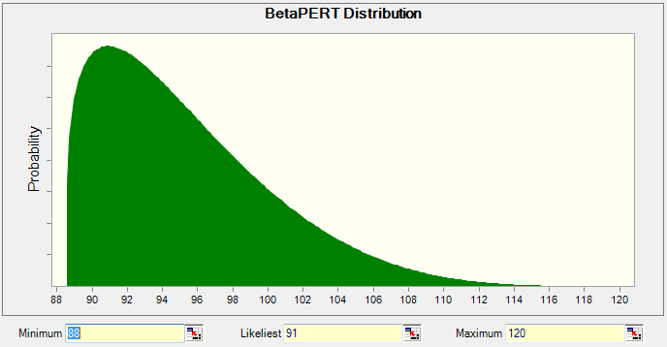

**Supplementary Figure S4:** Tornado diagram summarizing the results of one-way sensitivity analyses, selected variables.

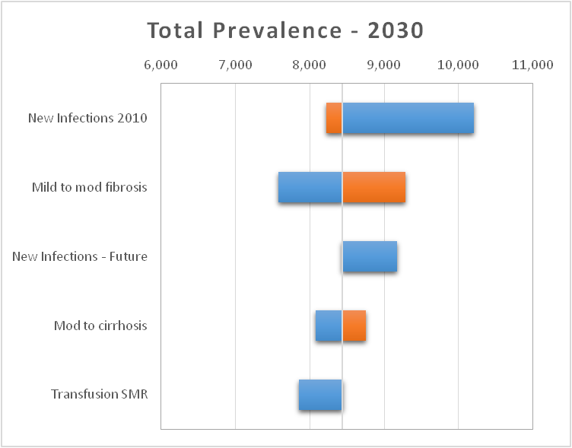

Note: each bar represents the minimum and maximum denoted by the lower and upper range shown in Table 1 or Table S2.

**Supplementary Material References**

(1) **Razavi H, et al.** Chronic hepatitis C virus (HCV) disease burden and cost in the United States. *Hepatology* 2013; **57**: 2164-2170.

(2) **Razavi H, et al.** The present and future disease burden of hepatitis C virus (HCV) infection with today's treatment paradigm. *Journal of Viral Hepatitis* 2014; **21**: 34-59.

(3) **Thein HH, et al.** Estimation of stage-specific fibrosis progression rates in chronic hepatitis C virus infection: A meta-analysis and meta-regression. *Hepatology* 2008; **48**: 418-431.

(4) **Siebert U, Sroczynski G.** Effectiveness and cost-effectiveness of initial combination therapy with interferon/peginterferon plus ribavirin in patients with chronic hepatitis C in germany: A health technology assessment commissioned by the german federal ministry of health and social security. *International journal of technology assessment in health care* 2005; **21**: 55-65.

(5) **Sennfält K, et al.** Cost-effectiveness of interferon alfa-2b with and without ribavirin as therapy for chronic hepatitis C in sweden. *Scandinavian journal of gastroenterology* 2001; **36**: 870-876.

(6) **Centers for Disease Control and Prevention.** Hepatocellular carcinoma — United States, 2001-2006. *MMWR: Morbidity and Mortality Weekly Report* 2010; **59**: 517-520.

(7) **El-Serag HB.** Epidemiology of viral hepatitis and hepatocellular carcinoma. *Gastroenterology* 2012; **142**: 1264-1273 e1261.

(8) **Dorfman JD, et al.** Differences in characteristics of patients with and without known risk factors for hepatocellular carcinoma in the United States. *World Journal of Gastroenterology* 2007; **13**: 781-784.

(9) **Thomas DL, Seeff LB.** Natural history of hepatitis C. *Clinics in liver disease* 2005; **9**: 383-398.

(10) **Alter MJ, et al.** The natural history of community-acquired hepatitis C in the United States. *New England journal of medicine* 1992; **327**: 1899-1905.

(11) **Villano SA, et al.** Persistence of viremia and the importance of long-term follow-up after acute hepatitis C infection. *Hepatology* 1999; **29**: 908-914.

(12) **Ries LAG, et al.** Cancer survival among adults: US seer program, 1988-2001. *Patient and tumor characteristics Bethesda, MD: US Department of Health and Human Services, National Institutes of Health, National Cancer Institute* 2007.

(13) **Poynard T, et al.** Viral hepatitis C. *The Lancet* 2003; **362**: 2095-2100.

(14) Centers for Disease and Control Prevention (CDC). Viral hepatitis surveillance: United States, 2011. In: Division of Viral Hepatitis, ed. Atlanta, GA: National Center for HIV/AIDS, Viral Hepatitis, STD, & TB Prevention, 2011.