**SUPPLEMENTARY APPENDIX**

Fig. A1. Term-level absenteeism density distribution by school type and influenza vaccine pilot status, 2013/14

Primary

spring term

autumn term

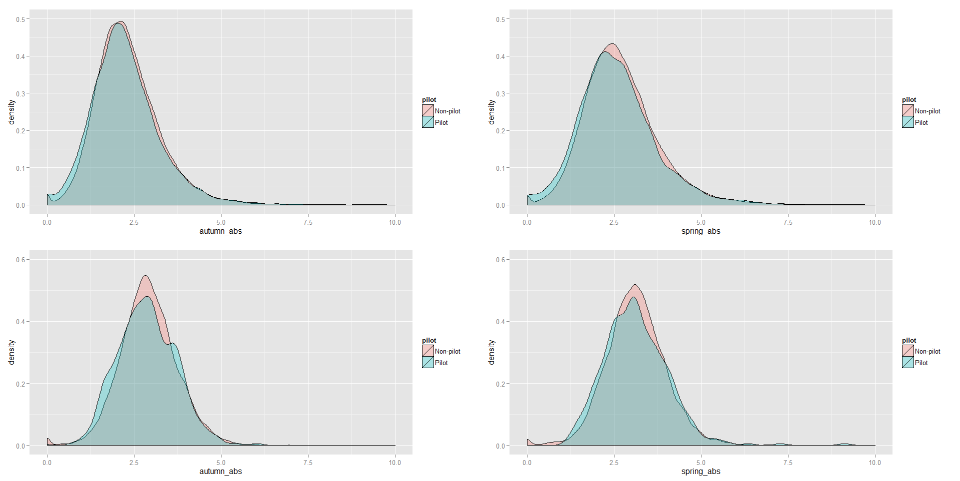

Secondary

Fig. A2. Term-level absenteeism by school type and influenza vaccine pilot status in autumn and spring terms, 2011 to 2014

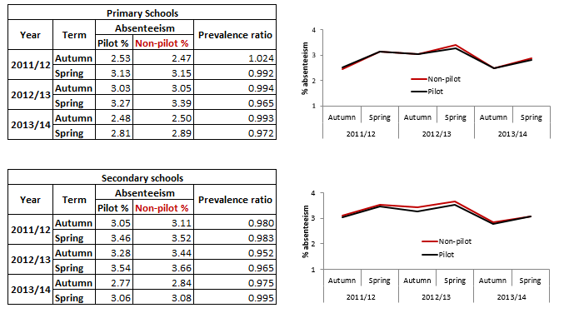

Fig. A3. Absenteeism during spring 2014 and vaccine uptake in primary schools*



*\*Spearman correlation coefficient of -0.097 (95% CI -0.186 to 0.002)*