SUPPLEMENTARY MATERIAL

S1. Model parameters

Table S1. Parameter descriptions, values, units and data sources used in the mathematical model described in Equations S.1—S.16.

Parameters | Description | Values | Unit | Source
$$α$$ | Maternal transmission | 0.9 | N/A | [1-3]
$$B$$ | Human birth rate | $$1/{(70 ×365)}$$ | day⁻¹ | [4]
$$b_{N}$$ | Biting rate of Non Wolbachia-mosquitoes | 0.63 | day⁻¹ | [5]
$$b_{W}$$ | Biting rate of Wolbachia-carrying mosquitoes | $$0.9 ×b_{N}$$ | day⁻¹ | [6]
$$η$$ | Seasonality strength | 0.6228 | N/A | [7]
$$γ_{H}$$ | Progression rate from exposed to infectious human | 1/5.5 | day⁻¹ | [8]
$$γ_{N}$$ | Progression rate from exposed to infectious non Wolbachia mosquitoes | 1/10 | day⁻¹ | [9]
$$γ_{W}$$ | Progression rate from exposed to infectious Wolbachia-carrying mosquitoes | 1/10 | day⁻¹ | [9]
$$K$$ | Carrying capacity | 450000 | N/A | [9]
$$λ$$ | Force of infection | See equations S.17, S.22, and S.23
$$μ_{H}$$ | Human death rate | $$1/{(70 ×365)}$$ | day⁻¹ | [4]
$$μ_{NA}$$ | Death rate of aquatic non-Wolbachia mosquitoes | 1/14 | day⁻¹ | [10]
$$μ_{N0}$$ | Average adult mosquito death rate of non-Wolbachia mosquitoes | 1/14 | day⁻¹ | [10]
$$μ_{WA}$$ | Death rate of aquatic Wolbachia mosquitoes | 1/14 | day⁻¹ | [10]
$$N_{H}$$ | Total human population | 150000 | N/A | [11]
$$ω$$ | Phase shift | 80.61 | day | [7]
$$ϕ$$ | Antibody dependent enhancement | 1.1 | N/A | [12]
$$ρ_{N}$$ | Reproductive rate of non Wolbachia mosquitoes | 1.25 | day⁻¹ | [2]
$$ρ_{W}$$ | Reproductive rate of Wolbachia  carrying mosquitoes | 0.95 $ρ_{N}$ | day⁻¹ | [13]
$$T$$ | Transmission probability | 0.2614 | N/A | [7]
$$T_{HW}$$ | Transmission probability from Wolbachia-carrying mosquitoes to human | 0.5 $T$ | N/A | [14]
$$τ_{N}$$ | Maturation rate of non Wolbachia mosquitoes. | 1/10 | day⁻¹ | [10]
$$τ_{W}$$ | Maturation rate of Wolbachia carrying mosquitoes | 1/10 | day⁻¹ | [10]
$$θ$$ | Progression rate from temporary immunity to second susceptible class | $$1/(0.5×365)$$ | day⁻¹ | [15]

S2. Mathematical model
A two-serotype dengue transmission model in the presence of Wolbachia-carrying mosquitoes is presented here. The model is an advancement of the model given in Ndii et al [7]. The human population is divided into those susceptible, $S_{H}$, exposed $E_{H}$, infectious $I_{H}$, temporary immunity $X_{H}$ and recovered class $R_{H}$. The mosquito population is divided into mosquitoes in the aquatic stage, $A_{N}$ and$A_{W}$ , susceptible $S_{N}$ and $S_{W}$ exposed $E_{N}$and $E_{W}$, infectious $I_{N}$ and $I_{W}$. Superscripts $i, j=1, 2$denote serotype 1 and serotype 2. Superscript $ji$refers to individuals that were previously infected by serotype $i$ and are progressing through Susceptible, Exposed, and Infectious states with respect to serotype $j$. For example, $S_{H}^{ji}$ refers to individuals previously infected by serotype $i$ and currently susceptible to serotype $j$. The model described by the system of ordinary differential equations below, for humans, non-Wolbachia and Wolbachia-carrying mosquito populations.
The human population is governed by
 | $$\frac{dS_{H}}{dt}=B N_{H}-\sum_{i=1}^{2}{λ_{H}^{i}S_{H}-μ_{H}S_{H},}$$ | - 1)
 | $$\frac{dE_{H}^{i}}{dt}=λ_{H}^{i}S_{H}-γ_{H}E_{H}^{i}-μ_{H}E_{H}^{i},$$ | - 2)
 | $$\frac{dI_{H}^{i}}{dt}= γ_{H}E_{H}^{i}-σI_{H}^{i}-μ_{H}I_{H}^{i},$$ | - 3)
 | $$\frac{dX_{H}^{i}}{dt}=σI_{H}^{i}-θ^{i}X_{H}^{i}-μ_{H}X_{H},$$ | (S. 4)
 | $$\frac{dS_{H}^{ji}}{dt}=θ_{i}X_{H}^{i}-λ_{H}^{j}S_{H}^{ji} - μ_{H}S_{H}^{ji},$$ | (S. 5)
 | $$\frac{dE_{H}^{ji}}{dt}=λ_{H}^{j}S_{H}^{ji}-γ_{H}E_{H}^{ji}-μ_{H}E_{H}^{ji},$$ | (S. 6)
 | $$\frac{dI_{H}^{ji}}{dt}= γ_{H}S_{H}^{ji}-σI_{H}^{ji}-μ_{H}I_{H}^{ji},$$ | (S. 7)
 | $$\frac{dR_{H}}{dt}=\sum_{j=1, j≠ i}^{2}{{σI}_{H}^{ji}-μ_{H}R_{H}. }$$ | (S. 8)
The non-Wolbachia mosquito population is governed by
 | $$\frac{dA_{N}}{dt}= \frac{ρ_{N}F_{N}^{2}}{2\left(F_{N}+F_{W}\right)}\left(1-\frac{A_{N}+A_{W}}{K}\right)-τ_{N}A_{N}-μ_{NA}A_{N},$$ | - 9)
 | $$\frac{dS_{N}}{dt}=\frac{τ_{N}A_{N}}{2}+\frac{\left(1-α\right)τ_{W}A_{W}}{2}-\sum_{i=1}^{2}{λ_{N}^{i}S_{N}-μ_{N}\left(t\right)}S_{N},$$ | - 10)
 | $$\frac{dE_{N}^{i}}{dt}= λ_{N}^{i}S_{N}-γ_{N}E_{N}^{i}-μ_{N}\left(t\right)E_{N}^{i},$$ | - 11)
 | $$\frac{dI_{N}^{i}}{dt }= γ_{N}^{i}E_{N}^{i}-μ_{N}\left(t\right).$$ | - 12)
The Wolbachia-carrying mosquito population is governed by
 | $$\frac{dA_{W}}{dt}= \frac{ρ_{W}F_{W}}{2}\left(1-\frac{A_{N}+A_{W}}{K}\right)-τ_{W}A_{W}-μ_{WA}A_{W},$$ | - 13)
 | $$\frac{dS_{W}}{dt}=\frac{{ατ}_{W}A_{W}}{2}-\sum_{i=1}^{2}{λ_{W}^{i}S_{W}-μ_{W}\left(t\right)}S_{W},$$ | - 14)
 | $$\frac{dE_{W}^{i}}{dt}= λ_{W}^{i}S_{W}-γ_{W}E_{W}^{i}-μ_{W}\left(t\right)E_{W}^{i},$$ | - 15)
 | $$\frac{dI_{W}^{i}}{dt }= γ_{W}^{i}E_{W}^{i}-μ_{W}\left(t\right).$$ | (S. 16)
Humans are exposed to dengue serotypes after being bitten by infectious non-Wolbachia and Wolbachia-carrying mosquitoes at rate $λ_{H}^{i}$,
 | $$λ_{H}^{i}= \frac{b_{N}T^{i}I_{N}^{i}}{N_{H}}+\frac{b_{W}T_{HW}^{i}I_{W}^{i}}{N_{H}} ∙$$ | (S.17)
They then become infectious at rate $γ_{H}$and progress to the temporary immunity class $\left(X\right)$at rate $σ$. After a time period of $1/θ$ in this temporary immunity class, they are then susceptible to the other serotype of dengue. If they are bitten by infectious mosquitoes carrying this other serotype, they are exposed to dengue for a second time, become infectious and then recover.
For the mosquito population, the effect of cytoplasmic incompatibility (CI) is included. First, non-Wolbachia females can only reproduce when mating with non-Wolbachia males. Second, Wolbachia-carrying females can reproduce when mating with either non-Wolbachia or Wolbachia-carrying males.
Aquatic non-Wolbachia mosquitoes are produced after non-Wolbachia females mate with non-Wolbachia males and their growth is limited by carrying capacity, $K$, as:
 | $$\frac{ρ_{N}F_{N}M_{N}}{F_{N}+M_{N}+F_{W}+M_{W}}\left(1-\frac{A_{N}+A_{W}}{K}\right),$$ | - 18)
Where non-Wolbachia females: $F_{N}=S_{N}+\sum_{i=1}^{2}{E_{N}^{i}}+\sum_{i=1}^{2}{I_{N}^{i}}$and Wolbachia-carrying females: $F_{W}=S_{W}+\sum_{i=1}^{2}{E_{W}^{i}}+\sum_{i=1}^{2}{I_{W}^{i}}$. As the ratio of male and female mosquitoes is typically found to be approximately 1.02:1[16], we assume that the population of male and female mosquitoes are the same, and hence Equation S. 18 is reduced to:
 | $$\frac{ρ_{N}F_{N}^{2}}{2\left(F_{N}+F_{W}\right)}\left(1-\frac{A_{N}+A_{W}}{K}\right)∙$$ | - 19)
Wolbachia-carrying aquatic mosquitoes are produced after Wolbachia-carrying females mate with either non-Wolbachia or Wolbachia-carrying males and their growth is limited by carrying capacity, $K$, as per
 | $$\frac{ρ_{W}F_{W}\left(M_{N}+M_{W}\right)}{F_{N}+M_{N}+F_{W}+M_{W}}\left(1-\frac{A_{N}+A_{W}}{K}\right)$$ | - 20)
which is then reduced to
 | $$\frac{ρ_{W}F_{W}}{2}\left(1-\frac{A_{N}+A_{W}}{K}\right)∙$$ | - 21)
Aquatic state mosquitoes mature to be susceptible mosquitoes at rate $τ_{N}$ and $τ_{W}$ for non-Wolbachia and Wolbachia-carrying mosquitoes, respectively. Since only half of these become female, and we only track the disease status of female mosquitoes since only they bite humans, the factor of a half appears. Susceptible mosquitoes are exposed to dengue after biting infectious human with primary or secondary infection at rate $λ_{N}^{i}$ for non-Wolbachia mosquitoes,
 | $$λ_{N}^{i}= \frac{b_{N}T^{i}I_{H}^{i}}{N_{H}}+ϕ_{i}\frac{b_{N}T^{i}I_{H}^{ij}}{N_{H}},$$ | (S.22)
and${ λ}_{W}^{i}$ for Wolbachia-carrying mosquitoes,
 | $$λ_{W}^{i}= \frac{b_{W}T^{i}I_{H}^{i}}{N_{H}}+ϕ_{i}\frac{b_{W}T^{i}I_{H}^{ij}}{N_{H}},$$ | (S.23)
where$ϕ_{i}$ is the antibody-dependent enhancement factor of serotype $i$. Exposed mosquitoes become infectious at rate $γ_{N}$ and $γ_{W}$ for non-Wolbachia and Wolbachia-carrying mosquitoes, respectively. Although most of the mosquito's parameters are season-dependent, the adult mosquito death rate is found to be the most important parameters [7]. The fluctuation in mosquito population results in seasonal dengue transmission dynamics, and hence forcing adult mosquito death rate is sufficient.The death rate of mosquitoes is sinusoidally forced according to:
 | $$μ_{N}=μ_{N0}\left(1-η\cos\left(\frac{2 π (t+ω)}{365}\right)\right),$$ | (S. 24)
and the parameter descriptions and values are given in Table S1. The parameter $ω$ is shifted 60 days from our estimated value so our start time is January. Although the time-shift $ω$ is not necessary, it is included here to aid human readability as the week number coincides with the calendar week of the year, since the model parameters were fitted with this [7], and to ensure consistency with previous work [7].
S.3 Supplementary results
Supplementary materials are given in Figures S1-S4. In the exploration of the case where the characteristics of the two dengue serotypes are the same (the ‘symmetric case’), when varying the antibody dependent enhancement factor and the transmission probability at the same time, we found that the maximum reduction in secondary dengue infections (approximately 90%) due to Wolbachia is higher than that of primary infections (approximately 80%) (Figures S1 and S2).
In the exploration of the case where the characteristics of two dengue serotypes differ, when the dengue serotypes have different antibody-dependent enhancement (ADE) factors, an increase in the ADE factor for serotype 2 leads to slight increases in the overall outbreak size and the outbreak size due to primary and secondary infections in the absence and presence of Wolbachia-carrying mosquitoes. The proportional reduction in dengue incidence caused by Wolbachia also decreases (Figure S3). The proportional reduction in secondary infections (73--78%) is higher than that of primary infections (40--45%), and the overall reduction in dengue incidence varies between 53% and 58%. As the transmission probability of serotype 2 is higher than that of serotype 1, the overall outbreak size and the outbreak sizes for primary and secondary infections in the absence and presence of Wolbachia-carrying mosquitoesincrease, and the proportional reduction in overall, primary and secondary cases due to Wolbachia decreases (Figure S4). The overall reduction varies between 31% and 58%, and the reduction in primary and secondary infections decreases from 45% to 13% and 78% to 60%, respectively.

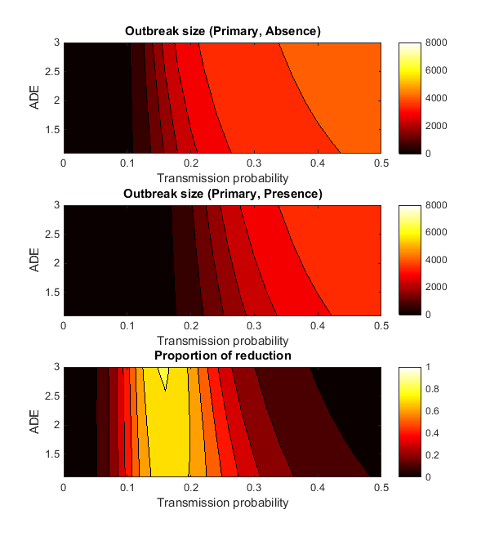
Fig S1.Plot of the outbreak size in the absence (top) and presence (middle) of Wolbachia-carrying mosquitoes. The bottom plot gives the proportional reduction in dengue due to Wolbachia. All plots show primary infections (only) assumingsymmetric epidemiological characteristics of the two serotypes. ADE is the antibody-dependent enhancement.

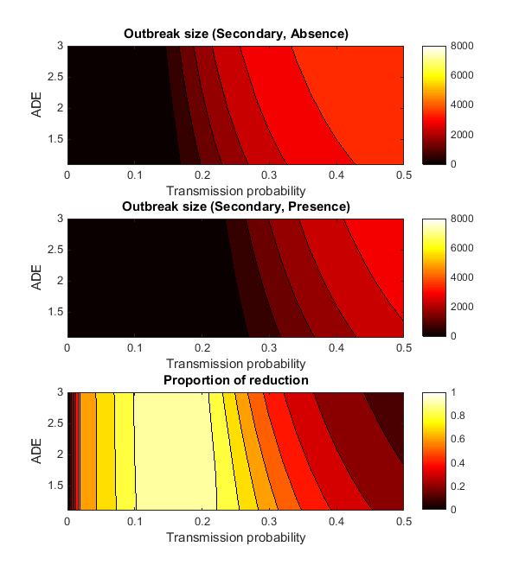
Fig. S2.Plot of the outbreak size in the absence (top) and presence (middle) of Wolbachia-carrying mosquitoes. The bottom plot gives the proportional reduction in dengue due to Wolbachia. All plots show secondary infections (only) assuming symmetric epidemiological characteristics of the two serotypes. ADE is the antibody-dependent enhancement.

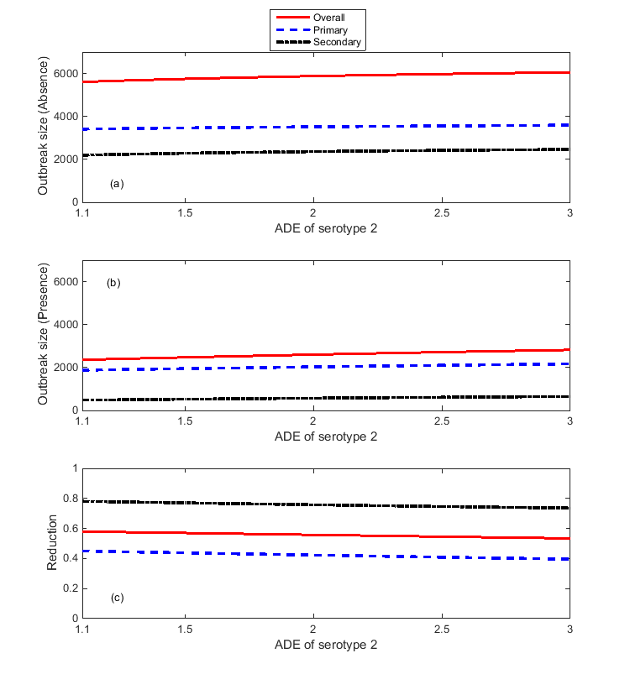
Fig. S3.The effect of changes in the antibody dependent enhancement for serotype 2 on
dengue cases. All plots show overall (solid red lines), primary (dashed blue lines) and secondary(dash-dot black lines) infections. Plots (a) and (b) show outbreak sizes in the absence and presenceof Wolbachia-carrying mosquitoes, respectively, and plot (c) shows the proportional reduction indengue incidence due to Wolbachia.
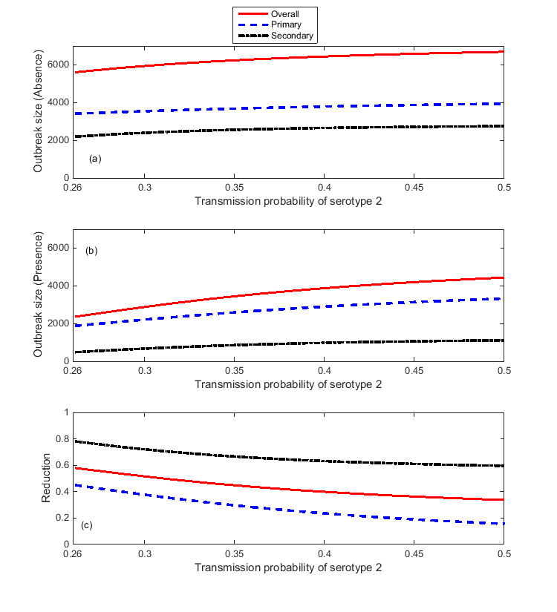
Fig.S4.The effect of changes in the transmission probability of serotype 2 in dengue cases,
when the transmission probability of serotype 1 is fixed. All plots show the overall(solid red lines), primary (dashed blue lines) and secondary (dash-dot black lines) infections.The plots (a) and (b) show outbreak size in the absence and presence of Wolbachia-carryingmosquitoes, respectively, and the plot (c) shows proportional reduction in dengue due to Wolbachia.

References
1. Hoffmann AA, et al. Successful establishment of Wolbachia in Aedes populations to suppress dengue transmission. Nature, 2011; 476:454-457.
2. Ndii MZ, Hickson RI, and Mercer GN. Modelling the introduction of Wolbachia into Aedes aegypti to reduce dengue transmission. The ANZIAM Journal, 2012; 53:213-227.
3. Hoffmann AA, Turelli M, and Harshman LG. Factors affecting the distribution of cytoplasmic incompatibility in Drosophila simulans. Genetics, 1990; 126:933-948.
4. World Health Organisation, Global Health Observatory (GHO). 2012 [cited 2015 1 May ].
5. Scott TW, et al. Longitudinal studies of Aedes aegypti (Diptera: Culicidae) in Thailand and Puerto Rico: blood feeding frequency. Journal of Medical Entomology, 2000; 37:89-101.
6. Turley AP, et al. Wolbachia infection reduces blood-feeding success in the dengue fever mosquito, Aedes aegypti. PLoS Neglected Tropical Diseases, 2009; 3:e516.
7. Ndii MZ, et al. Modelling the transmission dynamics of dengue in the presence of Wolbachia. Mathematical Biosciences, 2015; 262:157-166.
8. Gubler DJ. Dengue and Dengue Hemorrhagic Fever. Clinical Microbiology Reviews, 1998; 11:480-496.
9. Chowell G, et al. Estimation of the reproduction number of dengue fever from spatial epidemic data. Mathematical Biosciences, 2007; 208:571-589.
10. Yang HM, et al. Assessing the effects of temperature on the population of Aedes aegypti, the vector of dengue. Epidemiology & Infection, 2009; 137:1188-1202.
11. Population and housing fact sheet. 2009 [cited 2015 12 May].
12. Hu K, et al. The effect of antibody-dependent enhancement, cross immunity, and vector population on the dynamics of dengue fever. Journal of Theoretical Biology, 2013; 319:62-74.
13. Walker T, et al. The wMel Wolbachia strain blocks dengue and invades caged Aedes aegypti populations. Nature, 2011; 476:450-453.
14. Bian G, et al. The Endosymbiotic Bacterium Wolbachia Induces Resistance to Dengue Virus in Aedes aegypti. PLoS Pathogen, 2010; 6:e1000833.
15. Matheus S, et al. Discrimination between primary and secondary dengue virus infection by an immunoglobulin G avidity test using a single acute-phase serum sample. Journal of Clinical Microbiology, 2005; 43:2793-2797.
16. Arrivillaga J and Barrera R. Food as a limiting factor for Aedes aegypti in water-storage containers. Journal of Vector Ecology, 2004; 29:11-20.

