SUPPLEMENTARY MATERIAL

Supplementary Table S1. Awareness of the spread of Ebola early April, especially in French news articles
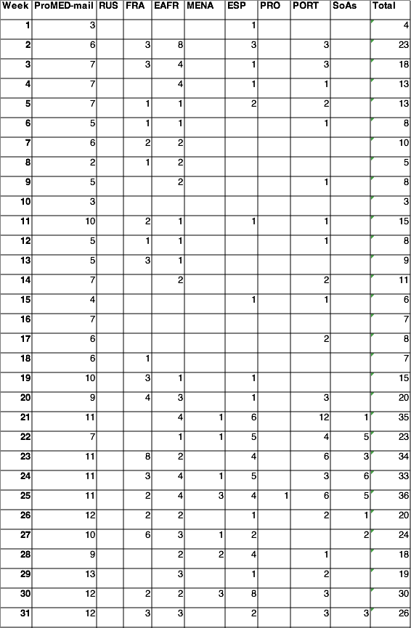

Supplementary Table S2. Search results for mass media news articles with headlines containing ‘Ebola’: ProQuest Newsstand; Dow Jones Factiva.

