SUPPLEMENTARY MATERIAL
Estimation of atypical scrapie prevalence of infection in GB at animal level
Methods
The basic approach used followed that described in Gubbins [1], where abattoir survey and fallen stock data were integrated using a back-calculation approach to determine the prevalence of infection in the national flock.
Back-calculation model
There are two possible ways that an animal could end up as a fallen stock positive at age a: (i) it reached clinical onset without being identified by the farmer and died of scrapie (we assume that there are no reported cases of scrapie so animals reaching clinical onset will die and become fallen stock) (ii) it died on farm (not of scrapie) and happened to have scrapie. Probability (i) is the product of the risk of infection (denoted r), the probability of surviving to age a (denoted S(a)), and the probability density of the incubation period at age a (denoted f(a)). Probability (ii) is the product of the risk of infection, the proportion of animals of age a that are found dead on farm (denoted (S(a)-S(a+1)), and the likelihood that an infected animal of age a will be detected by the diagnostic test. We also allow the potential for differential slaughter of subclinically affected sheep, where subclinical sheep may be at higher risk of slaughter due to an effect of scrapie on their production traits, so that sheep end up in the fallen stock/clinical stream with probability 1-K, and in the healthy slaughter stream with probability K. Therefore the probability of being detected as a fallen stock positive at age a, denoted, is given by:
Where is the probability that the diagnostic test will detect an infected animal t months before clinical onset.
The likelihood that an animal would end up as an abattoir survey positive was given by the product of the risk of infection, the proportion of animals of age a that are sent for slaughter (i.e. do not die on farm) (1- (S(a)-S(a+1)), and the likelihood that an infected animal of age a will be detected by the diagnostic test. Therefore the probability of being detected as an abattoir survey positive at age a is given by:
The total likelihood of an animal ending up in the fallen stock or abattoir survey streams is the sum of the respective probabilities over all ages. The final log-likelihood is then the sum of the log-likelihoods of the binomial probabilities of the observed number of fallen stock/abattoir survey positives given the number of fallen stock/abattoir survey tested.
Estimation of the age of onset distribution
The age of onset distribution was estimated by fitting a lognormal incubation period to the observed age at onset of clinical cases in the Scrapie Notifications Database (SND) between 1993 and 2011, accounting for the age distribution of the population as applied by Gubbins and Gubbins et al. [1,2]. However due to a low number of passive surveillance cases with known ages (n=8), the positive cases confirmed by the Fallen Stock survey (2003-2012) were also included in the calculation, making the assumption that the majority of fallen stock atypical scrapie positives died due to scrapie. When the fallen stock positives were included, the total number of positive animals increased to 50 (Figure S1).
Although there was no data with which to estimate the sensitivity of the rapid test to detect atypical scrapie, it can be assumed it has the same sensitivity as the rapid test to detect classical scrapie [3], where it was estimated that it followed a logistic regression curve, with a sensitivity of 50% at approximately 70% of the incubation period completed, increasing to 100% at clinical onset
Results
Estimation of the age of onset distribution
The estimated prevalence of atypical scrapie in GB varied between years (Fig. S2) but a linear regression applied to the data showed no statistically significant trend in the prevalence of infection over time (p=0.79). The estimated prevalence of atypical scrapie, using the test sensitivity estimate from classical scrapie data was 0.10% (95% CI: 0.08-0.11%)
All data used in the preparation of this manuscript and supplementary material can be provide by contacting the corresponding author.

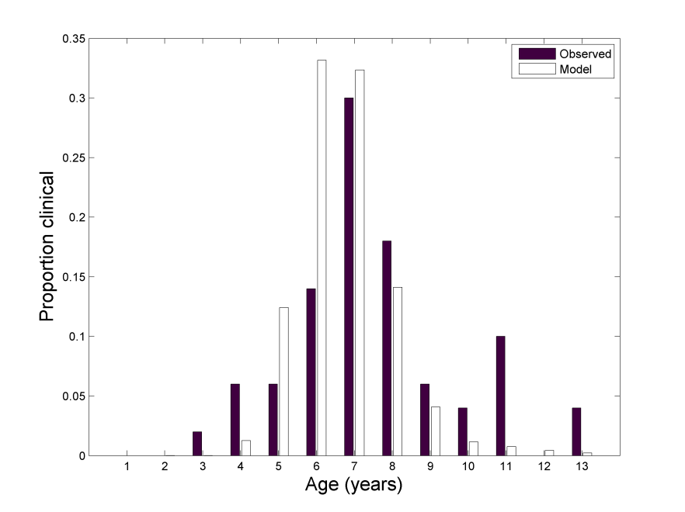
Figure S1. Comparison of the age distribution of reported cases/fallen stock of atypical scrapie in the Scrapie Notifications Database compared with that predicted by the lognormal incubation period distribution used in the back-calculation model of atypical scrapie infection prevalence.
Figure S2. The estimated prevalence of atypical scrapie each year 2005-2012 (black dots) and the mean prevalence across all years (dotted line) estimated using a back-calculation model applied to the number of atypical scrapie cases in GB.

Convergence diagnostics of the MCMC simulations
The function gelman.diag within the coda package in R to test the convergence of the MCMC with the number of iterations used. Values closed to 1 indicates convergence. Tables S1 and S2 contain the median of all Gelman-Rubin values from all replications for the random case.

Table S1. Median of all Gelman-Rubin values from all replications of random data in the yearly models
Year | Probability of detecting at least one holding with 2 cases of AS | # holdings with 1 case of AS
2006 | 1.00205 | 1.00044
2007 | 1.00853 | 1.00010
2008 | 1.01198 | 1.00052
2009 | 1.01435 | 1.00063
2010 | 1.01654 | 1.00031
2011 | 1.00383 | 1.00016
2012 | 1.00985 | 1.00025

Table S2. Median of all Gelman-Rubin values from all replications of random data in the three-year models
Year | # holdings ≥1 AS case1 CS case | # holdings ≥1 AS case 2 CS cases | # holdings ≥1 AS case 3 CS cases | Prob of detecting at least a holding with 2 AS cases | Prob of detecting ≥1 AS case 1 CS case | Prob of detecting ≥1 AS case 2 CS case | Prob of detecting ≥1 AS case 3 CS case | # holdings with 1 AS case | # holdings with 2 AS cases | # holdings with 3 AS cases
2006-09 | 1.0001 | 1.0098 | 1.0303 | 1.0003 | 0.9998 | 1.0098 | 1.0309 | 1.0002 | 1.0008 | 1.0556
2007-10 | 1.0004 | 1.0223 | 1.0821 | 1.0001 | 1.0000 | 1.0223 | 1.0408 | 1.0004 | 1.0005 | 1.0364
2008-11 | 1.0002 | 1.0192 | 1.0556 | 1.0002 | 0.9999 | 1.0192 | 1.0387 | 1.0002 | 1.0003 | 1.0294

Tables S3 and S4 contain the results from autocorr.diag command in the coda package. This command checks the correlation between different simulated lags. The table shows the median values for all population samples.
Table S3. Median values of correlation values between the different simulated lags in the yearly models
Probability of detecting at least one holding with 2 cases of AS
Lag | 2006 | 2007 | 2008 | 2009 | 2010 | 2011 | 2012
0 | 1 | 1 | 1 | 1 | 1 | 1 | 1
1 | -0.0022 | -0.0023 | -0.0071 | -0.0073 | -0.0069 | 0.0020 | -0.0019
5 | -0.0050 | -0.0100 | -0.0068 | -0.0065 | -0.0070 | 0.0017 | -0.0013
10 | 0.0011 | -0.0003 | -0.0071 | -0.0071 | -0.0071 | -0.0012 | -0.0006
50 | -0.0006 | -0.0097 | -0.0072 | -0.0072 | -0.0070 | -0.0006 | -0.0003
# holdings with 1 case of AS
0 | 1 | 1 | 1 | 1 | 1 | 1 | 1
1 | -0.0080 | 0.0019 | -0.0021 | 0.0020 | -0.0054 | -0.0014 | 0.0026
5 | 0.0002 | -0.0021 | 0.0026 | 0.0001 | 0.0048 | 0.0003 | 0.0015
10 | 0.0020 | 0.0032 | 0.0031 | -0.0039 | 0.0032 | -0.0017 | -0.0027
50 | -0.0079 | 0.0029 | 0.0014 | 0.0001 | -0.0051 | -0.0023 | -0.0021

Table S4. Median values of correlation values between the different simulated lags in the three-year models
Lag | # holdings ≥1 AS case1 CS case | # holdings ≥1 AS case 2 CS cases | # holdings ≥1 AS case 3 CS cases | Prob of detecting at least a holding with 2 AS cases |  | Prob of detecting ≥1 AS case 1 CS case |  | Prob of detecting ≥1 AS case 2 CS case | Prob of detecting ≥1 AS case 3 CS case |  | # holdings with 1 AS case | # holdings with 2 AS cases |  | # holdings with 3 AS cases
2006-2009
0 | 1 | 1 | 1 | 1 | 1 |  | 1 |  | 1 | 1 |  | 1 | 1
1 | -0.0013 | -0.0075 | -0.0006 | 0.0003 | 0.0032 |  | -0.0075 |  | -0.0005 | -0.0060 |  | -0.0007 | -0.0010
5 | -0.0034 | -0.0071 | -0.0006 | -0.0037 | -0.0004 |  | -0.0073 |  | -0.0005 | 0.0007 |  | -0.0048 | -0.0010
10 | -0.0023 | -0.0075 | -0.0006 | 0.0010 | 0.0003 |  | -0.0075 |  | -0.0004 | -0.0049 |  | 0.0027 | -0.0010
50 | 0.0001 | -0.0068 | -0.0006 | -0.0021 | 0.0039 |  | -0.0068 |  | -0.0004 | -0.0008 |  | -0.0018 | -0.0010
2007-2010
0 | 1 | 1 | 1 | 1 | 1 |  | 1 |  | 1 | 1 |  | 1 | 1
1 | -0.00321 | -0.00382 | -0.0003 | -0.00289 | 0.004353 |  | -0.00382 |  | -0.0003 | 0.005677 |  | -0.0047 | -0.0005
5 | -0.00157 | -0.00342 | -0.0003 | 0.000647 | -0.00333 |  | -0.00342 |  | -0.0003 | 0.000134 |  | -0.00043 | -0.0005
10 | 0.003968 | -0.00383 | -0.0003 | -0.00216 | 0.007838 |  | -0.00383 |  | -0.0003 | 0.004421 |  | -0.00431 | -0.0005
50 | 0.00112 | -0.00349 | -0.0003 | -0.00295 | 0.001661 |  | -0.00349 |  | -0.0002 | -0.00367 |  | -0.00011 | -0.00041
2008-2011
0 | 1 | 1 | 1 | 1 | 1 |  | 1 |  | 1 | 1 |  | 1 | 1
1 | -0.0003 | -0.0042 | -0.0004 | -0.0022 | 0.0050 |  | -0.0042 |  | -0.0004 | 0.0011 |  | -0.0031 | -0.0008
5 | 0.0019 | -0.0046 | -0.0004 | 0.0030 | 0.0020 |  | -0.0046 |  | -0.0004 | -0.0055 |  | 0.0012 | -0.0008
10 | -0.0049 | -0.0046 | -0.0004 | 0.0028 | 0.0006 |  | -0.0046 |  | -0.0004 | -0.0003 |  | 0.0006 | -0.0008
50 | -0.0021 | -0.0043 | -0.0004 | 0.0081 | -0.0004 |  | -0.0043 |  | -0.0004 | -0.0007 |  | 0.0017 | -0.0008

REFERENCES
- Gubbins S. Prevalence of sheep infected with classical scrapie in Great Britain: integrating multiple sources of surveillance data for 2002. Journal of the Royal Society Interface 2008; 5: 1343-1351.
- Gubbins S, et al. Prevalence of scrapie infection in Great Britain: interpreting the results of the 1997-1998 abattoir survey. Proceedings of the Royal Society of London, Series B 2003; 270: 1919-1924.
- Arnold M, Ortiz-Pelaez A. The evolution of the prevalence of classical scrapie in sheep in Great Britain using surveillance data between 2005 and 2012. Preventive Veterinary Medicine 2014; 117: 242-250.

