SUPPLEMENTARY MATERIAL

Supplementary Table S1: Classification of lower tract respiratory infection codes according to the 10th Revision of the International Classification of Diseases.
Category and subcategory |  | ICD-10 code | Label
Category: Empyema
 | Empyema | J86 | Pyothorax
Category: Pneumonia
 | Subcategory: Lobar (pneumococcal) pneumonia
 | Pneumococcal pneumonia | J13 | Pneumonia due to Streptococcus pneumonia
 |  | J18.1 | Lobar pneumonia, unspecified
 | subcategory: Unspecified pneumonia
 | Bacterial pneumonia unspecified | J15.9 | Bacterial pneumonia, unspecified
 | Bronchopneumonia, organism unspecified | J18.0 | Bronchopneumonia, unspecified
 | Pneumonia, organism unspecified | J18 | Pneumonia, organism unspecified
 |  | J18.8 | Other pneumonia, organism unspecified
 |  | J18.9 | Pneumonia, unspecified
 | Subcategory: Other pneumonia
 | Viral pneumonia | J12 | Viral pneumonia, not elsewhere classified
 | Pneumonia due to adenovirus | J12.0 | Adenoviral pneumonia
 | Pneumonia due to respiratory syncytial virus | J12.1 | Respiratory syncytial virus pneumonia
 | Pneumonia due to parainfluenza virus | J12.2 | Parainfluenza virus pneumonia
 | Pneumonia due to SARS-associated coronavirus
 | Pneumonia due to other virus not elsewhere classified | J12.8 | Other viral pneumonia
 | Viral pneumonia, unspecified | J12.9 | Viral pneumonia, unspecified
 | Influenza with pneumonia | J10.0 | Influenza with pneumonia, other influenza virus identified
 |  | J11.0 | Influenza with pneumonia, virus not identified
 | Other bacterial pneumonia | J15 | Bacterial pneumonia, not elsewhere classified
 | Pneumonia due to Klebsiella  Pneumonia | J15.0 | Pneumonia due to Klebsiella pneumonia
 | Pneumonia due to Pseudomonas | J15.1 | Pneumonia due to Pseudomonas
 | Pneumonia due to Hemophilus  influenzae | J14 | Pneumonia due to Haemophilus influenza
 | Pneumonia due to Streptococcus** | J15.3 | Pneumonia due to streptococcus, category B
 |  | J15.4 | Pneumonia due to other streptococci***
 | Pneumonia due to Staphylococcus | J15.2 | Pneumonia due to staphylococcus
 | Pneumonia due to other specified bacteria | J15.8 | Other bacterial pneumonia
 |  | J15.5 | Pneumonia due to Escherichia coli
 |  | J15.6 | Pneumonia due to other aerobic Gram-negative bacteria
 | Pneumonia due to other specified organism | J16 | Pneumonia due to other infectious organisms, not elsewhere classified
 |  | J15.7 | Pneumonia due to Mycoplasma pneumonia
 |  | J16.0 | Chlamydial pneumonia
 | Pneumonia in infectious diseases classified elsewhere | J17.X | Pneumonia in diseases classified elsewhere
Category: Bronchiolitis - Bronchitis
 | Subcategory: Bronchiolitis
 | Acute bronchiolitis | J21.X | Acute bronchiolitis
 | Subcategory: Bronchitis
 | Acute bronchitis  Bronchitis not specified as acute or chronic | J20.X | Acute bronchitis
 |  | J40 | Bronchitis, not specified as acute or chronic

Supplementary Table S2: Classification of birth cohorts according to the main vaccines used (≥ 90% of doses) for the primary immunization series and booster doses, as measured in the Quebec City Immunization Registry covering approximately 10% of births in the province of Quebec.

Date of birth | Main vaccines used | Follow-up (months) |  |  | Person (N) | Person-months  observation | Hospital admissions  (No)
 |  | Min | Median | Max
2007.01.01
to | PCV-7 + PCV-7 | 24.0 | 24.0 | 24.0 | 112249 | 2694563 | 3873
2008.05.01
to | PCV-7 + PCV-7/PCV-10 | 24.0 | 24.0 | 24.0 | 22764 | 547078 | 688
2008.08.01
to | PCV-7 + PCV-10 | 24.0 | 24.0 | 24.0 | 44447 | 1068178 | 1793
2009.02.01
to | PCV-7/PCV-10 + PCV-10 | 24.0 | 24.0 | 24.0 | 28760 | 691198 | 827
2009.06.01
to | PCV-10 + PCV-10 | 24.0 | 24.0 | 24.0 | 38929 | 935568 | 1349
2009.11.01 | -13
to | PCV-10 + PCV-10/PCV-13 | 24.0 | 24.0 | 24.0 | 27481 | 660347 | 1036
2010.03.01
to | PCV-10 + PCV-13 | 18.9 | 21.5 | 23.9 | 37370 | 803013 | 863
2010.08.01
to | PCV-10/PCV-13 + PCV-13 | 15.9 | 17.5 | 18.9 | 23470 | 411306 | 588
2010.11.01
to | PCV-13 + PCV-13 | 13.9 | 14.9 | 15.9 | 14175 | 212870 | 344
2010.12.31

Supplementary Table S3: Additive and multiplicative models for first and all hospitalizations for pneumonia among children born January 2007 to December 2010 older than 90 days and less than 2 years of age, in the province of Quebec, Canada.

Predictors |  | Additive Poisson model ¹ |  | Multiplicative Poisson model ²
 |  | First hospitalizations |  | First hospitalizations |  | All hospitalizations
 |  | Coefficient | P | Rate Ratio | P | Rate Ratio | P
Viral Circulation ³ | RSV | 0.002 | <.0001 | 1.02 | <.0001 | 1.02 | <.0001
 | hMPV | 0.002 | <.0001 | 1.05 | <.0001 | 1.05 | <.0001
 | Influenza | 0.0004 | 0.03 | 1.01 | 0.00019 | 1.01 | <.01
Temperature ⁴ | ºC | 0.001 | <.0001 | 1.03 | <.0001 | 1.03 | <.0001
Age in months | 3 – 5 months | Ref | - | Ref | - | Ref | -
 | 6 – 8 months | 0.002 | 0.52 | 1.23 | <.01 | 1.28 | <.01
 | 9 – 11 months | 0.010 | <.001 | 1.67 | <.0001 | 1.73 | <.0001
 | 12 – 17 months | 0.0206 | <.0001 | 2.02 | <.0001 | 2.15 | <.0001
 | 18- 23 months | 0.012 | 0.006 | 1.78 | <.0001 | 1.92 | <.0001
Month of birth | Jan – Sep | Ref | - | Ref | - | Ref | -
 | Oct – Dec | 0.004 | 0.07 | 1.15 | <.01 | 1.23 | 0.02
Hospitalization year | 2007 to 2012 | 0.001 | 0.75 | 0.93 | 0.15 | 0.95 | 0.44
Main vaccines ⁵ | PCV-7 + PCV-7 | Ref | - | Ref | - | Ref | -
 | PCV-7 + PCV-7/PCV-10 | -0.007 | 0.07 | 0.96 | 0.58 | 0.90 | 0.48
 | PCV-7 + PCV-10 | -0.003 | 0.48 | 1.09 | 0.27 | 1.05 | 0.69
 | PCV-7/PCV-10 + PCV-10 | -0.001 | 0.89 | 1.13 | 0.23 | 1.07 | 0.68
 | PCV-10 + PCV-10 | 0.003 | 0.69 | 1.13 | 0.27 | 1.02 | 0.92
 | PCV-10 + PCV-10/PCV-13 | -0.001 | 0.90 | 1.14 | 0.30 | 1.12 | 0.58
 | PCV-10 + PCV-13 | -0.0002 | 0.98 | 1.22 | 0.16 | 1.11 | 0.64
 | PCV-10/PCV-13 + PCV-13 | -0.010 | 0.25 | 1.08 | 0.66 | 0.95 | 0.82
 | PCV-13 + PCV-13 | -0.015 | <.01 | 0.64 | <.01 | 0.57 | 0.04

¹ Additive Poisson model assumes a linear relationship between intensity of exposure and response; ² Multiplicative Poisson model implies an exponential relationship between intensity of exposure and response; ³ Weekly percentage of positive tests; ⁴ 7-day moving average ambient air temperature (inversed) recorded in Trois-Rivières; ⁵ ≥90% of doses administered in each monthly birth cohorts for the primary infant series + toddler booster.

Supplementary Table S4: Additive and multiplicative models for the first and all hospitalizations of bronchiolitis among children born January 2007 to December 2010 (48 cohorts) older than 90 days of age and less than 2 years of age, in the province of Quebec, Canada.

Predictors |  | Additive Poisson model ¹ |  | Multiplicative Poisson model ²
 |  | First hospitalizations |  | First hospitalizations |  | All hospitalizations
 |  | Coefficient | P | Rate Ratio | P | Rate Ratio | P
Viral Circulation ³ | RSV | 0.006 | <.0001 | 1.04 | <.0001 | 1.04 | <.0001
 | hMPV | 0.003 | <.01 | 1.04 | <.0001 | 1.05 | <.0001
 | Influenza | 0.0003 | 0.50 | 1.01 | 0.00026 | 1.01 | 0.00223
Temperature ⁴ | ºC | 0.004 | <.0001 | 1.03 | <.0001 | 1.03 | <.0001
Age in months | 3 – 5 months | 0.200 | <.0001 | 6.68 | <.0001 | 6.11 | <.0001
 | 6 – 8 months | 0.138 | <.0001 | 4.56 | <.0001 | 4.44 | <.0001
 | 9 – 11 months | 0.114 | <.0001 | 3.60 | <.0001 | 3.69 | <.0001
 | 12 – 17 months | 0.071 | <.0001 | 2.14 | <.0001 | 2.17 | <.0001
 | 18- 23 months | Ref | - | Ref | - | Ref | -
Month of birth | Jan – Sep | Ref | - | Ref | - | Ref | -
 | Oct – Dec | 0.015 | 0.03 | 1.23 | <.0001 | 1.31 | 0.00151
Hospitalization year | 2007 to 2012 | -0.015 | 0.04 | 0.95 | 0.22 | 0.96 | 0.55
Main vaccines ⁵ | PCV-7 + PCV-7 | Ref | Ref | Ref | Ref | Ref | Ref
 | PCV-7 + PCV-7/PCV-10 | -0.007 | 0.58 | 0.95 | 0.47 | 0.90 | 0.46
 | PCV-7 + PCV-10 | 0.016 | 0.18 | 0.98 | 0.81 | 0.93 | 0.59
 | PCV-7/PCV-10 + PCV-10 | 0.019 | 0.20 | 0.96 | 0.68 | 0.88 | 0.39
 | PCV-10 + PCV-10 | 0.037 | 0.03 | 0.99 | 0.91 | 0.90 | 0.52
 | PCV-10 + PCV-10/PCV-13 | 0.031 | 0.12 | 1.17 | 0.15 | 1.12 | 0.54
 | PCV-10 + PCV-13 | 0.022 | 0.32 | 1.00 | 1.00 | 0.88 | 0.54
 | PCV-10/PCV-13 + PCV-13 | 0.036 | 0.16 | 1.00 | 0.97 | 0.90 | 0.63
 | PCV-13 + PCV-13 | -0.036 | 0.09 | 0.84 | 0.13 | 0.82 | 0.35

¹ Additive Poisson model assumes a linear relationship between intensity of exposure and response; ² Multiplicative Poisson model implies an exponential relationship between intensity of exposure and response; ³ Weekly percentage of positive tests; ⁴ 7-day moving average ambient air temperature (inversed) recorded in Trois-Rivières; ⁵ ≥90% of doses administered in each monthly birth cohorts for the primary infant series + toddler booster.

Supplementary Table S5: Fraction of pneumonia hospitalization cases attributable to virus and temperature in the additive model and multiplicative models

Predictors |  | Additive Poisson model ¹ |  | Multiplicative Poisson model ²
 |  | First hospitalizations |  | First hospitalizations |  | All hospitalizations
 |  | % | 95% CI | % | 95% CI | % | 95% CI
Viral Circulation ³ | RSV | 24.0 | 16.0, 30.4 | 20.9 | 13.1, 27.4 | 17.5 | 9.8, 24.1
 | hMPV | 7.8 | 4.7, 11.3 | 13.0 | 10.1, 15.8 | 12.2 | 9.5, 14.8
 | Influenza | 3.4 | 0.9, 6.8 | 6.9 | 3.5, 10.2 | 5.9 | 2.3, 9.2
Temperature ⁴ | (ºC) | 41.4 | 28.7, 51.0 | 49.2 | 40.5, 56.3 | 49.2 | 41.0, 55.9

¹ Additive Poisson model assumes a linear relationship between intensity of exposure and response; ² Multiplicative Poisson model implies an exponential relationship between intensity of exposure and response; ³ Weekly percentage of positive tests; ⁴ 7-day moving average ambient air temperature (inversed) recorded in Trois-Rivières.

Supplementary Table S6: Fraction of bronchiolitis (without bronchitis) hospitalization cases attributable to virus and temperature in the additive model and multiplicative models

 |  | Additive Poisson model ¹ |  | Multiplicative Poisson model ²
Predictors |  | First hospitalizations |  | First hospitalizations |  | All hospitalizations
 |  | % | 95% CI | % | 95% CI | % | 95% CI
Viral Circulation ³ | RSV | 21.8 | 17.6, 26.4 | 47.5 | 43.3, 51.1 | 42.6 | 38.3, 46.5
 | hMPV | 2.9 | 1.0, 4.9 | 12.3 | 9.6, 14.9 | 12.9 | 10.3, 15.3
 | Influenza | 0.6 | -1.2,2.7 | 6.1 | 2.9, 9.0 | 5.1 | 1.9, 8.1
Temperature ⁴ | (ºC) | 26.7 | 18.3, 34.3 | 54.2 | 46.9, 60.2 | 52.8 | 46.1, 58.4

¹ Additive Poisson model assumes a linear relationship between intensity of exposure and response; ² Multiplicative Poisson model implies an exponential relationship between intensity of exposure and response; ³ Weekly percentage of positive tests; ⁴ 7-day moving average ambient air temperature (inversed) recorded in Trois-Rivières.

Supplementary Figure S1. Univariate analysis of all LTRI hospitalization rate according to weekly viral positive test percentage and ambient temperature: A: 7-day moving average ambient temperature (ºC) in the city of Trois-Rivières; B: RSV; C: Influenza A&B; D: human Metapneumovirus (hMPV).

A.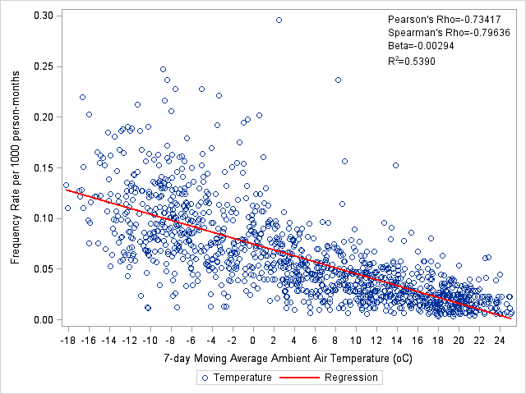
B.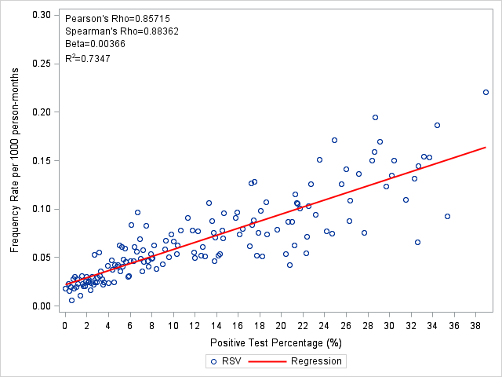
C.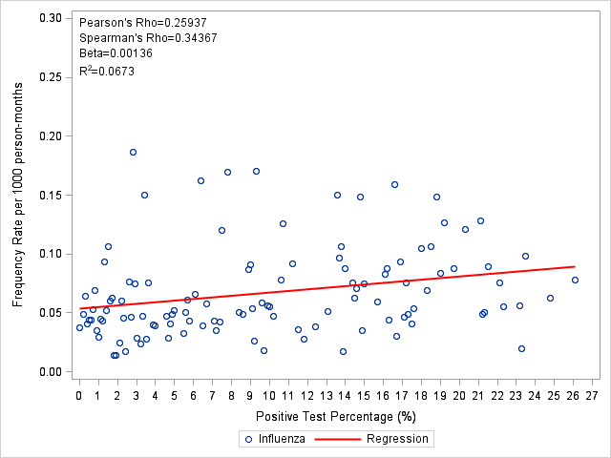
D.