EPIDEMIOLOGY AND INFECTION
Second-hand smoking and the risk of tuberculosis - a systematic review and a meta-analysis
O. F. Dogar*¹, N. Pillai¹, N. Safdar², S.K. Shah¹, R. Zahid², K. Siddiqi¹
Supplementary material:
Supplementary Figure S1. Sensitivity analysis by quality of study: Second-hand smoking and tuberculosis infection
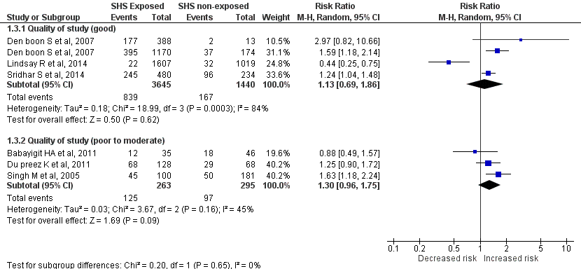

Supplementary Figure S2. Sensitivity analysis by TB diagnostic criteria: Second-hand smoking and tuberculosis infection
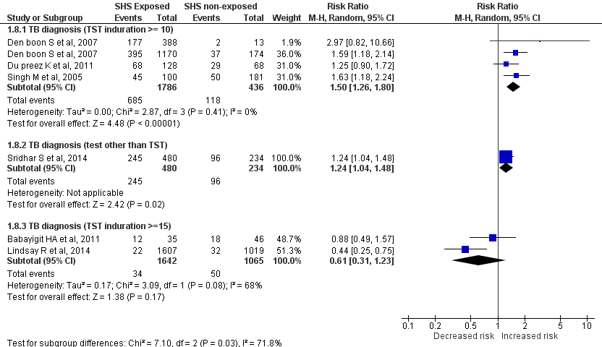

Supplementary Figure S3. Sensitivity analysis by quality of study: Second-hand smoking and tuberculosis disease
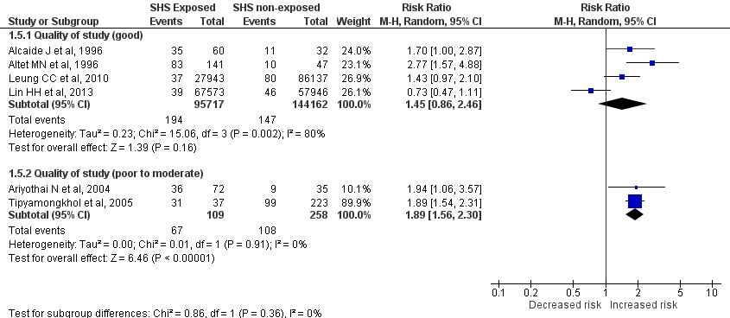

Supplementary Figure S4. Sensitivity analysis by design of study: Second-hand smoking and tuberculosis disease
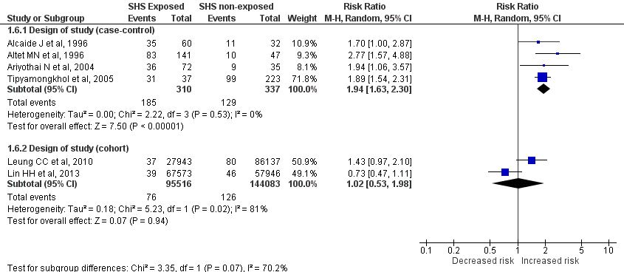

Supplementary Figure S5. Sensitivity analysis by diagnostic test for TB: Second-hand smoking and tuberculosis disease
