SUPPLEMENTARY MATERIAL

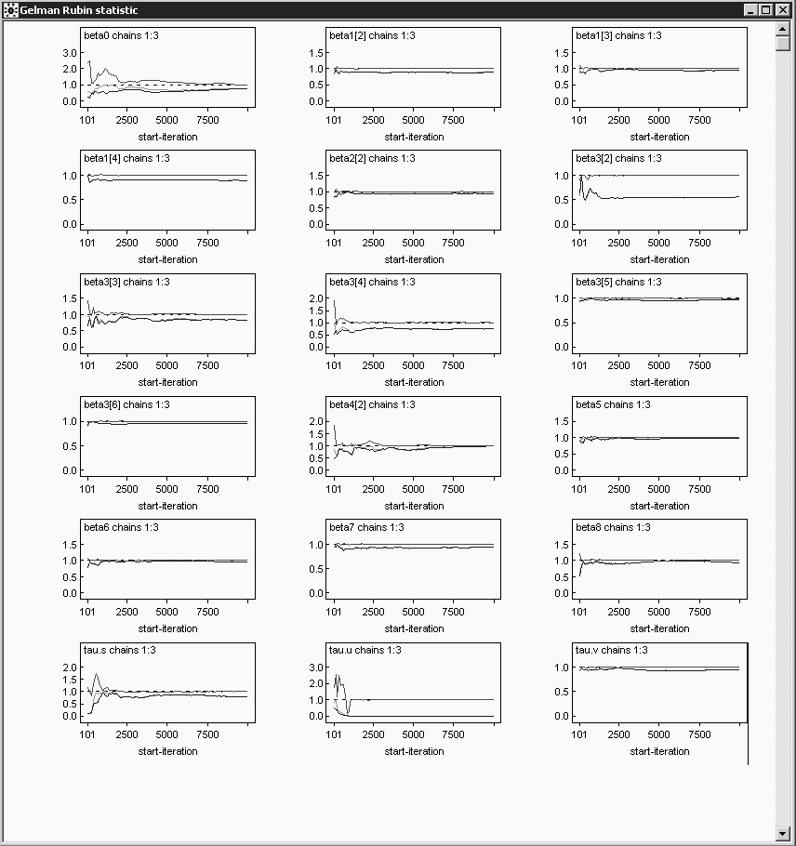
Supplementary Figure 1: Gelman Rubin diagnostic plots for monitored nodes.
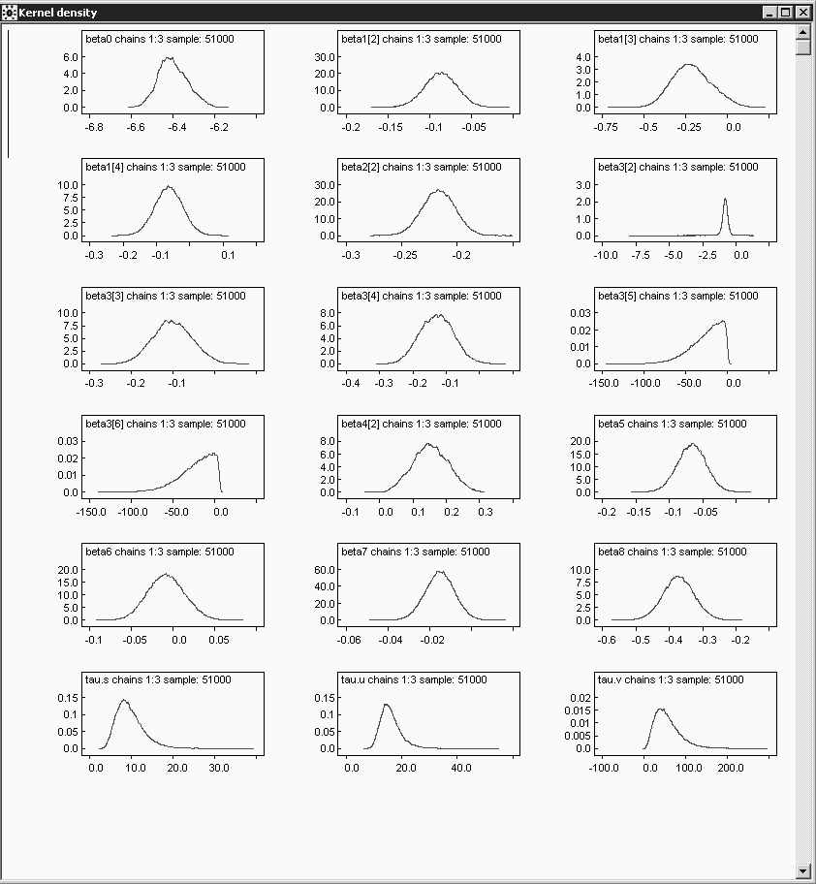
Supplementary Figure 2: Posterior distributions for monitored nodes.

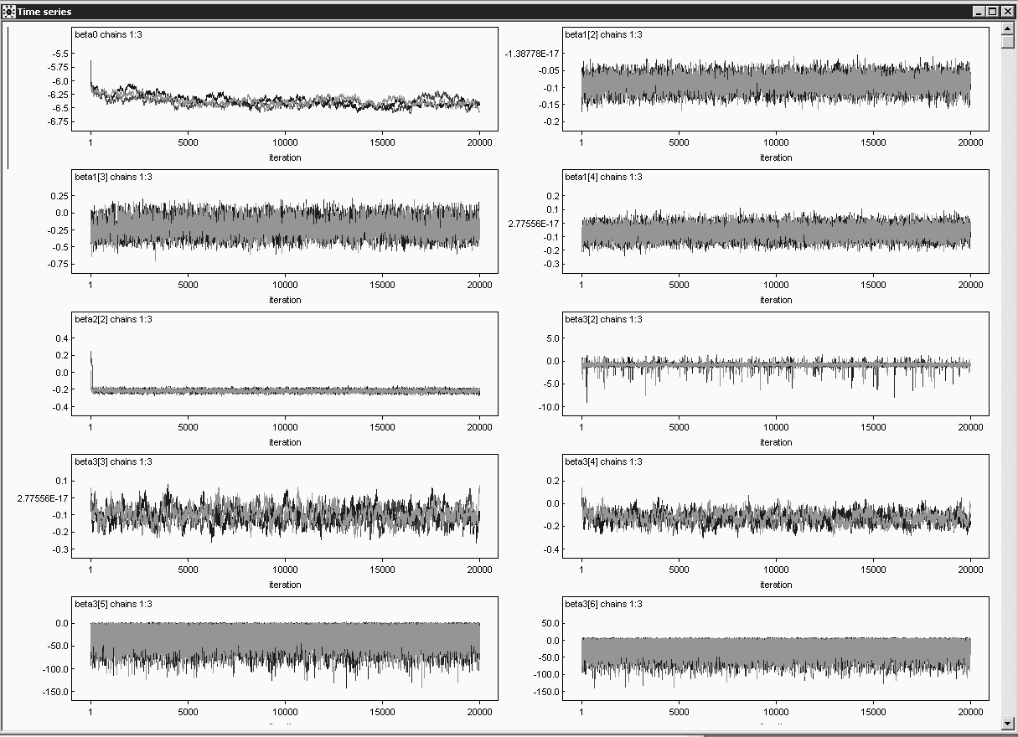
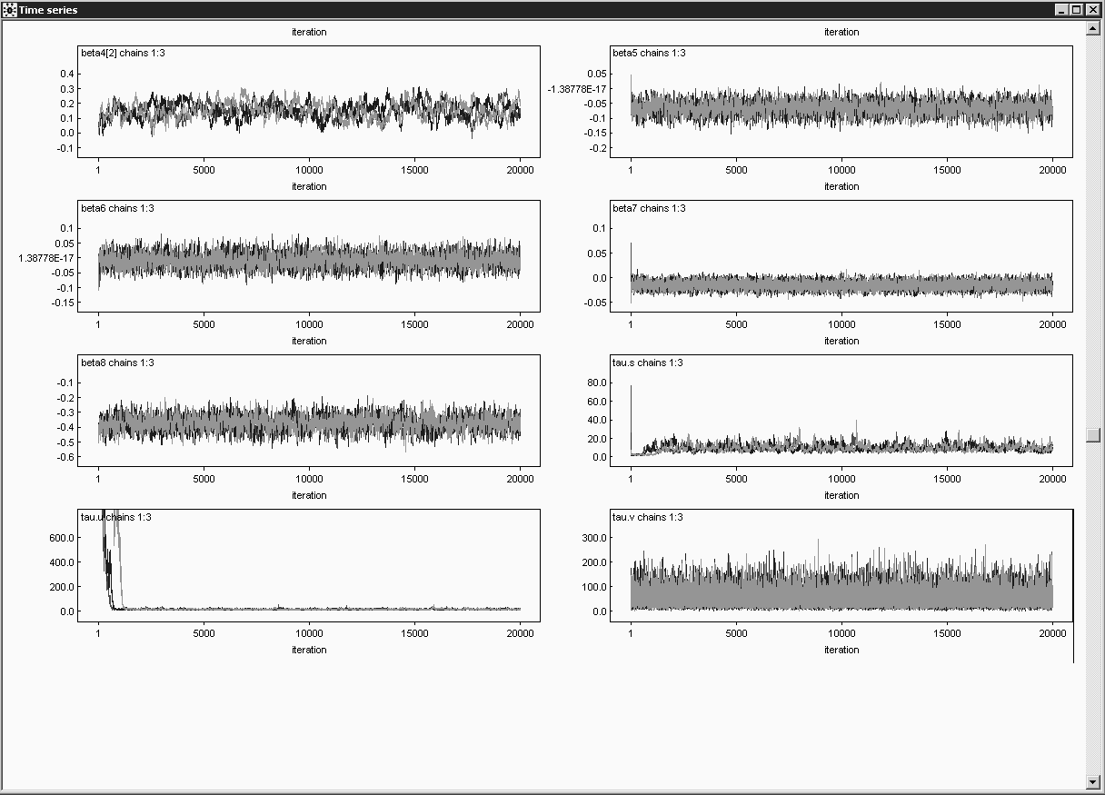
Supplementary Figure 3: Trace plots for monitored nodes.

