**SUPPLEMENTARY MATERIAL**

**Fig. S1**. Age-adjusted incidence by month and year of occurrence.

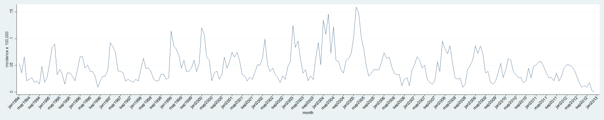

**Fig. S2.** Climate variables z-scores by month.

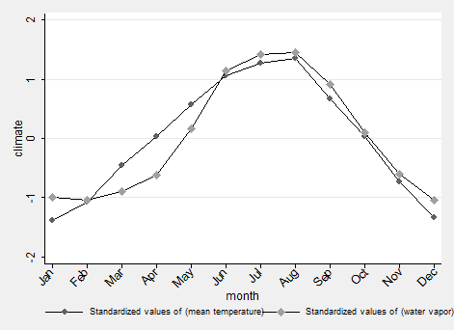

**Fig. S3.** Observed and expected incidence. Results from the random effect Poisson model.

