**SUPPLEMENTARY ONLINE MATERIAL**

**Meningococcal transmission model with differential equations**

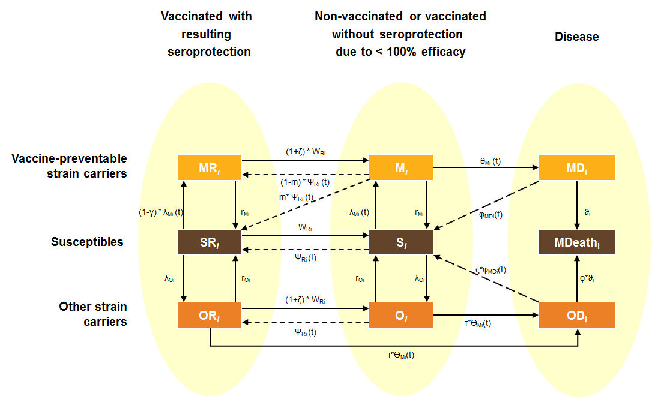

MR = infected – seroprotected (vaccine-preventable); M = infected (vaccine-preventable); MD = meningococcal disease (vaccine-preventable strains); SR = susceptible – seroprotected; S = susceptible; MDeath = death due to Invasive Meningococcal Disease (IMD); OR = infected – seroprotected (non-vaccine-preventable); O = infected (non-vaccine-preventable); OD = meningococcal disease (vaccine-preventable strains);

λ = force of infection; γ= vaccine efficacy against carriage acquisition (subject level); Ψ = effective coverage proportion; r = recovery rate from carriage; W = waning; case fatality rate; φ = rate surviving meningococcal disease; invasive disease rate;m = proportion of carriers of vaccine-preventable strains who recover immediately after successful vaccination; ζ = factor indicating higher waning under carriage; factor indicating different case fatality rate from other strains, τ = factor indicating different invasive disease rate for other strains; i = age stratum



Note: all-cause mortality is not covered in the figure above

The following equations describe the flow through the transmission model:

**Vaccine-preventable strain carriers vaccinated with resulting sero-protection**

 (1 - m) * ΨRi(t)* Mi(t) + (1 - γ) * λMi(t) * SRi(t) - (1 + ζ)*WRi * MRi(t) - rMi MRi(t)

**Susceptibles vaccinated with resulting seroprotection**

 rMi*MRi(t) + rOi*ORi(t) * + ΨRi(t)*Si(t) + m*ΨRi(t)*Mi(t) - λOi*SRi(t)   
 - (1 - γ)*λMi(t)*SRi(t) - WRi*SRi(t)

**Other strain carriers vaccinated with resulting seroprotection**

 ΨRi(t)*Oi(t) + λOi(t)*SRi(t) - (1 + ζ)*WRi*ORi(t) - rOi*ORi(t) - τ*Mi(t)*ORi(t)



**Vaccine preventable carriers non-vaccinated or vaccinated without seroprotection**

 λMi(t)*Si(t) + (1 + ζ)*WRi*MRi(t) - (1 - m) * ΨRi(t)* Mi(t) - m*ΨRi(t)*Mi(t) – rMi* Mi(t)   
 - Mi(t)*Mi(t)



**Susceptibles non-vaccinated or vaccinated without seroprotection**

 rMi* Mi(t) + rOi*Oi(t) + WRi*SRi(t) + φMDi(t)*MDi(t) + ς*φMDi(t)*ODi(t) - λMi(t)*Si(t)   
 - λOi(t)*Si(t) - ΨRi(t)*Si(t)

**Other strain carriers non-vaccinated or vaccinated without seroprotection**

 λOi(t)*Si(t) + (1 + ζ)*WRi*ORi(t) - rOi*Oi(t) - ΨRi(t)*Oi(t) – τ*Mi(t)*Oi(t)



**Invasive Meningococcal Disease cases due to vaccine preventable strains**

 Mi(t)*Mi(t) - φMDi(t)*MDi(t) – i*MDi(t)



**Invasive Meningococcal Disease cases due to other strains**

 τ*Mi(t)*Oi(t) + τ*Mi(t)*ORi(t) - ς*φMDi(t)*ODi(t) – *i*ODi(t)



**Number of meningococcal deaths**

 i*MDi(t) + *i*ODi(t)

