SUPPLEMENTARY MATERIAL

Table S1. Optimal fitted function for mean temperature, relative humidity, and rainfall in Hwalien, Taitung, Pingtung Counties, and Taipei City, respectively
Environmental factors | Fitted equationsª | r²
Temperature (°C)
Hwalien County (Fig. S2A) | Sinewave (23.64, −5.09, 12.00, 57.36) | 0.96
Taitung County (Fig. S2B) | Sinewave (24.77, −4.64, 12.00, 57.44) | 0.94
Pingtung County (Fig. S2C) | Sinewave (25.50, −3.71, 12.00, 57.47) | 0.90
Taipei City (Fig. S2D) | Sinewave (23.43, −6.67, 12.00, 57.39) | 0.96
Relative humidity (%)
Hwalien County (Fig. S2E) | Sinewave (76.46, −4.54, 12.00, 59.05) | 0.47
Taitung County (Fig. S2F) | Sinewave (73.27, −3.38, 12.00, 58.22) | 0.42
Pingtung County (Fig. S2G) | Sinewave (73.29, −6.02, 12.00, 57.95) | 0.62
Taipei City (Fig. S2H) | Sinewave (75.78, −2.20, 12.00, 53.86) | 0.18
Rainfall (mm)
Hwalien County (Fig. S2I) | Sinewave (197.65, 179.30, 12.00, 22.53) | 0.38
Taitung County (Fig. S2J) | Sinewave (138.39, 152.14, 12.00, 22.84) | 0.45
Pingtung County (Fig. S2K) | Sinewave (171.07, 238.27, 12.00, 22.82) | 0.42
Taipei City (Fig. S2L) | Sinewave (229.76, 162.34, 12.00, 23.54) | 0.32
ª$\text{Sinewave}\left(a,b,c,d\right)=a+b\text{sin}\left(2{πx}/c+d\right)$.

Table S2. Fitted coefficients in regression model for Hwalien, Taitung, Pingtung Counties, and Taipei City during 2005 – 2008, respectively
Fitted coefficient
Parameter | Hwalien County | Taitung County | Pingtung County | Taipei  City
Intercept | 34.37* | 20.27* | 78.77* | 106.00*
sin(2nπt/12)
n = 1 | 3.29* | −0.03 | −1.64 | −3.44
n = 2 | −1.70 | −0.58 | −1.88 | −2.92
n = 3 | −1.63 | 0.04 | −0.75 | −1.58
n = 4 | 1.19 | 0.36 | 1.01 | −2.49
n = 5 | 3.58* | 2.07* | 4.14 | 6.23*
cos(2nπt/12)
n = 1 | −4.15* | −2.13* | −4.03 | −7.04*
n = 2 | 3.10 | −0.08 | 1.37 | −2.52
n = 3 | −1.29 | 0.25 | 3.46 | 0.17
n = 4 | −1.44 | −0.70 | 0.04 | 0.44
n = 5 | −0.18 | 0.25 | 1.45 | 1.12
* p < 0.05.

Treatment failure

S
T_{R}
T_{S}
L_{R}
L_{S}
Transmission (DS strain)
Transmission (MDR strain)
Primary progression
Primary progression
Latency
Reactivation
Reinfection
Cure
Reactivation
Reinfection
Reinfection
Birth
Cure

Fig. S1. Drug-sensitive and drug-resistant two-strain TB model describing MDR TB population transmission dynamics in the present study.

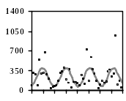
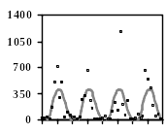
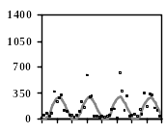
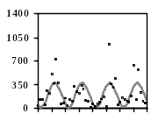
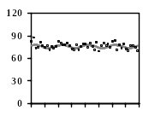
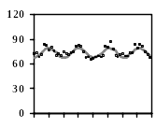
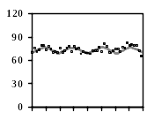
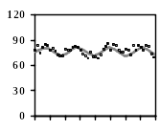
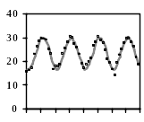
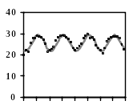
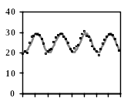
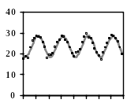
Time (mon)
Model
Data
r² = 0.96
r² = 0.94
r² = 0.90
r² = 0.96
r² = 0.47
r² = 0.42
r² = 0.62
r² = 0.18
r² = 0.38
r² = 0.45
r² = 0.42
r² = 0.32
Hwalien Country
Taitung Country
Pingtung Country
Taipei City
7
2005
7
2006
7
2007
7
2008
A
B
C
D
E
F
G
H
I
J
K
L
7
2005
7
2006
7
2007
7
2008
7
2005
7
2006
7
2007
7
2008
7
2005
7
2006
7
2007
7
2008
Temperature (°C)

Relative humidity (%)

Rainfall (mm)

Fig. S2. Monthly based time-series dynamics and sine wave function fitted results of (A, B, C, D) temperature, (E, F, G, H) relative humidity, and (I, J, K, L) rainfall from 2005 to 2008 in Hwalien, Taitung, and Pingtung Counties, and Taipei City, respectively.

