 | 2002 | 2003 | 2004 | 2005 | 2006 | 2007 | 2008 | 2009 | Overall
April-July | 2(2) | 169(43) | 183(66) | 184(57) | 205(66) | 117(51) | 150(59) | 88(57) | 1098(53)
April-Oct | 23(18) | 208(53) | 232(83) | 289(90) | 309(100) | 222(96) | 252(99) | 155(100) | 1690(82)

Supplementary Table S2. The number (percentage of annual total in parentheses) of birds sampled in April to July (that could be considered “early warning” surveillance), and April to October (the presumed vector season) for 2002 to 2009 in Great Britain.

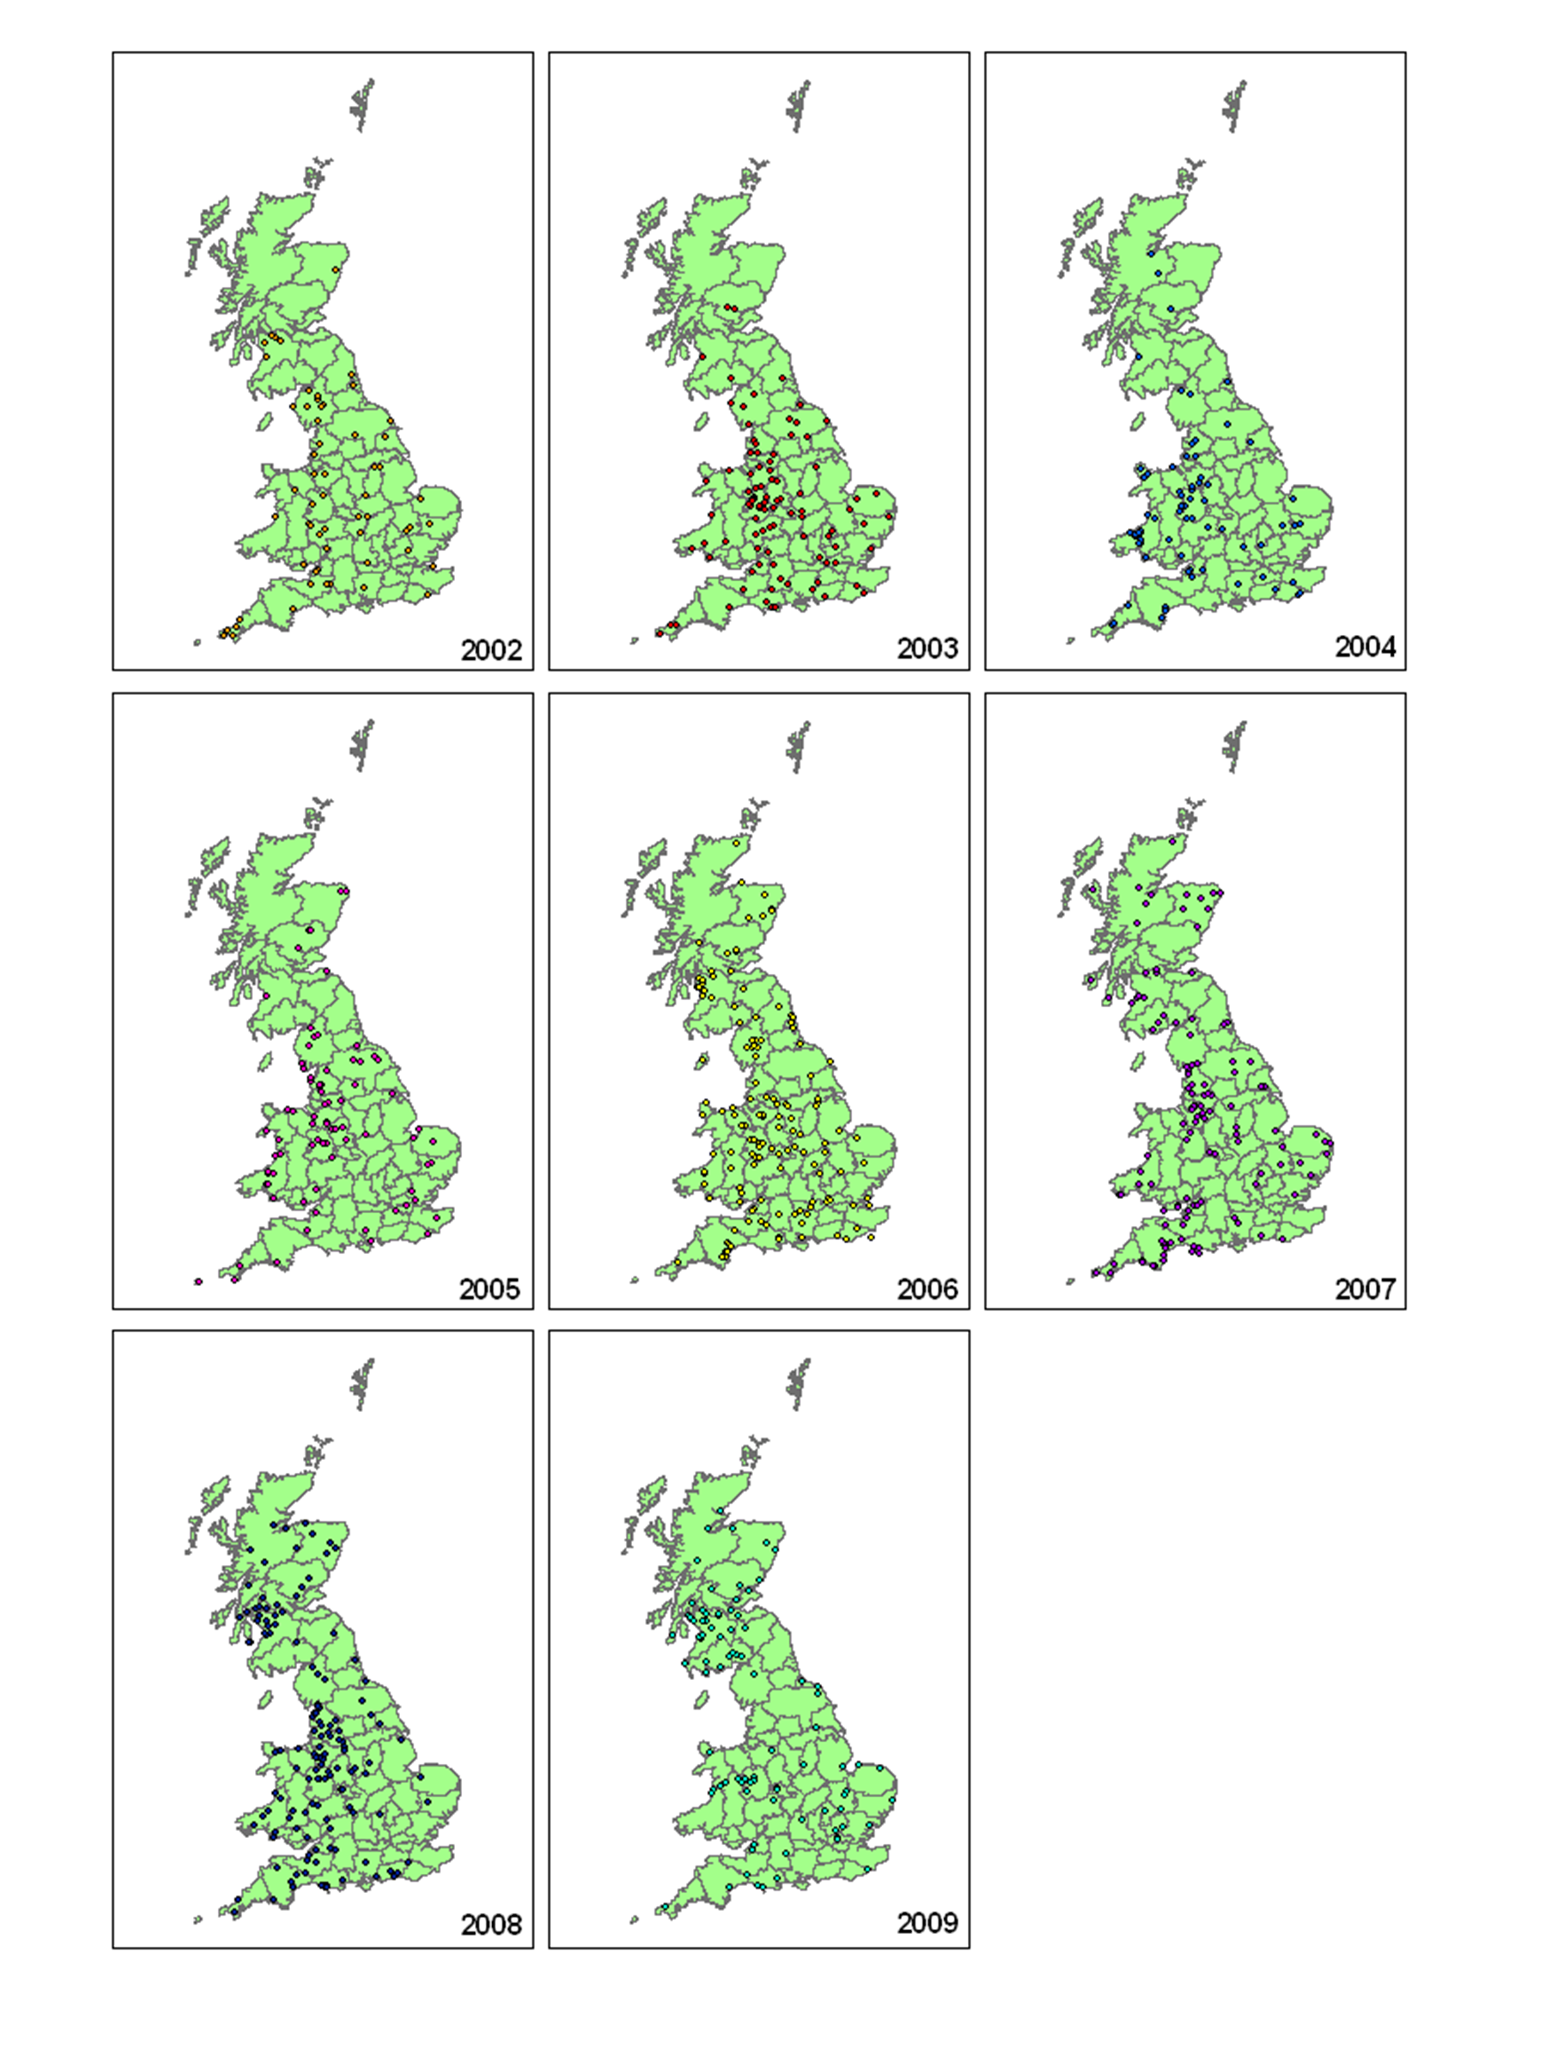
Supplementary Figure S1. Locations of dead bird samples received in Great Britain 2002-2009. Each point represents a single sampling location and does not show sampling intensity at any one point.

