Supplementary Figure S1
Fadeouts and Interepidemic periods (adapted from [1])

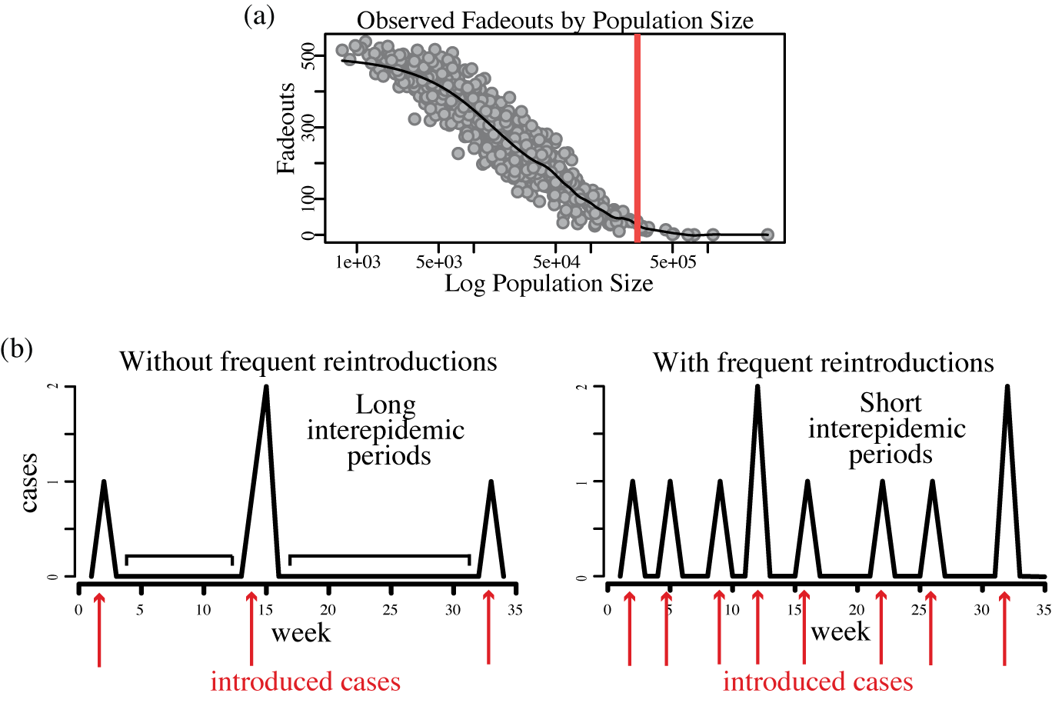

Figure S1. (a) This figure illustrates the classic relationship between population size and number of measles fadeouts as seen in pre-vaccination England and Wales from 1944-1964. Red line indicates CCS [2]. (b) Schematic showing the relationship between interepidemic periods and reintroductions for measles. Introduced cases end interepidemic periods and therefore determine their length. Infrequent or few introductions (red arrows) produce long interepidemic periods (left) whereas frequent or many introduced cases produce short interepidemic periods (right) [3, 4]. See discussion for application to meningitis.
References
(1) Bharti N, et al. Measles hotspots and epidemiological connectivity Epidemiology and Infection 2010; 138(09): 1308-1316.
(2) Bartlett MS. Measles periodicity and community size. Journal of the Royal Statistical Society Series a-General 1957; 120(1): 48-70.
(3) Bjornstad ON, Finkenstadt BF, Grenfell BT. Dynamics of measles epidemics: Estimating scaling of transmission rates using a Time series SIR model. Ecological Monographs 2002; 72(2): 169-184.
(4) Bjornstad ON, Grenfell BT. Hazards, spatial transmission and timing of outbreaks in epidemic metapopulations. Environmental and Ecological Statistics, 2008; 15: 265-277.

