Appendix 1: Pre and after satellite imagery analysis of the 9 identified Syrian dual KDE hotspots

Pre and after satellite imagery analysis of the 9 identified Syrian dual KDE hotspots. Photograph credits Marco Tiberio; ©Google Earth.
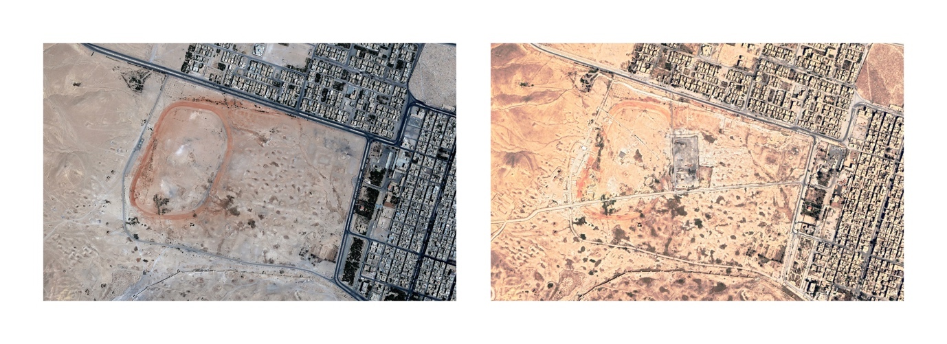
1) Hotspot R42C49 (08/09/2011 – 11/09/2019)
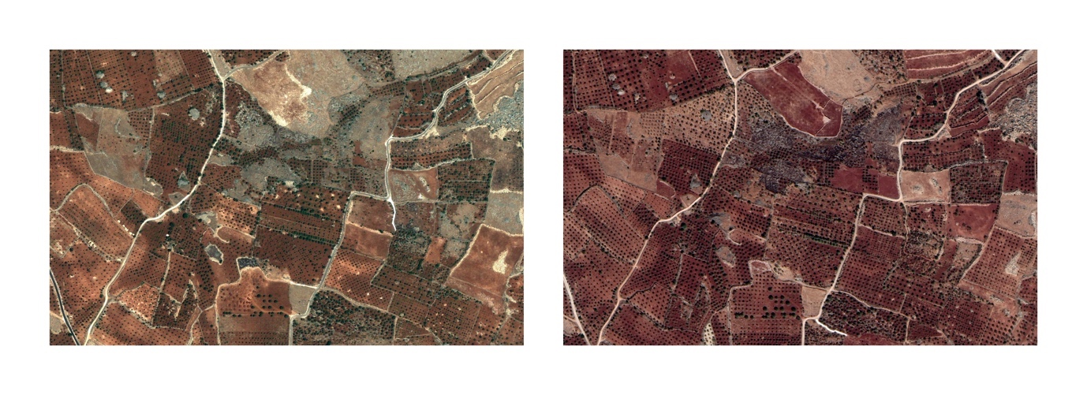
2) Hotspot R64C14 (26/06/2010 - 18/09/2019)
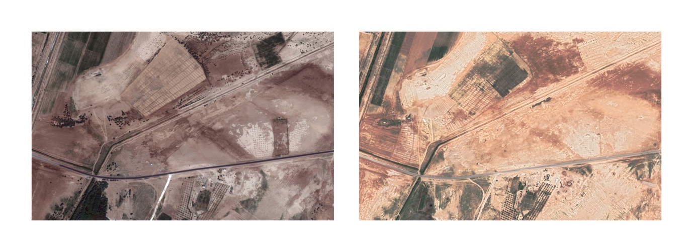
3) Hotspot R70C64 (17/08/2010 – 05/07/2018)
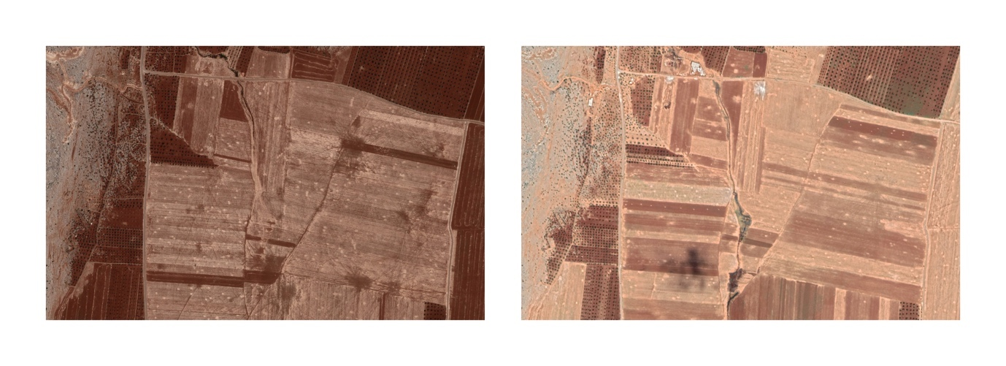
4) Hotspot R74C17 (07/07/2010 – 14/07/2019)
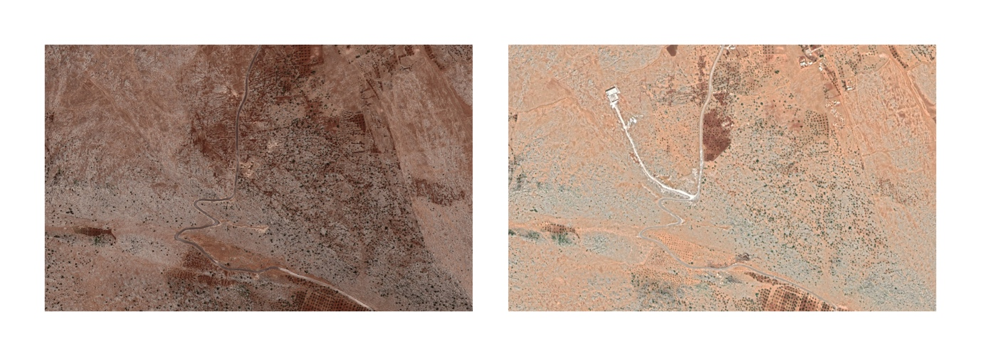
5) Hotspot R75C17 (07/07/2010 – 14/07/2019)
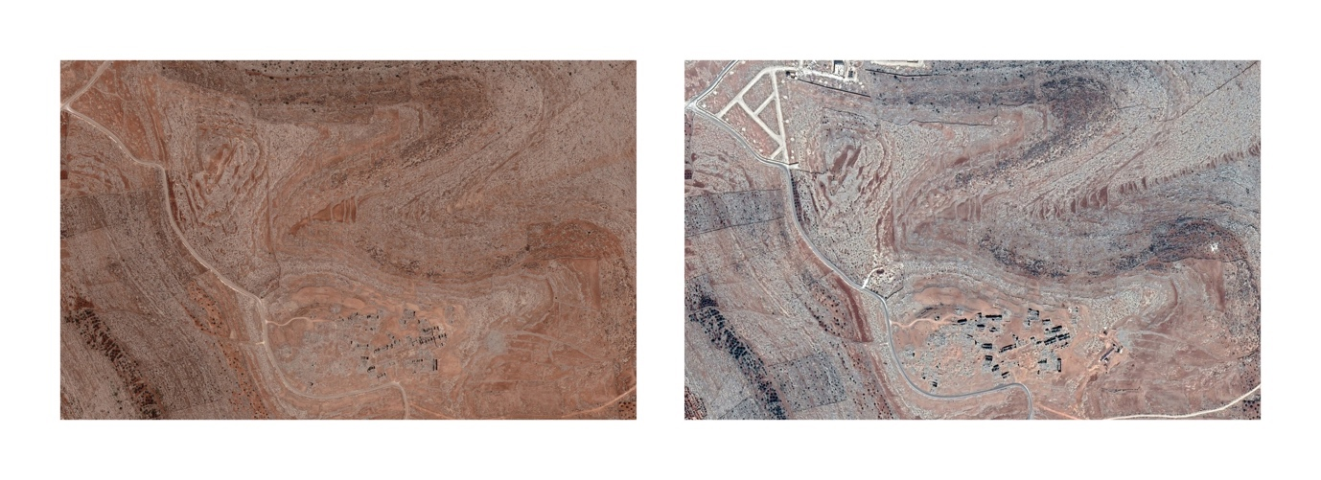
6) Hotspot R75C20 (07/07/2010 – 05/09/2018)
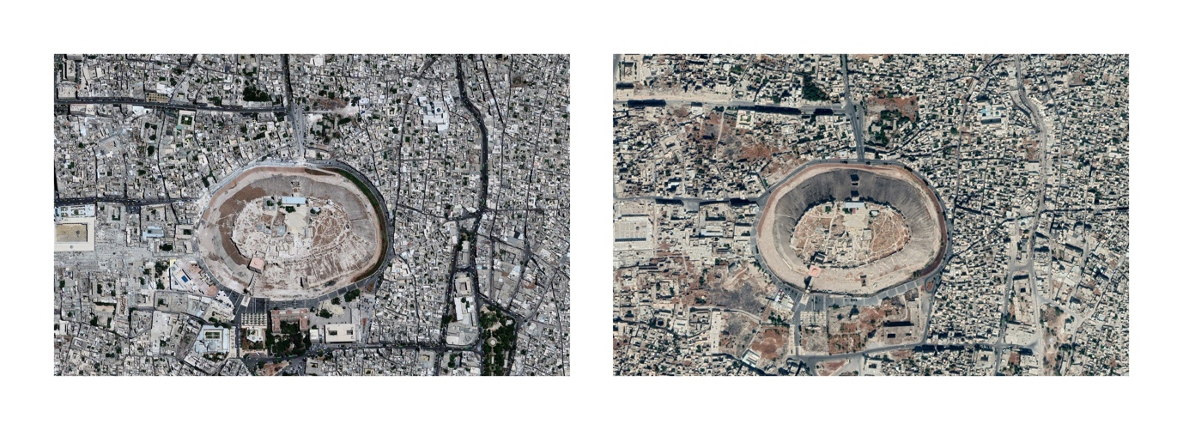
7) Hotspot R75C27 (04/07/2010 – 29/08/2019)
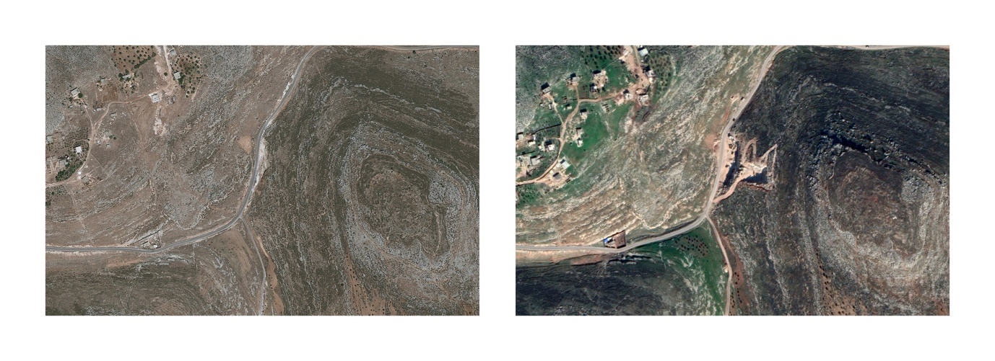
8) Hotspot R76C18 (26/06/2011 – 05/02/2019)
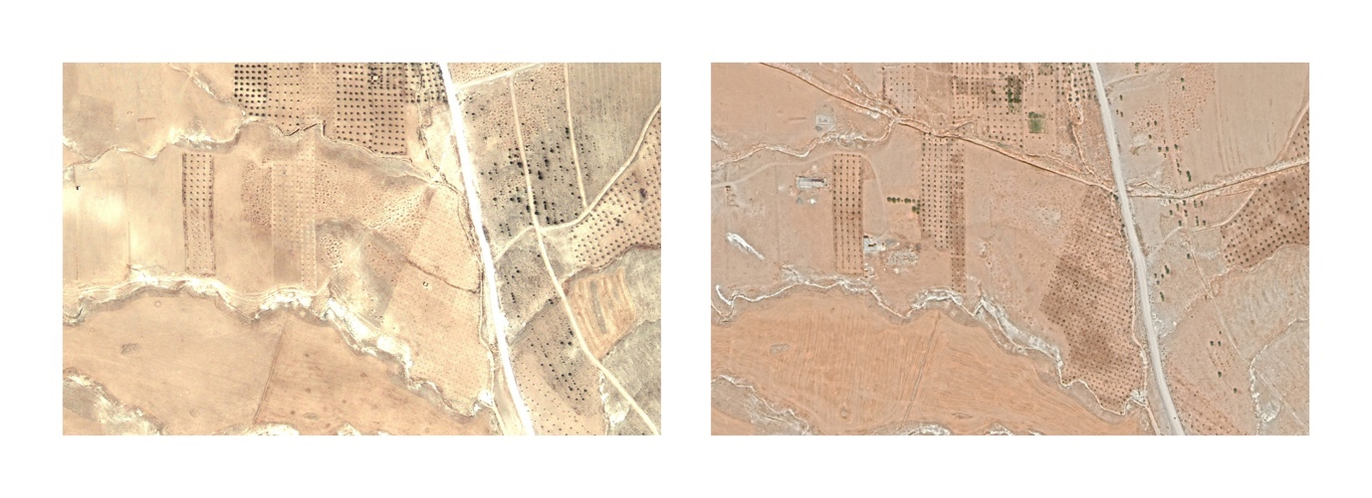
9) Hotspot R78C47 (29/07/2010 – 04/09/2019)

