Supplementary Appendix

Table 1. Edge weights in the network analyzing symptoms associated with PLEs based on continuous scores. Abbreviations: A, age; ADHD, attention–deficit/hyperactivity disorder symptoms; E, education; D, depressive symptoms; G, gender; GAD, generalized anxiety disorder symptoms; M, manic symptoms; O, occupation; PLEs, psychotic–like experiences.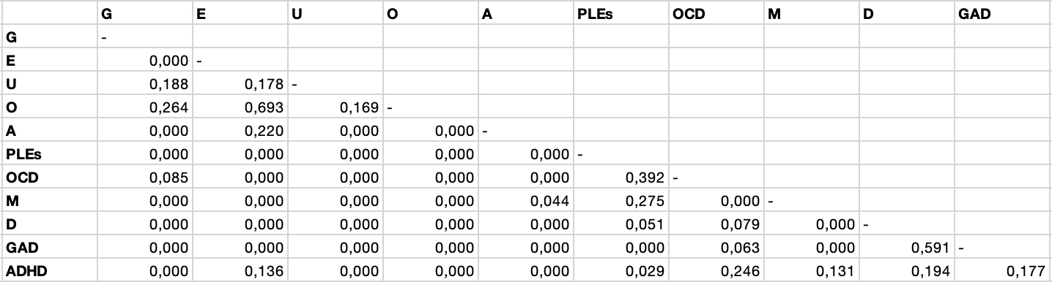

Table 2. Edge weights in the network analyzing clinically relevant symptoms associated with PLEs. Abbreviations: A, age; ADHD, attention–deficit/hyperactivity disorder symptoms; E, education; D, depressive symptoms; G, gender; GAD, generalized anxiety disorder symptoms; M, manic symptoms; O, occupation; PLEs, psychotic–like experiences.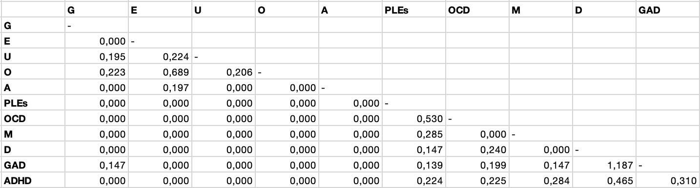

Table 3. Node predictability. Abbreviations: A, age; ADHD, attention–deficit/hyperactivity disorder symptoms; E, education; D, depressive symptoms; G, gender; GAD, generalized anxiety disorder symptoms; M, manic symptoms; O, occupation; PLEs, psychotic–like experiences.
Node | Predictability
 | Symptoms as continuous variables | Clinically relevant symptoms
G | 0.221 | 0.161
A | 0.051 | 0.037
E | 0.020 | 0.000
U | 0.037 | 0.075
O | 0.000 | 0.000
PLEs | 0.469 | 0.327
OCD | 0.503 | 0.332
M | 0.271 | 0.038
D | 0.647 | 0.535
GAD | 0.637 | 0.479
ADHD | 0.512 | 0.156
Figure 1. Stability of the strength centrality index in the network analyzing symptoms associated with PLEs based on continuous scores (A) and clinically relevant thresholds (B). The red line depicts the strength changes after removing various proportions of data
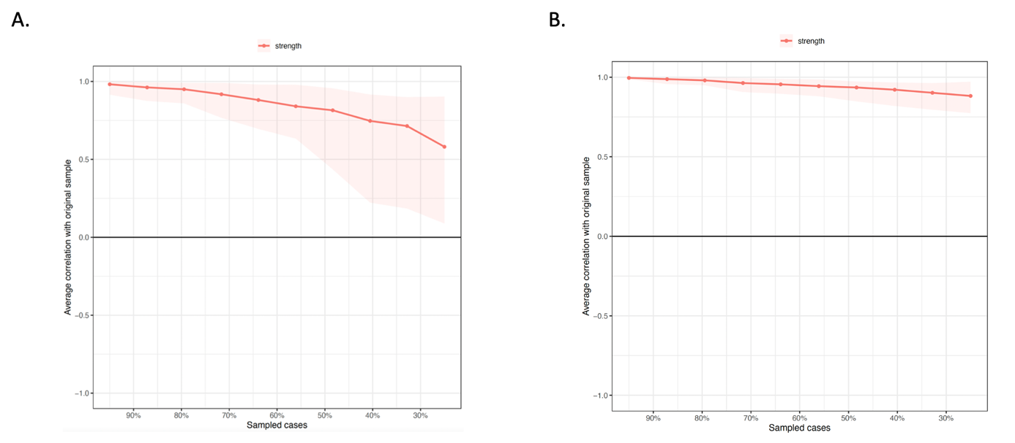

Figure 2. Bootstrapped 95% confidence intervals of estimated edge weights in the network analyzing symptoms associated with PLEs based on continuous scores (A) and clinically relevant thresholds (B). The sample values are illustrated with red lines. The bootstrapped 95% confidence intervals are depicted within the grey area. Abbreviations: A, age; ADHD, attention–deficit/hyperactivity disorder symptoms; E, education; D, depressive symptoms; G, gender; GAD, generalized anxiety disorder symptoms; M, manic symptoms; O, occupation; PLEs, psychotic–like experiences.

