Supplementary Information
Figure 1 - Protocol Workflow
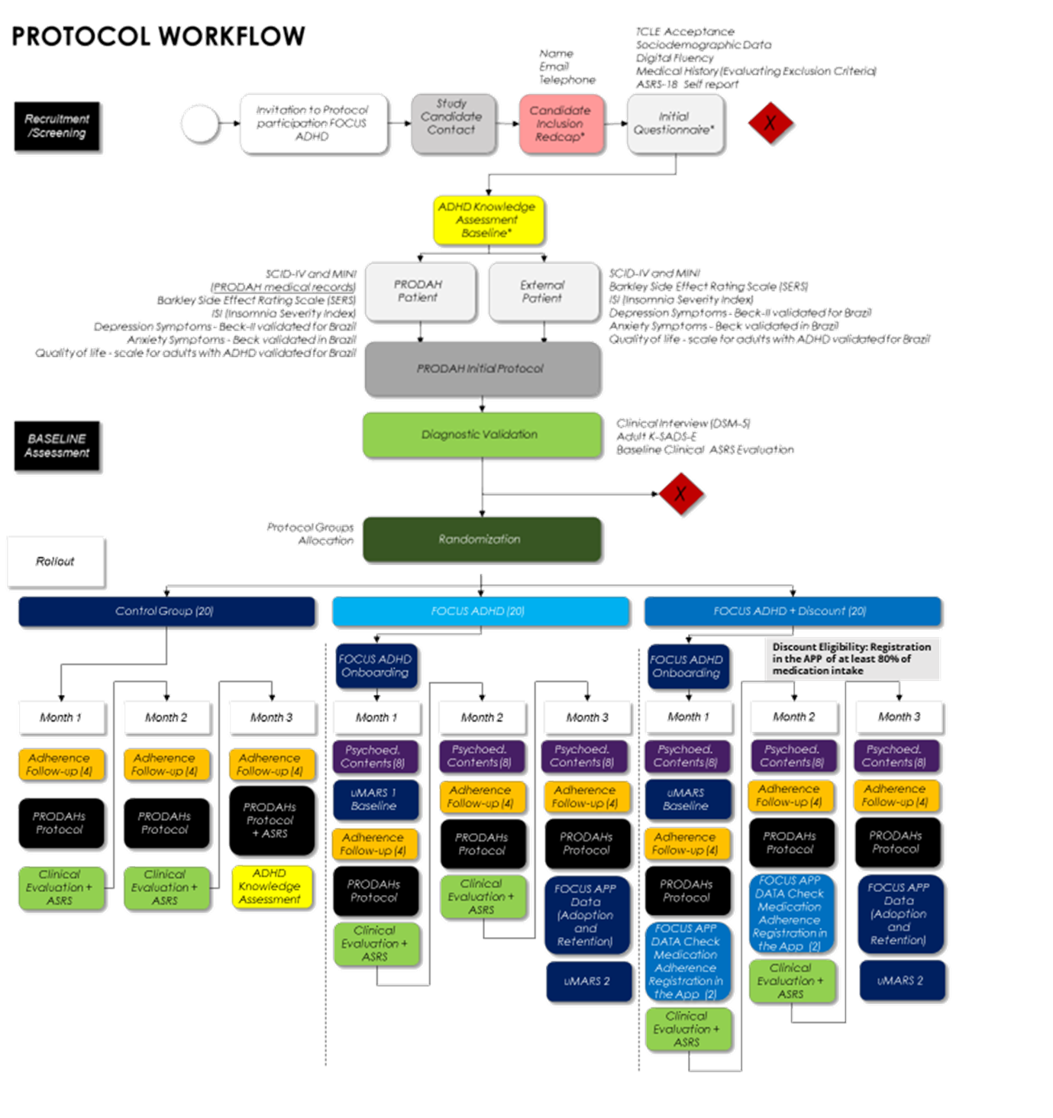

Table 1. Sample Characteristics and Sociodemographic Factors
 |  | Control |  |  | Focus |  |  | Focus + Discount |  |  | Total
 |  | N | M | SD | N | M | SD | N | M | SD | N | M | SD | Stat | p-value
Age¹ |  | 23 | 34.2 | 7.66 | 22 | 39.2 | 6.47 | 24 | 34.6 | 6.11 | 69 | 35.9 | 7.04 | 3.9 | 0.029
Family_Income² |  | 20 | 5.31 | 6.13 | 24 | 8.89 | 13.81 | 21 | 5.33 | 3.38 | 65 | 6.64 | 9.29 | 0.5 | 0.787
 |  |  |  | % col |  |  | % col |  |  | % col |  |  | % col
 | Female | 13 |  | 54.2% | 13 |  | 52.0% | 10 |  | 41.7% | 36 |  | 49.3%
Race⁴ | Non-White | 4 |  | 17.4% | 4 |  | 16.7% | 6 |  | 25.0% | 14 |  | 19.7% | 0.6 | 0.807
 | White | 19 |  | 82.6% | 20 |  | 83.3% | 18 |  | 75.0% | 57 |  | 80.3%
Civil Status ³ | Single/Divorced | 14 |  | 63.6% | 15 |  | 62.5% | 16 |  | 66.7% | 45 |  | 64.3% | 0.10 | 0.953
 | Married | 8 |  | 36.4% | 9 |  | 37.5% | 8 |  | 33.3% | 25 |  | 35.7%
Education⁴ | Postgraduate | 5 |  | 21.7% | 9 |  | 37.5% | 10 |  | 41.7% | 24 |  | 33.8% | 5.7 | 0.491
 | University | 9 |  | 39.1% | 6 |  | 25.0% | 5 |  | 20.8% | 20 |  | 28.2%
 | High School | 2 |  | 8.7% | 1 |  | 4.2% | 4 |  | 16.7% | 7 |  | 9.9%
 | University Incomplete | 7 |  | 30.4% | 8 |  | 33.3% | 5 |  | 20.8% | 20 |  | 28.2%
Employment³ | No | 7 |  | 30.4% | 6 |  | 25.0% | 4 |  | 16.7% | 17 |  | 23.9% | 1.2 | 0.537
 | Yes | 16 |  | 69.6% | 18 |  | 75.0% | 20 |  | 83.3% | 54 |  | 76.1%
1 ANOVA; 2 Kruskal Wallis; 3 X2; 4 Fisher's exact test

Table 2. Comorbidities and ADHD Type
 |  | Control |  |  | Focus |  |  | Focus + Disc. |  |  | Total
 |  | N | % lin | % col | N | % lin | % col | N | % lin | % col | N | % col | X² | p-val
Current major depressive disorder¹ | Absent | 23 | 31.9% | 95.8% | 25 | 34.7% | 100.0% | 24 | 33.3% | 100.0% | 72 | 98.6% | 2.07 | 0.658
 | Present | 1 | 100.0% | 4.2% | 0 | 0.0% | 0.0% | 0 | 0.0% | 0.0% | 1 | 1.4%
Past major depressive disorder | Absent | 8 | 32.0% | 33.3% | 8 | 32.0% | 32.0% | 9 | 36.0% | 37.5% | 25 | 34.2% | 0.18 | 0.915
 | Present | 16 | 33.3% | 66.7% | 17 | 35.4% | 68.0% | 15 | 31.3% | 62.5% | 48 | 65.8%
Current mania episode | Absent | 24 | 32.9% | 100.0% | 25 | 34.2% | 100.0% | 24 | 32.9% | 100.0% | 73 | 100.0% | - | -
Past mania episode¹ | Absent | 24 | 33.3% | 100.0% | 25 | 34.7% | 100.0% | 23 | 31.9% | 95.8% | 72 | 98.6% | 2.07 | 0.658
 | Present | 0 | 0.0% | 0.0% | 0 | 0.0% | 0.0% | 1 | 100.0% | 4.2% | 1 | 1.4%
Current hypomanic episode | Absent | 24 | 32.9% | 100.0% | 25 | 34.2% | 100.0% | 24 | 32.9% | 100.0% | 73 | 100.0% | - | -
Past hypomanic episode¹ | Absent | 23 | 32.4% | 95.8% | 24 | 33.8% | 96.0% | 24 | 33.8% | 100.0% | 71 | 97.3% | 1.01 | ~1
 | Present | 1 | 50.0% | 4.2% | 1 | 50.0% | 4.0% | 0 | 0.0% | 0.0% | 2 | 2.7%
Persistent Depression | Absent | 24 | 32.9% | 100.0% | 25 | 34.2% | 100.0% | 24 | 32.9% | 100.0% | 73 | 100.0% | - | -
Substance induced depressive disorder | Absent | 24 | 32.9% | 100.0% | 25 | 34.2% | 100.0% | 24 | 32.9% | 100.0% | 73 | 100.0% | - | -
Other bipolar disorder¹ | Absent | 23 | 32.4% | 95.8% | 25 | 35.2% | 100.0% | 23 | 32.4% | 95.8% | 71 | 97.3% | 1.07 | 0.543
 | Present | 1 | 50.0% | 4.2% | 0 | 0.0% | 0.0% | 1 | 50.0% | 4.2% | 2 | 2.7%
Substance Use Disorder¹ | Absent | 23 | 33.8% | 95.8% | 24 | 35.3% | 96.0% | 21 | 30.9% | 87.5% | 68 | 93.2% | 1.79 | 0.520
 | Present | 1 | 20.0% | 4.2% | 1 | 20.0% | 4.0% | 3 | 60.0% | 12.5% | 5 | 6.8%
Panic disorder¹ | Absent | 24 | 33.3% | 100.0% | 25 | 34.7% | 100.0% | 23 | 31.9% | 95.8% | 72 | 98.6% | 2.07 | 0.658
 | Present | 0 | 0.0% | 0.0% | 0 | 0.0% | 0.0% | 1 | 100.0% | 4.2% | 1 | 1.4%
Agoraphobia | Absent | 24 | 32.9% | 100.0% | 25 | 34.2% | 100.0% | 24 | 32.9% | 100.0% | 73 | 100.0% | - | -
Social phobia¹ | Absent | 21 | 32.8% | 87.5% | 22 | 34.4% | 88.0% | 21 | 32.8% | 87.5% | 64 | 87.7% | ~0 | ~1
 | Present | 3 | 33.3% | 12.5% | 3 | 33.3% | 12.0% | 3 | 33.3% | 12.5% | 9 | 12.3%
Generalized anxiety disorder¹ | Absent | 22 | 33.3% | 91.7% | 22 | 33.3% | 91.7% | 22 | 33.3% | 91.7% | 66 | 91.7% | ~0 | ~1
 | Present | 2 | 33.3% | 8.3% | 2 | 33.3% | 8.3% | 2 | 33.3% | 8.3% | 6 | 8.3%
ADHD symptoms before 12 years old¹ | Yes | 23 | 31.9% | 95.8% | 25 | 34.7% | 100.0% | 24 | 33.3% | 100.0% | 72 | 98.6% | 2.07 | 0.658
 | No | 1 | 100.0% | 4.2% | 0 | 0.0% | 0.0% | 0 | 0.0% | 0.0% | 1 | 1.4%
ADHD presentation¹ | Inattentive | 8 | 28.6% | 33.3% | 11 | 39.3% | 44.0% | 9 | 32.1% | 37.5% | 28 | 38.4% | 0.91 | 0.926
 | Hyperactive | 2 | 40.0% | 8.3% | 1 | 20.0% | 4.0% | 2 | 40.0% | 8.3% | 5 | 6.8%
 | Combined | 14 | 35.0% | 58.3% | 13 | 32.5% | 52.0% | 13 | 32.5% | 54.2% | 40 | 54.8%
Actual pharmachotherapy (Treatment as Usual - TAU) | Yes | 24 | 32.9% | 100.0% | 25 | 34.2% | 100.0% | 24 | 32.9% | 100.0% | 73 | 100.0% | - | -
Actual psychotherapy | Yes | 12 | 40.0% | 50.0% | 8 | 26.7% | 32.0% | 10 | 33.3% | 41.7% | 30 | 41.1% | 1.64 | 0.440
 | No | 12 | 27.9% | 50.0% | 17 | 39.5% | 68.0% | 14 | 32.6% | 58.3% | 43 | 58.9%
¹ Fisher's exact test

Table 3. Mean uMARS Score Evaluation
 | App |  |  | App + Discount |  |  | Total Focus
 | N | M | DP | N | M | DP | N | M | DP | Stat | p
uMARS | 9 | 3.16 | 0.59 | 16 | 3.62 | 0.61 | 25 | 3.45 | 0.63 | 40.00 | 0.074
Engagement | 9 | 2.64 | 0.57 | 16 | 3.02 | 0.62 | 25 | 2.89 | 0.62 | 44.50 | 0.125
Functionality | 8 | 3.54 | 0.88 | 16 | 3.74 | 0.89 | 24 | 3.67 | 0.88 | 58.50 | 0.759
Aesthetics | 8 | 3.20 | 0.59 | 16 | 3.63 | 0.66 | 24 | 3.49 | 0.66 | 37.50 | 0.108
Information | 8 | 3.41 | 0.92 | 15 | 4.08 | 0.73 | 23 | 3.84 | 0.85 | 28.50 | 0.043

