Supplementary material
Figure S1. Path diagram for valuing the invariance by the diagnostic subtype: standardized coefficients (results adjusted by age).

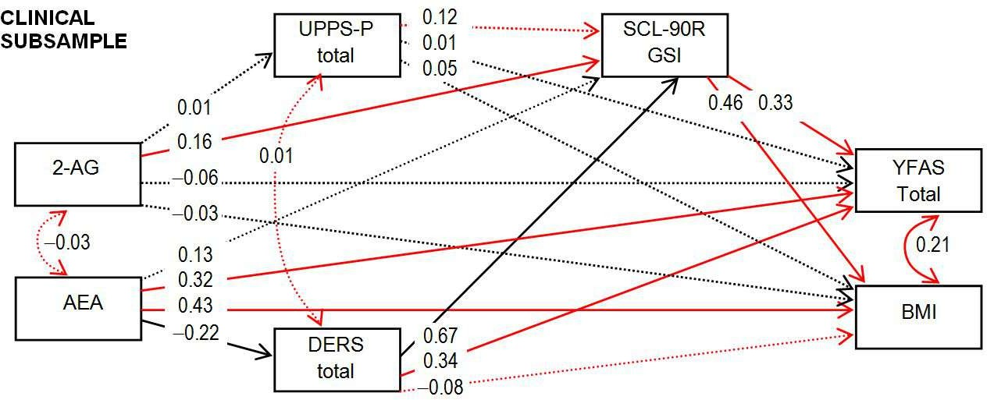
Note. AEA: anandamide. 2-AG: 2-arachidonoylglycerol. BMI: body mass index. UPPS-P: Impulsive Behavior Scale. SCL-90-R GSI: Symptom Checklist-90-Revised, global severity index. DERS: Difficulties in Emotion Regulation Scale. YFAS-2: Yale Food Addiction Scale. Continuous line: significant parameter. Dash line: non-significant parameter. Black line: invariant parameter (the coefficient is statistically equal between the diagnostic subtypes). Red line: non-invariant parameter (the coefficient is statistically different between the diagnostic subtypes).

