Contents
Supplement Material A. Bioinformatics analysis of genes 1
Supplement Table 1. The effects of diagnosis groups on cortical thickness and gyrification 2
Supplement Table 2. The differences in cortical thickness and gyrification among clustering subgroups 4
Supplement Figure 1. The effect of candidate SNVs related to heterogeneity on cortical thickness and gyrification 6
Supplement Figure 2. The interaction effect between SNVs and heterogeneous groups on cortical thickness and gyrification 6
Supplement Material B. The observations in siblings 7

Supplement Material A. Bioinformatics analysis of genes
Alignment. Raw sequencing data were demultiplexed into individual Fastq read files with Illumina’s bcl2fastq v2.1 6.0.10 based on unique index pairs. Low quality (Q<15) reads/bases were trimmed using fastx tool（http://hannonlab.cshl.edu/fastx_toolkit/index.html by Hannon Lab）. High quality reads were aligned to the NCBI human reference genome (hg19) using the Burrows Wheeler Aligner (BWA) software[1]. Subsequently, the aligned reads were processed further using Picard’s MarkDuplicates, SAMtools[2] and the Indel Realignment and Base Quality Score Recalibration tools from Genome Analysis Toolkit[3].
Variant calling. GATK (v3.5)[3] and Varscan programs（v2.3.9[4] was used to generate genotype information of candidate SNV in targeted regions for each individual, and the called SNV data were then combined. When we called the variants if SNVs had minimal depth coverage >20× and a quality score >30 in more than 80% of the subjects sequenced, a total of 1588 variants within 4 genes were identified.
Statistical Methods. Hardy–Weinberg equilibrium for each marker was tested by using the Pearson’s chi-square test with 1 degree of freedom in control populations. Case–control association was tested on the combined case samples as well as individually for work and no-cure groups using chi-square test. All association testing was performed using PLINK version 1.07 (http://pngu.mgh.harvard.edu/ purcell/plink/)[5]. Logistic regression analysis under an additive genetic model was also used to test for the association, adjusting age and sex. For each gene, it compares the number of individuals with no or ≥1 mutations in the gene region between affected and unaffected individuals, using a standard χ2 or Fisher exact test. In this study, we use the χ2 test throughout to avoid bias due to distributional approximation.

Supplement Table 1. The effects of diagnosis groups on cortical thickness and gyrification
Glm with age and sex as covariates was conducted to analysis the difference in cortical thickness and gyrification. The results showed no significant difference in gyrification among 3 groups (SZ, HC and Sb). But significant differences of cortical thickness were observed in lh_middletemporal, lh_parsopercularis, rh_bankssts, rh_middletemporal, rh_parstriangularis, rh_postcentral and rh_insula. In these regions, schizophrenia showed significant lower thickness compared to healthy control.

Supplement table 1. The effects of diagnosis groups on cortical thickness and gyrification
Gyrification of each region | F | Partial Eta² | P_FDR | Cortical thickness of each region | F | Partial Eta2 | P_FDR
lh_bankssts_lgi | .971 | .007 | 0.834 | lh_bankssts_thickness | 4.530 | .033 | 0.079
lh_caudalanteriorcingulate_lgi | 2.418 | .018 | 0.680 | lh_caudalanteriorcingulate_thickness | .515 | .004 | 0.697
lh_caudalmiddlefrontal_lgi | 1.845 | .014 | 0.680 | lh_caudalmiddlefrontal_thickness | 1.843 | .014 | 0.328
lh_cuneus_lgi | 2.025 | .015 | 0.680 | lh_cuneus_thickness | .017 | .000 | 0.983
lh_entorhinal_lgi | .345 | .003 | 0.852 | lh_entorhinal_thickness | 1.137 | .009 | 0.492
lh_fusiform_lgi | .307 | .002 | 0.863 | lh_fusiform_thickness | 4.311 | .032 | 0.079
lh_inferiorparietal_lgi | .508 | .004 | 0.852 | lh_inferiorparietal_thickness | 2.773 | .021 | 0.218
lh_inferiortemporal_lgi | .023 | .000 | 0.977 | lh_inferiortemporal_thickness | 4.356 | .032 | 0.079
lh_isthmuscingulate_lgi | 1.007 | .008 | 0.834 | lh_isthmuscingulate_thickness | 2.418 | .018 | 0.238
lh_lateraloccipital_lgi | 1.648 | .012 | 0.697 | lh_lateraloccipital_thickness | 1.074 | .008 | 0.492
lh_lateralorbitofrontal_lgi | .738 | .006 | 0.852 | lh_lateralorbitofrontal_thickness | 1.166 | .009 | 0.492
lh_lingual_lgi | 1.013 | .008 | 0.834 | lh_lingual_thickness | .635 | .005 | 0.657
lh_medialorbitofrontal_lgi | 1.194 | .009 | 0.830 | lh_medialorbitofrontal_thickness | .998 | .008 | 0.503
lh_middletemporal_lgi | .035 | .000 | 0.977 | lh_middletemporal_thickness | 6.043 | .044 | 0.049
lh_parahippocampal_lgi | .545 | .004 | 0.852 | lh_parahippocampal_thickness | 3.110 | .023 | 0.184
lh_paracentral_lgi | 3.803 | .028 | 0.589 | lh_paracentral_thickness | .155 | .001 | 0.896
lh_parsopercularis_lgi | 1.928 | .014 | 0.680 | lh_parsopercularis_thickness | 8.002 | .057 | 0.029
lh_parsorbitalis_lgi | .592 | .004 | 0.852 | lh_parsorbitalis_thickness | 2.969 | .022 | 0.200
lh_parstriangularis_lgi | 1.772 | .013 | 0.688 | lh_parstriangularis_thickness | 1.083 | .008 | 0.492
lh_pericalcarine_lgi | 2.684 | .020 | 0.680 | lh_pericalcarine_thickness | .672 | .005 | 0.656
lh_postcentral_lgi | 3.815 | .028 | 0.589 | lh_postcentral_thickness | 2.057 | .015 | 0.295
lh_posteriorcingulate_lgi | 1.906 | .014 | 0.680 | lh_posteriorcingulate_thickness | 2.183 | .016 | 0.279
lh_precentral_lgi | 3.705 | .027 | 0.589 | lh_precentral_thickness | 1.366 | .010 | 0.436
lh_precuneus_lgi | .369 | .003 | 0.852 | lh_precuneus_thickness | 2.419 | .018 | 0.238
lh_rostralanteriorcingulate_lgi | 1.976 | .015 | 0.680 | lh_rostralanteriorcingulate_thickness | .433 | .003 | 0.723
lh_rostralmiddlefrontal_lgi | 3.397 | .025 | 0.595 | lh_rostralmiddlefrontal_thickness | 2.100 | .016 | 0.293
lh_superiorfrontal_lgi | 1.861 | .014 | 0.680 | lh_superiorfrontal_thickness | 2.517 | .019 | 0.238
lh_superiorparietal_lgi | 1.093 | .008 | 0.834 | lh_superiorparietal_thickness | .486 | .004 | 0.697
lh_superiortemporal_lgi | .621 | .005 | 0.852 | lh_superiortemporal_thickness | 3.463 | .026 | 0.173
lh_supramarginal_lgi | 1.934 | .014 | 0.680 | lh_supramarginal_thickness | 3.293 | .024 | 0.179
lh_frontalpole_lgi | .769 | .006 | 0.852 | lh_frontalpole_thickness | .332 | .003 | 0.780
lh_temporalpole_lgi | .073 | .001 | 0.977 | lh_temporalpole_thickness | 1.438 | .011 | 0.422
lh_transversetemporal_lgi | 1.417 | .011 | 0.773 | lh_transversetemporal_thickness | 1.070 | .008 | 0.492
lh_insula_lgi | .398 | .003 | 0.852 | lh_insula_thickness | 1.344 | .010 | 0.436
rh_bankssts_lgi | .050 | .000 | 0.977 | rh_bankssts_thickness | 5.504 | .040 | 0.049
rh_caudalanteriorcingulate_lgi | 1.394 | .010 | 0.773 | rh_caudalanteriorcingulate_thickness | 1.064 | .008 | 0.492
rh_caudalmiddlefrontal_lgi | .399 | .003 | 0.852 | rh_caudalmiddlefrontal_thickness | 1.796 | .013 | 0.328
rh_cuneus_lgi | .525 | .004 | 0.852 | rh_cuneus_thickness | .076 | .001 | 0.943
rh_entorhinal_lgi | .390 | .003 | 0.852 | rh_entorhinal_thickness | .616 | .005 | 0.657
rh_fusiform_lgi | .241 | .002 | 0.900 | rh_fusiform_thickness | 2.519 | .019 | 0.238
rh_inferiorparietal_lgi | 1.316 | .010 | 0.798 | rh_inferiorparietal_thickness | 1.031 | .008 | 0.497
rh_inferiortemporal_lgi | .437 | .003 | 0.852 | rh_inferiortemporal_thickness | 4.809 | .035 | 0.068
rh_isthmuscingulate_lgi | .034 | .000 | 0.977 | rh_isthmuscingulate_thickness | 2.487 | .019 | 0.238
rh_lateraloccipital_lgi | 2.533 | .019 | 0.680 | rh_lateraloccipital_thickness | .496 | .004 | 0.697
rh_lateralorbitofrontal_lgi | .216 | .002 | 0.900 | rh_lateralorbitofrontal_thickness | 2.891 | .022 | 0.204
rh_lingual_lgi | .585 | .004 | 0.852 | rh_lingual_thickness | .325 | .002 | 0.780
rh_medialorbitofrontal_lgi | .908 | .007 | 0.852 | rh_medialorbitofrontal_thickness | .746 | .006 | 0.621
rh_middletemporal_lgi | .431 | .003 | 0.852 | rh_middletemporal_thickness | 6.213 | .045 | 0.049
rh_parahippocampal_lgi | .449 | .003 | 0.852 | rh_parahippocampal_thickness | 2.266 | .017 | 0.267
rh_paracentral_lgi | .813 | .006 | 0.852 | rh_paracentral_thickness | 1.077 | .008 | 0.492
rh_parsopercularis_lgi | 1.593 | .012 | 0.697 | rh_parsopercularis_thickness | 1.845 | .014 | 0.328
rh_parsorbitalis_lgi | .783 | .006 | 0.852 | rh_parsorbitalis_thickness | 1.789 | .013 | 0.328
rh_parstriangularis_lgi | .540 | .004 | 0.852 | rh_parstriangularis_thickness | 5.903 | .043 | 0.049
rh_pericalcarine_lgi | .214 | .002 | 0.900 | rh_pericalcarine_thickness | 1.645 | .012 | 0.358
rh_postcentral_lgi | 1.629 | .012 | 0.697 | rh_postcentral_thickness | 5.712 | .042 | 0.049
rh_posteriorcingulate_lgi | .748 | .006 | 0.852 | rh_posteriorcingulate_thickness | 3.222 | .024 | 0.179
rh_precentral_lgi | 2.295 | .017 | 0.680 | rh_precentral_thickness | .255 | .002 | 0.823
rh_precuneus_lgi | .099 | .001 | 0.977 | rh_precuneus_thickness | .497 | .004 | 0.697
rh_rostralanteriorcingulate_lgi | .705 | .005 | 0.852 | rh_rostralanteriorcingulate_thickness | .074 | .001 | 0.943
rh_rostralmiddlefrontal_lgi | .154 | .001 | 0.941 | rh_rostralmiddlefrontal_thickness | 3.219 | .024 | 0.179
rh_superiorfrontal_lgi | .338 | .003 | 0.852 | rh_superiorfrontal_thickness | 1.429 | .011 | 0.422
rh_superiorparietal_lgi | 2.452 | .018 | 0.680 | rh_superiorparietal_thickness | .648 | .005 | 0.657
rh_superiortemporal_lgi | .976 | .007 | 0.834 | rh_superiortemporal_thickness | 5.012 | .037 | 0.060
rh_supramarginal_lgi | .571 | .004 | 0.852 | rh_supramarginal_thickness | 2.596 | .019 | 0.238
rh_frontalpole_lgi | .762 | .006 | 0.852 | rh_frontalpole_thickness | .785 | .006 | 0.609
rh_temporalpole_lgi | .489 | .004 | 0.852 | rh_temporalpole_thickness | 1.806 | .014 | 0.328
rh_transversetemporal_lgi | 1.206 | .009 | 0.830 | rh_transversetemporal_thickness | 1.701 | .013 | 0.348
rh_insula_lgi | 1.137 | .009 | 0.834 | rh_insula_thickness | 5.459 | .040 | 0.049
Notes: lh, left hemisphere; rh, right hemisphrere.

Supplement Table 2. The differences in cortical thickness and gyrification among clustering subgroups
After clustering solution was determined, Glm with age and sex as covariates was conducted to reveal the cortical morphological features of each subgroup. As showed in below table, we found subgroup 1 (S1) showed hypo-gyrification in widespread regions compared to subgroup 2 (S2) and subgroup 3 (S3), but there is no significant difference between subgroup 2 and 3. Across three subgroups, the cortical thickness of S2 is the greatest, S3 is the smallest, and S1 is at the intermediate level in widespread regions. From the overall trend, the gyrification of the three subgroups showed the following order: S1< S3= S2, and the cortical thickness showed S3< S1< S2.

Supplement table 2. The differences in cortical thickness and gyrification among clustering subgroups
Gyrification of each region | P_FDR (S1<S3=S2) |  |  | Cortical thickness of each region | P_FDR (S3<S1<S2)
 | S1vsS2 | S1vsS3 | S2vsS3 |  | S1vsS2 | S1vsS3 | S2vsS3
lh_bankssts_lgi | 5.26E-11 | 7.82E-21 | .688 | lh_bankssts_thickness | 0.0548 | 0.0000 | 0.0001
lh_caudalanteriorcingulate_lgi | 5.52E-04 | 1.20E-10 | .665 | lh_caudalanteriorcingulate_thickness | 0.0548 | 0.0015 | 0.0300
lh_caudalmiddlefrontal_lgi | 9.22E-06 | 1.53E-11 | .932 | lh_caudalmiddlefrontal_thickness | 0.0001 | 0.0000 | 0.0000
lh_cuneus_lgi | 1.81E-04 | 4.18E-10 | .996 | lh_cuneus_thickness | 0.0416 | 0.0304 | 0.8039
lh_entorhinal_lgi | 4.94E-03 | 4.37E-06 | .715 | lh_entorhinal_thickness | 0.4552 | 0.0018 | 0.0209
lh_fusiform_lgi | 7.19E-07 | 3.38E-17 | .665 | lh_fusiform_thickness | 0.0002 | 0.0000 | 0.0000
lh_inferiorparietal_lgi | 1.90E-12 | 6.92E-21 | .996 | lh_inferiorparietal_thickness | 0.0001 | 0.0000 | 0.0000
lh_inferiortemporal_lgi | 2.95E-06 | 3.58E-14 | .665 | lh_inferiortemporal_thickness | 0.0710 | 0.0000 | 0.0000
lh_isthmuscingulate_lgi | 2.98E-06 | 1.72E-13 | .665 | lh_isthmuscingulate_thickness | 0.0384 | 0.0000 | 0.0336
lh_lateraloccipital_lgi | 8.17E-05 | 2.09E-15 | .692 | lh_lateraloccipital_thickness | 0.0000 | 0.0000 | 0.3076
lh_lateralorbitofrontal_lgi | 3.40E-13 | 4.07E-15 | .715 | lh_lateralorbitofrontal_thickness | 0.0104 | 0.0000 | 0.0143
lh_lingual_lgi | 9.89E-06 | 1.37E-12 | .692 | lh_lingual_thickness | 0.0001 | 0.0001 | 0.7354
lh_medialorbitofrontal_lgi | 2.65E-04 | 3.22E-07 | .996 | lh_medialorbitofrontal_thickness | 0.0002 | 0.0023 | 0.2629
lh_middletemporal_lgi | 6.48E-10 | 1.46E-21 | .370 | lh_middletemporal_thickness | 0.0020 | 0.0000 | 0.0000
lh_parahippocampal_lgi | 5.09E-05 | 7.04E-12 | .682 | lh_parahippocampal_thickness | 0.9530 | 0.1021 | 0.0144
lh_paracentral_lgi | 6.26E-04 | 4.08E-11 | .665 | lh_paracentral_thickness | 0.0000 | 0.0000 | 0.0000
lh_parsopercularis_lgi | 2.39E-09 | 3.43E-16 | .692 | lh_parsopercularis_thickness | 0.0000 | 0.0000 | 0.0025
lh_parsorbitalis_lgi | 4.50E-07 | 6.69E-09 | .715 | lh_parsorbitalis_thickness | 0.0010 | 0.0014 | 0.6421
lh_parstriangularis_lgi | 2.03E-09 | 4.45E-16 | .665 | lh_parstriangularis_thickness | 0.0001 | 0.0000 | 0.1879
lh_pericalcarine_lgi | 7.11E-05 | 4.57E-09 | .989 | lh_pericalcarine_thickness | 0.0047 | 0.2030 | 0.1444
lh_postcentral_lgi | 1.20E-13 | 1.15E-20 | .978 | lh_postcentral_thickness | 0.0001 | 0.0000 | 0.0307
lh_posteriorcingulate_lgi | 1.18E-05 | 7.59E-09 | .996 | lh_posteriorcingulate_thickness | 0.0085 | 0.0006 | 0.4158
lh_precentral_lgi | 1.20E-13 | 1.99E-18 | .758 | lh_precentral_thickness | 0.0000 | 0.0000 | 0.0000
lh_precuneus_lgi | 6.08E-05 | 1.36E-11 | .692 | lh_precuneus_thickness | 0.0002 | 0.0000 | 0.0000
lh_rostralanteriorcingulate_lgi | 1.96E-04 | 5.14E-09 | .896 | lh_rostralanteriorcingulate_thickness | 0.9530 | 0.0552 | 0.0209
lh_rostralmiddlefrontal_lgi | 7.38E-07 | 1.42E-13 | .974 | lh_rostralmiddlefrontal_thickness | 0.0000 | 0.0000 | 0.1110
lh_superiorfrontal_lgi | 5.09E-05 | 3.94E-16 | .370 | lh_superiorfrontal_thickness | 0.0000 | 0.0000 | 0.0000
lh_superiorparietal_lgi | 2.07E-07 | 4.45E-16 | .715 | lh_superiorparietal_thickness | 0.0000 | 0.0000 | 0.0000
lh_superiortemporal_lgi | 8.31E-12 | 1.45E-28 | .068 | lh_superiortemporal_thickness | 0.1625 | 0.0000 | 0.0001
lh_supramarginal_lgi | 4.72E-11 | 2.01E-18 | .715 | lh_supramarginal_thickness | 0.0001 | 0.0000 | 0.0000
lh_frontalpole_lgi | 1.42E-02 | 1.44E-05 | .665 | lh_frontalpole_thickness | 0.0003 | 0.0001 | 0.3792
lh_temporalpole_lgi | 8.15E-03 | 3.49E-07 | .704 | lh_temporalpole_thickness | 0.4102 | 0.1817 | 0.0459
lh_transversetemporal_lgi | 2.57E-11 | 3.25E-25 | .306 | lh_transversetemporal_thickness | 0.0186 | 0.0000 | 0.0000
lh_insula_lgi | 8.37E-11 | 5.43E-19 | .370 | lh_insula_thickness | 0.0167 | 0.0000 | 0.0478
rh_bankssts_lgi | 3.02E-08 | 2.56E-12 | .978 | rh_bankssts_thickness | 0.0841 | 0.0000 | 0.0002
rh_caudalanteriorcingulate_lgi | 1.30E-05 | 8.56E-11 | .665 | rh_caudalanteriorcingulate_thickness | 0.0566 | 0.1246 | 0.6631
rh_caudalmiddlefrontal_lgi | 3.07E-05 | 6.48E-07 | .843 | rh_caudalmiddlefrontal_thickness | 0.0018 | 0.0000 | 0.0000
rh_cuneus_lgi | 3.07E-05 | 1.07E-11 | .866 | rh_cuneus_thickness | 0.0000 | 0.0000 | 0.4358
rh_entorhinal_lgi | 1.51E-02 | 1.26E-09 | .370 | rh_entorhinal_thickness | 0.7788 | 0.0023 | 0.0023
rh_fusiform_lgi | 1.84E-06 | 1.96E-15 | .428 | rh_fusiform_thickness | 0.0076 | 0.0000 | 0.0000
rh_inferiorparietal_lgi | 1.93E-12 | 2.67E-19 | .715 | rh_inferiorparietal_thickness | 0.0014 | 0.0000 | 0.0000
rh_inferiortemporal_lgi | 9.68E-05 | 9.55E-11 | .665 | rh_inferiortemporal_thickness | 0.0533 | 0.0000 | 0.0000
rh_isthmuscingulate_lgi | 2.67E-05 | 1.70E-12 | .665 | rh_isthmuscingulate_thickness | 0.0166 | 0.0004 | 0.2534
rh_lateraloccipital_lgi | 4.15E-06 | 2.23E-13 | .715 | rh_lateraloccipital_thickness | 0.0000 | 0.0000 | 0.0478
rh_lateralorbitofrontal_lgi | 1.58E-11 | 3.00E-19 | .665 | rh_lateralorbitofrontal_thickness | 0.0046 | 0.0000 | 0.0640
rh_lingual_lgi | 4.01E-05 | 1.36E-13 | .665 | rh_lingual_thickness | 0.0000 | 0.0001 | 0.8039
rh_medialorbitofrontal_lgi | 2.35E-08 | 6.87E-14 | .692 | rh_medialorbitofrontal_thickness | 0.0680 | 0.0317 | 0.8039
rh_middletemporal_lgi | 5.61E-07 | 2.23E-13 | .665 | rh_middletemporal_thickness | 0.0205 | 0.0000 | 0.0009
rh_parahippocampal_lgi | 5.98E-04 | 7.36E-11 | .370 | rh_parahippocampal_thickness | 0.8966 | 0.0718 | 0.0129
rh_paracentral_lgi | 8.28E-05 | 1.70E-12 | .715 | rh_paracentral_thickness | 0.0000 | 0.0000 | 0.0006
rh_parsopercularis_lgi | 2.99E-10 | 1.09E-17 | .665 | rh_parsopercularis_thickness | 0.0058 | 0.0000 | 0.0002
rh_parsorbitalis_lgi | 1.66E-08 | 5.34E-08 | .692 | rh_parsorbitalis_thickness | 0.0014 | 0.0001 | 0.3792
rh_parstriangularis_lgi | 8.50E-09 | 8.50E-18 | .665 | rh_parstriangularis_thickness | 0.0157 | 0.0000 | 0.1689
rh_pericalcarine_lgi | 8.17E-05 | 1.48E-12 | .692 | rh_pericalcarine_thickness | 0.0022 | 0.0511 | 0.3627
rh_postcentral_lgi | 3.84E-15 | 6.65E-19 | .704 | rh_postcentral_thickness | 0.0243 | 0.0000 | 0.0006
rh_posteriorcingulate_lgi | 5.26E-05 | 1.56E-11 | .665 | rh_posteriorcingulate_thickness | 0.0002 | 0.0000 | 0.7354
rh_precentral_lgi | 2.99E-14 | 2.67E-19 | .848 | rh_precentral_thickness | 0.0000 | 0.0000 | 0.0002
rh_precuneus_lgi | 1.48E-07 | 7.53E-14 | .842 | rh_precuneus_thickness | 0.0001 | 0.0000 | 0.0002
rh_rostralanteriorcingulate_lgi | 1.48E-07 | 6.00E-13 | .715 | rh_rostralanteriorcingulate_thickness | 0.9530 | 0.1351 | 0.0384
rh_rostralmiddlefrontal_lgi | 2.39E-09 | 7.63E-17 | .665 | rh_rostralmiddlefrontal_thickness | 0.0000 | 0.0000 | 0.0449
rh_superiorfrontal_lgi | 6.08E-05 | 3.72E-14 | .370 | rh_superiorfrontal_thickness | 0.0001 | 0.0000 | 0.0011
rh_superiorparietal_lgi | 4.72E-11 | 7.63E-17 | .692 | rh_superiorparietal_thickness | 0.0000 | 0.0000 | 0.0001
rh_superiortemporal_lgi | 9.08E-10 | 2.00E-19 | .370 | rh_superiortemporal_thickness | 0.0680 | 0.0000 | 0.0011
rh_supramarginal_lgi | 1.72E-14 | 4.26E-17 | .793 | rh_supramarginal_thickness | 0.0024 | 0.0000 | 0.0000
rh_frontalpole_lgi | 1.96E-04 | 4.38E-08 | .665 | rh_frontalpole_thickness | 0.0157 | 0.0304 | 0.8340
rh_temporalpole_lgi | 1.56E-04 | 5.87E-10 | .665 | rh_temporalpole_thickness | 0.5213 | 0.0344 | 0.0015
rh_transversetemporal_lgi | 1.87E-10 | 1.69E-18 | .665 | rh_transversetemporal_thickness | 0.1313 | 0.0000 | 0.0044
rh_insula_lgi | 3.05E-11 | 2.00E-19 | .665 | rh_insula_thickness | 0.1881 | 0.0002 | 0.0021
Notes: lh, left hemisphere; rh, right hemisphrere.

Supplement Figure 1. The effect of candidate SNVs related to heterogeneity on cortical thickness and gyrification
In all participants, Glm with age and sex as covariates showed that 5 candidate SNPs with effects on heterogeneous groups (Figure.2B in manuscript) was also associated with regional cortical thickness and gyrification. Concretely, on cortical gyrification, the effects of rs145139281 were observed in bilateral lingual (P_{FDR}=0.045, 0.027), bilateral pericalcarine (P_{FDR}=0.027, 0.036) and left paracentral (P_{FDR}=0.045); the effects of rs9940680 and rs14200040 were respectively observed in parstriangularis (P_{FDR}=0.027, 0.018) (Supplement Figure.1). On cortical thickness, the effect of rs55684413 was observed in left pericalcarine (P_{FDR}=0.042); the effect of rs2239016 was observed in right temporal pole (P_{FDR}=0.018); the effects of rs9940680 and rs14200040 were also respectively observed in left pericalcarine (P_{FDR}=0.011, 0.02) (Supplement Figure.1).

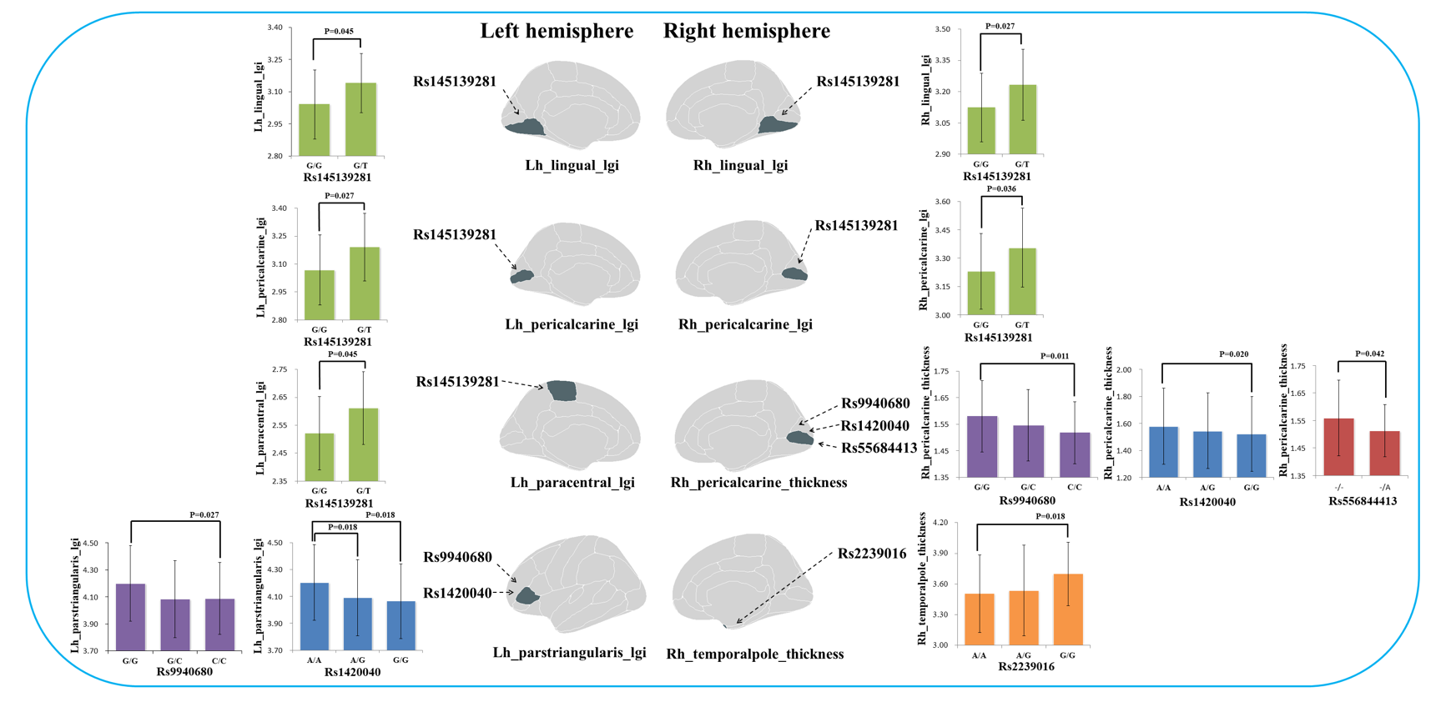
Supplement Figure 1. The significant effects of candidate SNVs on cortical thickness and gyrification in each significant region. Note: lgi, the local gyrification index. GRIN2A (rs9940680 and rs1420040) was more closely related to the morphology of left parstriangularis and pericalcarine; GRM3 (rs145139281) was more closely related to the morphology of bilateral lingual, pericalcarine and left paracentral; CACNA1C (rs55684413 and rs2239016) was more closely related to the morphology of left pericalcarine and right temporal pole.

Supplement Figure 2. The interaction effect between SNVs and heterogeneous groups on cortical thickness and gyrification
Additionally, the current study also found an interaction effect between two risk SNVs (rs9940680, P=0.029 and rs1420040, P=0.011) of GRIN2A and heterogeneous group on cortical gyrification of left parstriangularis, which showed that the effect of risk SNVs in supranormal cluster was similar to healthy controls: the homozygous subjects without polymorphisms (G/G or A/A respectively) exhibited higher gyrification in left parstriangularis than the homozygous subjects with polymorphisms (C/C or G/G). But a similar effect was not observed in hypo-gyric and impoverished-thickness clusters. Thus, the relationship between gyrification in left parstriangularis and SNVs of GRIN2A was restricted to the supranormal group (Supplement Figure.1).
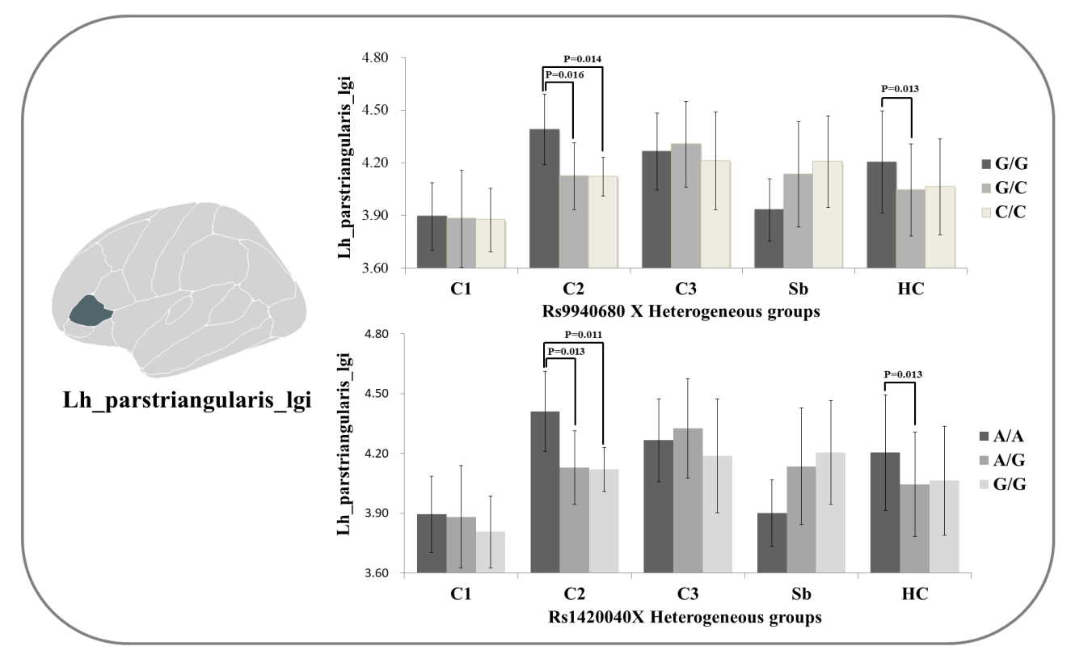
Supplement Figure.2 Interaction effect of rs9940680 and rs1420040 X Heterogeneous group on cortical gyrification of left parstriangularis. A specific role of GRIN2A (rs9940680 and rs1420040) in left inferior frontal – parstriangularis (Broca’s area) morphology was observed.

Supplement Material B. The observations in siblings
The current study also included the unaffected siblings as a control group. With respect to the cortical morphometric analysis, the unaffected siblings showed no difference from healthy controls, indicating the need for higher genetic dose, or other interacting non-genetic factors in shaping cortical morphology. But the cognitive functioning of siblings was intermediate between schizophrenia and healthy group, consistent with previous studies(6-9). The siblings also showed lower variation rate in protective SNV (rs14513928) of GRM3 compared to healthy controls. The interaction between gyrification in left parstriangularis and SNVs of GRIN2A that was seen among patients, was not observed among the siblings.
Reference
[1] Li H, Durbin R. Fast and accurate long-read alignment with Burrows-Wheeler transform. Bioinformatics. 2010;26:589-95.
[2] Li H, Handsaker B, Wysoker A, Fennell T, Ruan J, Homer N, et al. The Sequence Alignment/Map format and SAMtools. Bioinformatics. 2009;25:2078-9.
[3] McKenna A, Hanna M, Banks E, Sivachenko A, Cibulskis K, Kernytsky A, et al. The Genome Analysis Toolkit: a MapReduce framework for analyzing next-generation DNA sequencing data. Genome research. 2010;20:1297-303.
[4] Koboldt DC, Zhang Q, Larson DE, Shen D, McLellan MD, Lin L, et al. VarScan 2: somatic mutation and copy number alteration discovery in cancer by exome sequencing. Genome research. 2012;22:568-76.
[5] Purcell S, Neale B, Todd-Brown K, Thomas L, Ferreira MA, Bender D, et al. PLINK: a tool set for whole-genome association and population-based linkage analyses. Am J Hum Genet. 2007;81:559-75.

