Supplemental Information Content

Supplemental Methods page 2
Supplemental Results page 2
Supplemental References page 5
Supplemental Figures page 6

Supplemental Methods
Inclusion criteria
Inclusion criteria were: age 16-60 years; living in the catchment area; experiencing their first episode of psychosis (FEP); no prior treatment with AP medication or, if previously treated, a total life-time of adequate AP treatment of less than 6 weeks. AP polypharmacy, although not recommended, was allowed if clinically justified. The diagnoses were confirmed using the Structured Clinical Interview for DSM-IV (SCID–I) conducted by an experienced psychiatrist at six months from baseline. DSM-IV criteria for drug or alcohol dependence, intellectual disability and having a history of neurological disease or head injury were exclusion criteria.
Quality control
Quality control was performed with PLINK to exclude: single-nucleotide polymorphisms (SNPs) with a minor allele frequency (MAF) <0.05, genotyping failure >2%, a Hardy-Weinberg equilibrium p-value <10e-06; individuals with inconsistent sex and with heterozygosity levels 3 standard deviations away from the mean; and related individuals with pihat > 0.2 (the relative with the lower call rate was removed). In addition, samples showing evidence of population stratification (without European ancestry) were identified by principal component (PC) analysis and excluded. The top 10 PC scores were saved for further analysis. SNP imputation was conducted with the Michigan Imputation Server¹ against the full European reference panel. The imputed SNPs underwent another round of quality control, SNPs with MAF < 0.001, a Hardy-Weinberg equilibrium p-value <10e-06, --geno 0.01, --mind 0.01, and an imputation information score <0.9 were excluded. At the end, 6,910,431 SNPs were included in the Training set and 6,552,380 SNPs in the Validation set.
Identification of Independent SNPs by pleiofdr
Independent genomic loci were identified merging any physically overlapping lead SNPs (LD blocks < 250 kb apart), as described previously. Significant SNPs were identified as SNPs with a conjFDR < 0.05 and at LD r² < 0.6 with each other². Then, the borders of the genomic loci were defined by identifying all SNPs in LD (r² ≧ 0.1) with one of the independent significant SNPs in the locus. The region containing all these candidate SNPs was defined as a single independent genomic locus and the most significant SNP within the region was selected as the lead SNP. Finally, we kept as pleiotropic all the significant independent SNPs identified by the software at conjFDR<0.05. The directional effects of the loci shared between SCZ and BMI measures were evaluated by comparing their z-scores. All p-values were adjusted for standard genomic control (GC) and Z-scores were adjusted for sample overlap between GWAS, using intergenic SNPs as implemented in pleioFDR. The European populations from the 1KGP project were used as the reference panel for the computation of the LD structure between SNPs.
Supplemental Results
Differences among AP drugs in ∆BMI
The effects of AP treatment on BMI were initially assessed in the 202 individuals that remained with the same AP drug during the period of the study. Although all APs were associated, on average, with a positive ∆BMI (Figure S4 and Supplementary Material), the AP drug was important for the extent of ∆BMI₃ and ∆BMI₁₂ (Kruskal-Wallis test; P=6.1e-04 and P=2e-03, respectively). Among them, olanzapine was the AP drug associated with the highest ∆BMI₃ (12.1% mean increase) and ∆BMI₁₂ (17.3% mean increase) and ziprasidone the one associated with the lowest outcomes (2.1% mean increase at ∆BMI₃ and 5.0% at ∆BMI₁₂).
These changes were consistently observed when including those patients that switched AP during the study. Altogether, 57 patients out of 224 (25.4%) in the Training set and 13 out of 157 (8.3%) in the Validation set changed their baseline AP medication to another one during the first 3 months. When comparing 3 and 12 months, 59 (29.2%) and 40 (29.0%) patients switched AP medication in the Training and Validation sets, respectively, being three and 18 patients the same that switched the AP between baseline and 3 months (Figure S2).
We compared ∆BMI across AP drugs including individuals that switched AP drugs during the study period. Significant differences in ∆BMI₃ were observed according to the AP drug taken at baseline and at t=3m (P=3.7e-04 and P=3.9e-05, respectively). Those individuals treated with clozapine and paliperidone showed the largest ∆BMI₃, while ziprasidone was associated with the lowest ∆BMI₃ (Figure S11). After 12 months of treatment, patients at clozapine and paliperidone treatment at t=3m showed the greatest rise in BMI (32% and 38.2% ∆BMI₃ mean increase, respectively; P=8.4e-03), while those treated with ziprasidone presented the lowest values (9% ∆BMI₁₂ mean increase, Figure S12). ∆BMI₁₂ was also evaluated based on AP prescribed at t=12m, resulting also in significant statistical differences across AP drugs (P=1.8e-04). Paliperidone and clozapine were the AP with the highest ∆BMI₁₂ (26.8% and 23.2%) while ziprasidone and quetiapine were the AP associated with lower ∆BMI₁₂ (7.7% and 10.1%, Figure S11B). Finally, the use of antidepressant treatment during the first 3 months did not show significant differences in ∆BMI₃ and ∆BMI₁₂ (P=0.71 and P=0.44, respectively), nor the specific diagnosis (P=0.70 and P=0.05, respectively).
Enrichments in agonistic and antagonistic SNPs
SNPs with agonistic pleiotropy between SCZ and BMI (n=2,686) were mapped to 293 genes with ANNOVAR. Among them, the list was enriched in GO processes such as axon guidance (FDR=1,44e-03), but also pathways such as MAPK signaling pathway (FDR=4,72e-04), signal transduction (FDR=2,10e-05), and insulin resistance (FDR=2,11e-02, eTable 6). Among the antagonistic SNPs (6,864 SNPs corresponding to 631 genes) enriched categories included glutamatergic synapse (FDR=2,75e-10), positive regulation of neuron projection development (FDR=1,96e-04), cAMP signaling pathway (FDR=1,07e-06), axon guidance (FDR=9,89e-05), nicotinic acetylcholine receptor signaling pathway (FDR=5,42e-05), HDACs deacetylate histones (FDR=2,52e-16), and DNA methylation (FDR=1,21e-15). Also these genes were enriched in nervous system diseases (FDR=5,15e-03), among others (a complete list of enriched pathways can be found in eTable 5).

Supplemental References

1. Das S, Forer L, Schönherr S, et al. Next-generation genotype imputation service and methods. Nat Genet. 2016;48(10):1284-1287. doi:10.1038/ng.3656
2. Muntané G, Farré X, Bosch E, Martorell L, Navarro A, Vilella E. The shared genetic architecture of schizophrenia, bipolar disorder and lifespan. Hum Genet. Published online August 9, 2020. doi:10.1007/s00439-020-02213-8

Supplemental Figures

Figure S1. Boxplot of ∆BMI₃ and ∆BMI₁₂ in the whole dataset.

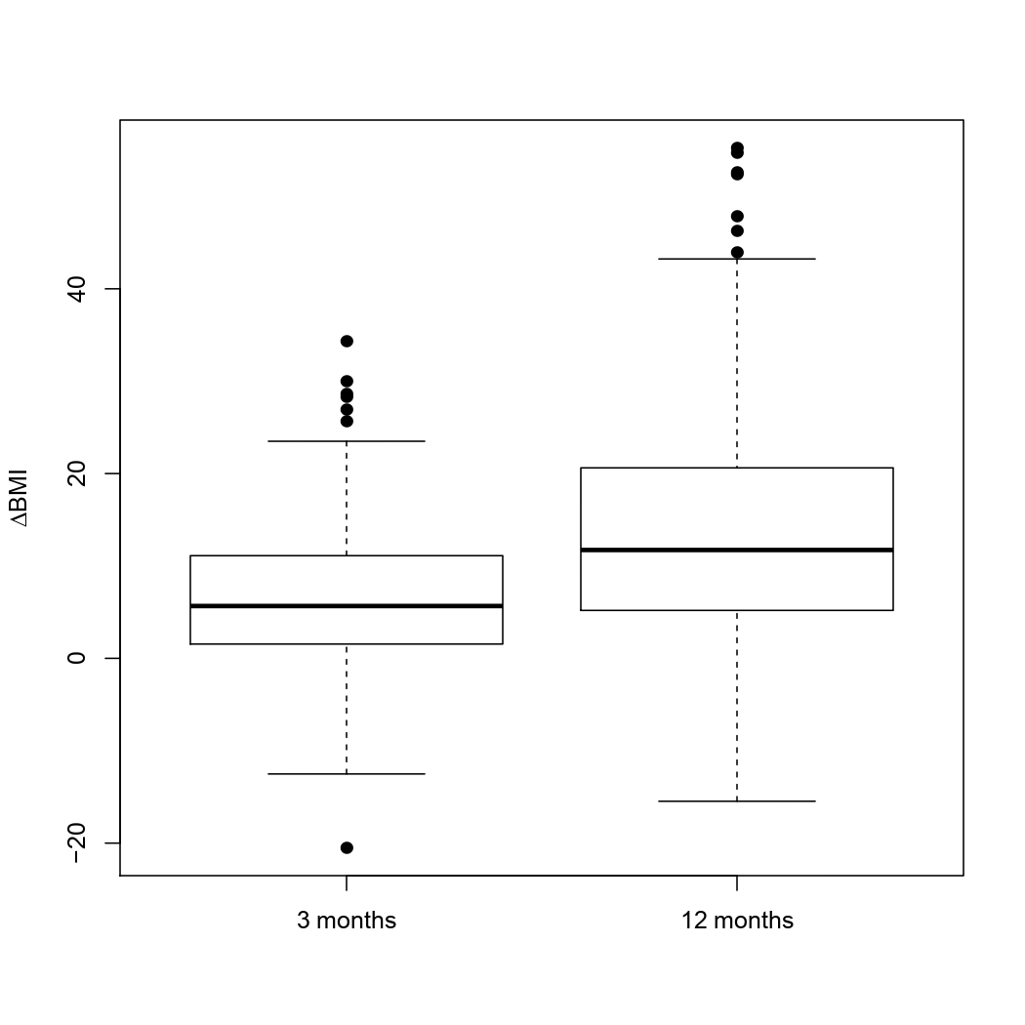

Figure S2. Graphic representation showing the individuals that discontinued the AP drug medication during the first year of the study. Both Validation and Training datasets are represented. Numbers in the boxes represent the patients that continued with the same AP treatment as baseline.

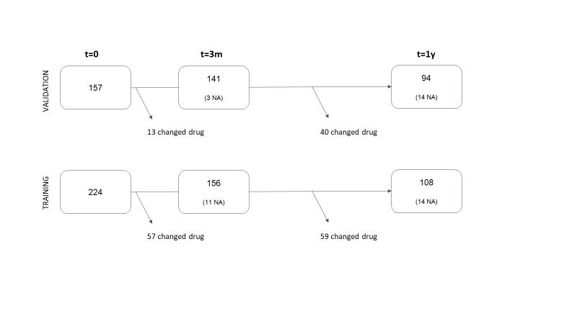

Figure S3. A) Correlation plot of BMI₀, ∆BMI₃, and ∆BMI₁₂. Note that BMI₀ was negatively correlated with all ∆BMI, while ∆BMI₃ and ∆BMI₁₂ were highly correlated among them. B) Scatterplot of Spearman's correlation of BMI₀ (y-axis) and ∆BMI₃ (x-axis) in 354 patients. C) Scatterplot of Spearman's correlation of BMI₀ (y-axis) and ∆BMI₁₂ (x-axis) in 340 patients. The dotted red lines show the best fit. r= correlation estimate. P= p-value of the correlations.

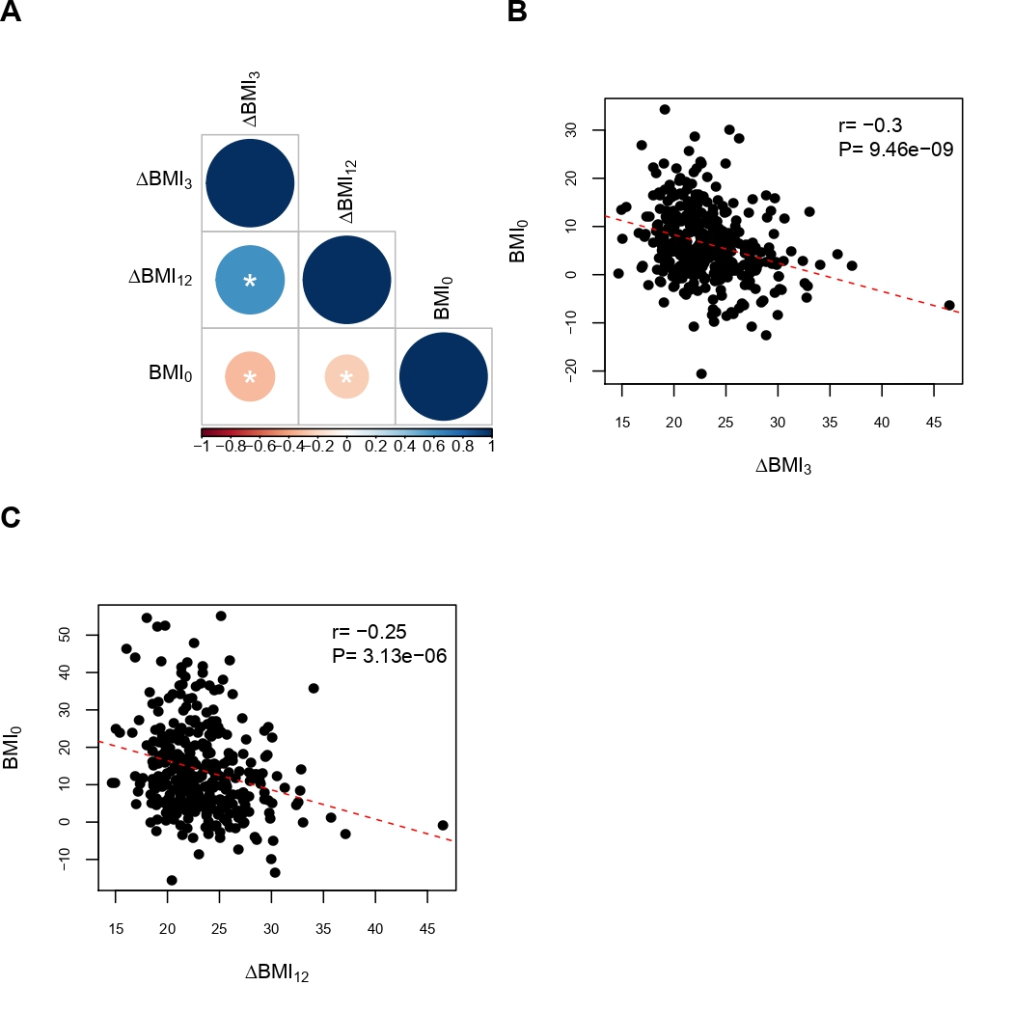

Figure S4. Boxplot of the A) ∆BMI₃ and B) ∆BMI₁₂, as a function of the AP drug (x-axes). Only the patients that did not switch AP during the follow-up have been considered (n=202).

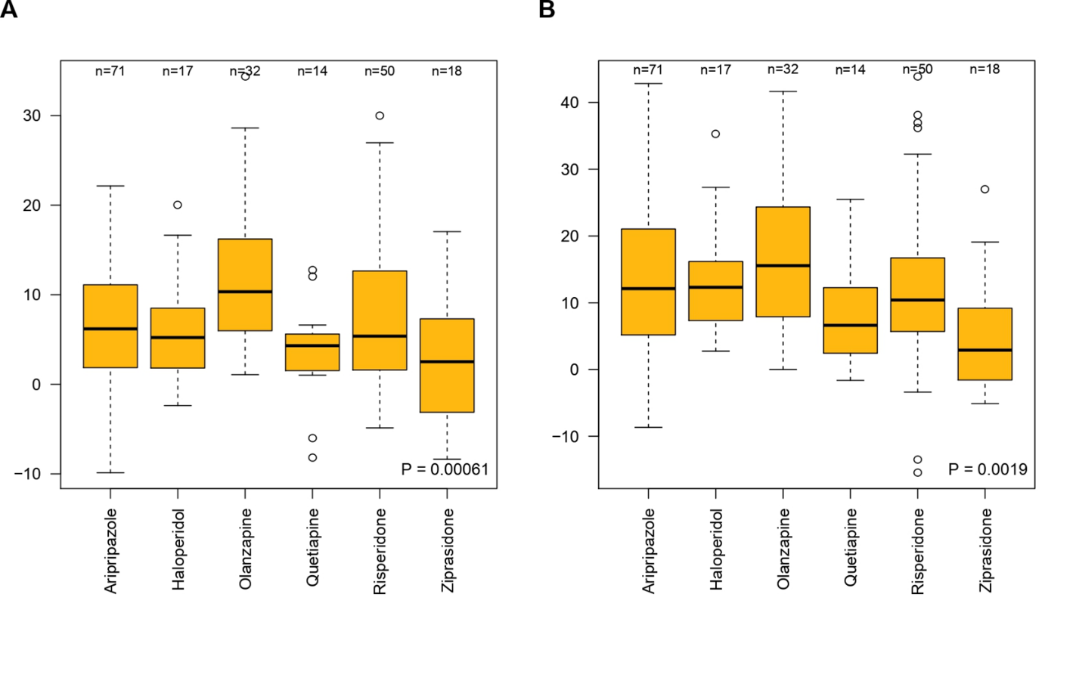

Figure S5. Boxplot representation of the ΔBMI₁₂ in individuals of the whole dataset as a function of clinical characteristics at baseline. P-values of the Mann-Whitney tests are shown in the upper right part of each graph. Note that only cannabis use and tobacco use were significantly associated to differences in ΔBMI₁₂.

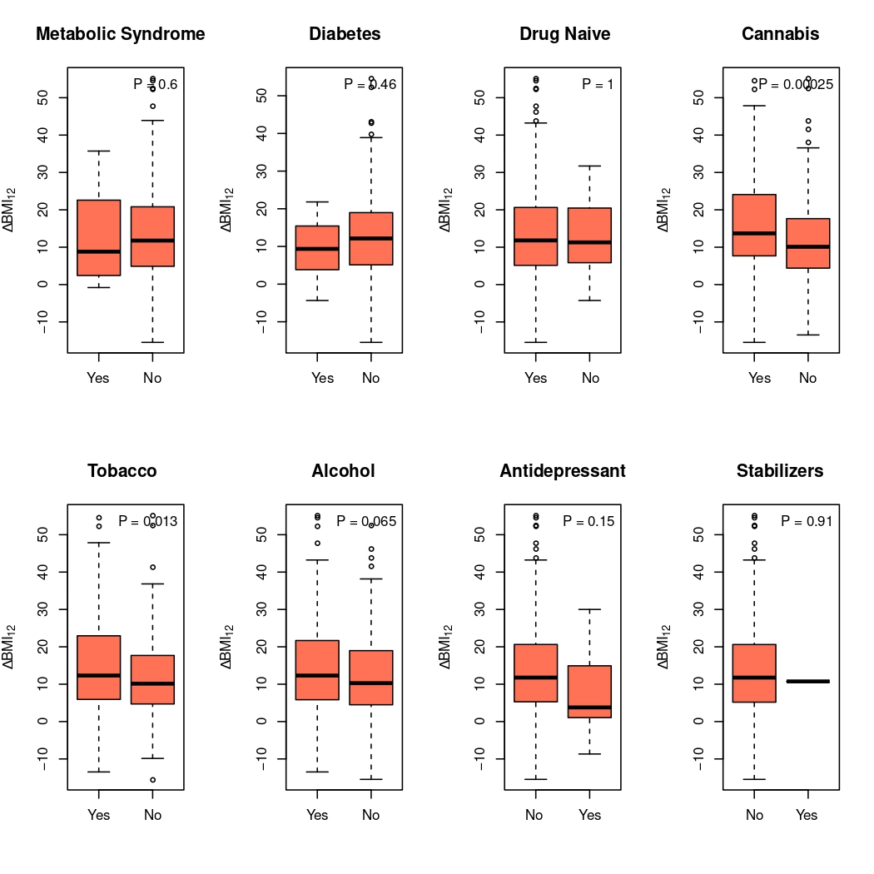
Figure S6. Ratio between antagonistic (negative) and agonistic (positive) pleiotropic variants across different conjFDR thresholds.

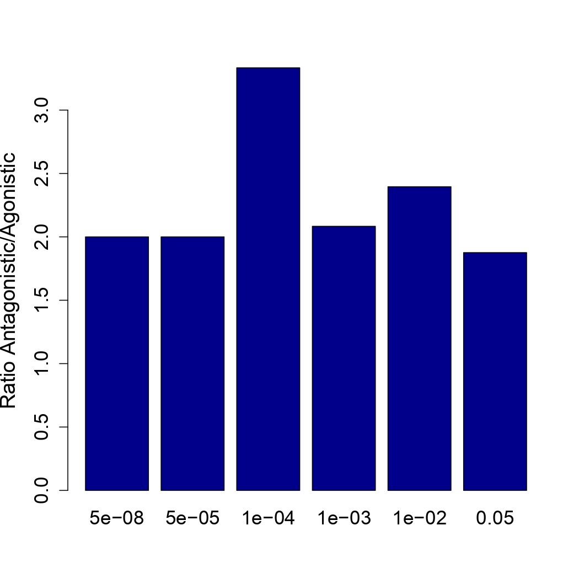

Figure S7. Bubble plot of enriched terms from KEGG pathways in A) all pleiotropic, B) only agonistic, and C) only antagonistic mapped genes. The color of the bar represents different clusters assigned by KOBAS-i. The size of the bubble is relative to the p-value, from small to large: [0.05,1], [0.01,0.05), [0.001,0.01), [0.0001,0.001), [1e-10,0.0001), [0,1e-10). For each cluster, if there are more than 5 terms, only top 5 with the highest enrich ratio are displayed.

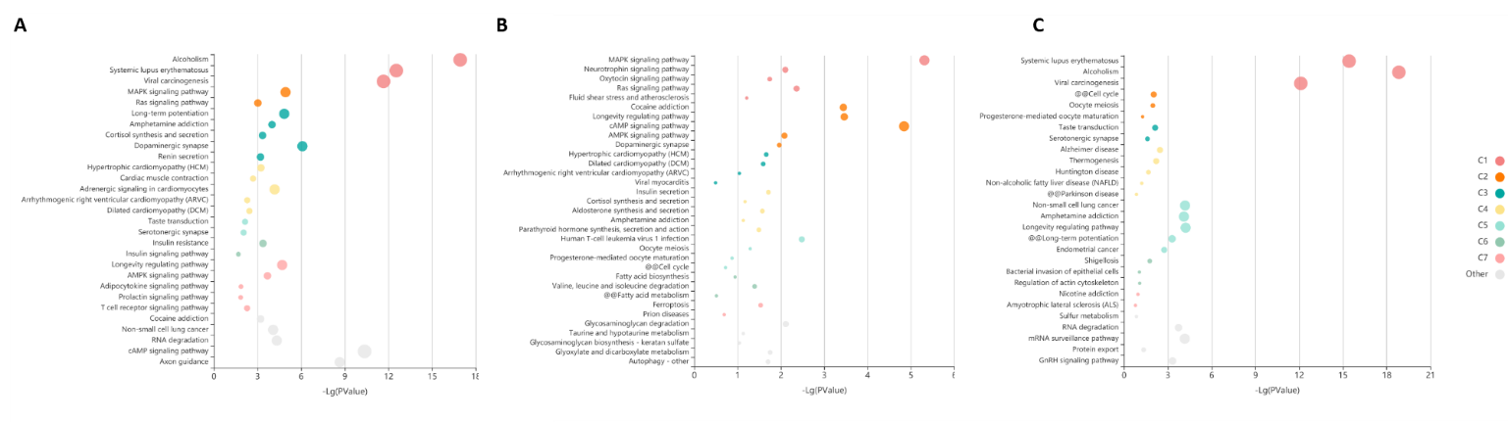

Figure S8. DEG in specific tissues for all SNPs at conjFDR<0.05, from GTEx v8 54 tissue types.

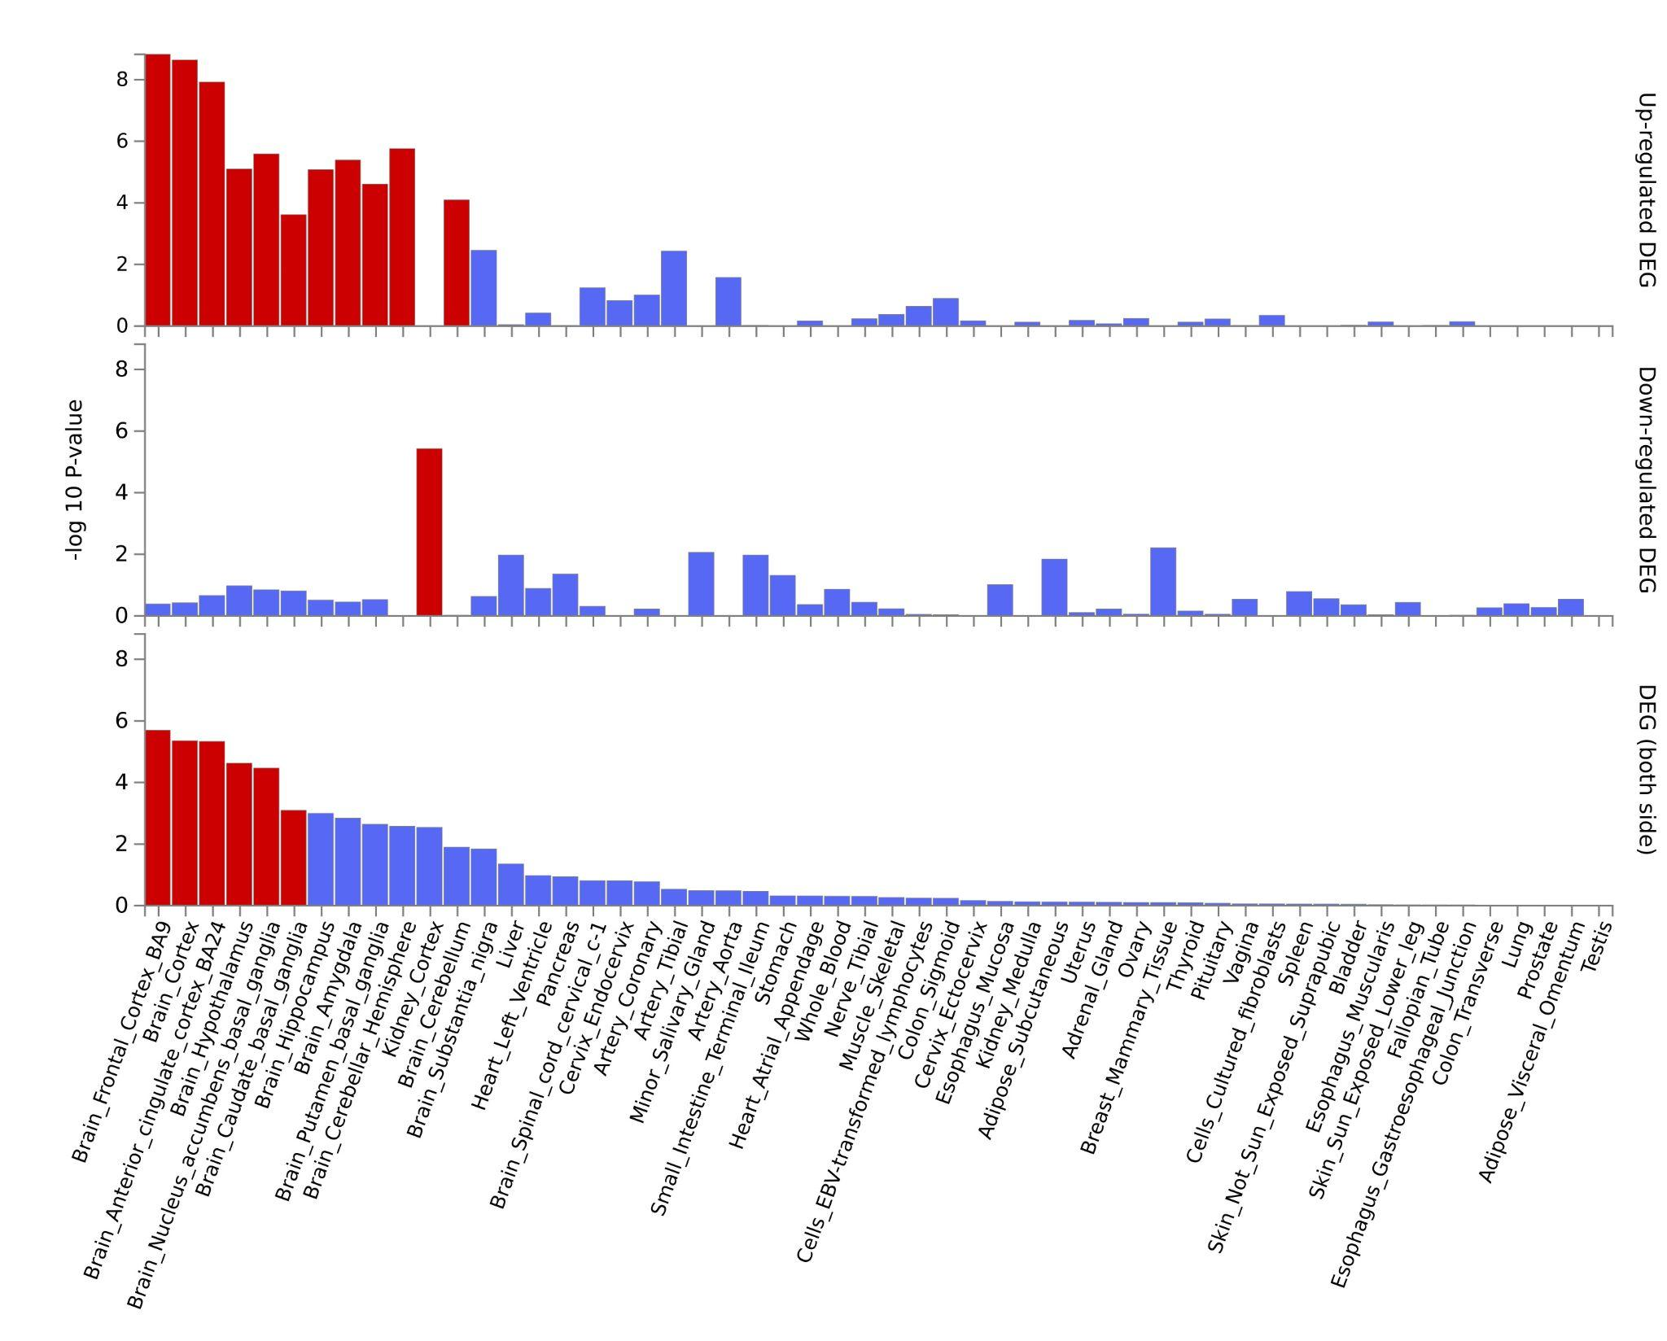
Figure S9. Manhattan plot of the Pulit et al. GWAS on BMI showing only the SNPs with pleiotropic information that were used for the PRS analyses. Green dots represent SNPs that were determined as pleiotropics betwen SCZ and BMI, while grey dots represent non-pleiotropic SNPs.

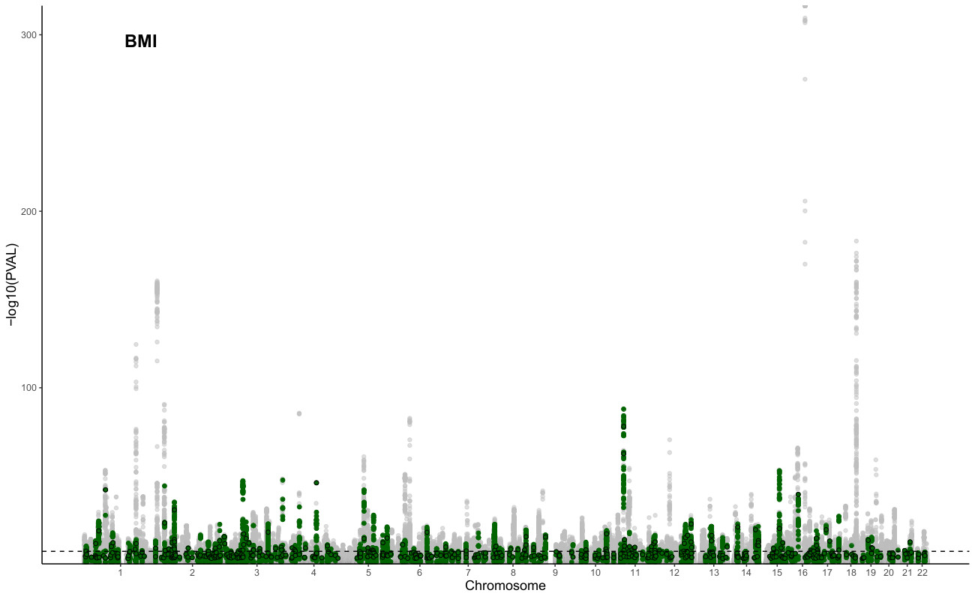

Figure S10. Bar plot showing the variance explained in BMI₁₂ (left), ∆BMI₃ (middle), and ∆BMI₁₂ including the PRS_{BMI}, PRS_{pleio}, PRS_{nopleio}, PRS_{antag} and PRS_{ago} (of pleiotropic antagonistic -negative- and pleiotropic agonistic -positive- regions). Asterisks refer to the significance in the independent ANOVA testing of the improvement from to the Clinical model (in red).
* P-value < 0.05.

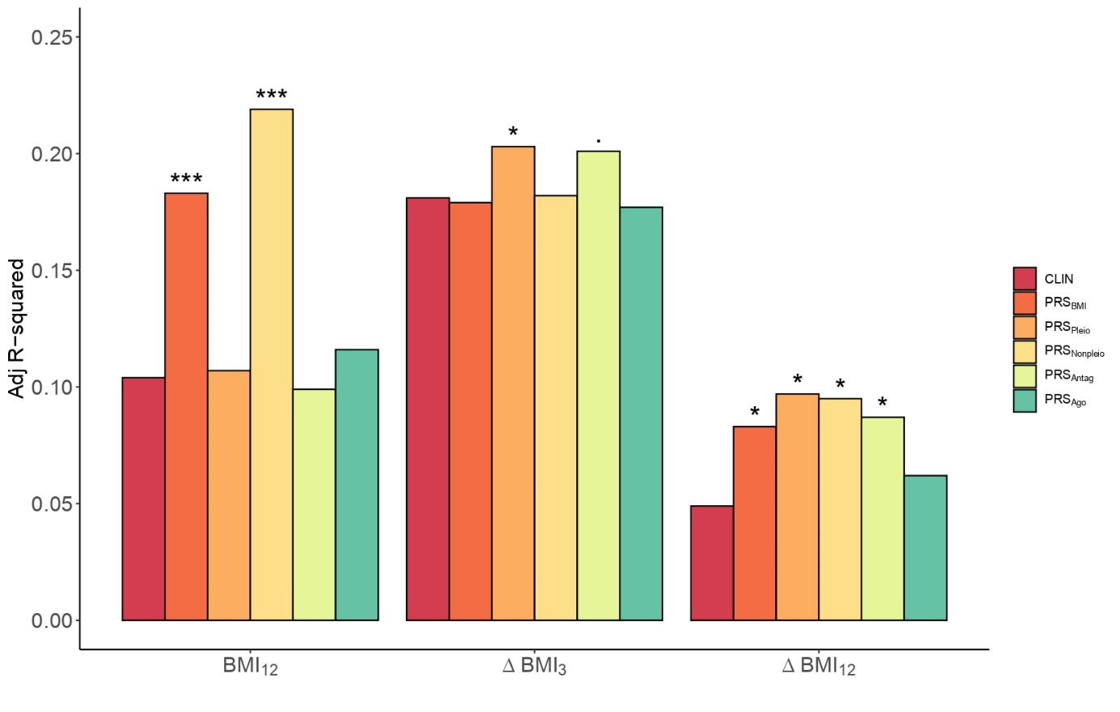

Figure S11. Boxplot of the ∆BMI₃, as a function of the AP drug (x-axes) taken at A) baseline and B) 3 months after treatment initiation. Number of individuals in each group are shown in the top of the graphs and P-values obtained from the kruskal-Wallis test are shown at the bottom right of the graph.

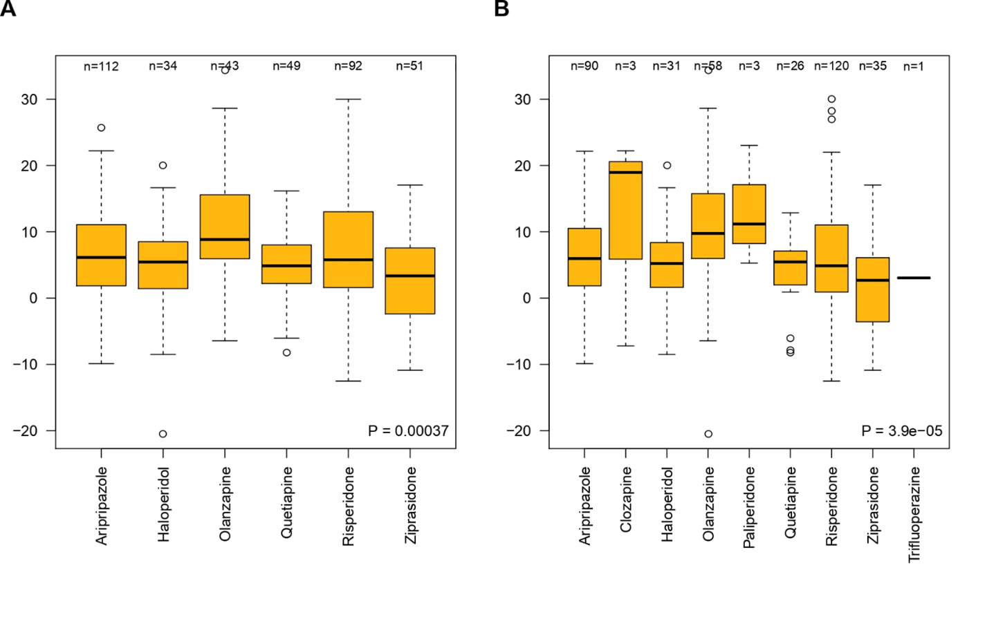

Figure S12. Boxplot of the ∆BMI₁₂, as a function of the AP drug (x-axes) taken at A) 3 months and B) 1 year after treatment initiation. Number of individuals in each group are shown in the top of the graphs and P-values obtained from the Kruskal-Wallis test are shown at the bottom right of the graph.

