**Supplementary information**

**Genetic assortative mating for schizophrenia and bipolar disorder**

**Authors**

Oskar Hougaard Jefsen1 †

Ron Nudel2, 3 †

Yunpeng Wang4

Jonas Bybjerg-Grauholm2, 5

Nicoline Hemager2, 3, 6

Camilla A. J. Christiani2, 3

Birgitte K. Burton2, 6, 10

Katrine S. Spang2, 6

Ditte Ellersgaard2, 3

Ditte L. Gantriis1, 2

Kerstin Jessica Plessen2, 6, 7

Jens Richardt M. Jepsen2, 3, 6, 8

Anne A. E. Thorup2, 6, 10

Thomas Werge2, 9, 10

Merete Nordentoft2, 3, 10

Ole Mors1, 2

Aja Neergaard Greve* 1, 2

† These authors contributed equally to this work

**Affiliations**

1 Psychosis Research Unit, Aarhus University Hospital, Central Denmark Region, Denmark.

2 iPSYCH, The Lundbeck Foundation Initiative for Integrative Psychiatric Research, Denmark.

3 CORE – Copenhagen Research Centre for Mental Health, Mental Health Centre Copenhagen, Copenhagen University Hospital, Copenhagen, Denmark

4 Centre for Lifespan Changes in Brain and Cognition, Department of Psychology, University of Oslo, Oslo, Norway.

5 Center for Neonatal Screening, Department for Congenital Disorders, Statens Serum Institut, Copenhagen, Denmark

6 Child and Adolescent Mental Health Centre – Research unit, Mental Health Services in the Capital Region of Denmark, Copenhagen, Denmark

7 Division of Child and Adolescent Psychiatry, Department of Psychiatry, University Hospital Lausanne and University of Lausanne.

8 Mental Health Services in the Capital Region of Denmark, Center for Neuropsychiatric Schizophrenia Research and Center for Clinical Intervention and Neuropsychiatric Schizophrenia Research

9 Institute of Biological Psychiatry, Mental Health Centre Sct. Hans, Mental Health Services Copenhagen, Roskilde, Denmark

10 Department of Clinical Medicine, Faculty of Health and Medical Sciences, University of Copenhagen, Copenhagen, Denmark

**\* Corresponding author**

Aja Neergaard Greve

Psychosis Research Unit, Aarhus University Hospital

Palle Juul-Jensens Blvd. 175, 8200 Aarhus, Denmark

Email: ajagreve@rm.dk

**Supplementary Results**

|  |  |  |  |  |
| --- | --- | --- | --- | --- |
|  | *PRSs* | *PRS residualized by first 20 PCs* | *Difference between correlation coefficients* | |
| *PRS* | *Correlation coefficient, r* | | *z-score* | *p-value* |
| Educational attainment | 0.193 | 0.189 | -0.16 | 0.877 |
| Bone mineral density | -0.015 | -0.012 | 0.14 | 0.886 |
| Schizophrenia | 0.121 | 0.105 | -0.98 | 0.329 |
| Bipolar disorder | 0.162 | 0.183 | 0.97 | 0.330 |

**Supplementary Table S1.** Correlation coefficients obtained with the PRSs residualized by the first 20 principal components. These estimates are from the total sample, and two-sided z-tests. To test for a significant difference between the correlation coefficients we bootstrapped the difference between the coefficients (with 10,000 repetitions), and calculated z-scores, based on the coefficient difference and the standard deviation of the bootstrap estimate distribution.

|  |  |  |  |  |  |
| --- | --- | --- | --- | --- | --- |
| **Total sample** | | **Mothers’ PRS** | | | |
|  | r (p-value) | EA | BMD | SZ | BP |
| **Fathers’PRS** | EA |  | 0.056  (0.351) | 0.041  (0.497) | 0.060  (0.321) |
| BMD | 0.034  (0.576) |  | 0.057  (0.341) | 0.026  (0.663) |
| SZ | -0.014  (0.813) | 0.007  (0.912) |  | 0.007  (0.911) |
| BP | 0.059  (0.323) | -0.047  (0.431) | 0.087  (0.149) |  |

**Supplementary Table S2.** Cross-trait between-parent PRS correlation coefficients (and corresponding p-values) calculated in the total sample (n = 279 pairs). EA = educational attainment. BMD = bone mineral density. SZ = schizophrenia. BP = bipolar disorder.

|  |  |  |  |  |  |
| --- | --- | --- | --- | --- | --- |
| **Population-based controls** | | **Mothers’ PRS** | | | |
|  | r (p-value) | EA | BMD | SZ | BP |
| **Fathers’PRS** | EA |  | 0.218  (0.013) | 0.019  (0.831) | 0.257  (0.003) |
| BMD | 0.042  (0.635) |  | 0.110  (0.214) | 0.048  (0.587) |
| SZ | -0.600  (0.500) | 0.161  (0.068) |  | 0.044  (0.618) |
| BP | 0.079  (0.373) | -0.065  (0.465) | -0.077  (0.382) |  |

**Supplementary Table S3.** Cross-trait between-parent PRS correlation coefficients (and corresponding p-values) calculated in the sample of population-based controls (n = 130 pairs). EA = educational attainment. BMD = bone mineral density. SZ = schizophrenia. BP = bipolar disorder.

|  |  |  |  |  |  |
| --- | --- | --- | --- | --- | --- |
| **Familial high-risk of schizophrenia sample** | | **Mothers’ PRS** | | | |
|  | r (p-value) | EA | BMD | SZ | BP |
| **Fathers’PRS** | EA |  | -0.094  (0.382) | 0.160  (0.136) | -0.077  (0.555) |
| BMD | 0.074  (0.495) |  | 0.047  (0.720) | -0.009  (0.944) |
| SZ | -0.002  (0.983) | -0.170  (0.191) |  | 0.035  (0.792) |
| BP | -0.012  (0.927) | 0.103  (0.429) | 0.037  (0.777) |  |

**Supplementary Table S4.** Cross-trait between-parent PRS correlation coefficients (and corresponding p-values) calculated in the sample of familial high-risk of schizophrenia (n = 88 pairs). EA = educational attainment. BMD = bone mineral density. SZ = schizophrenia. BP = bipolar disorder.

|  |  |  |  |  |  |
| --- | --- | --- | --- | --- | --- |
| **Familial high-risk of bipolar disorder sample** | | **Mothers’ PRS** | | | |
|  | r (p-value) | EA | BMD | SZ | BP |
| **Fathers’PRS** | EA |  | 0.018  (0.889) | -0.069  (0.599) | -0.163  (0.129) |
| BMD | -0.057  (0.664) |  | -0.005  (0.966) | 0.011  (0.916) |
| SZ | 0.113  (0.383) | -0.136  (0.208) |  | 0.164  (0.128) |
| BP | 0.092  (0.392) | -0.159  (0.140) | 0.104  (0.336) |  |

**Supplementary Table S5.** Cross-trait between-parent PRS correlation coefficients (and corresponding p-values) calculated in the sample of familial high-risk of bipolar disorder (n = 61 pairs). EA = educational attainment. BMD = bone mineral density. SZ = schizophrenia. BP = bipolar disorder.

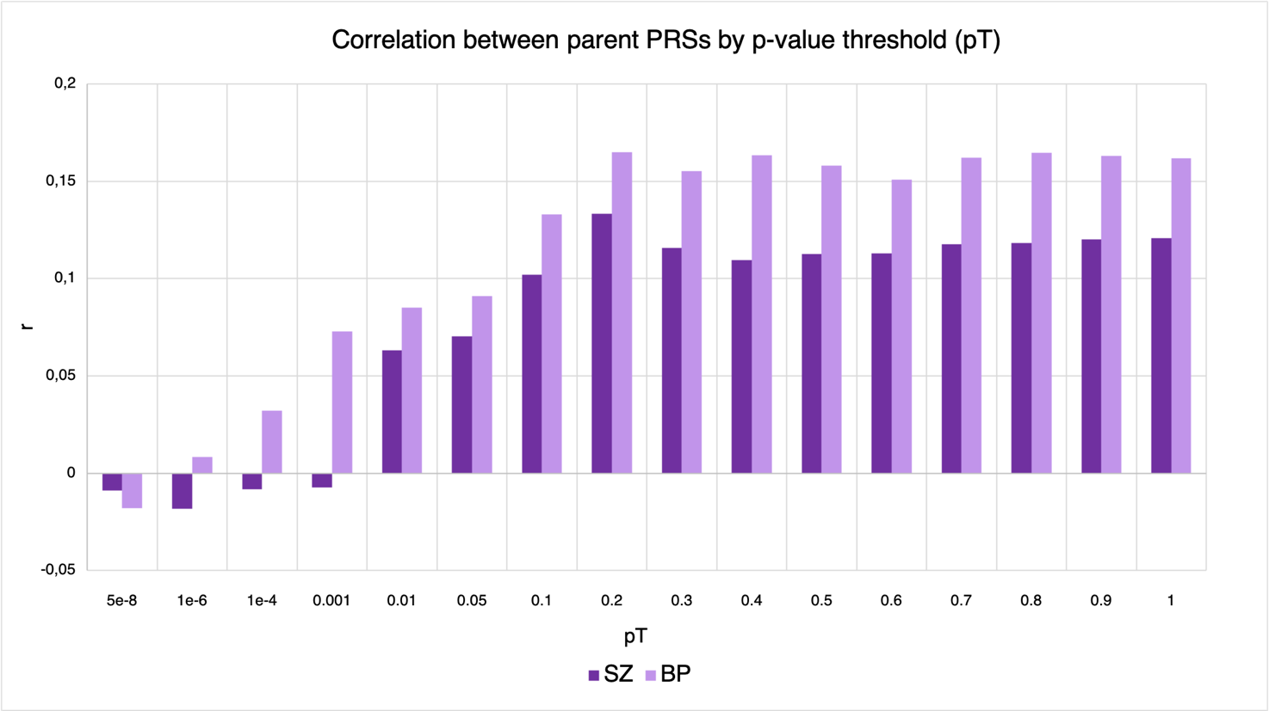

**Supplementary Figure S1.** Correlation coefficients (r) between parents’ polygenic risk scores (PRSs) for schizophrenia (SZ) and bipolar disorder (BP) using different p-value thresholds (pT) in the PRS generation.



**Supplementary Figure S2:** Directed acyclic graph (DAG) illustrating theoretical collider stratification bias in the patient samples. We are interested in the correlation between the PRS in one parent (PRSINDEX) and the PRS in the other parent (PRSNONINDEX) as a measure of genetic assortative mating. Here we assume that PRSINDEX as well as other unknown variables (U1) both affect the risk of illness. When selecting only index-parents with an illness, we condition on illness ([Illness]). In theory, this opens up a biasing path (red arrows) through unknown variables (U1), given that these could cause (or share a common cause, U2, with) PRS in the nonindex-parent (PRSNONINDEX). This could in theory give rise to a negative association between PRSINDEX andPRSNONINDEX if the direction of effect is similar for the U1 → Illness path as for the U1 → PRSNONINDEX path. The collider (illness) stratification bias described by this DAG can only generate a positive association between the two PRSs if U1 has opposite effects on (or association with) Illness and PRSNONINDEX. In other words, there would have to exist a variable (U2) that both increases the risk of illness and at the same time decreases the PRS of the non-index parent – a scenario that we find unlikely.