Comparing personalised brain-based and genetic risk scores for Major Depressive Disorder in large population samples of adults and adolescents

Supplementary Materials

Thng et al.

Supplementary Text

- Exclusion criteria for GS-Imaging and ABCD

GS-Imaging
For GS-Imaging, we excluded (a) individuals with neurological problems (brain tumour, hemotoma, stroke, epilepsy, haemorrhage, cerebral palsy and aneurysm, N=33), (b) related individuals, and (c) individuals with poor brain image quality (see Section 4 on Quality control measures for imaging data). As GS-Imaging is a family-based cohort, each participant within a family was assigned a random number and only one individual with the highest random number in each family was included.

ABCD
For ABCD, we excluded (a) individuals with neurological problems (N=114), (b) related individuals following the approach described for GS-Imaging, (3) individuals of non-European ancestry to match the MDD genome-wide association study discovery cohorts used to calculate PRS (see Section 2 on Selection of individuals of European ancestry in ABCD), and (4) individuals with poor image quality (see Section 4 on Quality control measures for imaging data).

- Selection of individuals of European ancestry in ABCD

We restricted our sample to include only individuals of European ancestry to ensure the accuracy of polygenic risk scores, as summary statistics from genome wide association studies are typically based on European populations. Principal component analysis (PCA) was undertaken on ABCD genotyped data to generate the top 15 genetic principal components (PC). 4-means clustering was then performed on the top two PCs corresponding to White, Black, Hispanic and Asian. We created an intersection between the White clusters for PC1 and PC2 to generate a final White cluster. Individuals who self-reported as White, have parents that self-reported as White, and fall under the final White cluster were selected (N=4160). A PCA plot was done together with data from the 1000 Genomes Project Consortium [1] – European Population to confirm that subjects were selected accurately (Figure S1).

- Quality control steps for ABCD imputed genetics data

The ABCD team conducted quality control (QC) on the genotyped data following the Ricopili pipeline [2] and then imputation using mixed ancestry and Eagle v2.4 phasing on the TOPMed imputation server (https://topmedimpute.readthedocs.io/en/latest) using the full sample. We filtered for INFO score<0.8 and then converted the genome build from hg38/GRCH38 to hg19/GRCh37 using LiftOver (https://github.com/sritchie73/liftOverPlink). As minor allele frequencies can differ between different ancestries, we further filtered for minor allele frequency <0.005 only after obtaining the European-only subsample.

- Quality control measures for imaging data

GS-Imaging
Full image acquisition details can be found in Habota el al [3] T1 data were acquired from N=1,080 individuals. The FreeSurfer processed scans were visually inspected and minor errors were manually corrected. Errors included incorrect skull stripping, exclusion of grey or white matter in tissue segmentation maps, or incorrect brain parcellation into separate regions as detailed in Neilson et al [4]. Individuals were excluded when there was at least one major error that could not be corrected (e.g., in segmentation or cortical parcellation) or when there were multiple minor errors (N=12). Within those included, data was edited for N=424 individuals. Diffusion tensor imaging (DTI) data were acquired from N=1,058 individuals and processed using the TBSS toolkit. QC was performed following ENIGMA DTI protocols (http://enigma.ini.usc.edu/protocols/dti-protocols/), which included (1) correcting for eddy current-induced distortions and subject movement in the scanner, (2) skull stripping using BET at a threshold of 0.2, (3) using DTIFIT in order to compute diffusion tensor characteristics, and (4) visually checking the quality of FA images at this stage in order to exclude distorted images. In total, N=21 individuals were excluded due to errors during diffusion tensor fitting (N=14) and errors during registration/skeleton fitting (N=7). More details on QC measures can be found in Green et al [5] and Stolicyn et al [6]. The final analysis sample for GS-Imaging (N=702 after applying all exclusion criteria and merging with genetic and clinical data) included individuals with either T1 (N=702) or DTI (N=686) data, with N=680 having both.

ABCD
Full image acquisition details are detailed in Hagler et al [7]. The minimally processed data for the full sample were downloaded from the ABCD repository. Further QC following the QC recommendations by the ABCD team [7] were conducted for the unrelated European-only subsample. For morphometric measures, only individuals who had satisfactory T1 scans (field name: iqc_t1_ok_ser > 0) and passed FreeSurfer quality control (field name: fsqc_qc =1) were included (N=243 excluded). For white matter microstructural measures, only individuals who had satisfactory T1 scans, satisfactory diffusion MRI scans (field name: iqc_dmri_ok_ser > 0) and passed FreeSurfer QC were included (N=377 excluded). In addition to the standard quality control steps above, for baseline data only, average FA and MD values that were five standard deviations from mean were also removed to reduce skewness (N=18), as described in Shen et al [8]. The final analysis sample for ABCD baseline (N=3,825 after applying all exclusion criteria and merging with genetic and clinical data) included individuals with either T1 (N=3,825) or DTI (N=3,630) data, with N=3,630 having both. The QC process was repeated for the two-year follow-up assessment. In total, N=30 and N=79 individuals were excluded for morphometric measures and white matter microstructural measures, respectively at two-year follow-up. The final analysis sample for ABCD two-year follow-up (N=2,081 after applying all exclusion criteria and merging with genetic and clinical data) included individuals with either T1 (N=2,081) or DTI (N=2,032) data, with N=2,032 having both.

- Calculation of Regional Vulnerability Index (RVI)

Using RVI-Sub as an example, the residuals for each of the 7 subcortical structures were first estimated by regressing out the effects of the same covariates used in the ENIGMA meta-analysis (refer to Table S1 to S4 for covariates used), and then z-score transformed using the mean and standard deviation of healthy individuals. In our sample, subjects were deemed as healthy if they did not self-report any psychiatric diagnoses and were not taking antidepressants at the point of assessment (Table 1 in main text). This procedure yielded a vector comprising 7 region-wise z-scores for each subject. Subject-specific RVI-Sub was then calculated as a single Pearson’s correlation coefficient between the vector of the 7 region-wise z-values and the corresponding regional effect sizes in the ENIGMA meta-analyses. This procedure was repeated for cortical thickness and surface area measures (using 33 cortical regions each), and for FA and MD measures (using 24 white matter tracts each), each yielding a single RVI. For ABCD, only 12 white matter tracts were used upon matching the tracts defined by AtlasTrack used in ABCD and the John Hopkins University atlas used in ENIGMA and GS-Imaging (Table S3). Measures from the left and right hemisphere were averaged. The RVI computation was implemented in the RVIpkg package version 0.2.3 in R (https://cran.r-project.org/web/packages/RVIpkg/RVIpkg.pdf).

- Phenotypes included in summary statistics used for PRS calculation

Summary statistics were obtained from Howard et al [9]. Three different cohorts were included in the meta-analysis: UK Biobank, 23nMe and Psychiatric Genetics Consortium (PGC). Within UK Biobank, the broad definition of depression was used, where subjects were asked: ‘Have you ever seen a general practitioner for nerves, anxiety, tension or depression?’ or ‘Have you ever seen a psychiatrist for nerves, anxiety, tension or depression?’. Within 23nMe, phenotypic status was based on responses to web-based surveys, with individuals that self-reported as having received a clinical diagnosis or treatment for depression classified as cases. For PGC, cases were required to meet international consensus criteria (DSM-IV, ICD-9, or ICD-10) for a lifetime diagnosis of MDD established using structured diagnostic instruments from assessments by trained interviewers, clinician-administered checklists, or medical record review.

Supplementary Figures

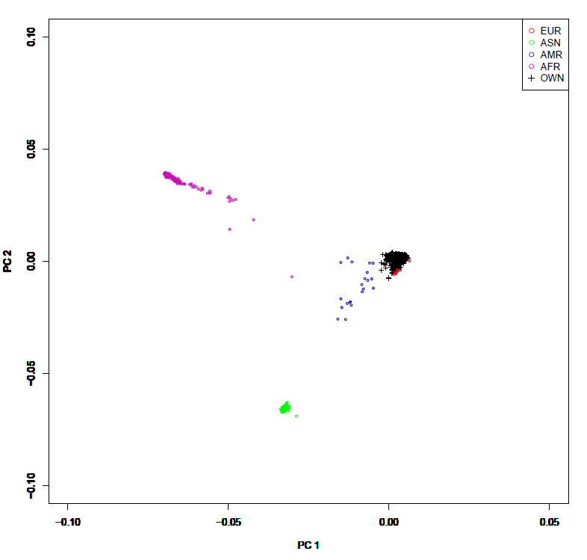

Figure S1. PCA plot using ABCD genotyped data and 1000 Genomes genetic data. The ABCD sample used in the current analyses were mostly of European ancestry, as indicated by the overlap with the 1000 Genomes European population. Figure legend: EUR – European, ASN – Asian, AMR – American, AFR – African, OWN – ABCD European-only sample.

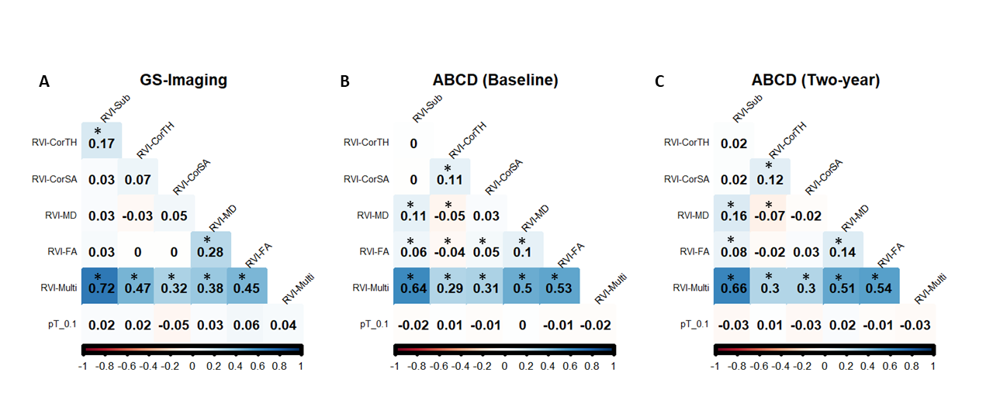
Figure S2. Correlation coefficients between the different MDD-RVIs and MDD-PRS at pT_0.1 for (A) GS-Imaging, (B) ABCD (Baseline), and (C) ABCD (Two-year). Boxes with “*” indicate that the correlation coefficient is significant at p<0.05.

Supplementary figures for GS-Imaging

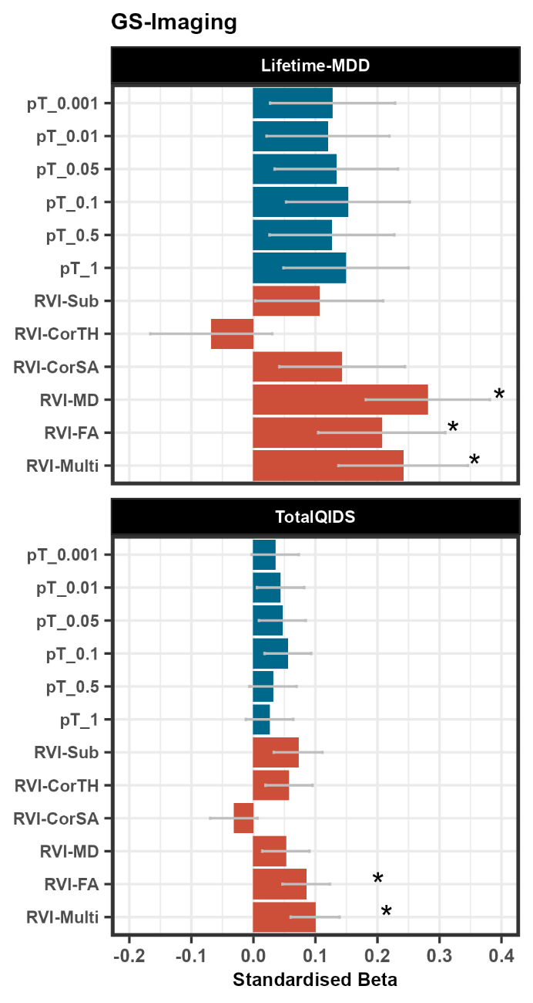

Figure S3. Association between MDD-RVIs/MDD-PRS (all thresholds) with Lifetime-MDD and TotalQIDS in GS-Imaging. The x-axis represents the standardised effect sizes and the y-axis represent the different RVI types and the MDD-PRS calculated at the different p-value thresholds.

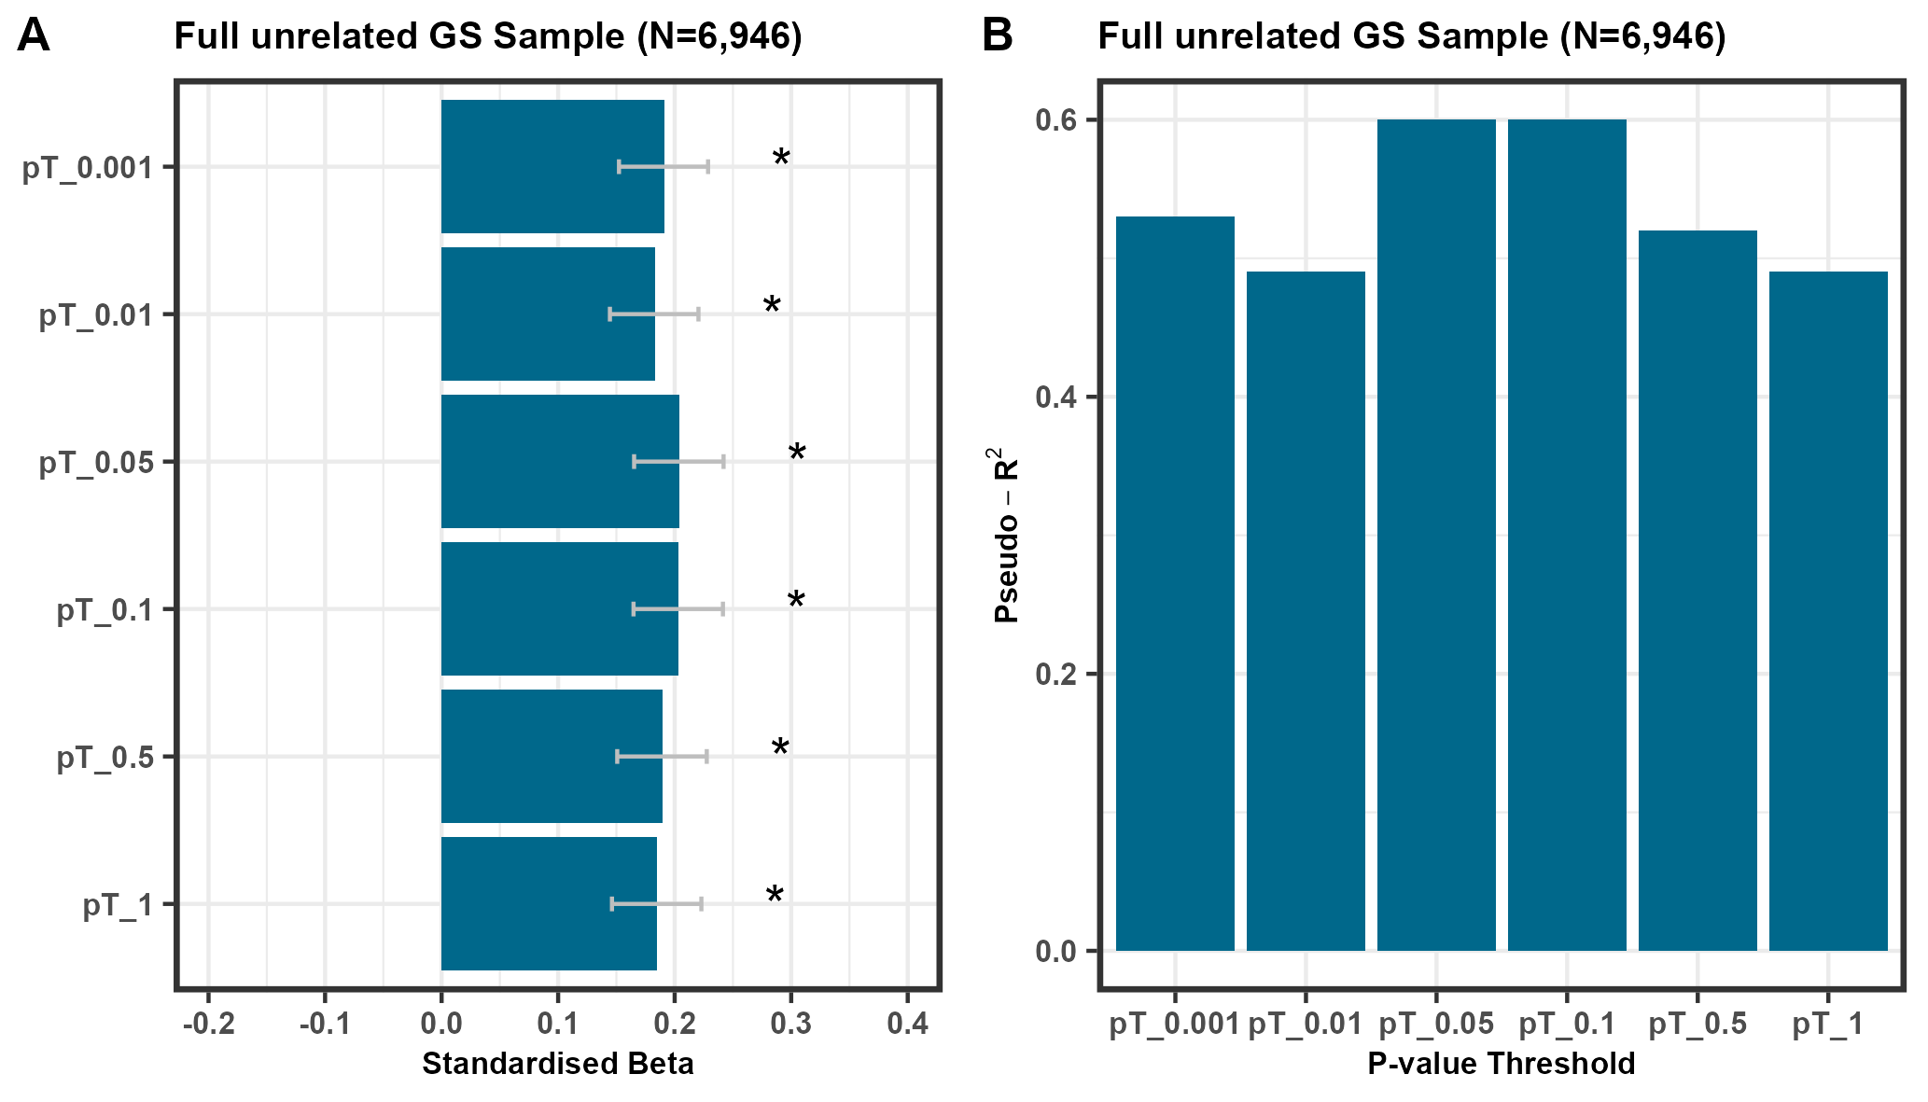

Figure S4. (A) Association between MDD-PRS and lifetime MDD diagnosis in the full unrelated GS sample (N=6,946) defined in Howard et al [9]. Individuals were defined as cases if they were given a MDD diagnosis using the Structured Clinical Interview for DSM disorders (975 cases and 5,975 controls). The x-axis represents the standardised effect sizes and the y-axis represent the different RVI types and the MDD-PRS calculated at the different p-value thresholds. (B) The change in McFadden Pseudo-R² was calculated for each p-value threshold to assess the improvement in model fit upon adding MDD-PRS as a predictor, relative to the null model including only covariates.

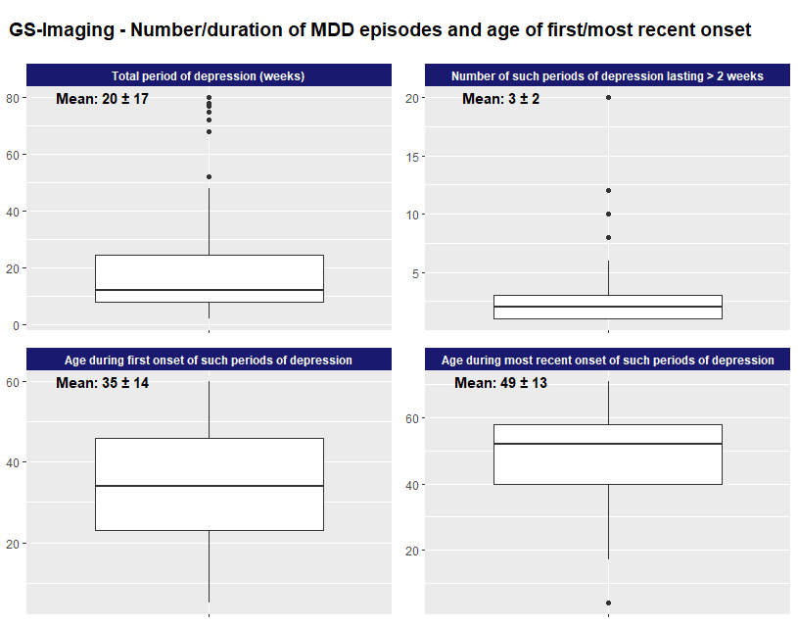

Figure S5. Additional information on number/duration of MDD episodes and age of first/most recent onset in GS-Imaging.

Supplementary figures for ABCD
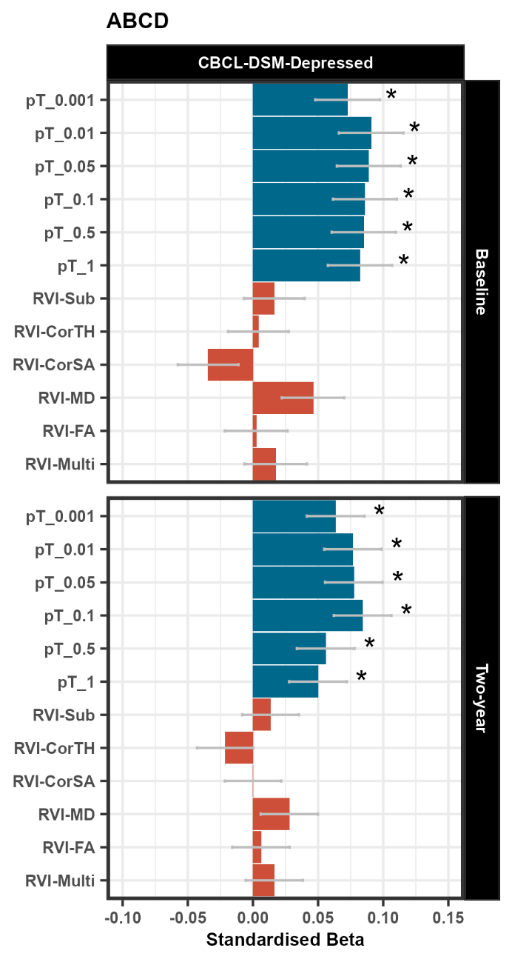

Figure S6. Association between MDD-RVIs/ MDD-PRS with CBCL-DSM-Depressed at baseline and two-year follow-up. The x-axis represents the standardised effect sizes and the y-axis represent the different RVI types and the MDD-PRS calculated at the different p-value thresholds.

Supplementary Tables

ENIGMA data tables

Table S1. MDD case-control effect sizes for subcortical volume obtained from Table 1 in Schmaal et al [10]. Covariates included age, sex, site and ICV.

Region | Cohen's d
Accumbens | -0.019
Amygdala | -0.060
Caudate | -0.023
Hippocampus | -0.144
Pallidum | -0.001
Putamen | 0.012
Thalamus | -0.044

Table S2. MDD case-control effect sizes for cortical surface area and thickness obtained from Table S19 and Table 1 in Schmaal et al [11], respectively. Covariates included age, sex and site. The left and right hemispheres were averaged to calculate cortical-based RVIs in the current analysis.

Region | Cohen’s d –  Cortical SA | Cohen’s d –  Cortical Thickness
Left banks superior temporal sulcus | -0.024 | −0.058
Left caudal anterior cingulate cortex | 0.021 | −0.042
Left caudal middle frontal gyrus | 0.045 | −0.014
Left cuneus | -0.007 | 0.05
Left entorhinal cortex | 0.008 | −0.041
Left frontal pole | -0.049 | −0.011
Left fusiform gyrus | 0.012 | −0.117
Left hemisphere total surface area | 0.026 | −0.057
Left inferior parietal cortex | -0.005 | −0.063
Left inferior temporal gyrus | 0.046 | −0.049
Left insula | 0.014 | −0.111
Left isthmus cingulate cortex | 0.063 | −0.104
Left lateral occipital cortex | 0.016 | −0.023
Left lateral orbitofrontal cortex | 0.041 | −0.046
Left lingual gyrus | 0.028 | 0.01
Left medial orbitofrontal cortex | 0.035 | −0.134
Left middle temporal gyrus | -0.034 | −0.090
Left paracentral lobule | 0.018 | −0.003
Left parahippocampal gyrus | -0.017 | −0.072
Left pars opercularis | -0.015 | −0.063
Left pars orbitalis | -0.002 | −0.073
Left pars triangularis | -0.063 | −0.054
Left pericalcarine cortex | -0.008 | 0.09
Left postcentral gyrus | 0.006 | 0.04
Left posterior cingulate cortex | 0.006 | −0.099
Left precentral gyrus | 0.034 | −0.020
Left precuneus | 0.011 | −0.024
Left rostral anterior cingulate cortex | 0.04 | −0.130
Left rostral middle frontal gyrus | 0.025 | −0.037
Left superior frontal gyrus | 0.052 | −0.066
Left superior parietal cortex | 0.017 | −0.005
Left superior temporal gyrus | 0.011 | 0.01
Left supramarginal gyrus | 0.04 | −0.045
Left temporal pole | 0.066 | 0.01
Left transverse temporal gyrus | 0.013 | −0.035
Right banks superior temporal sulcus | 0.01 | −0.074
Right caudal anterior cingulate cortex | 0.011 | −0.080
Right caudal middle frontal gyrus | 0.009 | 0.01
Right cuneus | 0.058 | 0.05
Right entorhinal cortex | 0.036 | −0.055
Right frontal pole | 0.024 | −0.062
Right fusiform gyrus | -0.034 | −0.116
Right hemisphere total surface area | 0.007 | −0.049
Right inferior parietal cortex | -0.024 | −0.041
Right inferior temporal gyrus | 0.005 | −0.117
Right insula | -0.004 | −0.115
Right isthmus cingulate cortex | 0.04 | −0.071
Right lateral occipital cortex | 0.067 | 0.01
Right lateral orbitofrontal cortex | 0.026 | −0.120
Right lingual gyrus | 0.016 | −0.012
Right medial orbitofrontal cortex | 0.027 | −0.131
Right middle temporal gyrus | 0.027 | −0.088
Right paracentral lobule | 0.014 | −0.006
Right parahippocampal gyrus | -0.04 | −0.061
Right pars opercularis | -0.011 | −0.017
Right pars orbitalis | 0.022 | −0.070
Right pars triangularis | -0.012 | −0.031
Right pericalcarine cortex | 0.007 | 0.08
Right postcentral gyrus | 0.022 | 0.03
Right posterior cingulate cortex | 0.016 | −0.093
Right precentral gyrus | 0.009 | −0.022
Right precuneus | 0.006 | 0.01
Right rostral anterior cingulate cortex | 0.029 | −0.098
Right rostral middle frontal gyrus | 0.054 | −0.038
Right superior frontal gyrus | 0.028 | −0.078
Right superior parietal cortex | -0.008 | 0.03
Right superior temporal gyrus | 0.029 | −0.031
Right supramarginal gyrus | 0.004 | −0.053
Right temporal pole | 0.051 | 0.01
Right transverse temporal gyrus | -0.021 | −0.051
Table S3. Tracts of interest listed in van Velzen et al [12]. Regions that match with ABCD and are used for the analyses are highlighted in yellow.

Abbreviation | Full tract name
AverageFA | Full skeleton average FA
ACR (L+R) | Anterior corona radiata
ALIC (L+R) | Anterior limb of internal capsule
BCC | Body of corpus callosum
CC (BCC+GCC+SCC) | Corpus callosum
CGC (L+R) | Cingulum (cingulate gyrus)
CGH (L+R) | Cingulum (hippocampal portion)
CR (L+R) | Corona radiata
CST (L+R) | Corticospinal tract
EC (L+R) | External capsule
FX | Fornix
FXST (L+R) | Fornix (cres) / Stria terminalis
GCC | Genu of corpus callosum
IC (L+R) | Internal capsule
IFO (L+R) | Inferior fronto-occipital fasciculus
PCR (L+R) | Posterior corona radiata
PLIC (L+R) | Posterior limb of internal capsule
PTR (L+R) | Posterior thalamic radiation
RLIC (L+R) | Retrolenticular part of internal capsule
SCC | Splenium of corpus callosum
SCR (L+R) | Superior corona radiata
SFO (L+R) | Superior fronto-occipital fasciculus
SLF (L+R) | Superior longitudinal fasciculus
SS (L+R) | Sagittal stratum
UNC (L+R) | Uncinate fasciculus
Table S4. Effect sizes for MD and FA obtained from Table S6 and Table S4 in van Velzen et al [12], respectively. Covariates included age, age², sex, age*sex, age²*sex and site.

Region | Cohen's d – MD | Cohen's d – FA
AACR | 0.065 | -0.253
ALIC | 0.124 | -0.232
BCC | 0.192 | -0.243
CC | 0.17 | -0.249
CGC | 0.085 | -0.165
CGH | 0.14 | -0.068
CR | 0.12 | -0.25
CST | 0.104 | -0.101
EC | 0.148 | -0.16
FX | 0.123 | -0.083
FXST | 0.18 | -0.183
GCC | 0.102 | -0.247
IC | 0.104 | -0.229
IFO | 0.093 | -0.121
PCR | 0.143 | -0.202
PLIC | 0.105 | -0.154
PTR | 0.111 | -0.135
RLIC | 0.075 | -0.151
SCC | 0.143 | -0.13
SCR | 0.192 | -0.197
SFO | 0.164 | -0.232
SLF | 0.126 | -0.169
SS | 0.12 | -0.23
UNC | 0.052 | -0.12
Average | 0.176 | -0.258

Table S5. Standardised betas from linear regression analyses examining the association between FA values and severity of symptoms measured by the Beck Depression Inventory in adults only. This table was obtained from Table S92 in van Velzen et al [12].

Region | Beta | SE | CI LB | CI UB | P-value | FDR P-value | I² | N
ACR | 0.000313 | 0.000187 | -0.000053 | 0.000679 | 0.093 | 0.883 | 34.109 | 477
ALIC | 0.000088 | 0.000139 | -0.000184 | 0.000360 | 0.528 | 0.975 | 19.424 | 477
BCC | 0.000020 | 0.000165 | -0.000304 | 0.000344 | 0.904 | 0.975 | 0.000 | 477
CC | 0.000006 | 0.000123 | -0.000235 | 0.000246 | 0.963 | 0.975 | 0.276 | 477
CGC | 0.000029 | 0.000261 | -0.000482 | 0.000539 | 0.913 | 0.975 | 41.845 | 477
CGH | -0.000359 | 0.000326 | -0.000997 | 0.000279 | 0.269 | 0.975 | 50.839 | 477
CR | 0.000165 | 0.000131 | -0.000091 | 0.000420 | 0.208 | 0.975 | 17.340 | 477
CST | -0.000346 | 0.000502 | -0.001331 | 0.000638 | 0.491 | 0.975 | 81.332 | 477
EC | 0.000018 | 0.000202 | -0.000378 | 0.000414 | 0.928 | 0.975 | 56.521 | 477
FX | -0.000419 | 0.000259 | -0.000926 | 0.000089 | 0.106 | 0.883 | 0.000 | 477
FXST | -0.000389 | 0.000214 | -0.000809 | 0.000031 | 0.069 | 0.883 | 31.235 | 477
GCC | -0.000075 | 0.000236 | -0.000537 | 0.000388 | 0.752 | 0.975 | 47.584 | 477
IC | -0.000019 | 0.000096 | -0.000206 | 0.000169 | 0.847 | 0.975 | 0.000 | 477
IFO | -0.000330 | 0.000487 | -0.001285 | 0.000625 | 0.498 | 0.975 | 78.024 | 477
PCR | 0.000054 | 0.000112 | -0.000167 | 0.000274 | 0.633 | 0.975 | 0.000 | 477
PLIC | -0.000032 | 0.000124 | -0.000276 | 0.000211 | 0.794 | 0.975 | 0.000 | 477
PTR | -0.000131 | 0.000133 | -0.000392 | 0.000130 | 0.326 | 0.975 | 0.000 | 477
RLIC | -0.000129 | 0.000118 | -0.000361 | 0.000103 | 0.276 | 0.975 | 0.000 | 477
SCC | 0.000055 | 0.000099 | -0.000139 | 0.000249 | 0.576 | 0.975 | 0.000 | 477
SCR | 0.000208 | 0.000215 | -0.000214 | 0.000631 | 0.333 | 0.975 | 53.738 | 477
SFO | 0.000122 | 0.000365 | -0.000593 | 0.000837 | 0.738 | 0.975 | 71.573 | 477
SLF | 0.000045 | 0.000114 | -0.000178 | 0.000267 | 0.695 | 0.975 | 0.000 | 477
SS | 0.000050 | 0.000119 | -0.000183 | 0.000282 | 0.677 | 0.975 | 0.000 | 477
UNC | -0.000023 | 0.000232 | -0.000477 | 0.000431 | 0.921 | 0.975 | 5.682 | 477
AverageFA | 0.000003 | 0.000078 | -0.000151 | 0.000156 | 0.975 | 0.975 | 5.459 | 477

Table S6. Standardised betas from linear regression analyses examining the association between MD values and severity of symptoms measured by the Beck Depression Inventory in adults only. This table was obtained from Table S94 in van Velzen et al [12].

Region | Beta | SE | CI LB | CI UB | P-value | FDR P-value | I² | N
ACR | -0.00000001 | 0.00000031 | -0.00000061 | 0.00000059 | 0.975 | 0.975 | 61.795 | 477
ALIC | -0.00000006 | 0.00000012 | -0.00000029 | 0.00000017 | 0.620 | 0.902 | 2.768 | 477
BCC | 0.00000011 | 0.00000018 | -0.00000024 | 0.00000047 | 0.541 | 0.902 | 0.000 | 477
CC | 0.00000005 | 0.00000015 | -0.00000025 | 0.00000035 | 0.745 | 0.902 | 1.767 | 477
CGC | 0.00000016 | 0.00000015 | -0.00000014 | 0.00000046 | 0.297 | 0.902 | 9.121 | 477
CGH | 0.00000025 | 0.00000020 | -0.00000014 | 0.00000064 | 0.207 | 0.902 | 15.588 | 477
CR | 0.00000005 | 0.00000020 | -0.00000034 | 0.00000044 | 0.794 | 0.902 | 41.998 | 477
CST | 0.00000013 | 0.00000024 | -0.00000034 | 0.00000061 | 0.586 | 0.902 | 41.516 | 477
EC | 0.00000003 | 0.00000011 | -0.00000019 | 0.00000025 | 0.794 | 0.902 | 0.000 | 477
FX | -0.00000023 | 0.00000112 | -0.00000243 | 0.00000197 | 0.838 | 0.908 | 11.894 | 477
FXST | 0.00000017 | 0.00000013 | -0.00000009 | 0.00000043 | 0.191 | 0.902 | 14.567 | 477
GCC | 0.00000003 | 0.00000017 | -0.00000031 | 0.00000037 | 0.872 | 0.908 | 0.000 | 477
IC | -0.00000008 | 0.00000010 | -0.00000027 | 0.00000012 | 0.441 | 0.902 | 0.000 | 477
IFO | 0.00000043 | 0.00000034 | -0.00000025 | 0.00000111 | 0.213 | 0.902 | 78.643 | 477
PCR | 0.00000013 | 0.00000013 | -0.00000012 | 0.00000038 | 0.301 | 0.902 | 0.000 | 477
PLIC | -0.00000004 | 0.00000013 | -0.00000028 | 0.00000021 | 0.761 | 0.902 | 0.000 | 477
PTR | 0.00000016 | 0.00000016 | -0.00000015 | 0.00000047 | 0.316 | 0.902 | 11.768 | 477
RLIC | -0.00000012 | 0.00000011 | -0.00000033 | 0.00000010 | 0.298 | 0.902 | 0.000 | 477
SCC | -0.00000005 | 0.00000016 | -0.00000037 | 0.00000027 | 0.775 | 0.902 | 15.737 | 477
SCR | 0.00000011 | 0.00000010 | -0.00000009 | 0.00000031 | 0.284 | 0.902 | 0.000 | 477
SFO | 0.00000005 | 0.00000015 | -0.00000023 | 0.00000034 | 0.718 | 0.902 | 0.000 | 477
SLF | 0.00000003 | 0.00000010 | -0.00000016 | 0.00000023 | 0.737 | 0.902 | 0.000 | 477
SS | 0.00000009 | 0.00000016 | -0.00000023 | 0.00000040 | 0.585 | 0.902 | 20.731 | 477
UNC | 0.00000022 | 0.00000024 | -0.00000025 | 0.00000070 | 0.353 | 0.902 | 0.000 | 477
AverageMD | 0.00000005 | 0.00000009 | -0.00000013 | 0.00000024 | 0.562 | 0.902 | 0.000 | 477

Supplementary tables for main analysis

Table S7. Delta AIC values (e.g., “M2-M1” refers to the difference between M2 and M1 AIC values) for each model type (M1 to M5) when MDD-RVIs and MDD-PRS are used as predictors individually or in conjunction with each other. For model comparison, negative delta AIC values are indicative of better model fit. The results for both GS-Imaging and ABCD are reported.

GS-Imaging
 |  | Lifetime-MDD |  |  |  |  |  | TotalQIDS
Model | Variables | RVI-Sub | RVI-CorTH | RVI-CorSA | RVI-MD | RVI-FA | RVI-Multi | RVI-Sub | RVI-CorTH | RVI-CorSA | RVI-MD | RVI-FA | RVI-Multi
M1 | Covs (for RVI) | NIL |  |  |  |  |  | NIL
M2-M1 | RVI+Covs (for RVI) | -38.428 | -24.372 | -13.828 | -21.965 | -18.047 | -57.694 | -122.529 | -89.208 | -37.53 | -52.889 | -56.001 | -174.54
M3 | Covs | NIL |  |  |  |  |  | NIL
M4-M3 | PRS+Covs | -0.363 |  |  |  |  |  | -0.273
M5-M4 | PRS+RVI+Covs | -38.347 | -24.715 | -12.897 | -22.276 | -19.151 | -58.55 | -124.326 | -90.384 | -39.086 | -54.432 | -56.834 | -177.55
ABCD
 |  | CBCL-DSM-Depressed (Baseline) |  |  |  |  |  | CBCL-DSM-Depressed (Two-year)
Model | Variables | RVI-Sub | RVI-CorTH | RVI-CorSA | RVI-MD | RVI-FA | RVI-Multi | RVI-Sub | RVI-CorTH | RVI-CorSA | RVI-MD | RVI-FA | RVI-Multi
M1 | Covs (for RVI) | NIL |  |  |  |  |  | NIL
M2-M1 | RVI+Covs (for RVI) | 1.497 | 1.966 | -0.212 | -256.563 | -252.825 | -253.354 | 1.605 | 1.017 | 2 | -163.139 | -161.579 | -162.062
M3 | Covs | NIL |  |  |  |  |  | NIL
M4-M3 | PRS+Covs | -11.385 |  |  |  |  |  | -12.823
M5-M4 | PRS+RVI+Covs | 0.892 | 1.988 | 0.494 | -253.625 | -249.971 | -251.168 | 1.504 | 0.734 | 1.977 | -164.721 | -163.399 | -163.875
*Covs: Covariates; “Covs (for RVI)“ models do not include the 15 genetic principal components and genotype plate number that were included in the “Covs” models

Table S8. Association between baseline MDD-RVIs and MDD-PRS with the residualised CBCL-DSM-Depressed scores from baseline to two-year follow up for all RVI types and p-value thresholds.

Dependent variable | Predictor | B | SD | t-value | p-value
CBCL-DSM-Depressed (residualised) | pT_0.001 | 0.022 | 0.028 | 0.784 | 0.433
 | pT_0.01 | 0.034 | 0.028 | 1.201 | 0.230
 | pT_0.05 | 0.026 | 0.028 | 0.914 | 0.361
 | pT_0.1 | 0.030 | 0.028 | 1.087 | 0.277
 | pT_0.5 | 0.004 | 0.028 | 0.146 | 0.884
 | pT_1 | -0.001 | 0.028 | -0.046 | 0.963
 | RVI-Sub | 0.009 | 0.026 | 0.331 | 0.741
 | RVI-CorTH | -0.024 | 0.026 | -0.916 | 0.360
 | RVI-CorSA | 0.022 | 0.026 | 0.842 | 0.400
 | RVI-MD | -0.003 | 0.027 | -0.095 | 0.924
 | RVI-FA | -0.007 | 0.027 | -0.248 | 0.804
 | RVI-Multi | -0.008 | 0.026 | -0.284 | 0.777

References

- The 1000 Genomes Project Consortium. A global reference for human genetic variation. Nature 2015; 526: 68-74.
- Lam M, Awsasthi S, Watson HJ, Goldstein J, Panagiotaropoulou G, Trubetskoy V, et al. RICOPILI: Rapid Imputation for COnsortias PIpeLIne. Bioinformatics 2020; 36: 930–933.
- Habota T, Sandu A, Waiter GD, McNeil CJ , Steele JD, Macfarlane JA, et al. Cohort profile for the STratifying resilience and depression longitudinally (STRADL) study: A depression-focused investigation of generation scotland, using detailed clinical, cognitive, and neuroimaging assessments. Wellcome Open Research 2019; 4:185.
- Neilson E, Shen X, Cox SR, Clarke T, Wigmore EM, Gibson J, et al. (2019). Impact of polygenic risk for schizophrenia on cortical structure in UK biobank. Biol Psychiatry 2019; 86: 536-544.
- Green C, Shen X, Stevenson AJ, Conole ELS, Harris MA, Barbu MC, et al. Structural brain correlates of serum and epigenetic markers of inflammation in major depressive disorder. Brain, Behavior, and Immunity 2021; 92: 39-48.
- Stolicyn A, Harris MA, Shen X, Barbu MC, Adams MJ, Hawkins EL, et al. Automated classification of depression from structural brain measures across two independent community‐based cohorts. Hum Brain Mapp 2020; 41: 3922-3937.
- Hagler DJ Jr, Hatton S, Cornejo MD, Makowski C, Fair DA, Dick AS, et al. Image processing and analysis methods for the Adolescent Brain Cognitive Development Study. NeuroImage 2019; 202: 116091.
- Shen X, MacSweeney N, Chan SWY, Barbu MC, Adams MJ, Lawrie SM, et al. Brain structural associations with depression in a large early adolescent sample (the ABCD study®). EClinicalMedicine 2021; 42:101204.
- Howard DM, Adams MJ, Clarke TK, Hafferty JD, Gibson J, Shirali M, et al. Genome-wide meta-analysis of depression identifies 102 independent variants and highlights the importance of the prefrontal brain regions. Nat Neurosci 2019; 22: 343-352.
- Schmaal L, Veltman DJ, van Erp TG, Sämann PG, Frodl T, Jahanshad N, et al. Subcortical brain alterations in major depressive disorder: findings from the ENIGMA Major Depressive Disorder working group. Mol Psychiatry 2016; 21: 806-12.
- Schmaal L, Hibar DP, Sämann PG, Hall GB, Baune BT, Jahanshad N, et al. Cortical abnormalities in adults and adolescents with major depression based on brain scans from 20 cohorts worldwide in the ENIGMA Major Depressive Disorder Working Group. Mol Psychiatry 2017; 22: 900-909.
- van Velzen LS, Kelly S, Isaev D, Aleman A, Aftanas LI, Bauer J, et al. White matter disturbances in major depressive disorder: a coordinated analysis across 20 international cohorts in the ENIGMA MDD working group. Mol Psychiatry 2020; 25: 1511-1525.

