Supplementary Figure A1: Detailed excerpt of model structure
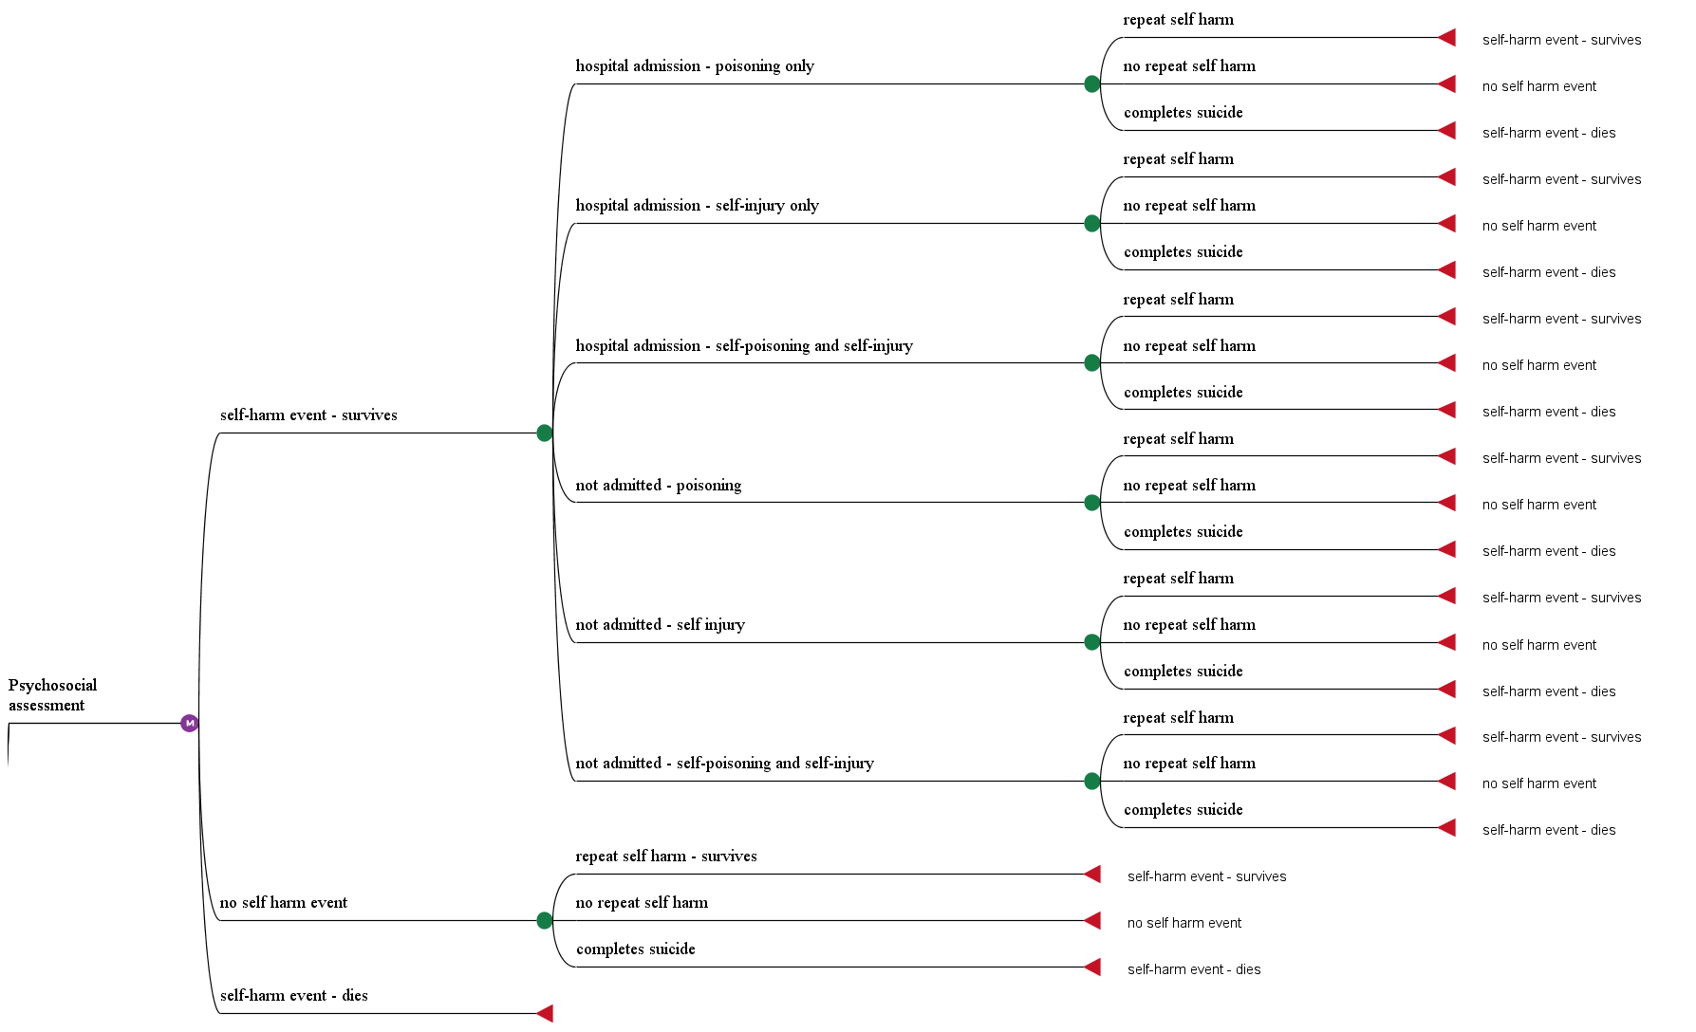
Note: Model structure is the same for the no intervention pathway (not shown)

