Supplementary Information
The analysis code is available at https://github.com/AmirhosseinModabbernia/ABCD/

Supplemental Methods
1. The ABCD study
2. ABCD Assessment Procedures and Definition of the Variables used in the Current Study
  - Childhood Behavior Checklist (CBCL)
  - Individual Characteristics and Neurobehavioral Measures Variables
Table S1. Childhood Behavior Checklist
Table S2. Definition of Non-Imaging Measures
- Neuroimaging
3.1 Structural Imaging
Table S3. Morphometric measures
3.2 Diffusion Magnetic Resonance Imaging
Table S4. Diffusion Magnetic Resonance Imaging Measures
3.3 Resting-State Functional Imaging
Table S5. Resting State Network Connectivity Measures
- Selection of Analyses Samples
- Statistical analysis
  - Uncovering Data-Driven Dimensions of Psychopathology
  - Identifying the Neurobehavioral and Functional Profile Associated with Dimensions of Psychopathology
  - Association of Imaging Measures with Dimensions of Psychopathology
  - Missing Values
Table S6. Distribution of Demographic Variables in Samples used for Different Analyses

Supplemental Results
Table S7. Correlation of the Three Components with Items of the CBCL
- Other stable independent component solutions:
Figure S1. the Two Component ICA solution.
Figure S2. the Four Component ICA solution.
Figure S3. the Five component ICA solution.
- External Validation of the Psychopathology Dimensions
Table S8. The Association of Psychopathology Dimensions with Cognitive and Behavioral Measures.
Figure S4. Similarity Score Between Cognitive and Behavioral Correlates of Dimensions of Psychopathology
Table S9. The Association of Psychopathology Dimensions with Academic Outcomes and Mental Health Service Utilization
Table S10. The Association of Psychopathology Dimensions with Global Morphometric Measures.
Figure S5. Association Between Global Morphometric Measures and Psychopathology Dimensions
Figure S6. Nonlinear Effect of Global Brain Measures on ICA-derived Dimensions
Figure S7. Nonlinear Effect of Global Brain Measures on EFA-derived Dimensions
Figure S8. Association ICA-derived Dimensions and Subcortical Volumes
Figure S9. Association EFA-derived Components and Subcortical Volumes
Figure S10. Association Between Dimensions of Psychopathology and Regional Morphometric Measures.
Figure S11. Similarity Score Between Regional Morphometric Correlates of Psychopathology Dimensions
Table S11. The Association of Psychopathology Dimensions with Global White Matter Integrity Measures
Figure S12. Association Between Global Measures of White Matter Integrity and Dimensions of Psychopathology
Figure S13. Nonlinear Effects of Measures of White Matter Integrity on ICA-derived Dimensions of Psychopathology
Figure S14. Nonlinear Effects of Measures of White Matter Integrity on EFA-derived Dimensions of Psychopathology
Figure S15. Association Between Data-Driven Dimensions of Psychopathology and Regional Measures of White Matter Integrity
Figure S16. Similarity Score Between Regional White Matter Integrity Correlates of Psychopathology Dimensions.
Figure S17. Top 3 Negative and Positive Associations Between Resting-State Functional Connectivity and the Cognitive Dyscontrol Components.
Figure S18. Association Between Dimensions of Psychopathology and Resting-State Functional Connectivity.
Figure S19. Similarity Scores Between Resting State Functional Connectivity Correlates of Dimensions of Psychopathology
Supplemental References
Figure S20. Association of Five-Component ICA-Derived and Five-Factor EFA-Derived Psychopathology Dimensions with Cognitive and Behavioral Measures.
Figure S21. Association of Five-Component ICA-Derived and Five-Factor EFA-Derived Psychopathology Dimensions with Academic Outcomes and Service Utilization.
Figure S22. Association Between Global Measures of Brain Morphometry and the 5-Component ICA Solution, and 5-factor EFA
Figure S23. Association Between Dimensions of Psychopathology and Regional Morphometric Measures for 5-Component and 5-Factor Solutions.
Figure S24. Similarity Score Between Regional Morphometric Correlates of Psychopathology Dimensions for 5-Component and 5-Factor Solutions.
Figure S25. Association between global measures of white matter integrity and the 5-component ICA solution, and 5-factor EFA solution using kernel regularized least squares (KRLS).
Figure S26. Association Between Data-Driven Dimensions of Psychopathology for 5-Component and 5-Factor Solutions and Regional Measures of White Matter Integrity.
Figure S27. Similarity Score Between Regional White Matter Integrity Correlates of Psychopathology Dimensions for 5-Component and 5-Factor Solutions.
Figure S28. Association Between Dimensions of Psychopathology for 5-Component and 5-Factor Solutions and Resting-State Functional Connectivity.
Figure S29. Similarity Scores Between Resting State Functional Connectivity Correlates of Dimensions of Psychopathology for 5-Component and 5-Factor Solutions.

Supplemental Methods
1. The ABCD study
The ABCD study (https://abcdstudy.org/study-sites/) is a prospective population–based multisite (n=22) study that aims to follow the physical, mental, cognitive and brain maturation trajectories of 9-10 year-olds for up for 10 years. The study sample was designed to match the sociodemographic variation of the US population using a within-site school-based sampling strategy of local randomization and representativeness^{1, 2}. All caregivers provided written informed consent and all children provided assent. The coordinating center is the University of California, San Diego, which had overnight on the ethical approval of the ABCD protocols. The other study sites are located in Ann Arbor, Michigan (University of Michigan); Baltimore, Maryland (University of Maryland); Boulder, Colorado (University of Colorado Boulder); Burlington, Vermont (University of Vermont); Charleston, South Carolina (Medical University of South Carolina); Gainesville, Florida (University of Florida); Los Angeles, California (Children’s Hospital Los Angeles); Los Angeles, California (University of California, Los Angeles); Menlo Park, California (SRI International); Miami, Florida (Florida International University); Milwaukee, Wisconsin (University of Wisconsin-Milwaukee); Minneapolis, Minnesota (University of Minnesota); New Haven, Connecticut (Yale University); Pittsburgh, Pennsylvania (University of Pittsburgh); Portland, Oregon (Oregon Health & Science University); Richmond, Virginia (Virginia Commonwealth University); Rochester, New York (University of Rochester); Salt Lake City, Utah (University of Utah); St. Louis, Missouri (Washington University); Tulsa, Oklahoma (Laureate Institute for Brain Research).
Details of the sampling rationale, methods and procedures are publicly available². The study used multi-stage probability sampling to ensure that the ABCD sample matched, as closely as possible, the sociodemographic variation of the US population. The sociodemographic factors on which the sample was recruited included age, sex, race and ethnicity, socio-economic status, and urbanicity. The stages involved were: (a) selection of a nationally distributed set primary study sites, a probability sampling of schools within the defined catchment areas for each site, and recruitment of eligible children in each sample school. The recruitment catchment areas of the participating sites encompass over 20% of the entire US population of nine and ten year olds; (b) probability sampling of schools within the defined catchment areas for each site, and (c) recruitment of eligible children in each sample school. The analyses presented here used data from 9983 children with an average age of 9.9 years (standard deviation (sd)=0.6 years; 47.8% female, 50.8% white) from an equal number of unique families (for twins and siblings, one child per family was randomly selected to circumvent relatedness). The ABCD study was approved by the institutional review board of the University of California, San Diego. Prior to participation, parents or guardians provided written informed consent and the children provided assent.
2. ABCD Assessment Procedures and Definition of the Variables used in the Current Study
Data analysis was performed on the ABCD preprocessed data downloaded as part of the ABCD Study Curated Annual Release 2.0.1 (https://data-archive.nimh.nih.gov/abcd). Details of the procedures and instruments used in the ABCD study to assess personal characteristics of the participants can be found elsewhere^{1, 3, 4}. We used a series of functional and neuropsychological measures to validate the extracted dimensions of psychopathology. These comprised cognition, psychological traits, and academic functioning, and mental health service utilization. Three cognitive principal components mapping onto general cognitive ability, executive functioning, and learning/memory and provided by the ABCD team were used⁵. For psychological traits, measures from Urgency, Premeditation, Perseverance, Sensation seeking, and Positive urgency scale (UPPS-P)⁶ and Child Behavioral Inhibition and Behavioral Activation System (BIS/BAS)⁷ as well as prosocial behavior were used. Academic functioning was characterized using measures pertaining to school performance, detention/suspension, and use of special services in school. A data dictionary providing detailed definition of all the variables can be accessed at https://nda.nih.gov/data_dictionary.html. We included variables pertaining to anthropometric measures, psychological traits, psychopathology, cognition, academic functioning and mental health service utilization. A detailed account of the measures and the corresponding assessment instruments can be found in Tables S1 and S2.

  - Childhood Behavior Checklist (CBCL)
CBCL is a well-validated and widely used assessment instrument with 119 items whose goal is to assess emotional and behavioral problems in children and was completed by caregivers in the ABCD study ^{8, 9}. Original CBCL items are rated on the scale of 0-2 (0=not true, 1=somewhat or sometimes true, 2=very true). In addition to analyzing individual items using independent component analysis (ICA), we used precomputed scores by the ABCD study group derived from factor analysis. These included two higher order internalizing and externalizing scores as well as eight syndrome scales: attention problems, rule-breaking behavior, and aggressive behavior, thought problems, social problems, somatic problems, withdrawn depressed, and anxious depressed ¹⁰. We excluded 15 items that were thought to be unhelpful or had low frequency of positive responses. These included: “Thumb-sucking”, “Wets the bed”, “Overweight”, “Bites fingernails”, “Rashes or other skin problems”, “Bowel movements outside toilet”, “Picks nose, skin, or other parts of body”, “Wishes to be of opposite sex”, “Drinks alcohol without parents' approval”, “Uses drugs for non medical purposes”, “Sexual problems”, “Smokes, chews, or sniffs tobacco”, “Uses drugs for non medical purposes”, “Truancy, Problems with eyes”, “Wets self during the day” (Table S1).
Table S1. Childhood Behavior Checklist
Items | Definition
cbcl_q01_p | Acts too young for his/her age Actúa como si fuera mucho menor que su edad
cbcl_q02_p | Drinks alcohol without parents' approval Toma bebidas alcohólicas sin permiso de los padres
cbcl_q03_p | Argues a lot Discute mucho
cbcl_q04_p | Fails to finish things he/she starts Deja sin terminar lo que él/ella empieza
cbcl_q05_p | There is very little he/she enjoys Disfruta de muy pocas cosas
cbcl_q06_p | Bowel movements outside toilet Hace sus necesidades en la ropa o en lugares inadecuados
cbcl_q07_p | Bragging, boasting Es engreído(a), presumido(a)
cbcl_q08_p | Can't concentrate, can't pay attention for long No puede concentrarse o prestar atención por mucho tiempo
cbcl_q09_p | Can't get his/her mind off certain thoughts; obsessions Obsesiones, que quiere decir que no puede sacarse de la mente ciertos pensamientos
cbcl_q10_p | Can't sit still, restless, or hyperactive No puede quedarse quieto(a); es inquieto(a) o hiperactivo(a)
cbcl_q11_p | Clings to adults or too dependent Es demasiado dependiente o apegado(a) a los adultos
cbcl_q12_p | Complains of loneliness Se queja de que se siente solo(a)
cbcl_q13_p | Confused or seems to be in a fog Está confundido(a) o parece como si estuviera en las nubes
cbcl_q14_p | Cries a lot Llora mucho
cbcl_q15_p | Cruel to animals Es cruel con los animales
cbcl_q16_p | Cruelty, bullying, or meanness to others Es cruel, abusador(a), y malo(a) con los demás
cbcl_q17_p | Daydreams or gets lost in his/her thoughts Sueña despierto(a), se pierde en sus propios pensamientos
cbcl_q18_p | Deliberately harms self or attempts suicide Se hace daño a sí mismo(a) deliberadamente o ha intentado suicidarse
cbcl_q19_p | Demands a lot of attention Exige mucha atención
cbcl_q20_p | Destroys his/her own things Destruye sus propias cosas
cbcl_q21_p | Destroys things belonging to his/her family or others Destruye las pertenencias de sus familiares o de otras personas
cbcl_q22_p | Disobedient at home Desobedece en casa
cbcl_q23_p | Disobedient at school Desobedece en la escuela
cbcl_q24_p | Doesn't eat well No come bien
cbcl_q25_p | Doesn't get along with other kids No se lleva bien con otros niños(as)/jóvenes
cbcl_q26_p | Doesn't seem to feel guilty after misbehaving No parece sentirse culpable después de portarse mal
cbcl_q27_p | Easily jealous Se pone celoso(a) facilmente
cbcl_q28_p | Breaks rules at home, school or elsewhere No respeta/rompe las reglas en casa, en la escuela, o en otro lugar
cbcl_q29_p | Fears certain animals, situations, or places, other than school Tiene miedo de ciertas situaciones, animales o lugares (no incluya la escuela)
cbcl_q30_p | Fears going to school Le da miedo ir a la escuela
cbcl_q31_p | Fears he/she might think or do something bad Tiene miedo de que pueda pensar o hacer algo malo
cbcl_q32_p | Feels he/she has to be perfect Siente que tiene que ser perfecto(a)
cbcl_q33_p | Feels or complains that no one loves him/her Siente o se queja de que nadie lo/la quiere
cbcl_q34_p | Feels others are out to get him/her Siente que los demás lo/la quieren perjudicar
cbcl_q35_p | Feels worthless or inferior Se siente inferior o cree que no vale nada
cbcl_q36_p | Gets hurt a lot, accident prone Se lastima accidentalmente con mucha frecuencia, propenso(a) a accidentes
cbcl_q37_p | Gets in many fights Se mete mucho en peleas
cbcl_q38_p | Gets teased a lot Los demás se burlan de él/ella a menudo
cbcl_q39_p | Hangs around with others who get in trouble Se junta con niños(as)/jóvenes que se meten en problemas
cbcl_q40_p | Hears sound or voices that aren't there Oye sonidos o voces que no existen
cbcl_q41_p | Impulsive or acts without thinking Impulsivo(a); actúa sin pensar
cbcl_q42_p | Would rather be alone than with others Prefiere estar solo(a) que con otras personas
cbcl_q43_p | Lying or cheating Dice mentiras o hace trampas
cbcl_q44_p | Bites fingernails Se come/muerde las uñas
cbcl_q45_p | Nervous, highstrung, or tense Nervioso(a), tenso(a)
cbcl_q46_p | Nervous movements or twitching Movimientos involuntarios o tics
cbcl_q47_p | Nightmares Pesadillas
cbcl_q48_p | Not liked by other kids No le cae bien a otros niños(as)/jóvenes
cbcl_q49_p | Constipated, doesn't move bowels Padece de estreñimiento
cbcl_q50_p | Too fearful or anxious Demasiado ansioso(a) o miedoso(a)
cbcl_q51_p | Feels dizzy or lightheaded Se siente mareado(a)
cbcl_q52_p | Feels too guilty Se siente demasiado culpable
cbcl_q53_p | Overeating Come demasiado
cbcl_q54_p | Overtired without good reason Se siente demasiado cansado(a) sin razón para estarlo
cbcl_q55_p | Overweight Tiene sobrepeso
cbcl_q56a_p | Aches or pains (not stomach or headaches) Dolores o molestias (sin que sean del estómago o dolores de cabeza)
cbcl_q56b_p | Headaches Dolores de cabeza
cbcl_q56c_p | Nausea, feels sick Náuseas, ganas de vomitar
cbcl_q56d_p | Problems with eyes (not if corrected by glasses) Problemas con los ojos (no incluya si se corrigió con gafas/lentes/espejuelos)
cbcl_q56e_p | Rashes or other skin problems Salpullido o irritación en la piel
cbcl_q56f_p | Stomachaches Dolores de estómago
cbcl_q56g_p | Vomiting, throwing up Vómitos
cbcl_q56h_p | Other (physical problems without known physical cause) Otros (problemas físicos sin causa médica conocida)
cbcl_q57_p | Physically attacks people Ataca/agrede físicamente a otras personas
cbcl_q58_p | Picks nose, skin, or other parts of body Mete el dedo en la nariz, se araña la piel u otras partes del cuerpo
cbcl_q59_p | Plays with own sex parts in public Se toca/juega con sus partes sexuales en público
cbcl_q60_p | Plays with own sex parts too much Se toca/juega demasiado con sus partes sexuales
cbcl_q61_p | Poor school work Tiene bajo rendimiento en la escuela
cbcl_q62_p | Poorly coordinated or clumsy Mala coordinación o torpeza
cbcl_q63_p | Prefers being with older kids Prefiere estar con niños(as) mayores que él/ella
cbcl_q64_p | Prefers being with younger kids Prefiere estar con niños(as) menores que él/ella
cbcl_q65_p | Refuses to talk Se rehusa a hablar
cbcl_q66_p | Repeats certain acts over and over; compulsions Repite ciertas acciones una y otra vez; compulsiones
cbcl_q67_p | Runs away from home Se fuga de la casa
cbcl_q68_p | Screams a lot Grita mucho
cbcl_q69_p | Secretive, keeps things to self Reservado(a); se calla todo
cbcl_q70_p | Sees things that aren't there Ve cosas que no existen
cbcl_q71_p | Self-conscious or easily embarrassed Se cohíbe y se avergüenza con facilidad
cbcl_q72_p | Sets fires Prende fuegos/inicia incendios
cbcl_q73_p | Sexual problems Problemas sexuales
cbcl_q74_p | Showing off or clowning Le gusta llamar la atención o hacerse el/la payaso(a), gracioso(a)
cbcl_q75_p | Too shy or timid Demasiado tímido(a)
cbcl_q76_p | Sleeps less than most kids Duerme menos que la mayoría de los/las niños(as)/jóvenes
cbcl_q77_p | Sleeps more than most kids during day and/or night Duerme más que la mayoría de los/las niños(as)/jóvenes durante el día y/o la noche
cbcl_q78_p | Inattentive or easily distracted No presta atención o se distrae fácilmente
cbcl_q79_p | Speech problem Problemas con el habla (describa)
cbcl_q80_p | Stares blankly Se queda con la mirada fija, mirando al vacío
cbcl_q81_p | Steals at home Roba en casa
cbcl_q82_p | Steals outside the home Roba fuera de casa
cbcl_q83_p | Stores up too many things he/she doesn't need Almacena demasiadas cosas que no necesita
cbcl_q84_p | Strange behavior Comportamiento raro
cbcl_q85_p | Strange ideas Ideas raras
cbcl_q86_p | Stubborn, sullen, or irritable Obstinado(a), malhumorado(a), irritable
cbcl_q87_p | Sudden changes in mood or feelings Súbitos cambios de humor o sentimientos
cbcl_q88_p | Sulks a lot Queda contrariado(a), pone mala cara con frecuencia
cbcl_q89_p | Suspicious Desconfiado(a), receloso(a)
cbcl_q90_p | Swearing or obscene language Dice groserías, usa lenguaje obsceno
cbcl_q91_p | Talks about killing self Habla de querer matarse
cbcl_q92_p | Talks or walks in sleep Habla o camina cuando está dormido(a)
cbcl_q93_p | Talks too much Habla demasiado
cbcl_q94_p | Teases a lot Se burla mucho de los demás
cbcl_q95_p | Temper tantrums or hot temper Le dan rabietas o tiene mal genio
cbcl_q96_p | Thinks about sex too much Parece pensar demasiado sobre temas sexuales
cbcl_q97_p | Threatens people Amenaza a otros
cbcl_q98_p | Thumb-sucking Se chupa el dedo
cbcl_q99_p | Smokes, chews, or sniffs tobacco Fuma, masca o inhala tabaco
cbcl_q100_p | Trouble sleeping No duerme bien
cbcl_q101_p | Truancy, skips school Falta a la escuela sin motivo
cbcl_q102_p | Underactive, slow moving, or lacks energy Poco activo(a), lento(a), o le falta energía
cbcl_q103_p | Unhappy, sad, or depressed Infeliz, triste, o deprimido(a)
cbcl_q104_p | Unusually loud Más ruidoso(a) de lo común
cbcl_q105_p | Uses drugs for non medical purposes (don't include alcohol or tobacco) Usa drogas sin motivo médico (no incluya alcohol o tabaco)
cbcl_q106_p | Vandalism Comete actos de vandalismo, como romper ventanas u otras cosas
cbcl_q107_p | Wets self during the day Se orina en la ropa durante el día
cbcl_q108_p | Wets the bed Se orina en la cama
cbcl_q109_p | Whining Se queja mucho
cbcl_q110_p | Wishes to be of opposite sex Desea ser del sexo opuesto
cbcl_q111_p | Withdrawn, doesn't get involved with others Se aísla, no se relaciona con los demás
cbcl_q112_p | Worries Se preocupa mucho
Items in red are excluded from the ICA analysis

Table S2. Definition of Non-Imaging Measures
Variable | ABCD Study assessment | Description
Baseline Covariates
Age | ABCD Child Demographics | Chronological age in months
Sex | ABCD Child Demographics | Male or female
Race | ABCD Child Demographics | Black, White, Hispanic, Asian, Other
Handedness | ABCD Youth Edinburgh Handedness Inventory Short Form (EHIS) | Handedness is coded as:  1=right handed  2=left handed  3=mixed handed  (For adjusting for handedness we used three dummy variables)
Height | ABCD Child Demographics | In inches
Weight | ABCD Child Demographics | In Kilograms
Pubertal Stage | ABCD Parent Pubertal Development Scale and Menstrual Cycle Survey History (PDMS) | Responses were coded as:  1: Prepuberty  2: Early puberty  3: Mid puberty  4: Late puberty  5: Post puberty
Waist circumference | ABCD Child Demographics | In centimeters
Cognition and Behavior
Cognitive Principal Components | Principal Component Analysis of 11 cognitive domains | Scores on three components corresponding to general cognitive ability, executive functioning, and learning/memory
Prosocial behavior | Strengths and Difficulties Questionnaire | Mean of three items on prosocial behavior
Psychological Traits  Child Report | Urgency, Premeditation, Perseverance, Sensation seeking, and Positive urgency scale (UPPS-P) | Negative urgency, Lack of premeditation, Lack of perseverance and sensation seeking scales were included
Psychological Traits  Child Report | Child Behavioral Inhibition & Behavioral Activation System (BIS/BAS) | BIS-Behavioral Inhibition, BAS-Drive, BAS-Reward Responsiveness scales were included
Academic Functioning and Service Utilization
General School Performance | ABCD Parent Diagnostic Interview for DSM-5 Background Items; Participants answered the following question “In general, how does your child do in school?” | Responses were coded as:  1 = Very well  2 = Average  3 = Below Average  4 = Failing
Special Services- Full-Time Emotional Support | ABCD Parent Diagnostic Interview for DSM-5 Background Items Question; Participants answered the following question: “Does your child receive special services at school? (1, Full-time Emotional Support Classroom) | Responses were coded as:  0 = No  1 = Yes
Special Services- Full-Time Learning Support | ABCD Parent Diagnostic Interview for DSM-5 Background Items Question; Participants answered the following question: “Does your child receive special services at school? (1, Full-time Learning Support Classroom) | Responses were coded as:  1= Yes  0= No
Special Services- Full-Time Aide | ABCD Parent Diagnostic Interview for DSM-5 Background Items Question; Participants answered the following question: “Does your child receive special services at school? (1, Full-time Aide) | Responses were coded as:  1= Yes  0= No
Special Services- Special Education for Specific Subjects | ABCD Parent Diagnostic Interview for DSM-5 Background Items Question; Participants answered the following question: “Does your child receive special services at school? (1, Special Education for specific subjects) | Responses were coded as:  1= Yes  0= No
Detention/Suspension | ABCD Parent Diagnostic Interview for DSM-5 Background Items Question; Participants answered the following question: “In the past year, has you/your child had any detentions or suspensions?” | Responses were coded as:  1 = Yes  2 = No
Mental Health Service Utilization | ABCD Parent Diagnostic Interview for DSM-5 Background Items Question; Participants answered the following question: “Has your child ever received mental health or substance abuse services?” | Responses were coded as:  1 = Yes  2 = No
Further details can be access through https://nda.nih.gov/data_dictionary.html

- Neuroimaging
All the data used for analysis in this study were preprocessed by the ABCD team and were downloaded in July 2019 as part of the 2.0.1 release. The ABCD study employed standardized acquisition, preprocessing and analyses protocols which been described in detail by Casey et al and Hagler et al^{11, 12}. Below we outline the neuroimaging acquisition and analyses protocols implemented by the ABCD study that are relevant to the analyses presented here. The description of neuroimaging acquisition and analyses methods is largely verbatim from the studies by Casey et al and Hagler et al^{11, 12}.
3.1 Structural Imaging
A child friendly movie was turned on during acquisition of 3D T₁- weighted images. The 3D T₁-weighted magnetization-prepared rapid acquisition gradient echo (MPRAGE) scan was obtained for cortical parcellation and subcortical segmentation using the following parameters: image matrix=256x256; voxel resolution=1x1x1 mm³ isotropic; repetition time (TR)=2500 ms; echo time (TE)=2.88 ms; field of view (FOV)=256 x 256 mm; flip angle=8 degrees. During the structural data acquisition prospective motion correction (PROMO) was implemented in General Electric (GE) and Volumetric Navigators (vNav) were used for prospective motion correction and selective reacquisition on the Siemens the Philips platforms.
Cortical reconstruction and volumetric segmentation of structural datasets was conducted using FreeSurfer image analysis suite (version 5.3.0), which is documented and freely available (http://surfer.nmr.mgh.harvard.edu/). Processing included removal of non-brain tissue using a hybrid watershed/surface deformation procedure, automated Talairach transformation, segmentation of the subcortical white matter and deep gray matter volumetric structures, intensity normalization, tessellation of the gray/white matter boundary, automated topology correction, and surface deformation following intensity gradients to optimally place the gray/white and gray/cerebrospinal fluid borders at the location where the greatest shift in intensity defines the transition to the other tissue class. This method uses both intensity and continuity information from the entire three dimensional MR volume during segmentation and deformation to produce representations of cortical thickness, calculated as the closest distance from the gray/white boundary to the gray/CSF boundary at each vertex on the tessellated surface. This process yielded 68 cortical thickness measures, 68 cortical area measures, 68 sulcal depth measures, and 18 subcortical volumetric measures (Table S3).

Table S3. Morphometric measures
Measure | Regions
Cortical Thickness | left_bankssts, left_caudalanteriorcingulate, left_caudalmiddlefrontal, left_cuneus, left_entorhinal, left_fusiform, left_inferiorparietal, left_inferiortemporal, left_isthmuscingulate, left_lateraloccipital, left_lateralorbitofrontal, left_lingual, left_medialorbitofrontal, left_middletemporal, left_parahippocampal, left_paracentral, left_parsopercularis, left_parsorbitalis, left_parstriangularis, left_pericalcarine, left_postcentral, left_posteriorcingulate, left_precentral, left_precuneus, left_rostralanteriorcingulate, left_rostralmiddlefrontal, left_superiorfrontal, left_superiorparietal, left_superiortemporal, left_supramarginal, left_frontalpole, left_temporalpole, left_transversetemporal, left_insula, right_bankssts, right_caudalanteriorcingulate, right_caudalmiddlefrontal, right_cuneus, right_entorhinal, right_fusiform, right_inferiorparietal, right_inferiortemporal, right_isthmuscingulate, right_lateraloccipital, right_lateralorbitofrontal, right_lingual, right_medialorbitofrontal, right_middletemporal, right_parahippocampal, right_paracentral, right_parsopercularis, right_parsorbitalis, right_parstriangularis, right_pericalcarine, right_postcentral, right_posteriorcingulate, right_precentral, right_precuneus, right_rostralanteriorcingulate, right_rostralmiddlefrontal, right_superiorfrontal, right_superiorparietal, right_superiortemporal, right_supramarginal, right_frontalpole, right_temporalpole, right_transversetemporal, right_insula
Cortical Surface Area | left_bankssts, left_caudalanteriorcingulate, left_caudalmiddlefrontal, left_cuneus, left_entorhinal, left_fusiform, left_inferiorparietal, left_inferiortemporal, left_isthmuscingulate, left_lateraloccipital, left_lateralorbitofrontal, left_lingual, left_medialorbitofrontal, left_middletemporal, left_parahippocampal, left_paracentral, left_parsopercularis, left_parsorbitalis, left_parstriangularis, left_pericalcarine, left_postcentral, left_posteriorcingulate, left_precentral, left_precuneus, left_rostralanteriorcingulate, left_rostralmiddlefrontal, left_superiorfrontal, left_superiorparietal, left_superiortemporal, left_supramarginal, left_frontalpole, left_temporalpole, left_transversetemporal, left_insula, right_bankssts, right_caudalanteriorcingulate, right_caudalmiddlefrontal, right_cuneus, right_entorhinal, right_fusiform, right_inferiorparietal, right_inferiortemporal, right_isthmuscingulate, right_lateraloccipital, right_lateralorbitofrontal, right_lingual, right_medialorbitofrontal, right_middletemporal, right_parahippocampal, right_paracentral, right_parsopercularis, right_parsorbitalis, right_parstriangularis, right_pericalcarine, right_postcentral, right_posteriorcingulate, right_precentral, right_precuneus, right_rostralanteriorcingulate, right_rostralmiddlefrontal, right_superiorfrontal, right_superiorparietal, right_superiortemporal, right_supramarginal, right_frontalpole, right_temporalpole, right_transversetemporal, right_insula
Subcortical Volumes | Left.Lateral.Ventricle, Left.Cerebellum.Cortex, Left.Thalamus, Left.Caudate, Left.Putamen, Left.Pallidum, Left.Hippocampus, Left.Amygdala, Left.Accumbens.area, Left.VentralDC ,right.Lateral.Ventricle, Right.Cerebellum.Cortex, Right.Thalamus, Right.Caudate, Right.Putamen, Right.Pallidum, Right.Hippocampus, Right.Amygdala, Right.Accumbens.area, Right.VentralDC
Global Measures | Mean Thickness (left, right, total), Total Intracranial Volume (TIV), Total Surface Area (left, right, total)

3.2 Diffusion Magnetic Resonance Imaging
The diffusion magnetic resonance imaging (dMRI) data were acquired using the following parameters: multiband EPI with slice acceleration factor 3 and 96 diffusion directions, 1.7 mm isotropic, seven b = 0 frames, and four b-values (6 directions with b = 500 s/mm2, 15 directions with b = 1000 s/mm2, 15 directions with b = 2000 s/mm2, and 60 directions with b = 3000 s/mm2). Each of the dMRI acquisition blocks included fieldmap scans for B0 distortion correction. Eddy current correction (ECC) used a model-based approach, predicting the pattern of distortions across the entire set of diffusion weighted volumes, based on diffusion gradient orientations and amplitudes, with corrections limited to displacement along the phase-encode direction. With a total of 12 free parameters across the entire set of volumes, displacements were modeled in the phase encode direction as functions of spatial location, gradient orientation, and gradient strength. Because abrupt head motion often results in severe signal loss in individual slices for a particular frame, a robust tensor fit was used to exclude these dark slices so that they do not influence the estimation of eddy current distortions. To identity these dark slices, standard linear estimation of tensor model parameters from log transformed images was used. The RMS of the residual error for each frame of each slice was calculated across brain voxels and then normalized by the median RMS value across frames within a given slice. For a given slice, frames with normalized RMS greater than 3.2 were censored from subsequent tensor fits, resulting in a tighter fit for the non-censored frames. A total of three iterations were sufficient to settle upon a Table Stensor fit excluding dark frames for a given slice (frame-slices). To prevent dark frame-slices from influencing the estimation of eddy current distortions, such frames were replaced (for a given slice) with the corresponding image synthesized from the censored tensor fit. ECC was optimized using Newton's method through minimization of RMS error between each eddy-current-corrected image and the corresponding image synthesized from the censored tensor fit, accounting for image contrast variation between frames. After applying corrections for the estimated distortions, the tensor was re-estimated, again excluding the dark frame-slices identified earlier, to produce a more accurate template for subsequent iterations of ECC, with five iterations in total. To correct images for head motion, each frame was rigid-body-registered to the corresponding volume synthesized from the post-ECC censored tensor fit. The influence of dark frame-slices was removed from motion correction and future analysis by replacing those images with values interpolated from the tensor fit calculated without their contribution. The diffusion gradient matrix was adjusted for head rotation, important for accurate model fitting and tractography. Spatial and intensity distortions caused by B0 field inhomogeneity were minimized using a robust and accurate procedure for reducing spatial and intensity distortions in EPI images that relies on reversing phase-encode polarities. Pairs of b = 0 (i.e., non-diffusion weighted) images with opposite phase encoding polarities (and thus opposite spatial and intensity distortion patterns) were aligned using a fast, nonlinear registration procedure, and the estimated displacement field volume was used to correct distortions in each frame (successive diffusion-weighted volumes). Gradient nonlinearity distortions were then corrected for each frame. The b = 0 dMRI images were registered to T₁w structural images using mutual information after coarse pre-alignment via within-modality registration to atlas brains. dMRI images were then resampled with 1.7 mm isotropic resolution (equal to the dMRI acquisition resolution), with a fixed rotation and translation relative to the corresponding T₁w image that has been rigidly resampled into alignment with an atlas brain. The diffusion gradient matrix was again adjusted for head rotation. Cubic interpolation is used for each of these resampling steps. A registration matrix is provided to specify the rigid-body transformation between dMRI and T₁w images.
Major white matter tracts were labeled using AtlasTrack, a probabilistic atlas-based method for automated segmentation of white matter fiber tracts. The fiber atlas contains prior probabilities and orientation information for specific long-range projection fibers, including some additional fiber tracts not included in the original description, such as cortico-striate connections and inferior to superior frontal cortico-cortical connections. Structural MRI images for each subject were nonlinearly registered to the atlas using discrete cosine transforms (DCT), and diffusion tensor imaging (DTI)-derived diffusion orientations for each participant were compared to the atlas fiber orientations, refining the a priori tract location probabilities, individualizing the fiber tract ROIs, and minimizing the contribution from regions inconsistent with the atlas. Voxels containing primarily gray matter or cerebral spinal fluid, identified using FreeSurfer's automated brain segmentation, were excluded from analysis. Several standard measures related to microstructural tissue properties using DTI were calculated, including fractional anisotropy (FA) and mean axial (AD) and radial diffusivity (RD). Diffusion tensor parameters were calculated using a standard, linear estimation approach with log-transformed diffusion-weighted signals. Mean DTI measures were calculated for white matter fiber tract ROIs created with AtlasTrack. With fiber tracts represented as thresholded probability maps, probability estimates were used to calculate weighted averages of DTI measures.

Table S4. Diffusion Magnetic Resonance Imaging Measures
Measure | Tracts
Fractional anisotropy | Fornix, cingulate cingulum, parahippocampal cingulum, corticospinal tract (pyramidal tract), anterior thalamic radiations, uncinate, inferior longitudinal fasciculus, inferior frontal occipital fasciculus, forceps major, forceps minor, corpus callosum, superior longitudinal fasciculus, temporal superior longitudinal fasciculus (arcuate fasciculus), parietal superior longitudinal fasciculus, superior corticostriate, frontal superior corticostriate, parietal superior corticostriate, striatal inferior frontal cortex tract, inferior frontal to superior frontal cortical tract, all fibers, all fibers except corpus callosum
Radial Diffusivity | Fornix, cingulate cingulum, parahippocampal cingulum, corticospinal tract (pyramidal tract), anterior thalamic radiations, uncinate, inferior longitudinal fasciculus, inferior frontal occipital fasciculus, forceps major, forceps minor, corpus callosum, superior longitudinal fasciculus, temporal superior longitudinal fasciculus (arcuate fasciculus), parietal superior longitudinal fasciculus, superior corticostriate, frontal superior corticostriate, parietal superior corticostriate, striatal inferior frontal cortex tract, inferior frontal to superior frontal cortical tract, all fibers, all fibers except corpus callosum
Mean diffusivity | Fornix, cingulate cingulum, parahippocampal cingulum, corticospinal tract (pyramidal tract), anterior thalamic radiations, uncinate, inferior longitudinal fasciculus, inferior frontal occipital fasciculus, forceps major, forceps minor, corpus callosum, superior longitudinal fasciculus, temporal superior longitudinal fasciculus (arcuate fasciculus), parietal superior longitudinal fasciculus, superior corticostriate, frontal superior corticostriate, parietal superior corticostriate, striatal inferior frontal cortex tract, inferior frontal to superior frontal cortical tract, all fibers, all fibers except corpus callosum
Axial Diffusivity | Fornix, cingulate cingulum, parahippocampal cingulum, corticospinal tract (pyramidal tract), anterior thalamic radiations, uncinate, inferior longitudinal fasciculus, inferior frontal occipital fasciculus, forceps major, forceps minor, corpus callosum, superior longitudinal fasciculus, temporal superior longitudinal fasciculus (arcuate fasciculus), parietal superior longitudinal fasciculus, superior corticostriate, frontal superior corticostriate, parietal superior corticostriate, striatal inferior frontal cortex tract, inferior frontal to superior frontal cortical tract, all fibers, all fibers except corpus callosum
3.3 Resting-State Functional Imaging
Resting-state functional magnetic resonance imaging (rsfMRI) data were acquired using the following parameters: multiband EPI with slice acceleration factor 6, 2.4 mm isotropic, TR = 800 ms. Each of the fMRI acquisition blocks included fieldmap scans for B0 distortion correction. Head motion was corrected by registering each frame to the first using AFNI's 3dvolreg, which also provided estimates of head motion time courses that were incorporated into rsfMRI single-subject analyses. B0 distortions were corrected using the reversing polarity method. To avoid signal “drop-out” due to within-voxel field gradients in gradient-echo acquisitions, the displacement field was estimated from separate spin-echo calibration scans, then adjusted for estimated between-scan head motion, and finally applied to the series of gradient-echo images. Images were next corrected for distortions due to gradient nonlinearities. To correct for between-scan motion, each scan was resampled with cubic interpolation into alignment with a reference scan that was chosen as the one nearest to the middle of the set of fMRI scans for a given participant. The alignment was based on rigidly-registering the first frame of each scan to the first frame of the reference scan. Automated registration between the spin-echo, B0 calibration scans (i.e., field maps) and T1w structural images was performed using mutual information with coarse pre-alignment based on within-modality registration to atlas brains. A registration matrix was provided to specify the rigid-body transformation between fMRI and T₁w images. The resulting fMRI images remain in “native-space” and have 2.4 mm isotropic resolution.
Measures of functional connectivity are computed using a seed-based, correlational approach, adapted for cortical surface-based analysis. Pre-analysis processing steps, which are not part of the fMRI preprocessing, included the removal of initial frames, normalization, regression, temporal filtering, and calculation of average time courses per region-of-interest (ROI). After removing the initial frames, voxel time series were normalized by dividing by the mean across time of each voxel and then linear regression was used to remove quadratic trends, signals correlated with estimated motion time courses, and the mean time courses of cerebral white matter, ventricles, and whole brain, as well as their first derivatives. The white matter, ventricle, and whole brain ROIs used to calculate mean time courses were derived from FreeSurfer's automated brain segmentation (aseg), resampled into voxel-wise alignment with the fMRI data, and then eroded by a single fMRI-resolution voxel. Motion regression includes six parameters plus their derivatives and squares. Correlation values were calculated for each pair of ROIs, which were Fisher transformed to z-statistics and averaged within or between networks to provide summary measures of network correlation strength. Within the Gordon parcellation, ROIs were grouped together into several networks. Average correlation within a network was calculated as the average of the Fisher-transformed correlations for each unique, pairwise combination of ROIs belonging to that network. Average correlation between one network and another was calculated similarly by averaging the correlations for each unique, pair-wise combination of ROIs in the first network with the ROIs in the second (Table S5).

Table S5. Resting State Network Connectivity Measures
Measure | Networks
Between and within network connectivity | auditory_and_auditory, auditory_and_cingulo_opercular, auditory_and_cingulo_parietal, auditory_and_default, auditory_and_dorsal_attention, auditory_and_fronto_parietal, auditory_and_retrosplenial_temporal, auditory_and_sensorimotor_hand, auditory_and_sensorimotor_mouth, auditory_and_salience, auditory_and_ventral_attention, auditory_and_visual, cingulo_opercular_and_cingulo_opercular, cingulo_opercular_and_cingulo_parietal, cingulo_opercular_and_default, cingulo_opercular_and_dorsal_attention, cingulo_opercular_and_fronto_parietal, cingulo_opercular_and_retrosplenial_temporal, cingulo_opercular_and_sensorimotor_hand, cingulo_opercular_and_sensorimotor_mouth, cingulo_opercular_and_salience, cingulo_opercular_and_ventral_attention, cingulo_opercular_and_visual, cingulo_parietal_and_cingulo_parietal, cingulo_parietal_and_default, cingulo_parietal_and_dorsal_attention, cingulo_parietal_and_fronto_parietal, cingulo_parietal_and_retrosplenial_temporal, cingulo_parietal_and_sensorimotor_hand, cingulo_parietal_and_sensorimotor_mouth,  cingulo_parietal_and_salience, cingulo_parietal_and_ventral_attention, cingulo_parietal_and_visual, default_and_default, default_and_dorsal_attention, default_and_fronto_parietal, default_and_retrosplenial_temporal, default_and_sensorimotor_hand, default_and_sensorimotor_mouth, default_and_salience, default_and_ventral_attention, default_and_visual, dorsal_attention_and_dorsal, dorsal_attention_and_fronto_parietal, dorsal_attention_and_retrosplenial, dorsal_attention_and_sensorimotor_hand, dorsal_attention_and_sensorimotor_mouth, dorsal_attention_and_salience dorsal_attention_and_ventral, dorsal_attention_and_visual, fronto_parietal_and_fronto_parietal, fronto_parietal_and_retrosplenial_temporal, fronto_parietal_and_sensorimotor_hand, fronto_parietal_and_sensorimotor_mouth, fronto_parietal_and_salience, fronto_parietal_and_ventral_attention, fronto_parietal_and_visual, retrosplenial_temporal_and_retrosplenial, retrosplenial_temporal_and_sensorimotor_hand retrosplenial_temporal_and_sensorimotor_mouth, retrosplenial_temporal_and_salience retrosplenial_temporal_and_ventral, retrosplenial_temporal_and_visual, sensorimotor_hand_and_sensorimotor_hand, sensorimotor_hand_and_sensorimotor_mouth, sensorimotor_hand_and_salience, sensorimotor_hand_and_ventral, sensorimotor_hand_and_visual, sensorimotor_mouth_and_sensorimotor_mouth, sensorimotor_mouth_and_salience, sensorimotor_mouth_and_ventral, sensorimotor_mouth_and_visual, salience_and_salience,, salience_and_ventral_attention, salience_and_visual,, ventral_attention_and_ventral, ventral_attention_and_visual, visual_and_visual

- Selection of Analyses Samples
Because many individuals from ABCD are related (twins, siblings, etc) and that can introduce a difficulty in our analysis, we randomly chose one participant from each family. Additionally, participants from the ABCD dataset were selected based on high-quality neuroimaging data. The quality assessment of the neuroimaging data was based on the “Quality Control and Recommended Inclusion Criteria for Structural data” provided as pdf document in the “Release Notes Imaging Instruments” folder. We used the following exclusion criteria:
- functional brain scans acquired using Phillips scanners were excluded due to incorrect post-processing (N=1512, 13% of all scans);
- any morphometric neuroimaging measure was excluded if quality control criteria as evaluated by the ABCD team was not met (Txt file= FreeSurfer QC; item= fsqc_qc; scan excluded if 0);
- outlier values for any neuroimaging measure with a mahalanobis distance of > quartile cut-off of 0.999 (0.995 in case of rs-fMRI) or low quality structural scan were excluded;
- rsfMRI scans with number of timepoints less than 5 minutes (based on the rsfmri_c_ngd_ntpoints > 375) were also excluded
- Statistical analysis
  - Uncovering Data-Driven Dimensions of Psychopathology Using Independent Component Analysis
There are multiple approaches to investigating dimensions of psychopathology such as factor analysis, non-negative matrix factorization, principal component analysis, and independent component analysis. We used Independent Component Analysis (ICA) to evaluate the dimensionality of CBCL items, because it maximizes independence between components while allowing for extracting data-driven constructs. ICA is a dimension reduction technique that belongs to a group of methods called matrix factorization and has been used extensively in a variety of biological applications including multiomics and imaging resulting in highly meaningful and Interpretable ¹³⁻¹⁵. More recently ICA has been applied to behavioral data to identify components that are independent of each other in order to study their biological basis^{16, 17}. In an ICA-derived model of psychopathology, each person’s total psychopathology is their combined score on all the uncovered components. The independence assumption behind ICA means that one’s position on a given dimension doesn’t dictate their position on other dimensions. ICA does however allow for symptoms that characterize a given dimensions to still load on other dimensions; For example, in our study although unhappiness most strongly loaded on negative affect, it correlated with other dimensions as well; similarly, “failing to finish tasks” loaded on both the opposition-disinhibition and cognitive dyscontrol components. This model resembles what we see in clinical setting, where the predominant psychopathology is often accompanied by other symptoms that might not belong to the same “category” (sometimes referred to as comorbidity). Mathematically, ICA takes a data matrix (n x p) as an input and approximates it as a sum of products of a number of pairs of vectors of size n x p (also called unmixing and source matrices). ICA requires the components to be maximally independent of each other, which is a stricter requirement than what is observed in other dimension reduction techniques such as principal component analysis or bifactor analysis (e.g. orthogonality). ICA algorithm seeks to maximize independence by minimizing mutual information. This can be accomplished through a variety of methods, but the most common one is maximizing non-Gaussianity of the individual components, implemented in the fastICA algorithm ¹⁸. An important parameter to define while performing ICA is the number of components. fastICA uses a random initial weight vector that can lead to different results in each iteration. By running ICA multiple times, one can evaluate the stability of a component, that is the internal compactness of clusters of matched independent components resulted from multiple runs ^{13, 19}. To run the fastICA algorithm, we used computational pipeline for Independent Component Analysis of Big Omics Data (BIODICA), a java-based advanced computational pipeline for omics data analysis (https://github.com/LabBandSB/BIODICA) ^{19, 20}. We ran ICA for 2-10 components in BIODICA. After preprocessing, BIODICA runs the ICA for the prespecified number of components and for each solution, then estimates the stability of the component among 100 runs for that solution. The optimal number of independent components was chosen based on the most stable solution; components found using this method have been shown to be more reproducible ¹⁹. The stability metric ranges between 0-1 (with 1 corresponding to the highest stability) and reflects the internal compactness of clusters of matched independent components resulting from the random runs^{19, 20}. Furthermore, it is possible to have multiple stable solutions in an ICA framework, wherein solutions with smaller number of components are interpreted as higher-order structures, similar to what is seen in higher-order factor analysis¹⁹. To establish the effect of site on ICA analysis, we further performed leave-one site out analysis by repeating the ICA after leaving one site out and calculating new stability measures for each ICA solution in each iteration. As a comparator to the ICA, we used EFA-derived components using (bass-ackwards method²¹) in a prior study of the ABCD sample⁹.

  - Identifying the Neurobehavioral and Functional Profile associated with Dimensions of Psychopathology
To externally validate the psychopathology dimensions we asked 1. whether each psychopathology dimension represent different neuropsychological process through characterizing their association with the children’s cognition and behavioral traits, and 2. whether each psychopathology dimension is independently associated with academic performance, detention/suspension, and mental health service utilization. For analysis 1 (i.e. neurobehavioral correlates), KRLS models were used to assess the association of psychopathology dimensions with cognitive and behavioral traits, and measures of cognition (general cognitive ability, executive function, learning/memory) and psychological traits (positive and negative urgency, lack of perseverance and premeditation, sensation seeking, behavioral inhibition, reward responsiveness, drive, and prosocial behavior) were entered together as independent variables while each psychopathology dimension was the dependent variable. For analysis 2 (analysis of outcomes), KRLS models were used to assess the association of psychopathology dimensions with academic performance and use of services, and all dimensions were entered simultaneously as independent variables while the measures pertaining to academic and use of services (overall school performance, use of learning and emotional support, detention/suspension, and use of mental health services) were the dependent variable in each model. all the dimensions were entered simultaneously as independent variables to predict each academic or service utilization outcomes separately. In biomedical and social sciences, the effect of independent variables on a dependent variable can often be nonlinear and nonconstant across the covariate space, and multiple independent variables may interact with each other to affect the outcome. In the real world, the marginal effect of a variable on an outcome can be heterogenous depending on the value of that variable itself or other variables. Modelling nonlinear associations and interactions, although possible in a linear model framework, often requires prior knowledge of the shape of association and/or interaction and needs testing multiple specific shapes and terms. Therefore, accurate linear model specification can become quickly impossible when the number of independent variables increases beyond a few. Kernel-based regularized least squares (KRLS) is a recently introduced modelling framework that seeks to automatically identify the shape of associations and interactions between independent variables^{22, 23}. KRLS is particularly suitable for modeling associations where the correct functional form is unknown. While being similar or superior in its performance compared to similarly flexible modelling techniques such as generalized additive model and neural networks, KRLS has many favorable statistical properties, and the added benefit of ease of interpretability, while safeguarding against overfitting by using regularization ^{22, 23}. KRLS was performed in R using bigKRLS package (version 3.0.5.1) that builds on the KRLS package and improves runtime and optimizes memory requirements. A limitation of the KRLS is that it can be slow in large datasets. We therefore ran KRLS on the high-performance computing cluster Chimera at the Icahn School of Medicine at Mount Sinai using 120 GB of RAM and 30 cores for parallel analysis. Running the full model once takes 2-3 hours for each component/subscale. Running models on 50% sample size, as done in stability analysis took about 48-72 hours. KRLS algorithm optimizes lambda parameter based on leave one out error in cross-validation. Based on prior theoretical studies ²² the parameter bandwidth (sigma) is assigned the dimension of matrix of independent variables by the algorithm. In addition to average effect estimates (comparable to beta coefficients from linear regression), KRLS estimates pointwise partial derivatives that allow for assessing pointwise marginal effect of each covariate in the covariate space and thus flexible interpretation of nonlinear and interaction effects. Vectors of t-value corresponding to each set of neurobehavioral measures was recorded for each KRLS run on each dimension and was used for calculating similarity between neurobehavioral profiles of different dimensions. All analyses were adjusted for sex, age, race, and site. To evaluate the similarity of the neurobiological and the neuropsychological profile of the ICA- and EFA-derived dimensions, the t-value vectors of the neuropsychological and neuroimaging measures from these analyses were then correlated to t-value vectors from the corresponding analyses for the ICA-derived dimension using Spearman’s correlation.

  - Association of Imaging Measures with Dimensions of Psychopathology
Complete sMRI, dMRI and rs-fMRI data were respectively available in 8114, 7171, and 5484 participants. Associations with psychopathology were undertaken separately for each modality as each is thought to inform about different properties of brain organization²⁴. In addition, merging modalities could incur loss of power as the number of individuals with high-quality data per modality varied. KRLS was also used to model the association between imaging measures and dimensions of psychopathology. To assess the effect of global brain development, we modeled the effect of three global morphometric measures, namely mean cortical thickness (MT), estimated total intracranial volume (TIV), and total surface area (TSA) on psychopathological dimensions. Similar procedure was performed for measures of white matter integrity, that is global MD, FA, RD, and AD were entered into the model together. This approach allowed for quantifying the unique contribution of each global measure to each dimension of psychopathology. To characterize regional patterns of association between measures of morphometry, white matter integrity, and within and between RSN connectivity and psychopathology, we further modeled the effect of each regional measure separately (i.e. without taking into account the effect of other regions). All models were adjusted for sex, age, and race, handedness, scanner, weight, height, pubertal stage while motion (max and mean rotation, translation, and motion) was also included in models considering rs-fMRI and dMRI variables. For benchmarking KRLS, an identical procedure using linear mixed effects model (with scanner as random effect) was performed for analysis of global imaging measures.

  - Missing Values
Individuals with missing data on a given neuroimaging modality were excluded from the analysis related to that imaging modality. The percentage missing values for the non-imaging measures of the children was generally low (<5%). Therefore, instead of performing multiple imputations we used the complete dataset in each five sets of analysis comprising the association between psychopathology dimensions and 1. cognitive and behavioral variables, 2. academic and mental health utilization outcomes, 3. morphometric correlates, 4. structural connectivity, and 5. functional connectivity. As an example, for analyzing the association between dimensional psychopathology and cognitive and behavioral variables, all subjects with complete data on psychopathology, cognition, and behavioral variables were included. Demographic characteristics of the five subsamples were comparable and presented in Table S6. To establish that the results of analyses were independent of sample composition, the KRLS models of cognitive, behavioral, functional outcomes, as well as global brain measures were repeated 100 times, each time by randomly resampling 50% of the sample.

Table S6. Distribution of Demographic Variables in Samples used for Different Analyses
Analysis Sample | Age, Months  Mean (SD) | Sex, Female  N (%) | Race, White  N (%)
Cognitive and Behavioral (N=9237) | 118.8 (7.4) | 4418 (47.8%) | 4720 (51.1%)
Academic Functioning and Mental Health Service Utilization (N=9547) | 118.8 (7.4) | 4587 (48.0%) | 4878 (51.1%)
Morphometry (N=8114) | 118.9 (7.4) | 4006 (49.4%) | 4151 (51.1%)
Structural Connectivity (N=7171) | 119 (7.4) | 3424 (47.7%) | 3862 (53.8%)
Functional Connectivity (N=5484) | 119.4 (7.5) | 2730 (49.8%) | 2964 (54%)

Supplemental Results
- Other Stable Independent Component Solutions:
On a two-component solution the top five items correlated with each component were as follows: Component 1: “Can’t concentrate”, “Inattentive”, and “Restless”, “Disobedient”, “Break rules”; Component 2: “Worries”, “Self-conscious”, “Feels the need to be perfect”, “Too fearful”, and “Nervous” (Figure S1). On a four-component solution the top five items correlated with each component were as follows: Component 1: “Can't concentrate”, ”Inattentive”, ”Daydreams”, “Too shy”, “Fails to finish”; Component 2: “Disobedient at home”, “Argues a lot”, “Breaks rules at home”, “Temper tantrums”, “Stubborn, sullen, or irritable”; Component 3: “Self-conscious”, “Worries”, “Feels has to be perfect”, “Too fearful”, “Too shy”; Component 4: “Talks too much”, “Restless”, “Inattentive”, “Can't concentrate”, “Can't get mind of off certain thoughts” (Figure S3). On a five-component solution the top five items correlated with each component were as follows: Component 1: “Headaches”, “Stomachaches”, “Argues a lot”, “Nausea”, Fails to finish”; Component 2: “Worries”, “Self-conscious”, “Feels has to be perfect”, “Too fearful”, “Nervous”; Component 3: “Talks too much”, “Restless”, “Can't get mind of off certain thoughts”, “Inattentive”, “Can't concentrate”; Component 4: “Can't concentrate”, “Inattentive”, “Too shy”, “Daydreams”, “Fails to finish”; Component 5: “Disobedient at home”, “Argues a lot”, “Breaks rules at home”, “Temper tantrums”, “Impulsive” (Figure S3). Supplemental analyses investigating the association between the most differentiated solutions (5-component for ICA solution and the 5-factor EFA solution) are provided in Figures S20-S29.

Table S7. Correlation of the Three Components with Items of the CBCL
Items | Definition | Opposition-Disinhibition | Cognitive Dyscontrol | Negative Affect
cbcl_q01_p | Argues a lot | 0.696 | -0.088 | 0.347
cbcl_q03_p | Disobedient at home | 0.688 | -0.058 | 0.199
cbcl_q04_p | Breaks rules at home, school or elsewhere | 0.605 | 0.03 | 0.05
cbcl_q05_p | Impulsive or acts without thinking | 0.543 | 0.264 | 0.082
cbcl_q07_p | Temper tantrums or hot temper | 0.528 | -0.087 | 0.314
cbcl_q08_p | Cannot sit still, restless, or hyperactive | 0.513 | 0.499 | -0.016
cbcl_q09_p | Lying or cheating | 0.511 | 0.032 | 0.035
cbcl_q10_p | Stubborn, sullen, or irritable | 0.507 | -0.046 | 0.411
cbcl_q11_p | Showing off or clowning | 0.483 | 0.122 | 0.028
cbcl_q12_p | Fails to finish things he/she starts | 0.473 | 0.447 | 0.122
cbcl_q13_p | Disobedient at school | 0.473 | 0.101 | -0.086
cbcl_q14_p | Demands a lot of attention | 0.472 | 0.092 | 0.247
cbcl_q15_p | Does not seem to feel guilty after misbehaving | 0.424 | -0.005 | 0.03
cbcl_q16_p | Easily jealous | 0.396 | -0.024 | 0.329
cbcl_q17_p | Bragging, boasting | 0.394 | 0.001 | 0.107
cbcl_q18_p | Sudden changes in mood or feelings | 0.385 | 0.03 | 0.364
cbcl_q19_p | Screams a lot | 0.378 | -0.066 | 0.184
cbcl_q20_p | Talks too much | 0.378 | 0.252 | 0.076
cbcl_q21_p | Whining | 0.368 | 0.021 | 0.35
cbcl_q22_p | Unusually loud | 0.367 | 0.141 | 0.105
cbcl_q23_p | Destroys things belonging to his/her family or others | 0.351 | -0.034 | 0.048
cbcl_q24_p | Teases a lot | 0.328 | -0.026 | 0.066
cbcl_q25_p | Cruelty, bullying, or meanness to others | 0.323 | -0.085 | 0.049
cbcl_q26_p | Destroys his/her own things | 0.321 | 0.042 | 0.052
cbcl_q27_p | Does not get along with other kids | 0.318 | 0.052 | 0.111
cbcl_q28_p | Poor school work | 0.317 | 0.296 | -0.041
cbcl_q29_p | Acts too young for his/her age | 0.296 | 0.267 | 0.08
cbcl_q30_p | Physically attacks people | 0.28 | -0.083 | 0.072
cbcl_q31_p | Hangs around with others who get in trouble | 0.256 | 0.043 | -0.031
cbcl_q32_p | Swearing or obscene language | 0.254 | -0.049 | 0.05
cbcl_q33_p | Gets in many fights | 0.245 | -0.026 | -0.014
cbcl_q34_p | Steals at home | 0.242 | -0.02 | -0.019
cbcl_q35_p | Not liked by other kids | 0.239 | 0.123 | 0.121
cbcl_q36_p | Threatens people | 0.231 | -0.069 | 0.046
cbcl_q37_p | Prefers being with older kids | 0.215 | 0.098 | 0.099
cbcl_q38_p | Gets teased a lot | 0.199 | 0.16 | 0.141
cbcl_q39_p | Feels others are out to get him/her | 0.192 | 0.028 | 0.182
cbcl_q40_p | Repeats certain acts over and over; compulsions | 0.19 | 0.177 | 0.097
cbcl_q41_p | Suspicious | 0.185 | 0.029 | 0.138
cbcl_q42_p | There is very little he/she enjoys | 0.181 | 0.088 | 0.172
cbcl_q43_p | Strange behavior | 0.178 | 0.113 | 0.079
cbcl_q45_p | Steals outside the home | 0.174 | 0.011 | -0.036
cbcl_q46_p | Does not eat well | 0.17 | 0.152 | 0.161
cbcl_q47_p | Gets hurt a lot, accident prone | 0.163 | 0.163 | 0.115
cbcl_q48_p | Strange ideas | 0.162 | 0.156 | 0.088
cbcl_q49_p | Vandalism | 0.137 | -0.013 | -0.022
cbcl_q50_p | Overeating | 0.131 | 0.044 | 0.131
cbcl_q51_p | Cruel to animals | 0.102 | -0.015 | 0.004
cbcl_q52_p | Runs away from home | 0.087 | -0.002 | 0.038
cbcl_q53_p | Plays with own sex parts too much | 0.084 | 0.012 | 0.01
cbcl_q54_p | Talks about sex too much | 0.083 | -0.004 | 0.004
cbcl_q56a_p | Sets fires | 0.077 | 0.01 | -0.021
cbcl_q56b_p | Hears sound or voices that are not there | 0.071 | 0.051 | 0.035
cbcl_q56c_p | Deliberately harms self or attempts suicide | 0.066 | 0.014 | 0.061
cbcl_q56f_p | Plays with own sex parts in public | 0.052 | 0.024 | -0.001
cbcl_q56g_p | Cannot concentrate, cannot pay attention for long | 0.491 | 0.666 | -0.011
cbcl_q56h_p | Inattentive or easily distracted | 0.492 | 0.659 | 0.05
cbcl_q57_p | Daydreams or gets lost in his/her thoughts | 0.145 | 0.47 | 0.114
cbcl_q59_p | Cannot get his/her mind off certain thoughts; obsessions | 0.285 | 0.347 | 0.268
cbcl_q60_p | Stares blankly | 0.144 | 0.288 | 0.082
cbcl_q61_p | Poorly coordinated or clumsy | 0.162 | 0.272 | 0.102
cbcl_q62_p | Confused or seems to be in a fog | 0.117 | 0.264 | 0.092
cbcl_q63_p | Nervous movements or twitching | 0.139 | 0.248 | 0.136
cbcl_q64_p | Prefers being with younger kids | 0.159 | 0.205 | 0.137
cbcl_q65_p | Sleeps less than most kids | 0.118 | 0.164 | 0.136
cbcl_q66_p | Speech problem | 0.064 | 0.158 | -0.016
cbcl_q67_p | Talks or walks in sleep | 0.075 | 0.096 | 0.087
cbcl_q68_p | Sees things that are not there | 0.046 | 0.053 | 0.031
cbcl_q69_p | Worries | 0.019 | 0.218 | 0.647
cbcl_q70_p | Self-conscious or easily embarrassed | 0.062 | 0.226 | 0.642
cbcl_q71_p | Feels he/she has to be perfect | -0.059 | 0.072 | 0.544
cbcl_q72_p | Too fearful or anxious | 0.035 | 0.265 | 0.512
cbcl_q74_p | Nervous, highstrung, or tense | 0.147 | 0.235 | 0.426
cbcl_q75_p | Too shy or timid | -0.082 | 0.189 | 0.39
cbcl_q76_p | Sulks a lot | 0.26 | 0.012 | 0.345
cbcl_q77_p | Unhappy, sad, or depressed | 0.175 | 0.071 | 0.344
cbcl_q78_p | Feels worthless or inferior | 0.147 | 0.147 | 0.335
cbcl_q79_p | Fears certain animals, situations, or places, other than school | 0.034 | 0.192 | 0.32
cbcl_q80_p | Feels or complains that no one loves him/her | 0.267 | 0.004 | 0.317
cbcl_q81_p | Stomachaches | 0.018 | 0.067 | 0.3
cbcl_q82_p | Complains of loneliness | 0.18 | 0.142 | 0.287
cbcl_q83_p | Feels too guilty | 0.023 | 0.127 | 0.28
cbcl_q84_p | Clings to adults or too dependent | 0.168 | 0.208 | 0.269
cbcl_q85_p | Cries a lot | 0.206 | 0.067 | 0.262
cbcl_q86_p | Fears he/she might think or do something bad | 0.037 | 0.148 | 0.257
cbcl_q87_p | Nausea, feels sick | 0.018 | 0.069 | 0.253
cbcl_q88_p | Headaches | 0.033 | 0.075 | 0.243
cbcl_q89_p | Trouble sleeping | 0.131 | 0.181 | 0.236
cbcl_q90_p | Secretive, keeps things to self | 0.158 | 0.093 | 0.223
cbcl_q91_p | Nightmares | 0.111 | 0.151 | 0.216
cbcl_q92_p | Would rather be alone than with others | 0.051 | 0.163 | 0.211
cbcl_q93_p | Stores up too many things he/she doesnot need | 0.184 | 0.142 | 0.21
cbcl_q94_p | Withdrawn, doesnot get involved with others | 0.066 | 0.133 | 0.208
cbcl_q95_p | Aches or pains (not stomach or headaches) | 0.039 | 0.081 | 0.206
cbcl_q96_p | Refuses to talk | 0.113 | 0.084 | 0.2
cbcl_q97_p | Fears going to school | 0.033 | 0.097 | 0.195
cbcl_q100_p | Constipated, doesnot move bowels | 0.036 | 0.087 | 0.183
cbcl_q102_p | Underactive, slow moving, or lacks energy | 0.069 | 0.125 | 0.172
cbcl_q103_p | Feels dizzy or lightheaded | 0.022 | 0.082 | 0.164
cbcl_q104_p | Overtired without good reason | 0.091 | 0.086 | 0.159
cbcl_q106_p | Talks about killing self | 0.1 | 0.02 | 0.115
cbcl_q109_p | Other (physical problems without known physical cause) | 0.031 | 0.042 | 0.084
cbcl_q111_p | Sleeps more than most kids during day and/or night | 0.046 | 0.07 | 0.079
cbcl_q112_p | Vomiting, throwing up | 0.014 | 0.049 | 0.058

Figure S1. The Two Component ICA Solution. For improved readability, only items with a loading of at least |0.2| on at least one component are shown
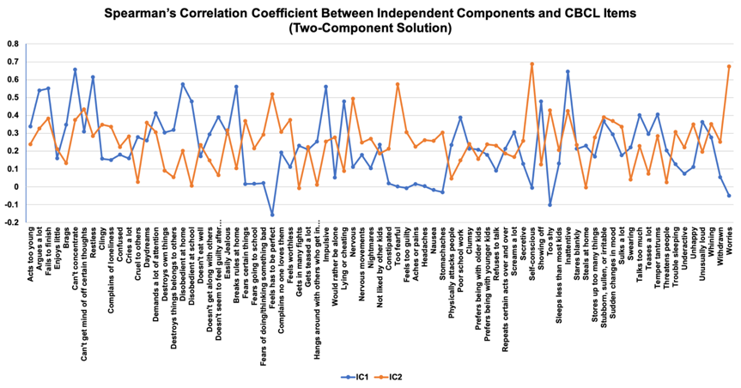

Figure S2. The Four Component ICA Solution. For improved readability, only items with a loading of at least |0.2| on at least one component are shown
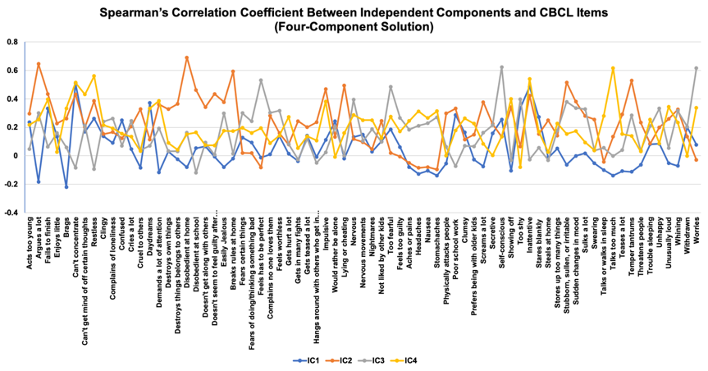

Figure S3. The Five Component ICA Solution. For improved readability, only items with a loading of at least |0.2| on at least one component are shown.
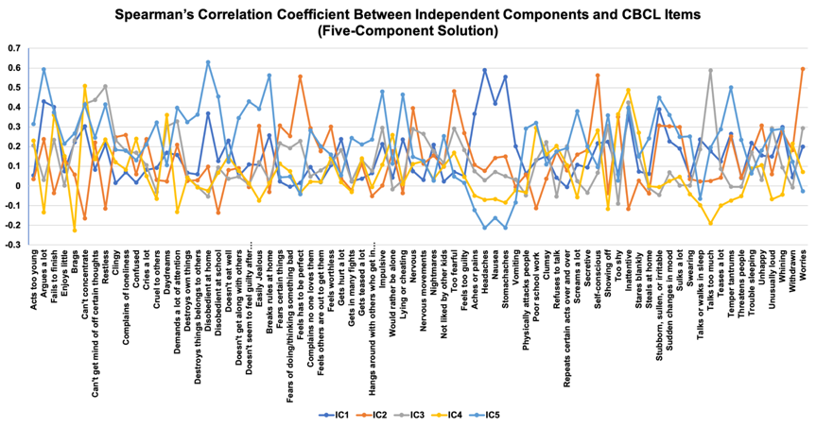

- External Validation of the Psychopathology Dimensions
Each ICA-derived dimension had a distinct profile of associations with cognitive and behavioral traits (Spearman’s ρ= -0.48 to 0.17). We report associations between ICA- and EFA-derived dimensions that were significant in more than 90% of the resampled models as these are likely to be the most robust to sample composition. Opposition-disinhibition was positively associated with negative urgency, drive, lack of premeditation, and negatively associated with behavioral inhibition, general cognitive ability and learning and memory. Cognitive dyscontrol was positively associated with lack of perseverance, and negatively associated with all measures of cognition. Negative affect was positively associated with behavioral inhibition and general cognitive ability, and negatively with sensation seeking. Both opposition-disinhibition and cognitive dyscontrol were associated with poorer school performance and greater use of special services, whereas the negative affect dimension was positively associated with school performance. Only opposition-disinhibition was significantly associated with detention and suspension. All three dimensions were associated with significantly higher mental health service utilization (Figure 2B, Tables S9-S10).
The three EFA-derived dimensions had overlapping cognitive and behavioral profiles (Spearman’s ρ = 0.44 to 0.82; Figure 2, Table S9, Figure S4). Broad-externalizing was positively associated with negative urgency, drive, and lack of premeditation, and negatively associated with general cognitive ability and learning and memory. The neurodevelopmental dimension was positively associated with lack of perseverance and lack of premeditation and negatively associated all cognitive measures. The broad internalizing dimension was positively associated with behavioral inhibition and lack of perseverance. The neurodevelopmental and externalizing dimensions were associated with poor academic conduct and performance.

Table S8. The Association of Psychopathology Dimensions with Cognitive and Behavioral Measures
 | Estimate | Std. Error | t-value | P-value
 | Opposition-Disinhibition
General Cognitive Ability | -0.114 | 0.013 | -8.693 | 4.18E-18
Executive Function | -0.034 | 0.012 | -2.831 | 0.00465081
Learning/Memory | -0.064 | 0.013 | -4.835 | 1.35E-06
Negative Urgency | 0.032 | 0.004 | 8.353 | 7.67E-17
Lack of Premeditation | 0.052 | 0.004 | 11.876 | 2.79E-32
Sensation Seeking | 0.013 | 0.003 | 3.749 | 0.00017878
Positive Urgency | 0.008 | 0.003 | 2.214 | 0.02684141
Lack of Perseverance | 0.016 | 0.005 | 3.497 | 0.00047303
Behavioral Inhibition | -0.022 | 0.003 | -6.626 | 3.65E-11
Reward Responsiveness | 0.018 | 0.004 | 4.358 | 1.33E-05
Drive | 0.022 | 0.003 | 6.681 | 2.51E-11
Prosocial Behavior | -0.026 | 0.027 | -0.951 | 0.34147395
 | Cognitive Dyscontrol
General Cognitive Ability | -0.074 | 0.014 | -5.444 | 5.35E-08
Executive Function | -0.109 | 0.012 | -8.765 | 2.22E-18
Learning/Memory | -0.082 | 0.014 | -5.966 | 2.53E-09
Negative Urgency | -0.011 | 0.004 | -2.829 | 0.00467442
Lack of Premeditation | 0.008 | 0.005 | 1.7 | 0.08918629
Sensation Seeking | 0.001 | 0.003 | 0.193 | 0.84682236
Positive Urgency | 0.008 | 0.004 | 2.135 | 0.03276433
Lack of Perseverance | 0.071 | 0.005 | 15.214 | 1.32E-51
Behavioral Inhibition | 0.015 | 0.003 | 4.491 | 7.19E-06
Reward Responsiveness | 0 | 0.004 | -0.079 | 0.93689993
Drive | 0.001 | 0.003 | 0.172 | 0.86375649
Prosocial Behavior | 0.112 | 0.028 | 4.051 | 5.15E-05
 | Negative Affect
General Cognitive Ability | 0.13 | 0.013 | 9.645 | 6.63E-22
Executive Function | 0.005 | 0.012 | 0.392 | 0.69536706
Learning/Memory | -0.008 | 0.014 | -0.607 | 0.54377078
Negative Urgency | 0.014 | 0.004 | 3.583 | 0.00034122
Lack of Premeditation | -0.014 | 0.005 | -3.051 | 0.0022845
Sensation Seeking | -0.021 | 0.003 | -6.136 | 8.83E-10
Positive Urgency | -0.006 | 0.004 | -1.822 | 0.06856499
Lack of Perseverance | 0.007 | 0.005 | 1.543 | 0.12280865
Behavioral Inhibition | 0.036 | 0.003 | 10.422 | 2.79E-25
Reward Responsiveness | -0.021 | 0.004 | -4.872 | 1.13E-06
Drive | 0 | 0.003 | 0.132 | 0.8949621
Prosocial Behavior | 0.017 | 0.028 | 0.631 | 0.52822183
 | Broad Externalizing
General Cognitive Ability | -0.088 | 0.011 | -7.76 | 9.55E-15
Executive Function | -0.028 | 0.01 | -2.671 | 0.00758462
Learning/Memory | -0.062 | 0.012 | -5.324 | 1.04E-07
Negative Urgency | 0.028 | 0.003 | 8.577 | 1.15E-17
Lack of Premeditation | 0.039 | 0.004 | 10.435 | 2.47E-25
Sensation Seeking | 0.007 | 0.003 | 2.232 | 0.02566708
Positive Urgency | 0.007 | 0.003 | 2.425 | 0.01532718
Lack of Perseverance | 0.016 | 0.004 | 4.105 | 4.07E-05
Behavioral Inhibition | -0.011 | 0.003 | -3.668 | 0.00024597
Reward Responsiveness | 0.01 | 0.004 | 2.711 | 0.00671246
Drive | 0.015 | 0.003 | 5.147 | 2.70E-07
Prosocial Behavior | -0.041 | 0.023 | -1.764 | 0.07769259
 | Neurodevelopmental
General Cognitive Ability | -0.089 | 0.011 | -7.928 | 2.52E-15
Executive Function | -0.093 | 0.01 | -9.054 | 1.70E-19
Learning/Memory | -0.093 | 0.011 | -8.125 | 5.15E-16
Negative Urgency | 0.006 | 0.003 | 1.719 | 0.08560159
Lack of Premeditation | 0.022 | 0.004 | 5.859 | 4.84E-09
Sensation Seeking | -0.002 | 0.003 | -0.567 | 0.57083915
Positive Urgency | 0.006 | 0.003 | 2.131 | 0.03311593
Lack of Perseverance | 0.054 | 0.004 | 14.031 | 3.27E-44
Behavioral Inhibition | 0.01 | 0.003 | 3.662 | 0.00025196
Reward Responsiveness | -0.003 | 0.004 | -0.827 | 0.40814922
Drive | 0.011 | 0.003 | 3.77 | 0.00016439
Prosocial Behavior | 0.036 | 0.023 | 1.571 | 0.11633112
 | Broad Internalizing
General Cognitive Ability | 0.015 | 0.012 | 1.239 | 0.21543588
Executive Function | -0.042 | 0.011 | -3.718 | 0.00020236
Learning/Memory | -0.058 | 0.013 | -4.596 | 4.38E-06
Negative Urgency | 0.013 | 0.004 | 3.765 | 0.0001675
Lack of Premeditation | 0.006 | 0.004 | 1.498 | 0.13411634
Sensation Seeking | -0.011 | 0.003 | -3.426 | 0.00061452
Positive Urgency | 0.002 | 0.003 | 0.692 | 0.48864884
Lack of Perseverance | 0.037 | 0.004 | 8.63 | 7.29E-18
Behavioral Inhibition | 0.023 | 0.003 | 7.482 | 8.09E-14
Reward Responsiveness | -0.014 | 0.004 | -3.465 | 0.00053367
Drive | 0.005 | 0.003 | 1.623 | 0.10456126
Prosocial Behavior | 0.044 | 0.026 | 1.717 | 0.08604281
The values represent the independent contribution of the variables to each psychopathology dimension in a multivariable Kernel-based regularized least squares model

Figure S4. Similarity Score Between Cognitive and Behavioral Correlates of Dimensions of Psychopathology. Similarity scores represent spearman’s correlation coefficient between t-value vectors (derived using kernel-based regularized least squares) for each pair of psychopathology dimensions.
Table S9. The Association of Psychopathology Dimensions with Academic Outcomes and Mental Health Service Utilization
 | Estimate | Std. Error | t-value | P-value
 | Overall school performance (higher values show poorer performance)
Opposition-Disinhibition | 0.149 | 0.006 | 24.028 | 8.50E-124
Cognitive Dyscontrol | 0.159 | 0.006 | 26.655 | 7.25E-151
Negative Affect | -0.046 | 0.006 | -7.492 | 7.41E-14
 | Special Services- Full-time Emotional Support
Opposition-Disinhibition | 0.007 | 0.001 | 7.098 | 1.36E-12
Cognitive Dyscontrol | 0.003 | 0.001 | 3.172 | 0.00151661
Negative Affect | 0.001 | 0.001 | 0.485 | 0.62803086
 | Special Services- Full-time Learning Support
Opposition-Disinhibition | 0.007 | 0.001 | 4.728 | 2.31E-06
Cognitive Dyscontrol | 0.009 | 0.001 | 6.484 | 9.37E-11
Negative Affect | -0.001 | 0.001 | -0.916 | 0.35994922
 | Special Services- Full-time Aide
Opposition-Disinhibition | 0.002 | 0.001 | 3.502 | 0.00046361
Cognitive Dyscontrol | 0.002 | 0.001 | 3.384 | 0.00071702
Negative Affect | -0.001 | 0.001 | -1.998 | 0.04575399
 | Special Services- Special Education for specific subjects
Opposition-Disinhibition | 0.015 | 0.003 | 6.131 | 9.08E-10
Cognitive Dyscontrol | 0.034 | 0.002 | 13.98 | 5.76E-44
Negative Affect | -0.008 | 0.003 | -3.397 | 0.00068535
 | Detention/Suspension
Opposition-Disinhibition | -0.042 | 0.002 | -17.637 | 1.70E-68
Cognitive Dyscontrol | 0.004 | 0.002 | 1.576 | 0.11512533
Negative Affect | 0.008 | 0.002 | 3.527 | 0.00042191
 | Mental Health Service Utilization
Opposition-Disinhibition | 0.067 | 0.004 | 17.871 | 2.99E-70
Cognitive Dyscontrol | 0.037 | 0.004 | 10.137 | 5.07E-24
Negative Affect | 0.053 | 0.004 | 14.161 | 4.73E-45
 | Estimate | Std. Error | t value | Pr(>|t|)
 | Overall school performance (higher values show poorer performance)
Broad Externalizing | 0.098 | 0.008 | 12.257 | 2.93E-34
Neurodevelopmental | 0.24 | 0.009 | 27.492 | 1.17E-159
Broad Internalizing | -0.08 | 0.008 | -9.545 | 1.73E-21
 | Special Services- Full-time Emotional Support
Broad Externalizing | 0.006 | 0.001 | 4.068 | 4.79E-05
Neurodevelopmental | 0.006 | 0.001 | 3.85 | 0.00011903
Broad Internalizing | 0.001 | 0.001 | 0.503 | 0.61509197
 | Special Services- Full-time Learning Support
Broad Externalizing | 0.004 | 0.002 | 1.985 | 0.04721837
Neurodevelopmental | 0.013 | 0.002 | 6.313 | 2.87E-10
Broad Internalizing | -0.001 | 0.002 | -0.303 | 0.7617678
 | Special Services- Full-time Aide
Broad Externalizing | 0.003 | 0.001 | 3.311 | 0.00093216
Neurodevelopmental | 0.004 | 0.001 | 3.834 | 0.00012691
Broad Internalizing | -0.002 | 0.001 | -1.662 | 0.09658853
 | Special Services- Special Education for specific subjects
Broad Externalizing | 0.002 | 0.003 | 0.523 | 0.60079521
Neurodevelopmental | 0.055 | 0.004 | 15.265 | 6.11E-52
Broad Internalizing | -0.012 | 0.003 | -3.65 | 0.00026332
 | Detention/Suspension
Broad Externalizing | -0.05 | 0.003 | -16.552 | 1.30E-60
Neurodevelopmental | -0.01 | 0.003 | -2.902 | 0.00371543
Broad Internalizing | 0.007 | 0.003 | 2.186 | 0.02885364
 | Mental Health Service Utilization
Broad Externalizing | 0.055 | 0.005 | 11.401 | 6.74E-30
Neurodevelopmental | 0.038 | 0.005 | 7.327 | 2.57E-13
Broad Internalizing | 0.067 | 0.005 | 13.393 | 1.65E-40
The values represent the independent contribution of the psychopathology dimensions to each outcome in a multivariable Kernel-based regularized least squares model

Table S10. The Association of Psychopathology Dimensions with Global Morphometric Measures.
 | Estimate | Std. Error | t-value | P-value
 | Opposition-Disinhibition
Mean Cortical Thickness | 0.1294167 | 0.11229039 | 1.153 | 0.24914401
Total Surface Area | -5.54E-06 | 9.44E-07 | -5.869 | 4.57E-09
Total Intracranial Volume | 1.98E-08 | 1.19E-07 | 0.166 | 0.86820156
 | Cognitive Dyscontrol
Mean Cortical Thickness | -0.1038169 | 0.11370028 | -0.913 | 0.3612315
Total Surface Area | -9.71E-07 | 9.56E-07 | -1.015 | 0.30993287
Total Intracranial Volume | -7.99E-08 | 1.21E-07 | -0.662 | 0.50822394
 | Negative Affect
Mean Cortical Thickness | 0.09781988 | 0.11380849 | 0.86 | 0.39008427
Total Surface Area | -1.12E-06 | 9.57E-07 | -1.172 | 0.24138229
Total Intracranial Volume | 1.54E-07 | 1.21E-07 | 1.276 | 0.20187366
 | Broad Externalizing
Mean Cortical Thickness | 0.08038088 | 0.09716877 | 0.827 | 0.40813405
Total Surface Area | -4.47E-06 | 8.09E-07 | -5.519 | 3.53E-08
Total Intracranial Volume | -1.16E-08 | 1.02E-07 | -0.113 | 0.91021046
 | Neurodevelopmental
Mean Cortical Thickness | -0.1061175 | 0.0954767 | -1.111 | 0.26641186
Total Surface Area | -3.37E-06 | 7.95E-07 | -4.236 | 2.31E-05
Total Intracranial Volume | -3.74E-08 | 1.01E-07 | -0.372 | 0.70999995
 | Broad Internalizing
Mean Cortical Thickness | -0.0025765 | 0.10340995 | -0.025 | 0.98012325
Total Surface Area | -2.70E-06 | 8.61E-07 | -3.14 | 0.00169563
Total Intracranial Volume | -9.28E-09 | 1.09E-07 | -0.085 | 0.93216136
The values represent the independent contribution of the morphometric measure to each psychopathology dimension in a multivariable Kernel-based regularized least squares model. Values were was adjusted for sex, age, handedness, race, weight, height, pubertal stage, and scanner site

Figure S5. Association Between Global Morphometric Measures and Psychopathology Dimensions. t-values calculated across 100 subsamples using linear mixed effects model (LM) and kernel-based regularized least squares (KRLS).

Figure S6. Nonlinear Effect of Global Brain Measures on ICA-derived Dimensions. Analysis was done using kernel-based regularized least squares and was adjusted for sex, age, handedness, race, weight, height, pubertal stage, and scanner site.
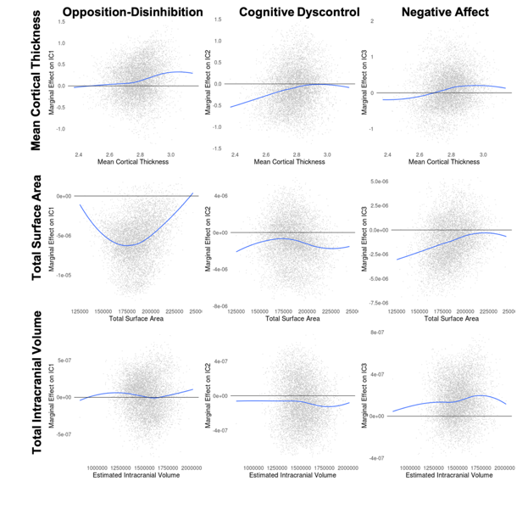
Figure S7. Nonlinear Effect of Global Brain Measures on EFA-derived Dimensions. Analysis was done using kernel-based regularized least squares and was adjusted for sex, age, handedness, race, weight, height, pubertal stage, scanner site, and two other global morphometric measures.
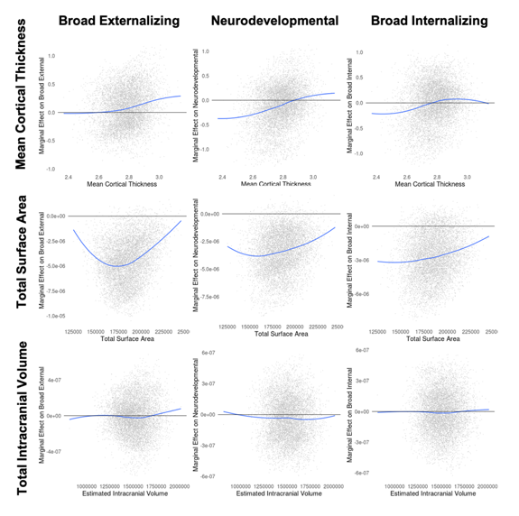
Figure S8. Association ICA-derived Dimensions and Subcortical Volumes. Analysis was done using kernel-based regularized least squares and was adjusted for sex, age, handedness, race, weight, height, pubertal stage, and scanner site.
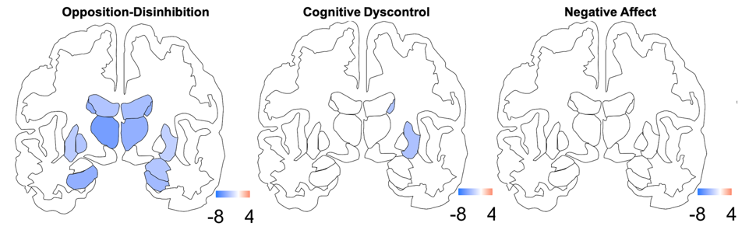

Figure S9. Association EFA-derived Components and Subcortical Volumes. Analysis was done using kernel-based regularized least squares and was adjusted for sex, age, handedness, race, weight, height, pubertal stage, and scanner site. Only t-values with an FDR-adjusted p-value< 0.05 are shown

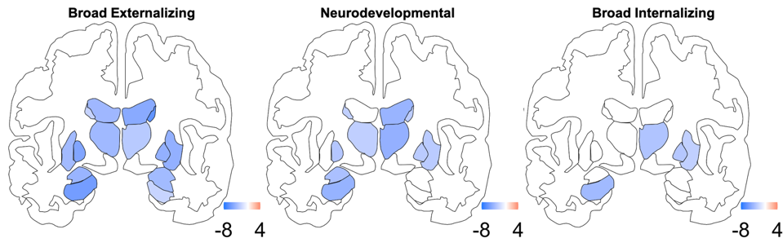

Figure S10. Association Between Dimensions of Psychopathology and Regional Morphometric Measures. Each cell represents the t-value from the kernel-based regularized least sqaures models

Figure S11. Similarity Score Between Regional Morphometric Correlates of Psychopathology Dimensions. Similarity scores represent spearman’s correlation coefficient between t-values derived from kernel-based regularized least squares.

Table S11. The Association of Psychopathology Dimensions with Global White Matter Integrity Measures
 | Estimate | Std. Error | t-value | P-value
 | Opposition-Disinhibition
Fractional Anisotropy | -0.349 | 0.319 | -1.095 | 0.27339114
Mean Diffusivity | 0.063 | 0.412 | 0.153 | 0.87844684
Axial Diffusivity | 0.024 | 0.301 | 0.079 | 0.93724093
Radial Diffusivity | 0.042 | 0.357 | 0.119 | 0.905619
 | Cognitive Dyscontrol
Fractional Anisotropy | -0.526 | 0.323 | -1.631 | 0.10286365
Mean Diffusivity | 0.689 | 0.417 | 1.653 | 0.09841329
Axial Diffusivity | -0.298 | 0.305 | -0.98 | 0.32722255
Radial Diffusivity | 1.434 | 0.362 | 3.961 | 7.55E-05
 | Negative Affect
Fractional Anisotropy | -0.415 | 0.322 | -1.292 | 0.19637888
Mean Diffusivity | -0.032 | 0.415 | -0.077 | 0.93899899
Axial Diffusivity | -0.196 | 0.303 | -0.645 | 0.51873384
Radial Diffusivity | 0.298 | 0.361 | 0.826 | 0.40863695
 | Broad Externalizing
Fractional Anisotropy | -0.355 | 0.273 | -1.301 | 0.19330065
Mean Diffusivity | 0.092 | 0.349 | 0.264 | 0.79150357
Axial Diffusivity | -0.006 | 0.253 | -0.024 | 0.98117768
Radial Diffusivity | 0.135 | 0.307 | 0.439 | 0.66034033
 | Neurodevelopmental
Fractional Anisotropy | -0.958 | 0.273 | -3.508 | 0.00045507
Mean Diffusivity | 0.562 | 0.346 | 1.625 | 0.10411729
Axial Diffusivity | -0.323 | 0.253 | -1.277 | 0.20163845
Radial Diffusivity | 1.326 | 0.304 | 4.357 | 1.34E-05
 | Broad Internalizing
Fractional Anisotropy | -0.729 | 0.296 | -2.46 | 0.01391031
Mean Diffusivity | -0.031 | 0.375 | -0.082 | 0.93463619
Axial Diffusivity | -0.352 | 0.274 | -1.285 | 0.19891276
Radial Diffusivity | 0.575 | 0.33 | 1.741 | 0.08167969
The values represent the independent contribution of the morphometric measure to each psychopathology dimension in a multivariable Kernel-based regularized least squares model. Values were was adjusted for sex, age, handedness, race, weight, height, pubertal stage, and scanner site

Figure S12. Association Between Global Measures of White Matter Integrity and Dimensions of Psychopathology. t-values calculated across 100 subsamples using linear mixed effects model (LM) and kernel-based regularized least squares.
Figure S13. Nonlinear Effects of Measures of White Matter Integrity on ICA-derived Dimensions of Psychopathology. Analysis was done using kernel-based regularized least squares and was adjusted for sex, age, handedness, race, weight, height, pubertal stage, head motion , scanner site, and three other global measures of white matter integrity.
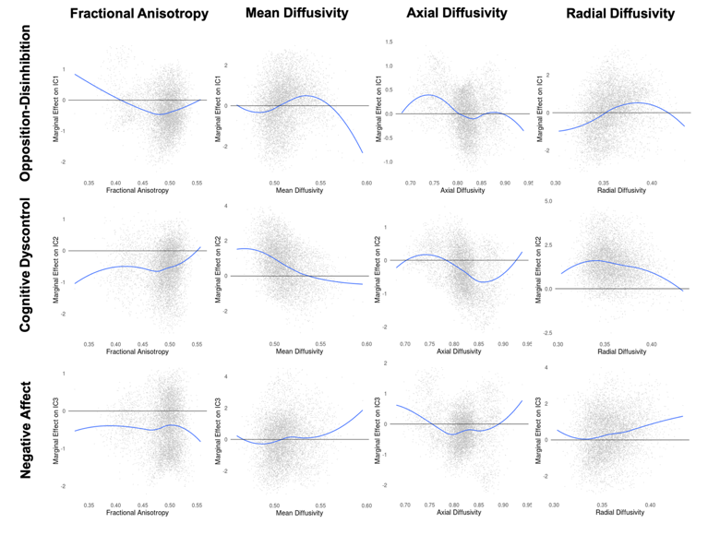
Figure S14. Nonlinear Effects of Measures of White Matter Integrity on EFA-derived Dimensions of Psychopathology. Analysis was done using kernel-based regularized least squares and was adjusted for sex, age, handedness, race, weight, height, pubertal stage, head motion, scanner site, and three other global measures of white matter integrity.
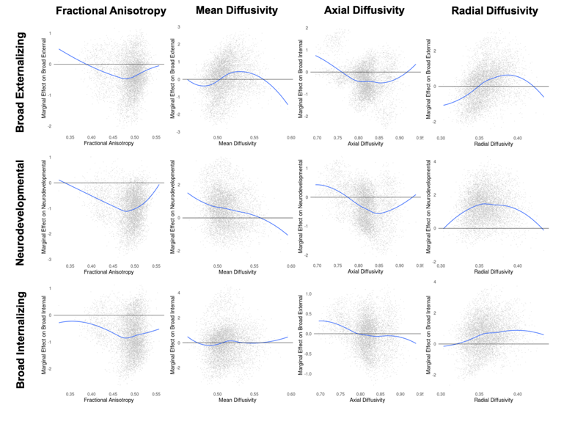
Figure S15. Association Between Data-Driven Dimensions of Psychopathology and Regional Measures of White Matter Integrity. Each cell represents the t-value from the kernel-based regularized least squares. FA=Fractional anisotropy; MD=Mean diffusivity; AD=Axial diffusivity; RD: Radial diffusivity

Figure S16. Similarity Score Between Regional White Matter Integrity Correlates of Psychopathology Dimensions. Similarity scores represent spearman’s correlation coefficient between t-values derived using kernel-based regularized least squares.
Figure S17. Top 3 Negative and Positive Associations Between Resting-State Functional Connectivity and Cognitive Dyscontrol Component. Upper panels show between network connectivity, whereas lower panels show within network connectivity
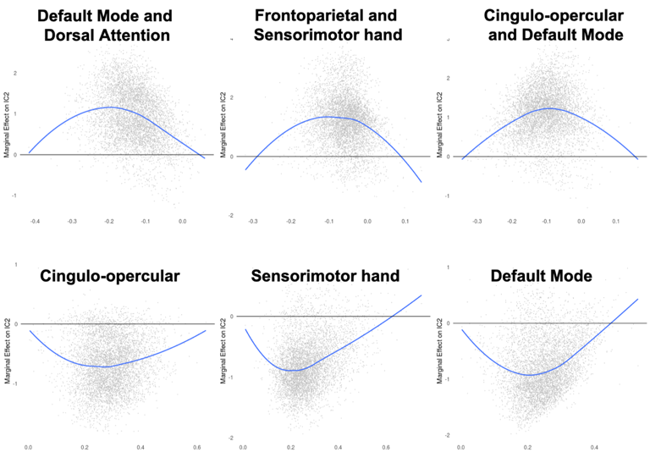
Figure S18. Association Between Dimensions of Psychopathology and Resting-State Functional Connectivity. Each cell represents the t-value derived using kernel-based regularized least squares

Figure S19. Similarity Scores Between Resting State Functional Connectivity Correlates of Dimensions of Psychopathology. Similarity scores represent spearman’s correlation coefficient between t-values calculated using kernel-based regularized least squares.
Figure S20. Association of Five-Component ICA-Derived and Five-Factor EFA-Derived Psychopathology Dimensions with Cognitive and Behavioral Measures. Each cell represents number of FDR-corrected P-values<0.05 in 100 reruns of the kernel regularized least squares (KRLS) analysis on 50% randomly resampled data multiplied by the sign of the association. All analyses were adjusted for sex, race, age, and site; for each psychopathology dimension, all measures are modeled together to characterize their independent contribution to psychopathology.

Figure S21. Association of Five-Component ICA-Derived and Five-Factor EFA-Derived Psychopathology Dimensions with Academic Outcomes and Service Utilization. Each cell represents number of FDR-corrected P-values<0.05 in 100 reruns of the kernel regularized least squares (KRLS) analysis on 50% randomly resampled data multiplied by the sign of the association. All analyses were adjusted for sex, race, age, and site; For each outcome, all five dimensions (ICA-derived or EFA-derived) are entered into the model together to quantify their independent contribution to the outcome.
Figure S22. Association Between Global Measures of Brain Morphometry and the 5-Component ICA Solution, and 5-factor EFA dimensions using kernel regularized least squares (KRLS); Values represent t-value for the association between morphometric brain measures and dimensions of psychopathology. For global measures, values represent t-values in 100 randomly resampled dataset of 50% original sample size. For regional measures values represent t-value from the model on the whole dataset; All analyses were adjusted for sex, age, and race, handedness, scanner, weight, height, pubertal stage; A, B, C Association between brain morphometric measures and ICA-derived dimensions. D, E, F. Association between brain morphometric measures and EFA-derived factors.

Figure S23. Association Between Dimensions of Psychopathology and Regional Morphometric Measures for 5-Component and 5-Factor Solutions. Each cell represents the t-value from the kernel-based regularized least sqaures models

Figure S24. Similarity Score Between Regional Morphometric Correlates of Psychopathology Dimensions for 5-Component and 5-Factor Solutions. Similarity scores represent spearman’s correlation coefficient between t-values derived from kernel-based regularized least squares.

Figure S25. Association between global measures of white matter integrity and the 5-component ICA solution, and 5-factor EFA solution using kernel regularized least squares (KRLS). Values represent t-value for the association between the measures of white matter integrity and psychopathology dimensions in 100 randomly resampled dataset of 50% original sample size; All analyses were adjusted for sex, age, and race, handedness, scanner, weight, height, pubertal stage, and head motion; A,B,C,D. Association between measures of white matter integrity and ICA-derived dimensions. E, F, G, H. Association between measures of white matter integrity and EFA-derived factors

Figure S26. Association Between Data-Driven Dimensions of Psychopathology for 5-Component and 5-Factor Solutions and Regional Measures of White Matter Integrity. Each cell represents the t-value from the kernel-based regularized least squares. FA=Fractional anisotropy; MD=Mean diffusivity; AD=Axial diffusivity; RD: Radial diffusivity
Figure S27. Similarity Score Between Regional White Matter Integrity Correlates of Psychopathology Dimensions for 5-Component and 5-Factor Solutions. Similarity scores represent spearman’s correlation coefficient between t-values derived using kernel-based regularized least squares.
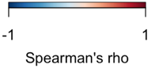
Figure S28. Association Between Dimensions of Psychopathology for 5-Component and 5-Factor Solutions and Resting-State Functional Connectivity. Each cell represents the t-value derived using kernel-based regularized least squares
Figure S29. Similarity Scores Between Resting State Functional Connectivity Correlates of Dimensions of Psychopathology for 5-Component and 5-Factor Solutions. Similarity scores represent spearman’s correlation coefficient between t-values calculated using kernel-based regularized least squares.

Supplemental References

1. Barch DM, Albaugh MD, Avenevoli S, et al. Demographic, physical and mental health assessments in the adolescent brain and cognitive development study: Rationale and description. Dev Cogn Neurosci. Aug 2018;32:55-66.
2. Garavan H, Bartsch H, Conway K, et al. Recruiting the ABCD sample: Design considerations and procedures. Dev Cogn Neurosci. Aug 2018;32:16-22.
3. Luciana M, Bjork JM, Nagel BJ, et al. Adolescent neurocognitive development and impacts of substance use: Overview of the adolescent brain cognitive development (ABCD) baseline neurocognition battery. Dev Cogn Neurosci. Aug 2018;32:67-79.
4. Zucker RA, Gonzalez R, Feldstein Ewing SW, et al. Assessment of culture and environment in the Adolescent Brain and Cognitive Development Study: Rationale, description of measures, and early data. Dev Cogn Neurosci. Aug 2018;32:107-120.
5. Thompson WK, Barch DM, Bjork JM, et al. The structure of cognition in 9 and 10 year-old children and associations with problem behaviors: Findings from the ABCD study's baseline neurocognitive battery. Dev Cogn Neurosci. Apr 2019;36:100606.
6. Whiteside SP, Lynam DR, Miller JD, Reynolds SK. Validation of the UPPS impulsive behaviour scale: a four‐factor model of impulsivity. European Journal of Personality: Published for the European Association of Personality Psychology. 2005;19(7):559-574.
7. Carver CS, White TL. Behavioral inhibition, behavioral activation, and affective responses to impending reward and punishment: the BIS/BAS scales. Journal of personality and social psychology. 1994;67(2):319.
8. Achenbach TM. The Achenbach system of empirically based assessment (ASEBA): Development, findings, theory, and applications: University of Vermont, Research Center for Children, Youth, & Families; 2009.
9. Michelini G, Barch DM, Tian Y, Watson D, Klein DN, Kotov R. Delineating and validating higher-order dimensions of psychopathology in the Adolescent Brain Cognitive Development (ABCD) study. Transl Psychiatry. Oct 17 2019;9(1):261.
10. Achenbach TM. The classification of children's psychiatric symptoms: a factor-analytic study. Psychol Monogr. 1966;80(7):1-37.
11. Casey BJ, Cannonier T, Conley MI, et al. The Adolescent Brain Cognitive Development (ABCD) study: Imaging acquisition across 21 sites. Dev Cogn Neurosci. Aug 2018;32:43-54.
12. Hagler DJ, Jr., Hatton S, Cornejo MD, et al. Image processing and analysis methods for the Adolescent Brain Cognitive Development Study. Neuroimage. Aug 12 2019:116091.
13. Cantini L, Kairov U, de Reyniès A, Barillot E, Radvanyi F, Zinovyev A. Stabilized Independent Component Analysis outperforms other methods in finding reproducible signals in tumoral transcript-tomes. bioRxiv. 2018:318154.
14. Hyvarinen A, Oja E. Independent component analysis: algorithms and applications. Neural Netw. May-Jun 2000;13(4-5):411-430.
15. Sompairac N, Nazarov PV, Czerwinska U, et al. Independent Component Analysis for Unraveling the Complexity of Cancer Omics Datasets. Int J Mol Sci. Sep 7 2019;20(18).
16. Norbom LB, Doan NT, Alnæs D, et al. Probing Brain Developmental Patterns of Myelination and Associations With Psychopathology in Youths Using Gray/White Matter Contrast. Biol Psychiatry. Mar 1 2019;85(5):389-398.
17. Alnaes D, Kaufmann T, Doan NT, et al. Association of Heritable Cognitive Ability and Psychopathology With White Matter Properties in Children and Adolescents. JAMA Psychiatry. Mar 1 2018;75(3):287-295.
18. Langlois D, Chartier S, Gosselin D. An introduction to independent component analysis: InfoMax and FastICA algorithms. Tutorials in Quantitative Methods for Psychology. 2010;6(1):31-38.
19. Kairov U, Cantini L, Greco A, et al. Determining the optimal number of independent components for reproducible transcriptomic data analysis. BMC Genomics. Sep 11 2017;18(1):712.
20. Himberg J, Hyvarinen A. Icasso: software for investigating the reliability of ICA estimates by clustering and visualization. Paper presented at: 2003 IEEE XIII Workshop on Neural Networks for Signal Processing (IEEE Cat. No. 03TH8718)2003.
21. Goldberg LR. Doing it all bass-ackwards: The development of hierarchical factor structures from the top down. Journal of Research in Personality. 2006;40(4):347-358.
22. Ferwerda J, Hainmueller J, Hazlett CJ. Kernel-based regularized least squares in R (KRLS) and Stata (krls). Journal of Statistical Software. 2017;79(3):1-26.
23. Hainmueller J, Hazlett C. Kernel regularized least squares: Reducing misspecification bias with a flexible and interpretable machine learning approach. Political Analysis. 2014;22(2):143-168.
24. Modabbernia A, Reichenberg A, Ing A, et al. Linked patterns of biological and environmental covariation with brain structure in adolescence: a population-based longitudinal study. Mol Psychiatry. May 22 2020.

