Surveilling COVID-19 emotional contagion on Twitter
- Sentiment analyses –

Supplementary material

Figure S1. Sentiment of tweets: VADER classification (number of tweets)

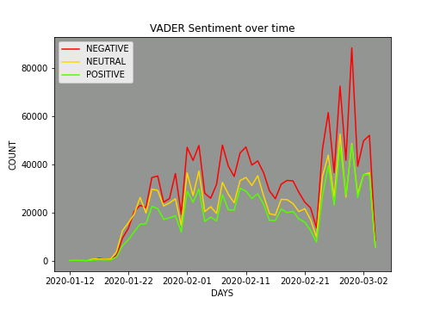
(a)
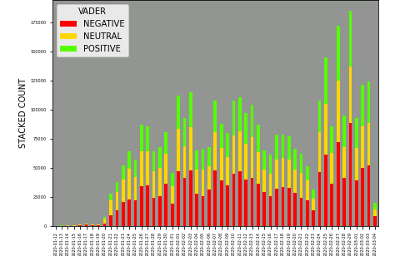
(b)
(a) count of tweets; (b) stacked count of tweets.
Proportions of sentiment of tweets using VADER: Negative: 42.1%; Neutral: 31.6%; Positive: 26.2%

Figure S2. Sentiment of tweets: CT-BERT classification (number of tweets)
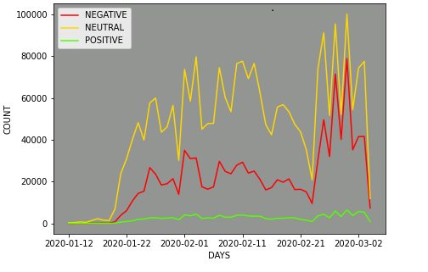
(a)

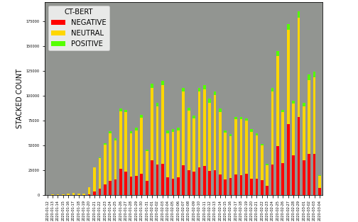

(b)

(a) count of tweets; (b) stacked count of tweets.
Proportions of sentiment of tweets using CT-BERT: Negative: 29.9%; Neutral: 66.8%; Positive: 3.4%

