Supplemental Table S.1 Characteristics of participants in different educational attainment levels

EA | Level 0 (n=4876) | Level 1 (n=21805) | Level 2 (n=20932) | Level 3 (n=34747) | Level 4 (n=4340) | Level 5 (n=21103) | Level 6 (n=812)
Age, median (IQR) | 72 (16) | 68 (16) | 63 (15) | 61 (13) | 61 (14) | 60 (14) | 62 (15)
Women, n (%) | 2933 (60%) | 13027 (60%) | 12111 (59%) | 17918 (52%) | 2355 (54%) | 10350 (49%) | 299 (37%)
Years of education, median (IQR) | 3 (6) | 6 (3) | 9 (2) | 12 (2) | 13 (3) | 16 (3) | 19 (3)

IQR, interquartile range

Supplemental Table S.2 Association of educational attainment levels with depressive symptoms in the whole analytical sample comparing EURO-D scale cut-off of 4 and 7 points
EA | Model 3_cut-off_4 | Model 3_cut-off_7
Level 0 | Reference | Reference
Level 1 | 0.79 (0.73; 0.85)** | 0.70 (0.63; 0.78)**
Level 2 | 0.71 (0.66; 0.77)** | 0.59 (0.52; 0.66)**
Level 3 | 0.67 (0.62; 0.72)** | 0.50 (0.44; 0.56)**
Level 4 | 0.68 (0.61; 0.75)** | 0.43 (0.35; 0.52)**
Level 5 | 0.60 (0.56; 0.66)** | 0.39 (0.34; 0.44)**
Level 6 | 0.76 (0.62; 0.92)* | 0.49 (0.30; 0.76)*
AIC | 101877 | 38444
Results are odds ratio with 95% confidence intervals derived from logistic regression for the association of educational attainment with depressive symptoms. The results are adjusted for age, sex, household net worth, employment status, family status, number of children, number of grandchildren, limitations in instrumental activities of daily living, 10 words delayed recall test, number of chronic diseases, chronic vascular disease, body mass index, physical activity, smoking, excessive alcohol intake, drugs for anxiety/depression, maximal grip strength
** p < 0.001; * p<0.05
AIC, Akaike information criterion

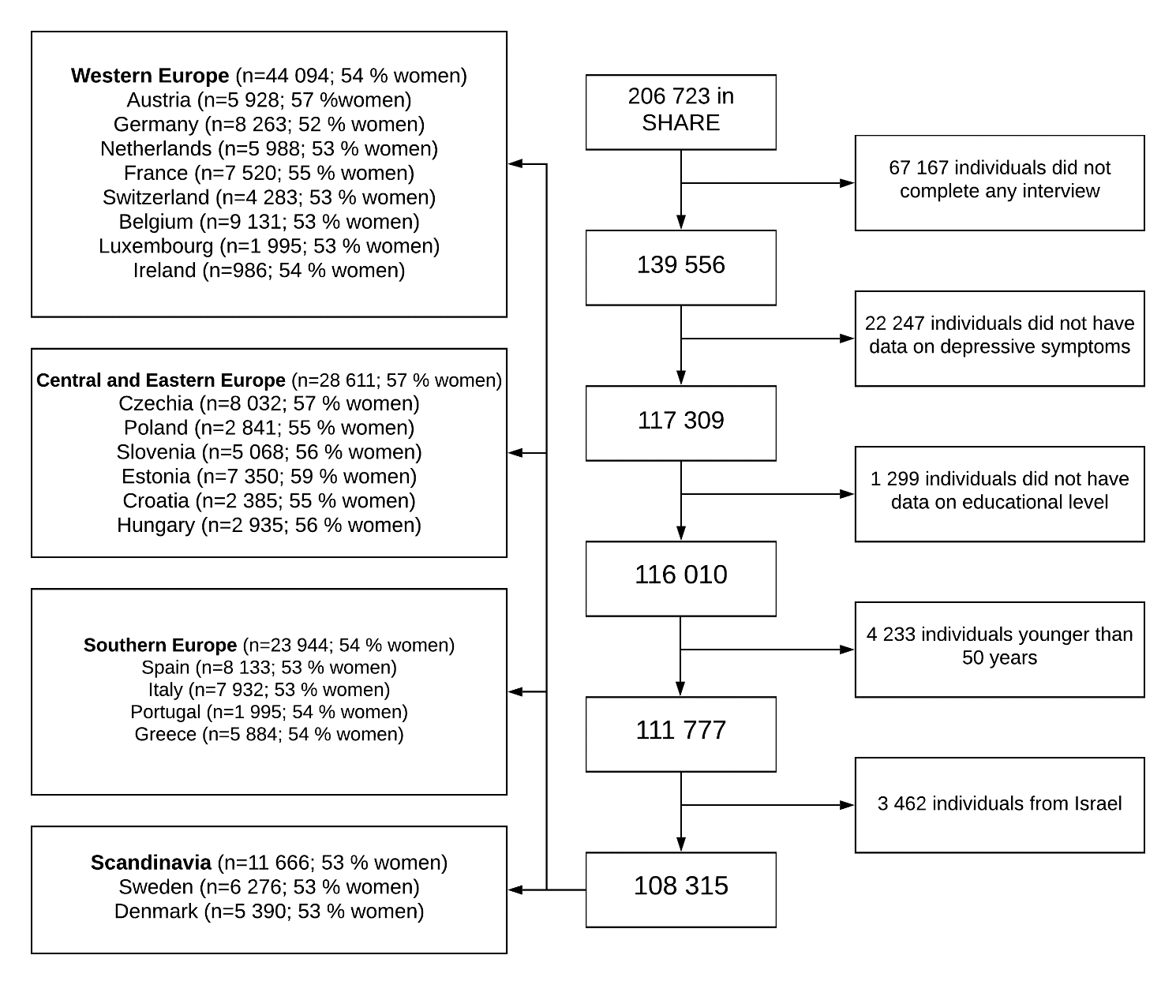
Supplemental Figure S.1 Selection of the study sample

