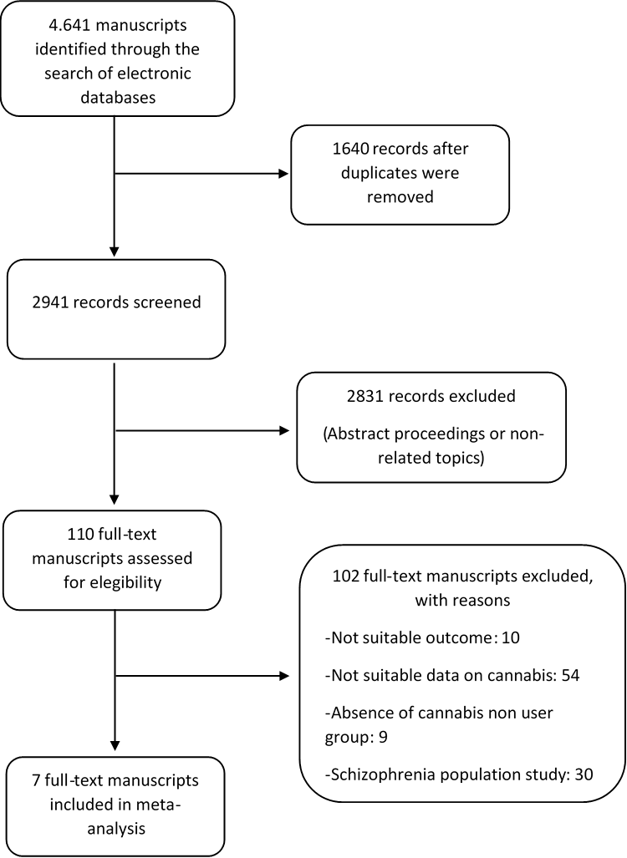

Supplementary material 1: PRISMA flowchart of the study selection process

