Web Appendix

Web Table 1

Sample size by country and sample type
 | PC sample | SC sample
Country | N | N
Austria ¹ | NA | 33
France | NA | 284
Germany ² | 1,356 | 232
Hungary | 2,306 | 254
Italy ³ | 943 | 276
Latvia | 1,302 | 250
Poland ⁴ | 1,197 | 289
Spain ⁵ | 1,372 | 149
Total | 8,476 | 1,767
Notes. PC = primary care. SC = specialized care. NA = not applicable.
¹ Selected region for SC sample: Carinthia.
² Selected regions for PC sample: Saxony, Berlin, Potsdam and Potsdam-Mittelmark.
Selected regions for SC sample: Saxony and Berlin-Brandenburg.
³ Selected regions for both samples: Friuli-Venezia Giulia & Tuscany.
⁴ Selected regions for PC sample: Podkarpackie and Łódzkie Voivodeship.
Selected regions for SC sample: Pomorskie, Warminsko-Mazurskie, Dolnoslaskie, Podlaskie, Podkarpackie and Malopolskie.
⁵ Selected region for both samples: Catalonia.

Web-Table 2a

Key socio-demographic variables across different diagnostic categories for women
 | From PC sample |  |  |  | From SC sample |  |  |  | Linear test
 | No alcohol use disorder | AA without treatment | AD without treatment | AUD with treatment |  | <4 DSM-5 criteria | >=4 DSM-5 criteria | Total | Coefficient / OR (95%CI) ª | P value
N | 4,670 | 92 | 214 | 51 |  | 165 | 321 | 5,513
Age mean (SD) | 44.5 (12.9) | 39.1 (14.3) | 43.4 (14.6) | 47.2 (11.5) |  | 48.5 (10.5) | 45.8 (10.1) | 44.6 (12.8) | 0.13  (-0.10 - 0.36) | .271
Married or cohabiting % (CI) | 64.4  (63.0 - 65.8) | 53.0  (44.6 - 63.3) | 54.6  (47.8 - 61.4) | 69.8  (57.0 - 82.6) |  | 51.5  (43.9 - 59.1) | 40.9  (35.5 - 46.3) | 62.2  (60.9 - 63.5) | 0.84  (0.80 - 0.88) | < .001 ^{b}
Employed  Paid work or self-employed % (CI) | 60.5  (59.1 - 61.9) | 47.8  (37.5 - 58.2) | 43.8  (37.1 - 50.6) | 39.3  (25.4 - 53.2) |  | 30.9  (23.9 - 38.0) | 36.8  (31.5 - 42.0) | 57.3  (56.0 - 58.6) | 0.76  (0.73 - 0.80) | < .001 ^{b}
Unemployed Health or other reason % (CI) | 12.4  (11.4 - 13.3) | 15.1  (7.8 - 22.7) | 26.4  (20.5 - 32.3) | 29.8  (17.0 - 42.6) |  | 25.5  (18.8 - 32.1) | 37.7  (32.4 - 43.0) | 14.9  (14.0 - 15.9) | 1.42  (1.35 - 1.49) | < .001 ^{b}
SES – self classified % (CI)
Above average | 6.6  (5.9 - 7.3) | 8.2  (2.4 - 14.1) | 9.9  (5.7 - 14.1) | 11.3  (2.5 - 20.2) |  | 3.0  (0.4 - 5.6) | 6.3  (3.6 - 8.9) | 6.7  (6.0 - 7.3) | 0.93  (0.85 - 1.02) | .127
Average | 72.8  (71.5 - 74.1) | 62.4  (52.3 - 72.6) | 59.5  (52.7 - 66.2) | 48.1  (33.9 - 62.3) |  | 53.3  (45.7 - 60.9) | 55.3  (49.9 - 60.8) | 70.4  (69.2 - 71.6) | 0.81  (0.77 - 0.84) | < .001 ^{b}
Below average | 20.6  (19.4 - 21.7) | 29.4  (19.9 - 38.9) | 30.6  (24.3 - 37.0) | 40.5  (26.5 - 54.5) |  | 43.6  (36.1 - 51.2) | 38.4  (33.1 - 43.8) | 22.9  (21.8 - 24.1) | 1.31  (1.25 - 1.38) | < .001 ^{b}
Education in years  mean (SD) | 12.8 (3.5) | 13.0 (3.1) | 12.5 (3.4) | 12.8 (3.6) |  | 12.3 (3.6) | 12.9 (3.3) | 12.8 (3.5) | -0.06  (-0.14 - 0.01) | .090
Notes. PC sample = four groups of patients sampled from primary care settings across six countries. SC sample = two groups of patients sampled from specialized care settings for alcohol treatment across eight countries. AA = alcohol abuse. AD = alcohol dependence. AUD = alcohol use disorder. DSM-5 = Diagnostic and Statistical Manual of Mental Disorders, Fifth Edition. OR = Odds Ratio. CI = confidence interval. SD = standard deviation. SES = socio-economic status.
Grouping variable was defined as follows with all diagnoses referring to past 12 months: 1 = no alcohol use disorder at all. 2 = AA (no AD) but not in treatment. 3 = AD but not in treatment. 4 = AUD (AA or AD) in treatment. 5 = in specialized care meeting at most three current DSM-5 alcohol use disorder criteria. 6 = in specialized care meeting at least four current DSM-5 alcohol use disorder criteria.
ª For continuous outcomes (age and education in years), weighted linear regressions were run using grouping variable, age and country as predictors. For dichotomous outcomes (all remaining variables), weighted logistic regressions were run using the same predictors. Coefficients and Odds Ratios of the grouping variable are reported, for linear and logistic regressions respectively.
^{b} significant Bonferroni-adjusted p-value: p < α=0.01/16 = 0.0006 ; Adjustment for 16 analyses using the same female sample (Table 3, Web Table 2 & Web Table 3).

Web-Table 2b

Key socio-demographic variables across different diagnostic categories for men
 | From PC sample |  |  |  | From SC sample |  |  |  | Linear test
 | No alcohol use disorder | AA without treatment | AD without treatment | AUD with treatment |  | <4 DSM-5 criteria | >=4 DSM-5 criteria | Total | Coefficient / OR (95%CI) ª | P value
N | 2,695 | 186 | 423 | 145 |  | 403 | 871 | 4,723
Age mean (SD) | 44.4 (13.3) | 40.3 (15.4) | 44.5 (14.0) | 48.7 (11.3) |  | 47.5 (10.2) | 45.5 (9.8) | 44.9 (12.6) | 0.23  (0.07 - 0.40) | .006
Married or cohabiting % (CI) | 67.5  (65.7 - 69.3) | 54.3  (47.0 - 61.6) | 58.3  (53.5 - 63.1) | 48.4  (39.9 - 56.9) |  | 43.2  (38.3 - 48.0) | 41.0  (37.7 - 44.3) | 58.7  (57.3 - 60.1) | 0.75  (0.73 - 0.78) | < .001 ^{b}
Employed  Paid work or self-employed % (CI) | 69.2  (67.5 - 71.0) | 61.5  (54.3 - 68.6) | 53.8  (48.9 - 58.7) | 45.1  (36.7 - 53.5) |  | 46.0  (41.4 - 50.9) | 41.4  (38.2 - 44.7) | 59.8  (58.4 - 61.2) | 0.77  (0.74 - 0.79) | < .001 ^{b}
Unemployed Health or other reason % (CI) | 10.5  (9.4 - 11.7) | 15.5  (10.2 - 20.9) | 23.5  (19.4 - 27.7) | 24.9  (17.7 - 32.0) |  | 30.8  (26.3 - 35.4) | 39.4  (36.1 - 42.6) | 19.3  (18.2 - 20.4) | 1.45  (1.39 - 1.50) | < .001 ^{b}
SES – self classified % (CI)
Above average | 8.2  (7.2 - 9.3) | 8.4  (4.2 - 12.6) | 8.1  (5.4 - 10.9) | 8.0  (3.2 - 12.7) |  | 3.0  (1.3 - 4.7) | 6.7  (5.0 - 8.3) | 7.5  (6.7 - 8.2) | 0.85  (0.79 - 0.91) | < .001 ^{b}
Average | 72.9  (71.2 - 74.6) | 70.0  (63.2 - 76.8) | 58.6  (53.7 - 63.4) | 56.7  (48.2 - 65.1) |  | 47.4  (42.5 - 52.3) | 49.3  (45.9 - 52.6) | 64.6  (63.2 - 65.9) | 0.78  (0.75 - 0.80) | < .001 ^{b}
Below average | 18.8  (17.4 - 20.3) | 21.6  (15.5 - 27.7) | 33.3  (28.7 - 38.0) | 35.4  (27.2 - 43.5) |  | 49.6  (44.7 - 54.5) | 44.1  (40.8 - 47.4) | 28.0  (26.7 - 29.3) | 1.39  (1.34 - 1.44) | < .001 ^{b}
Education in years  mean (SD) | 12.7 (3.4) | 12.7 (3.4) | 12.2 (3.4) | 11.0 (2.8) |  | 11.5 (3.2) | 12.1 (3.0) | 12.4 (3.3) | -0.20  (-0.25 -  -0.15) | < .001 ^{b}
Notes. PC sample = four groups of patients sampled from primary care settings across six countries. SC sample = two groups of patients sampled from specialized care settings for alcohol treatment across eight countries. AA = alcohol abuse. AD = alcohol dependence. AUD = alcohol use disorder. DSM-5 = Diagnostic and Statistical Manual of Mental Disorders, Fifth Edition. OR = Odds Ratio. CI = confidence interval. SD = standard deviation. SES = socio-economic status.
Grouping variable was defined as follows with all diagnoses referring to past 12 months: 1 = no alcohol use disorder at all. 2 = AA (no AD) but not in treatment. 3 = AD but not in treatment. 4 = AUD (AA or AD) in treatment. 5 = in specialized care meeting at most three current DSM-5 alcohol use disorder criteria. 6 = in specialized care meeting at least four current DSM-5 alcohol use disorder criteria.
ª For continuous outcomes (age and education in years), weighted linear regressions were run using grouping variable, age and country as predictors. For dichotomous outcomes (all remaining variables), weighted logistic regressions were run using the same predictors. Coefficients and Odds Ratios of the grouping variable are reported, for linear and logistic regressions respectively.
^{b} significant Bonferroni-adjusted p-value: p < α=0.01/16 = 0.0006 ; Adjustment for 16 analyses using the same male sample (Table 3, Web Table 2 & Web Table 3).

Web Table 3

Functionality measures across different diagnostic categories by sex
 | From PC sample |  |  |  | From SC sample |  |  |  | Linear test
 | No alcohol use disorder | AA without treatment | AD without treatment | AUD with treatment |  | <4 DSM-5 criteria | >=4 DSM-5 criteria | Total | Coefficient (95% CI) ª | P value
N | 7,365 | 278 | 637 | 196 |  | 568 | 1,194 | 10,238
WHODAS 2.0 total score
mean (SD)
Female cases | 9.4 (13.1) | 10.8 (11.8) | 13.0 (14.6) | 16.8 (17.2) |  | 11.0 (15.7) | 24.2 (20.4) | 10.5 (14.2) | 1.68  (1.30 - 2.06) | < .001 ^{b}
Male cases | 7.1 (11.6) | 9.1 (14.5) | 12.1 (15.2) | 17.5 (18.9) |  | 8.6 (12.7) | 21.2 (19.0) | 10.7 (15.0) | 1.91  (1.68 - 2.15) | < .001 ^{b}
Number of days of inability to carry out usual activities or work due to health condition in past month (WHODAS 2.0)
mean (SD)
Female cases | 1.4 (4.5) | 1.0 (1.7) | 2.2 (5.6) | 2.1 (6.2) |  | 2.2 (6.2) | 5.2 (8.2) | 1.6 (4.9) | 0.22  (0.18 - 0.27) | < .001 ^{b}
Male cases | 1.3 (4.7) | 1.9 (6.8) | 2.3 (6.4) | 4.3 (8.8) |  | 2.0 (5.6) | 4.8 (8.0) | 2.2 (6.0) | 0.22  (0.18 - 0.26) | < .001 ^{b}
Number of inpatient nights during past six months
mean (SD)
Female cases | 0.6 (3.3) | 0.5 (2.2) | 1.0 (4.3) | 5.5 (23.5) |  | 5.9 (13.5) | 12.1 (26.1) | 1.5 (8.1) | 0.58  (0.52 - 0.64) | < .001 ^{b}
Male cases | 0.8 (4.5) | 1.3 (12.8) | 1.5 (6.4) | 1.8 (5.9) |  | 6.0 (15.6) | 12.1 (23.2) | 3.5 (12.8) | 0.57  (0.51 - 0.63) | < .001 ^{b}
Notes. PC sample = four groups of patients sampled from primary care settings across six countries. SC sample = two groups of patients sampled from specialized care settings for alcohol treatment across eight countries. AA = alcohol abuse. AD = alcohol dependence. AUD = alcohol use disorder. DSM-5 = Diagnostic and Statistical Manual of Mental Disorders, Fifth Edition. CI = confidence interval. WHODAS 2.0 = World Health Organization Disability Assessment Schedule 2.0 – total score range: 0 - 100. SD = standard deviation.
Grouping variable was defined as follows with all diagnoses referring to past 12 months: 1 = no alcohol use disorder at all. 2 = AA (no AD) but not in treatment. 3 = AD but not in treatment. 4 = AUD (AA or AD) in treatment. 5 = in specialized care meeting at most three current DSM-5 alcohol use disorder criteria. 6 = in specialized care meeting at least four current DSM-5 alcohol use disorder criteria.
ª Weighted linear regressions (for WHODAS 2.0 total score) and poisson regressions (for both remaining variables) were run using grouping variable, age and country as predictors. Coefficients of the grouping variable are reported.
^{b} significant Bonferroni-adjusted p-value: p < α=0.01/16 = 0.0006 ; Adjustment for 16 analyses using the same female/male sample (Table 3, Web Table 2 & Web Table 3).

Web Table 4

Prediction of treatment (model 1) and sample origin (model 2) and model accuracy
 | From PC sample |  |  |  | From SC sample
 | No alcohol use disorder | AA without treatment | AD without treatment | AUD with treatment | <4 DSM-5 criteria | >=4 DSM-5 criteria | Total
N | 7,137 | 129 | 348 | 116 | 377 | 831 | 8,938
Model 1a – absolute number of predicted cases
No Treatment (%) | 7,094 (99.4) | 122 (94.6) | 277 (79.6) | 54 (45.6) | 112 (29.7) | 112 (13.5) | 7,771 (86.9)
Treatment (%) | 43 (0.6) | 7 (5.4) | 71 (20.4) | 62 (54.4) | 265 (70.3) | 717 (86.5) | 1,167 (13.1)
Model 2a – absolute number of predicted cases
PC sample (%) | 7,109 (99.6) | 122 (94.6) | 296 (85.1) | 66 (56.9) | 141 (37.4) | 143 (17.2) | 7,877 (88.1)
SC sample (%) | 28 (0.4) | 7 (5.4) | 52 (14.9) | 50 (43.1) | 236 (62.6) | 688 (82.8) | 1,061 (11.9)
 | F | p - value | Sensitivity (%) | Specificity (%) | Positive predictive value (%) | Negative predictive value (%) | Correctly classified (%)
Model 1a | 66.08 | < .001 | 79.0% | 98.4% | 89.6% | 96.4% | 95.5%
Model 1b | 88.86 | < .001 | 76.3% | 98.5% | 89.5% | 96.0% | 95.2%
Model 2a | 57.36 | < .001 | 76.5% | 98.2% | 87.1% | 96.4% | 95.3%
Model 2b | 74.89 | < .001 | 73.4% | 98.3% | 86.9% | 96.0% | 94.9%
Notes. AUD = alcohol use disorder. PC sample = four groups of patients sampled from primary care settings across six countries. SC sample = two groups of patients sampled from specialized care settings for alcohol treatment across eight countries. AA = alcohol abuse. AD = alcohol dependence. DSM-5 = Diagnostic and Statistical Manual of Mental Disorders, Fifth Edition.
Grouping variable was defined as follows with all diagnoses referring to past 12 months: 1 = no alcohol use disorder at all. 2 = AA (no AD) but not in treatment. 3 = AD but not in treatment. 4 = AUD (AA or AD) in treatment. 5 = in specialized care meeting at most three current DSM-5 alcohol use disorder criteria. 6 = in specialized care meeting at least four current DSM-5 alcohol use disorder criteria. Patients reporting less than 10g daily ethanol intake on average (i.e. 1 standard drink) in the past year were excluded. In total, 336 female and 461 male patients were excluded from the five groups.
Model 1 predicted AUD treatment status and model 2 predicted sample origin (primary care vs. specialized care). For model 1a and 2a all measures were included and the most predictive measures for each domain were included in model 1b and 2b (see Web Table 5). All models controlled for age and country influences.

Web Table 5

Results from logistic regression in predicting treatment status (model 1) and sample origin (model 2)
 | Model 1a (N=8,938) |  | Model 2a (N=8,938)
 | Odds Ratio | Confidence Interval (95%) | Odds Ratio | Confidence Interval (95%)
Sex | 0.39 ª | 0.31 - 0.50 | 0.45 ª | 0.35 - 0.57
Unmarried | 1.49 ª | 1.16 - 1.91 | 1.46 ª | 1.14 - 1.88
Lower SES than average | 1.11 | 0.85 - 1.44 | 1.34 | 1.02 - 1.75
Unemployment | 1.59 ª | 1.20 - 2.12 | 1.53 ª | 1.14 - 2.05
Liver problems | 3.36 ª | 2.28 - 4.96 | 1.96 ª | 1.29 - 2.97
Depression | 2.38 ª | 1.78 - 3.17 | 2.61 ª | 1.95 - 3. 50
Anxiety | 5.29 ª | 4.13 - 6.77 | 5.24 ª | 4.04 - 6.81
K10 sum score | 1.07 ª | 1.05 - 1.09 | 1.06 ª | 1.05 - 1.08
WHODAS H2 | 0.96 ª | 0.94 - 0.98 | 0.94 ª | 0.92 - 0.96
Inpatient nights | 1.07 ª | 1.05 - 1.08 | 1.07 ª | 1.05 - 1.08
Daily ethanol intake | 1.05 ª | 1.04 - 1.05 | 1.03 ª | 1.03 - 1.04
 | Model 1b (N=9,058) |  | Model 2b (N=9,056)
 | Odds Ratio | Confidence Interval (95%) | Odds Ratio | Confidence Interval (95%)
Sex | 0.50 ª | 0.39 - 0.63 | 0.53 ª | 0.42 - 0.67
Unemployed/unmarried | 1.92 ª | 1.47 - 2.52 | 1.86 ª | 1.47 - 2.35
Liver problems | 3.68 ª | 2.52 - 5.38 | 2.23 ª | 1.49 - 3.36
Anxiety | 9.30 ª | 7.45 - 11.62 | 9.57 ª | 7.59 - 12.07
Inpatient nights | 1.08 ª | 1.06 - 1.09 | 1.04 ª | 1.06 - 1.09
Daily ethanol intake | 1.05 ª | 1.04 - 1.06 | 1.04 ª | 1.04 - 1.05
Notes. Model 1 predicted AUD treatment status and model 2 predicted sample origin (primary care vs. specialized care). Both models controlled for age and country influences and excluded patients reporting less than 10g daily ethanol intake on average (i.e. 1 standard drink) in the past year. In total, 336 female and 461 male patients were excluded.
For model 1a and 2a all measures were included and the five most predictive variables (largest t-value) are marked bold. Model 1b and 2b included the most predictive variables (as being found in model 1a) from each domain (social disintegration, alcohol, mental and somatic comorbidity and functioning). Regarding social disintegration, unemployment was found to be the most important factor in model 1 and marital status in model 2.
WHODAS H2 = Number of days of being unable to carry out usual activities or work due to any health condition.
ª p-value < 0.01

Web Figures
The following figures are forest plots from meta-analyses conducted to test for heterogeneity of each predictor in the two simple models (1b and 2b) across the observed countries (for a description see manuscript). Heterogeneity analyses were only computed for countries where the assessed samples represented the respective target outcomes (model 1b: untreated vs. treated patients; model 2b: PC vs. SC patients). For model 1b (predicting treatment status), we excluded Austria and France because there were no untreated patients assessed. For model 2b (predicting sample origin), we excluded Austria, France (no PC sample assessed) and Poland. In Poland, no health variables have been assessed in the Polish SC sample, therefore all Polish SC cases were excluded due to missing values in all four models. Consequently, heterogeneity analyses including the Polish sample were carried out for model 1b (within the PC sample), but not for model 2. Please also note, that because of these missing values, certain variables (anxiety) were dropped in the Polish analysis of model 1b.
They are ordered by model, overall effects, and sex-specific effects.

Web Figure 1: Forest plot of meta-analysis on country-specific logits on treatment prediction (model 1b): heterogeneity of ‘unemployment’
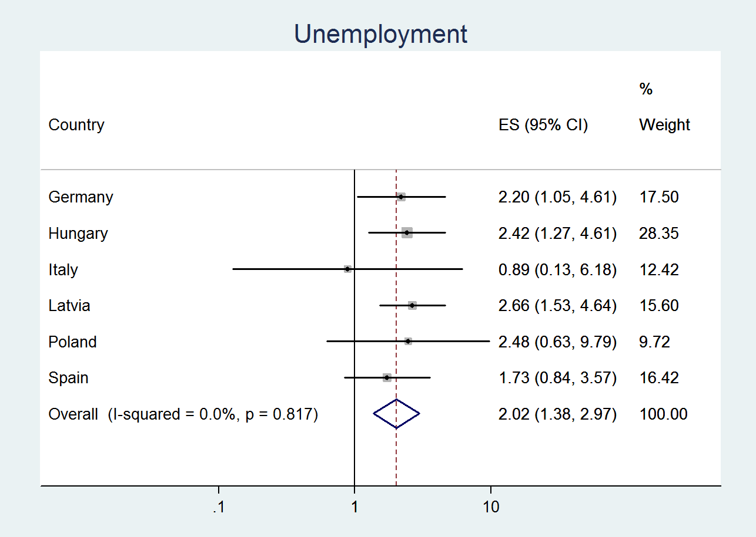
Web Figure 2: Forest plot of meta-analysis on country-specific logits on treatment prediction (model 1b): heterogeneity of ‘unemployment’ – females only
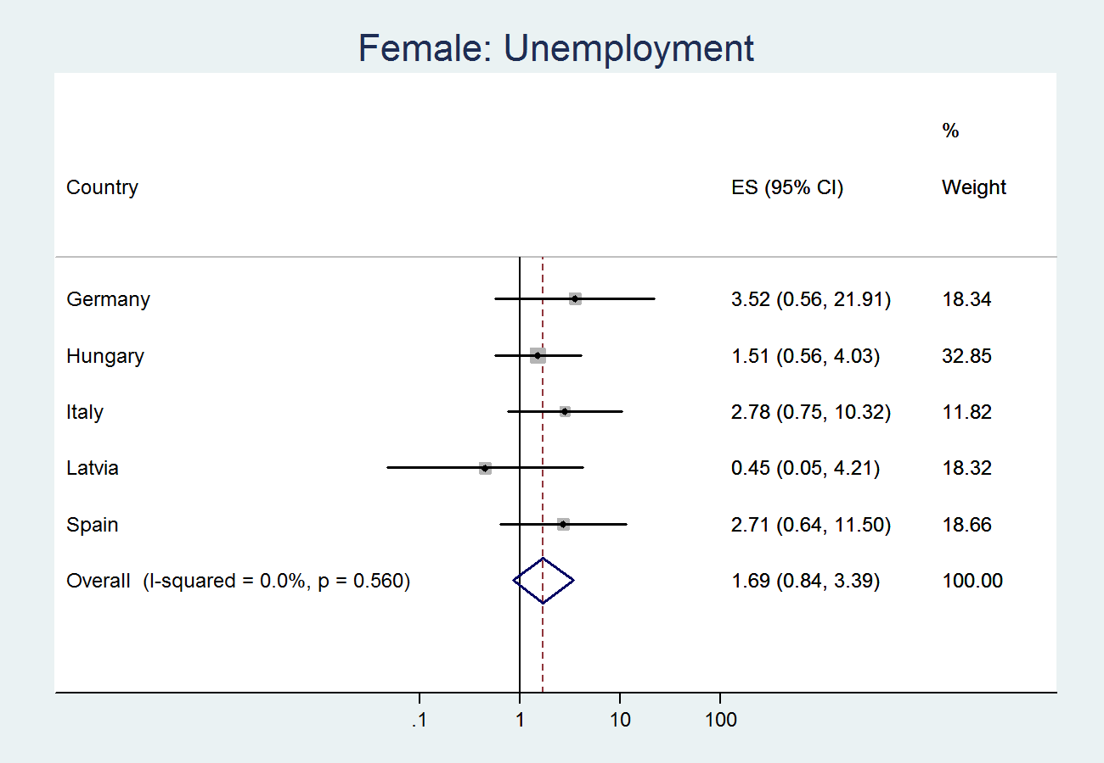
Web Figure 3: Forest plot of meta-analysis on country-specific logits on treatment prediction (model 1b): heterogeneity of ‘unemployment’ – males only
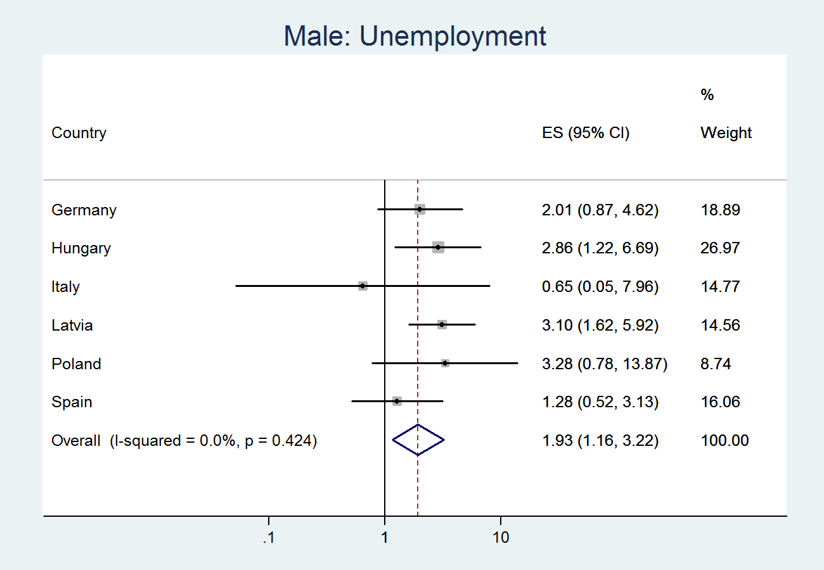
Web Figure 4: Forest plot of meta-analysis on country-specific logits on treatment prediction (model 1b): heterogeneity of ‘liver problems’
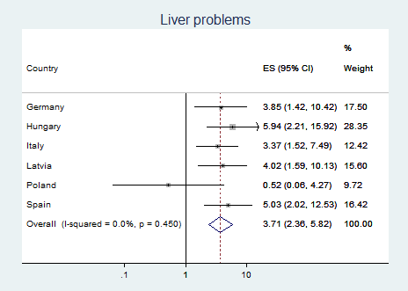
Web Figure 5: Forest plot of meta-analysis on country-specific logits on treatment prediction (model 1b): heterogeneity of ‘liver problems’ – females only
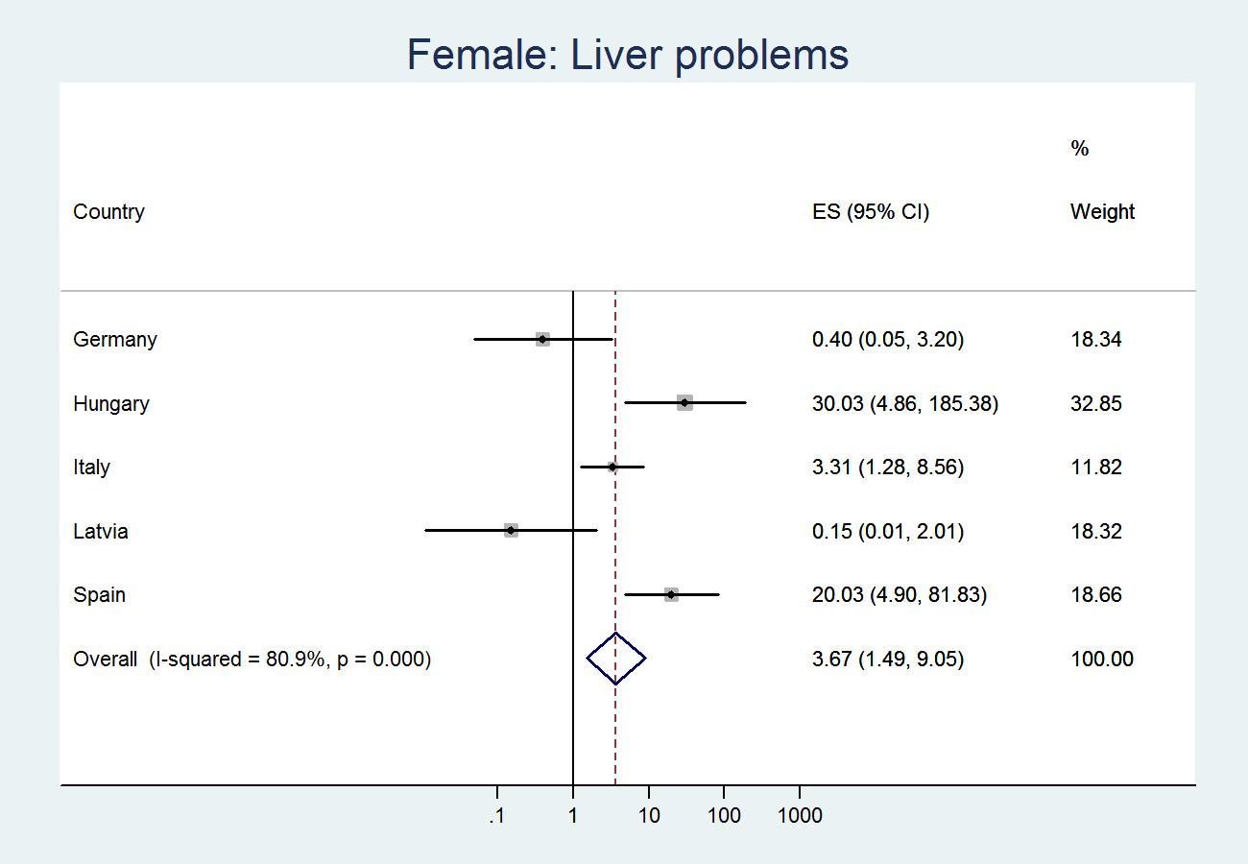
Web Figure 6: Forest plot of meta-analysis on country-specific logits on treatment prediction (model 1b): heterogeneity of ‘liver problems’ - males only
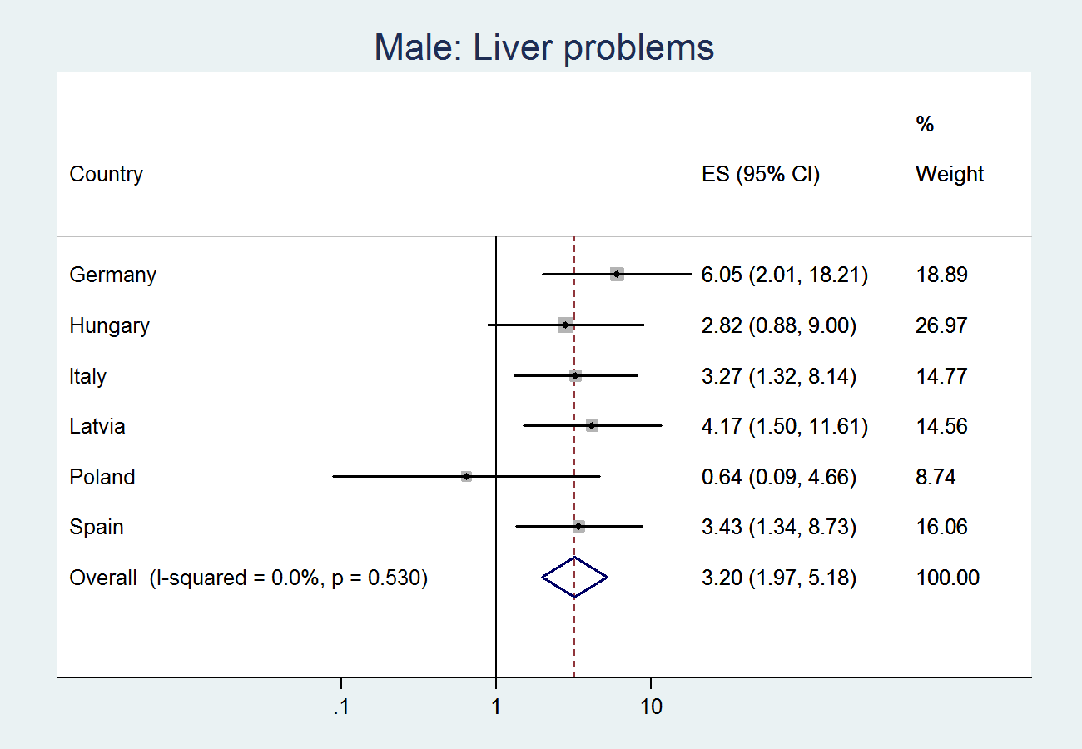
Web Figure 7: Forest plot of meta-analysis on country-specific logits on treatment prediction (model 1b): heterogeneity of ‘anxiety’
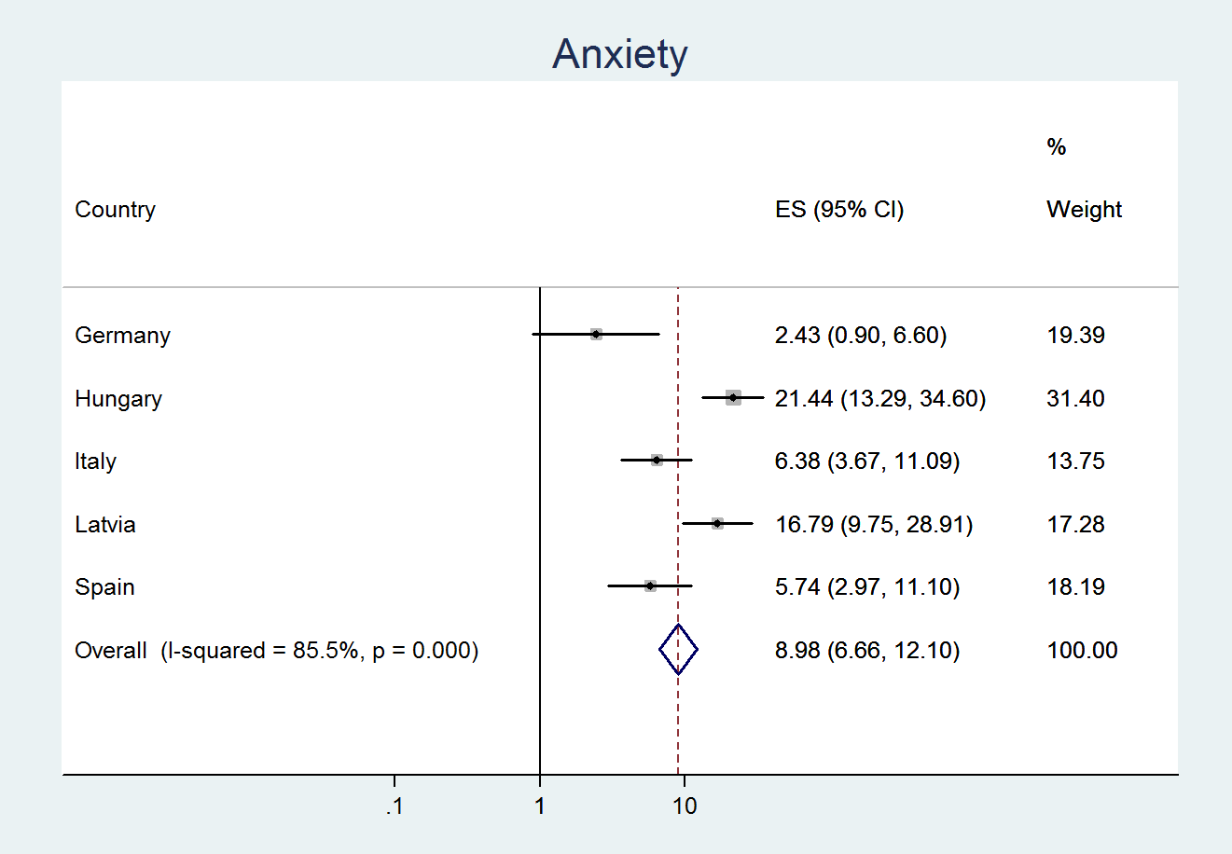
Web Figure 8: Forest plot of meta-analysis on country-specific logits on treatment prediction (model 1b): heterogeneity of ‘anxiety’ – females only
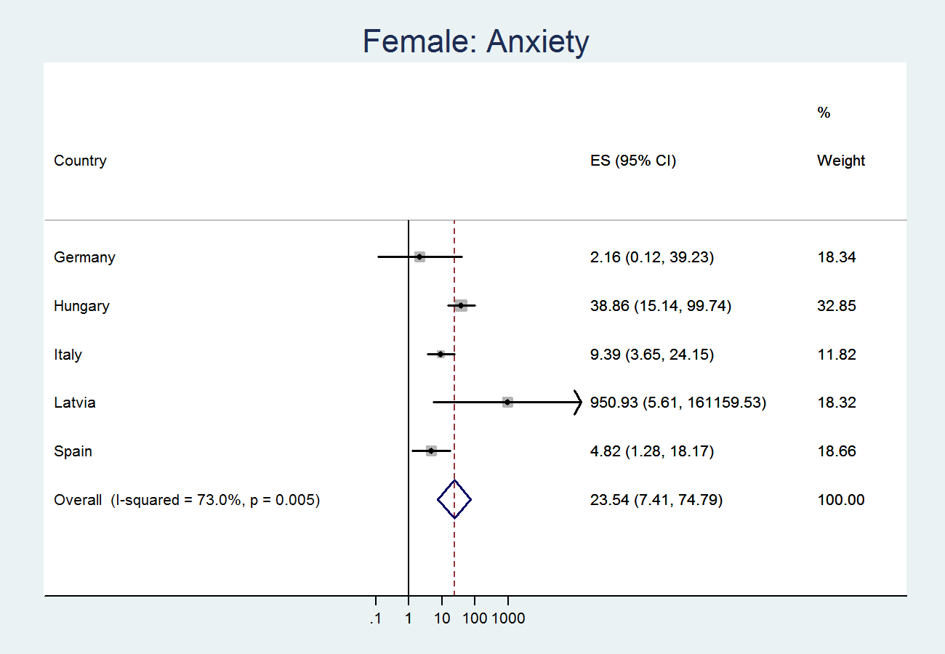
Web Figure 9: Forest plot of meta-analysis on country-specific logits on treatment prediction (model 1b): heterogeneity of ‘anxiety’ – males only
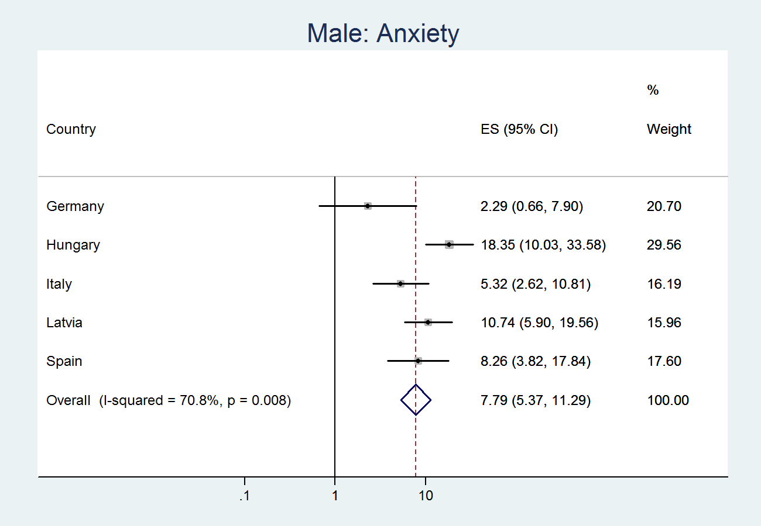
Web Figure 10: Forest plot of meta-analysis on country-specific logits on treatment prediction (model 1b): heterogeneity of ‘inpatient nights’
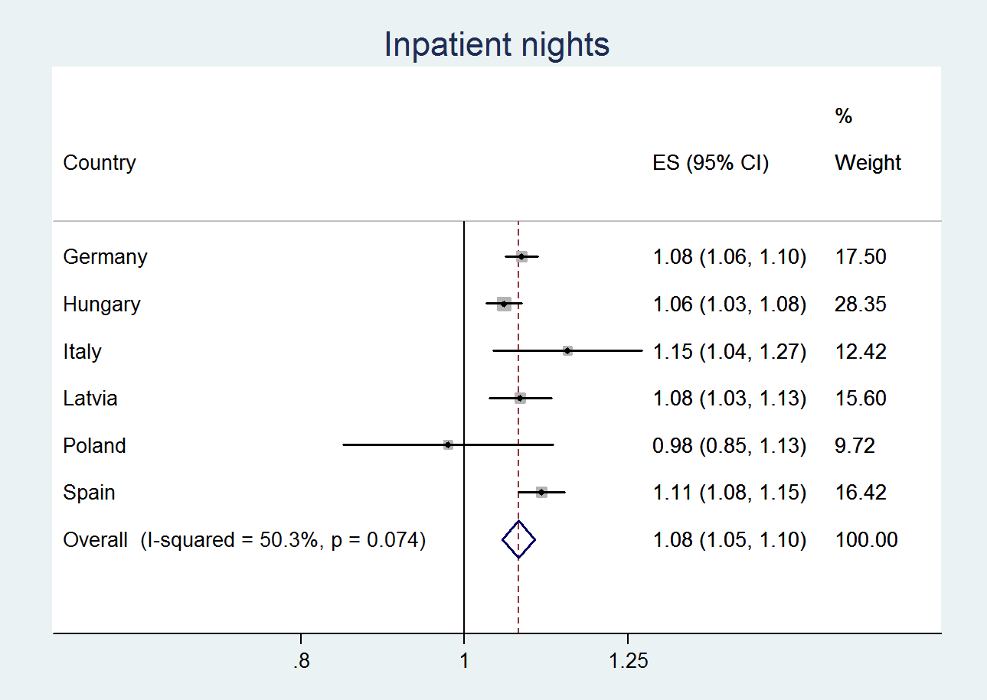
Web Figure 11: Forest plot of meta-analysis on country-specific logits on treatment prediction (model 1b): heterogeneity of ‘inpatient nights’ – females only
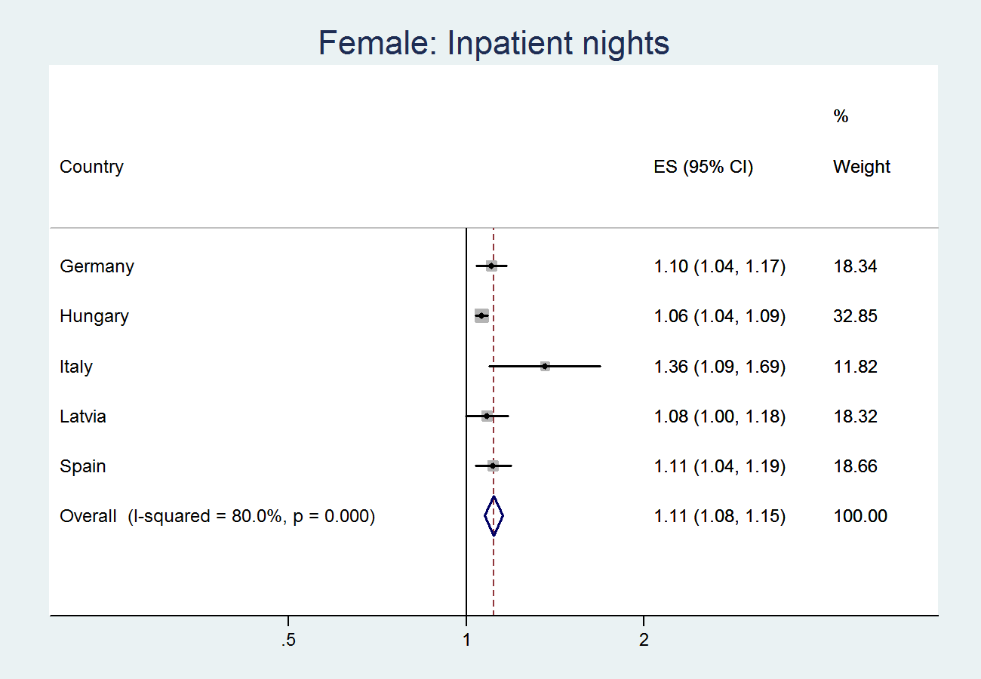
Web Figure 12: Forest plot of meta-analysis on country-specific logits on treatment prediction (model 1b): heterogeneity of ‘inpatient nights’ – males only
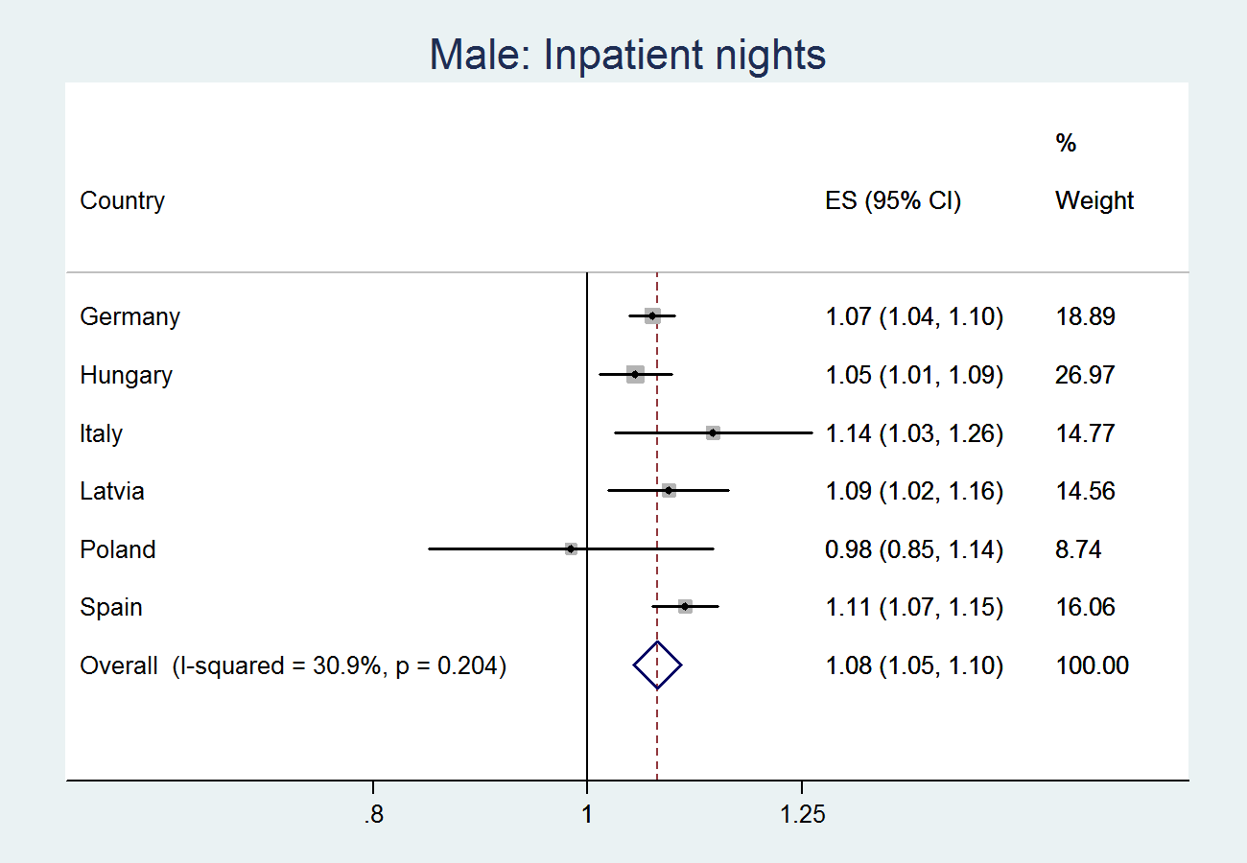
Web Figure 13: Forest plot of meta-analysis on country-specific logits on sample origin prediction (model 1b): heterogeneity of ‘daily ethanol intake’
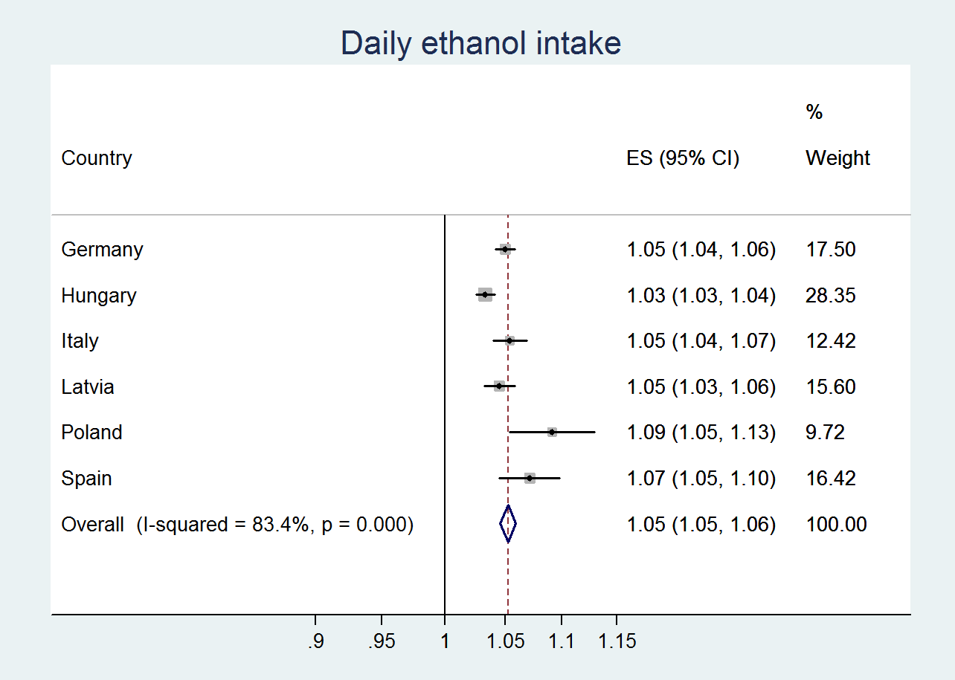
Web Figure 14: Forest plot of meta-analysis on country-specific logits on sample origin prediction (model 1b): heterogeneity of ‘daily ethanol intake’ – females only
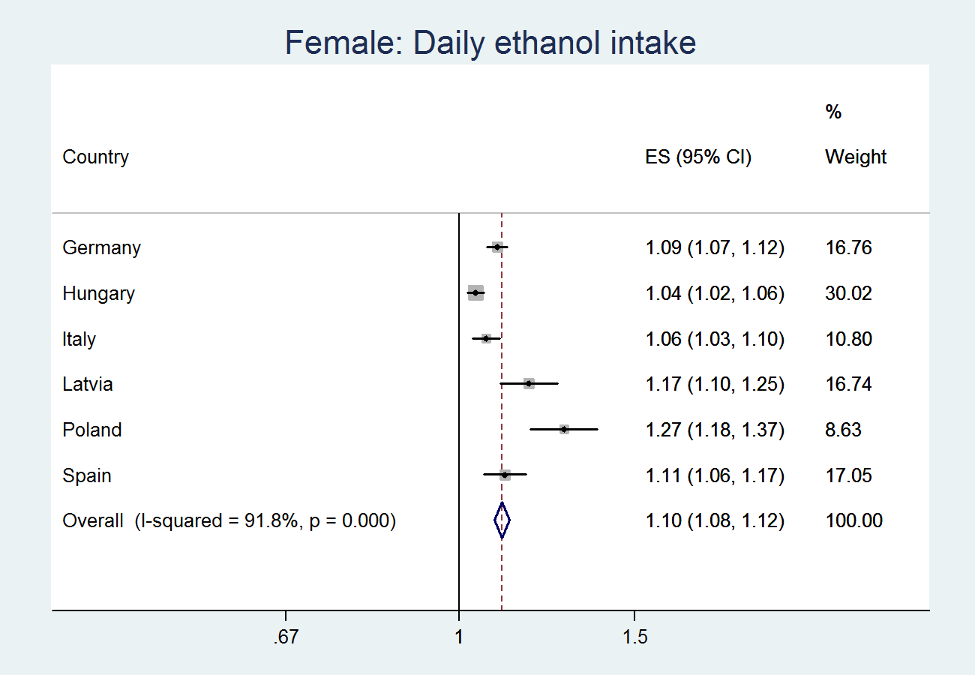
Web Figure 15: Forest plot of meta-analysis on country-specific logits on sample origin prediction (model 1b): heterogeneity of ‘daily ethanol intake’ – males only
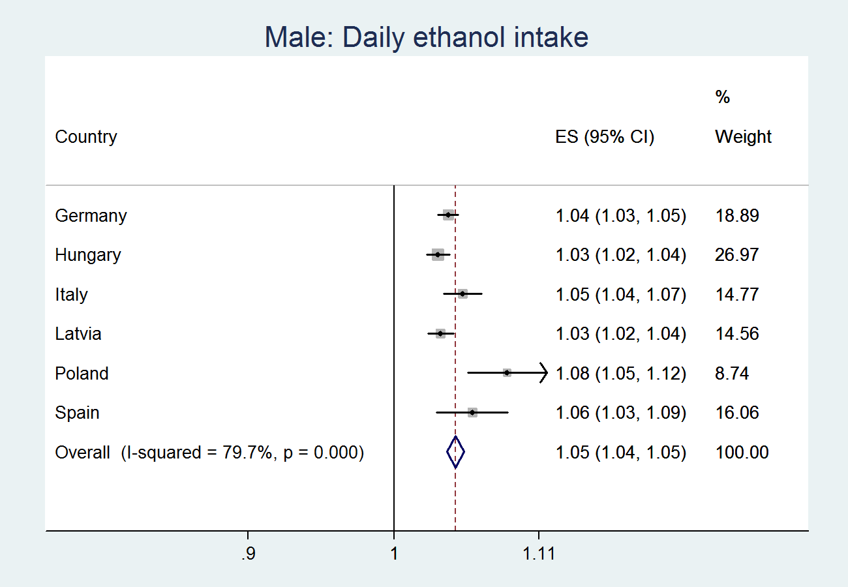

Web Figure 16: Forest plot of meta-analysis on country-specific logits on sample origin prediction (model 2b): heterogeneity of ‘unmarried’
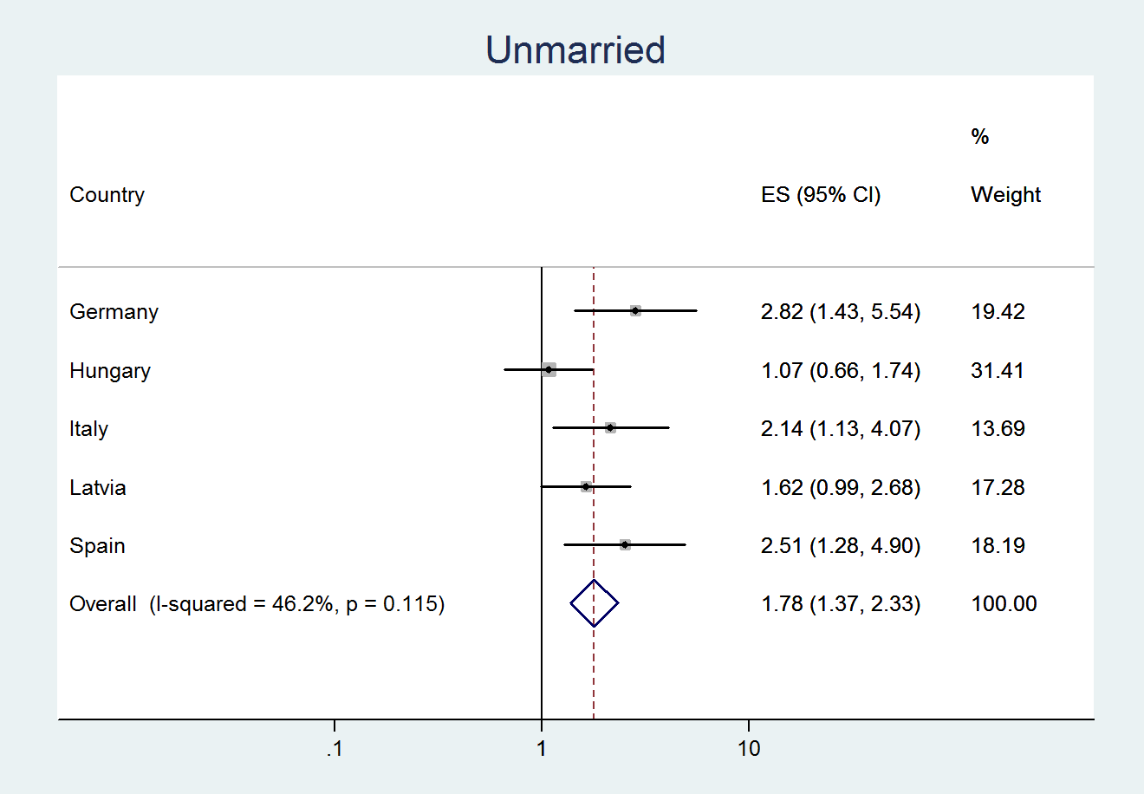
Web Figure 17: Forest plot of meta-analysis on country-specific logits on sample origin prediction (model 2b): heterogeneity of ‘unmarried’ – females only
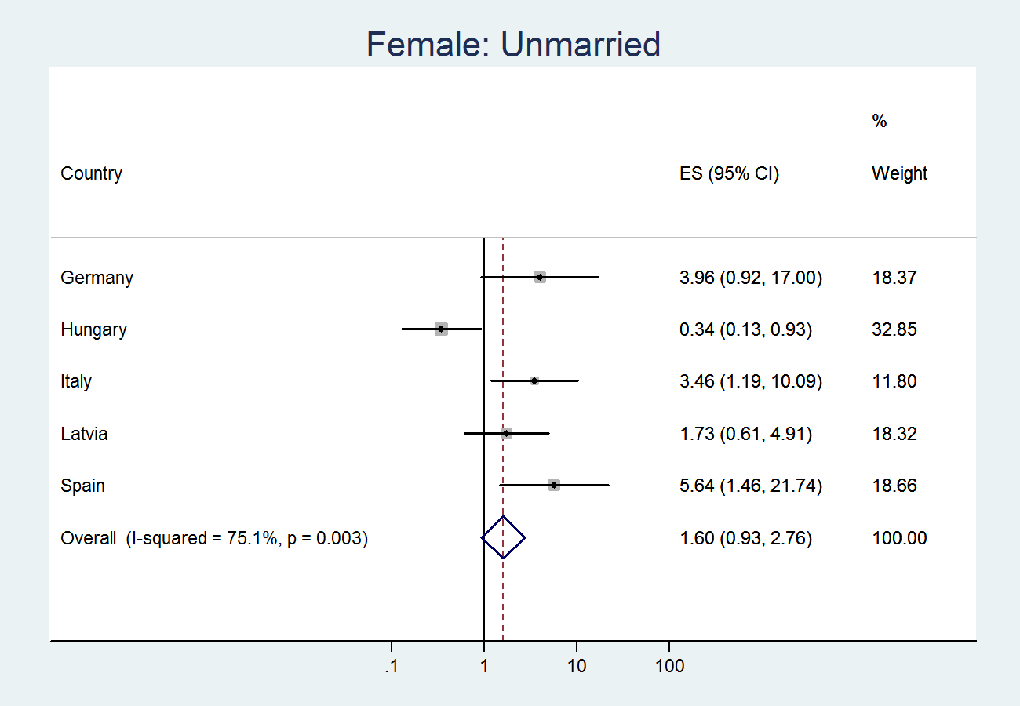
Web Figure 18: Forest plot of meta-analysis on country-specific logits on sample origin prediction (model 2b): heterogeneity of ‘unmarried’ – males only
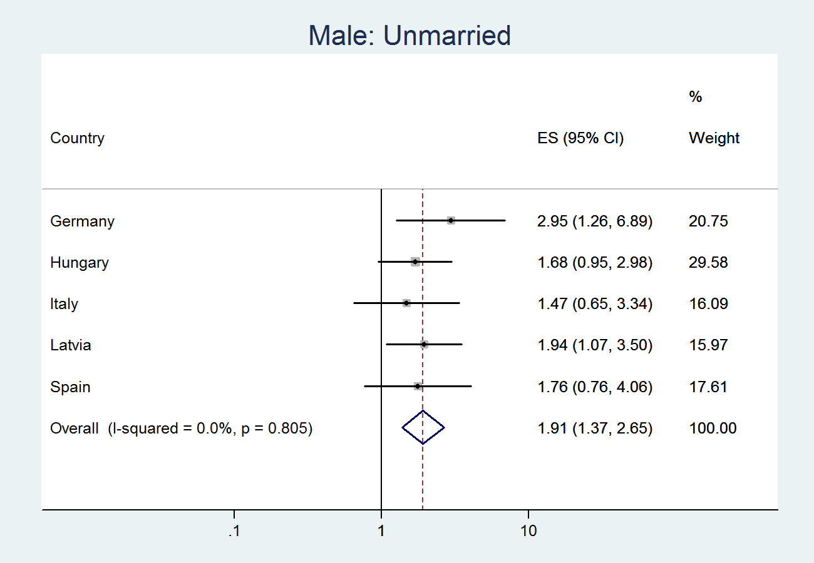
Web Figure 19: Forest plot of meta-analysis on country-specific logits on sample origin prediction (model 2b): heterogeneity of ‘liver problems’
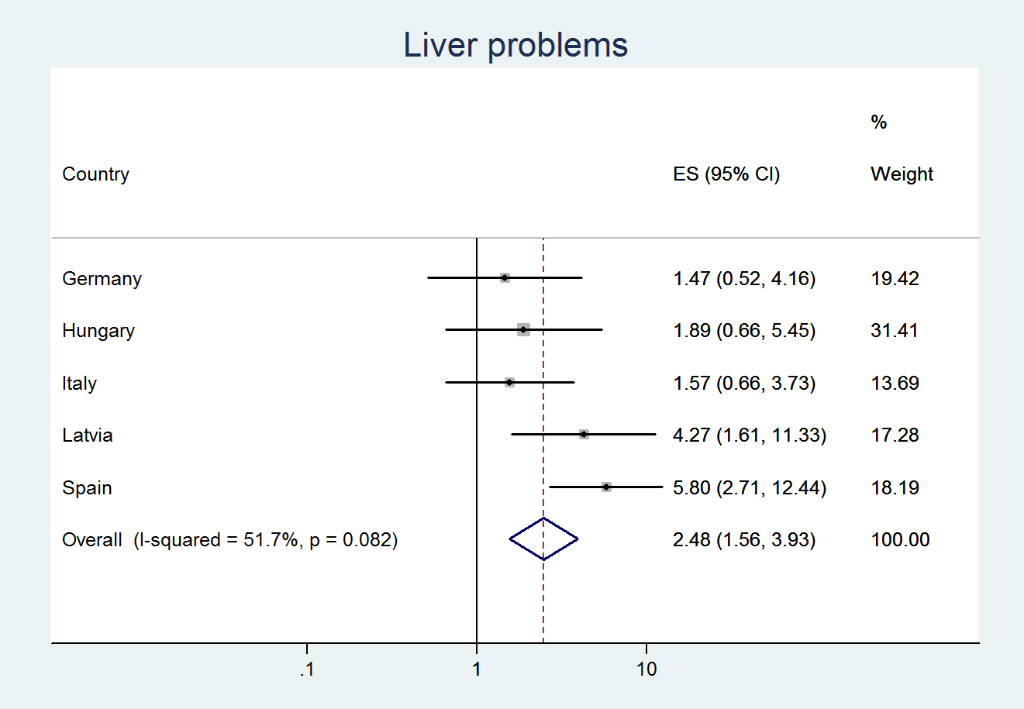
Web Figure 20: Forest plot of meta-analysis on country-specific logits on sample origin prediction (model 2b): heterogeneity of ‘liver problems’ – females only
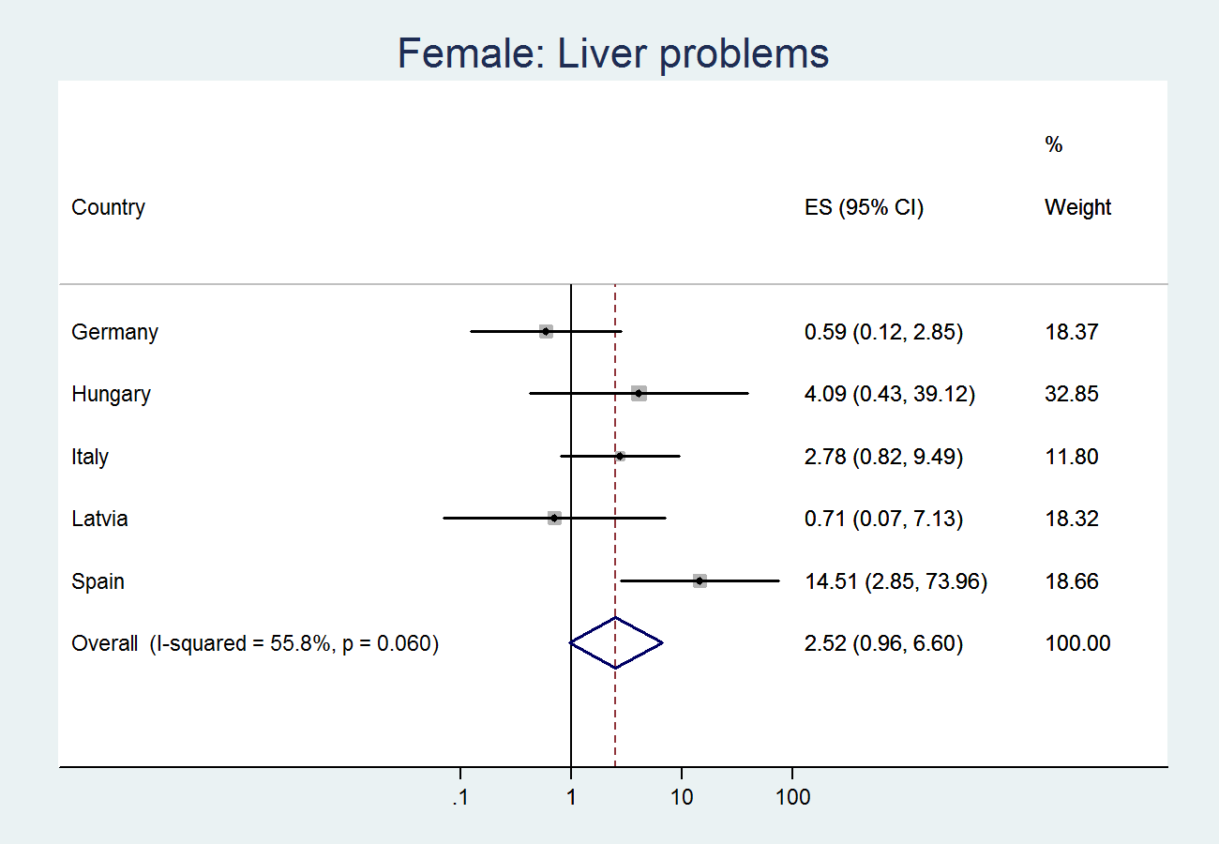
Web Figure 21: Forest plot of meta-analysis on country-specific logits on sample origin prediction (model 2b): heterogeneity of ‘liver problems’ – males only
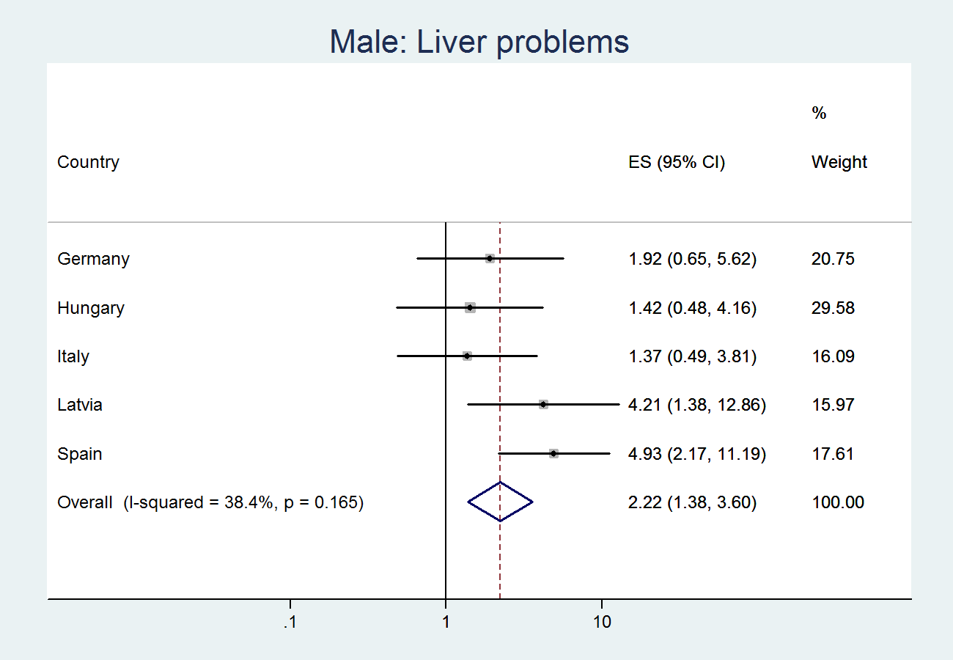

Web Figure 22: Forest plot of meta-analysis on country-specific logits on sample origin prediction (model 2b): heterogeneity of ‘anxiety’
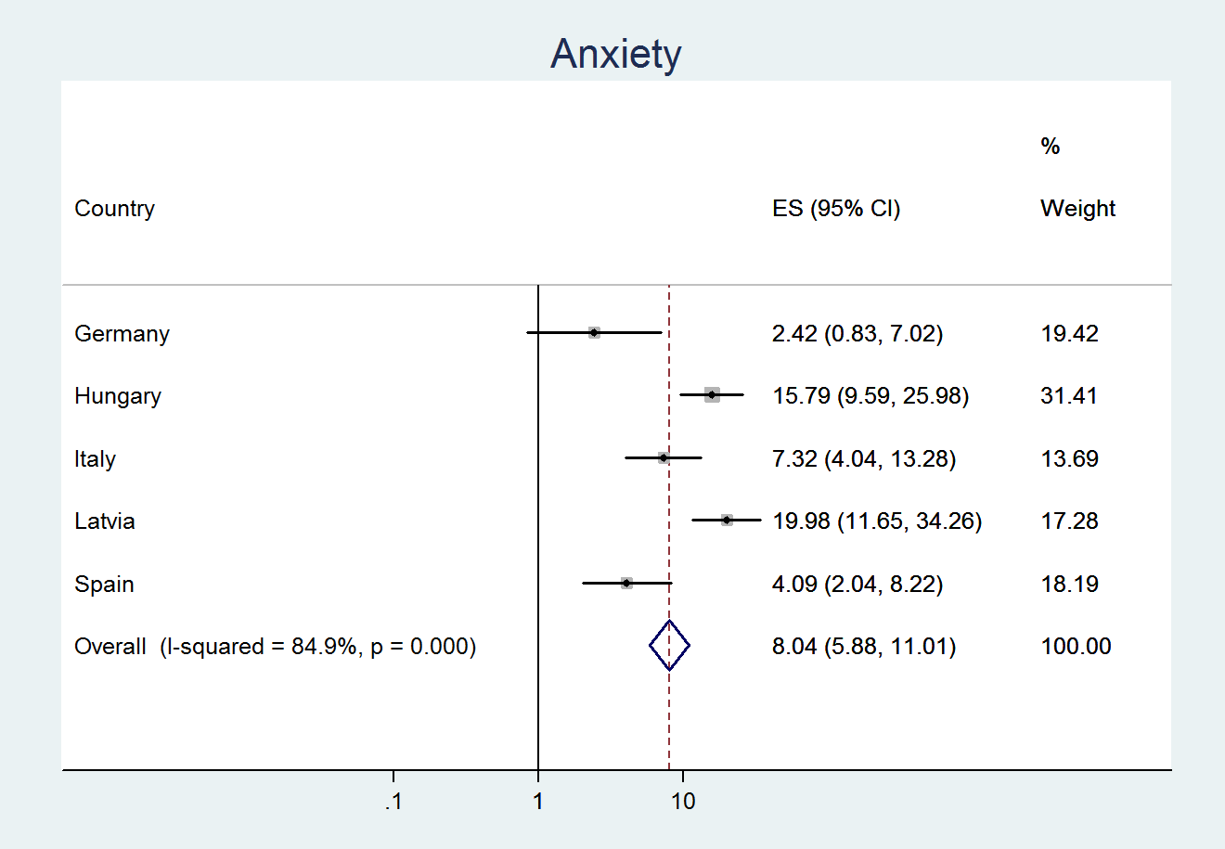
Web Figure 23: Forest plot of meta-analysis on country-specific logits on sample origin prediction (model 2b): heterogeneity of ‘anxiety’ – females only
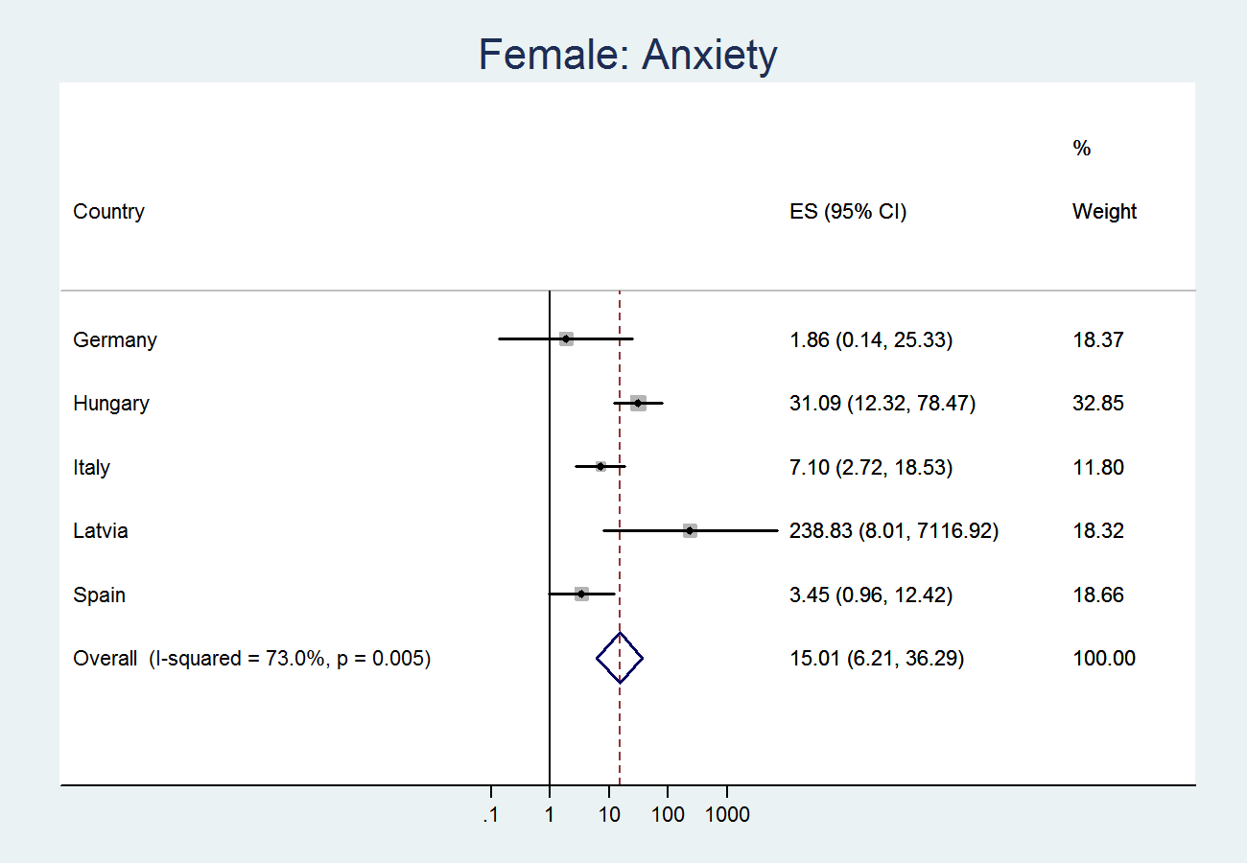
Web Figure 24: Forest plot of meta-analysis on country-specific logits on sample origin prediction (model 2b): heterogeneity of ‘anxiety’ – males only
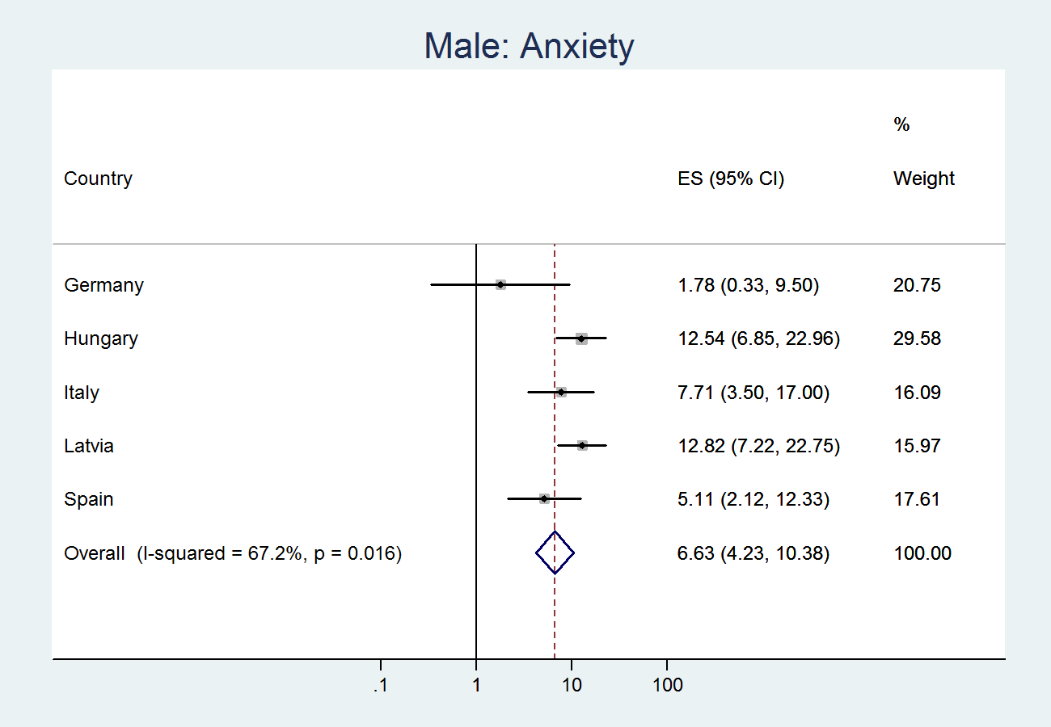
Web Figure 25: Forest plot of meta-analysis on country-specific logits on sample origin prediction (model 2b): heterogeneity of ‘inpatient nights’
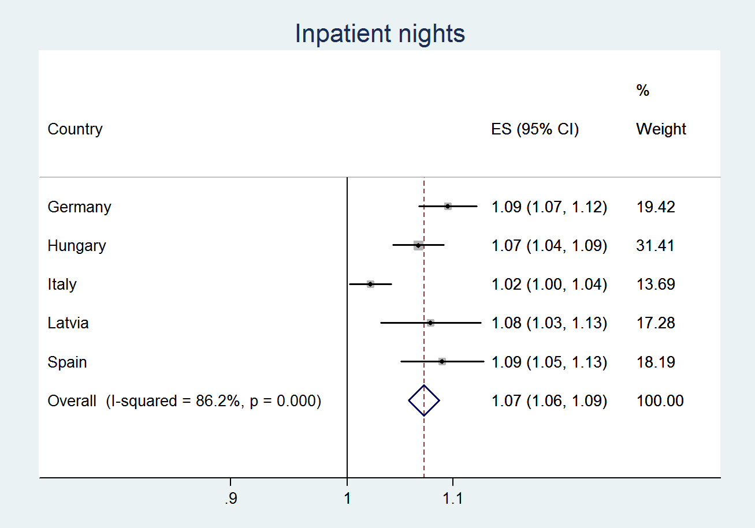
Web Figure 26: Forest plot of meta-analysis on country-specific logits on sample origin prediction (model 2b): heterogeneity of ‘inpatient nights’ – females only
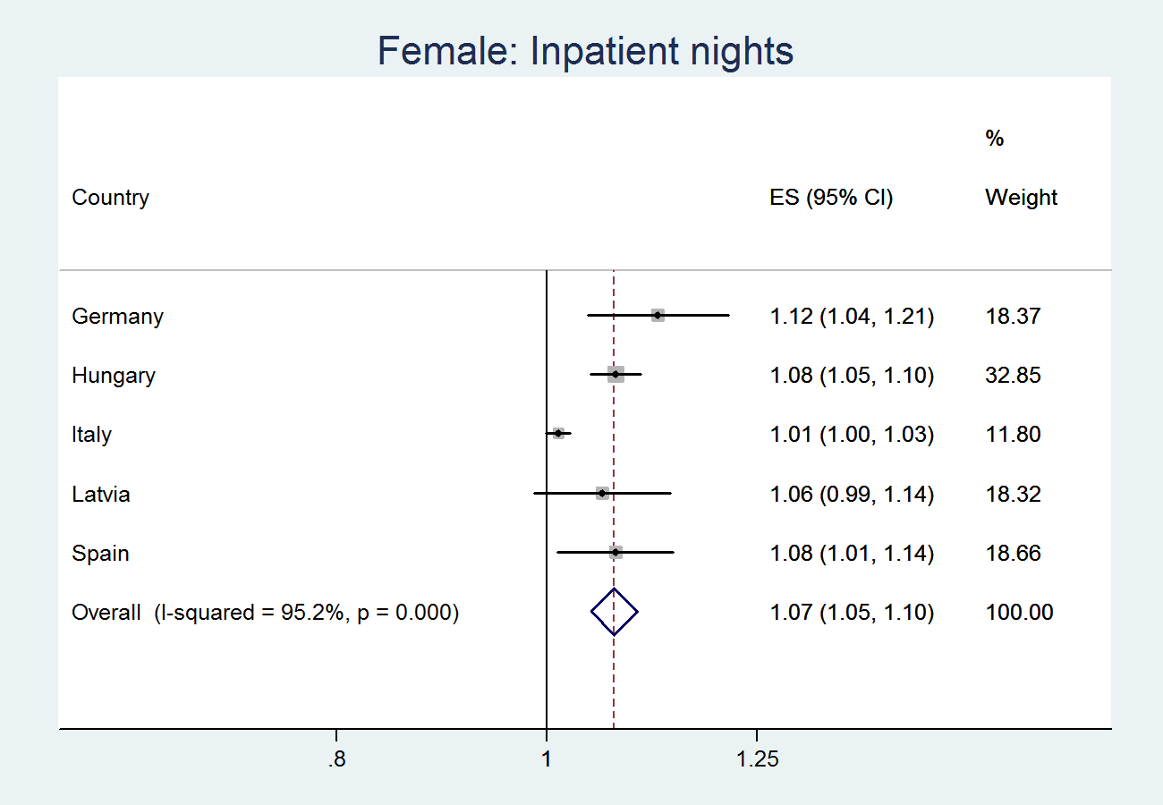
Web Figure 27: Forest plot of meta-analysis on country-specific logits on sample origin prediction (model 2b): heterogeneity of ‘inpatient nights’ – males only
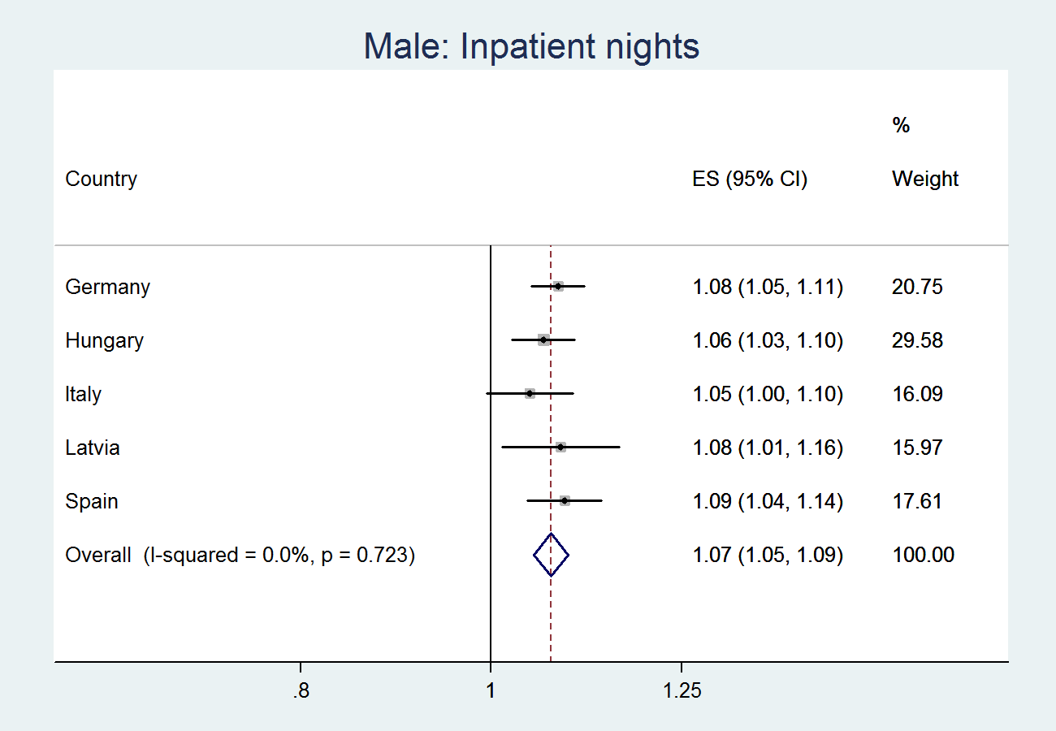
Web Figure 28: Forest plot of meta-analysis on country-specific logits on sample origin prediction (model 2b): heterogeneity of ‘daily ethanol intake’
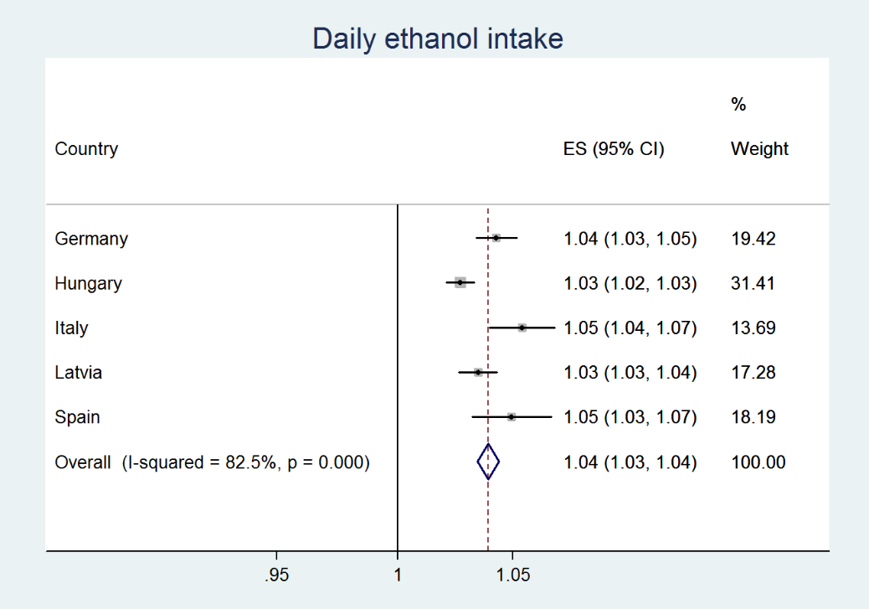
Web Figure 29: Forest plot of meta-analysis on country-specific logits on sample origin prediction (model 2b): heterogeneity of ‘daily ethanol intake’ – females only
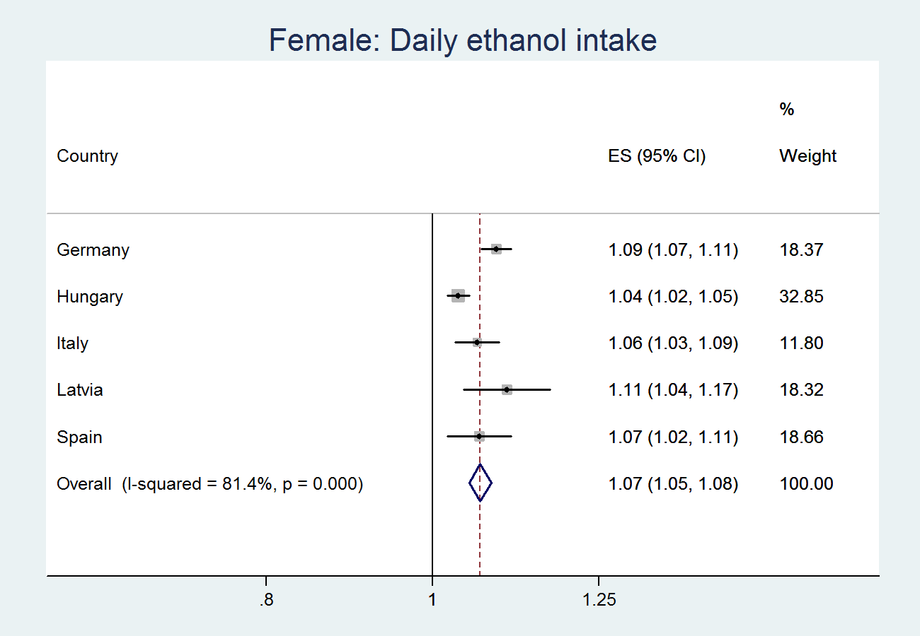
Web Figure 30: Forest plot of meta-analysis on country-specific logits on sample origin prediction (model 2b): heterogeneity of ‘daily ethanol intake’ – males only
