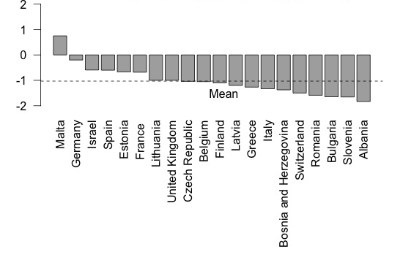

Figure S4: Country mean satisfaction of respondents regarding the funding of their psychotherapy training within the psychiatric curricula. 2 = very satisfied, 1 = satisfied, 0 = Neutral, -1 = dissatisfied, -2 = very dissatisfied.

