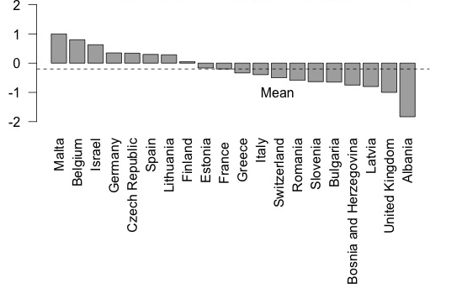

Figure S3: Country mean satisfaction of respondents regarding the quality of their psychotherapy training components within the psychiatric curricula. 2 = very satisfied, 1 = satisfied, 0 = Neutral, -1 = dissatisfied, -2 = very dissatisfied.

