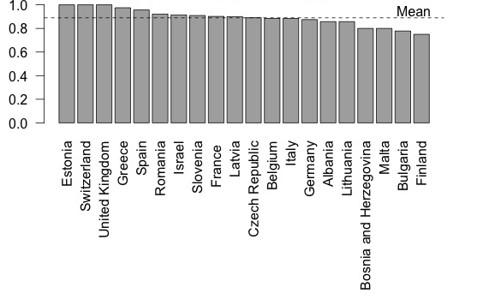

Figure S2: Country percentages of respondents who would like to practice psychotherapy training in the future.

